CS5560 Knowledge Discovery and Management

Problem Set 6

March 3, 2020

Name:

Class ID:

1. LDA

Read the following articles to learn more about LDA

* <https://algobeans.com/2015/06/21/laymans-explanation-of-topic-modeling-with-lda-2/>
* <http://engineering.intenthq.com/2015/02/automatic-topic-modelling-with-lda/>

Consider the topics discovered from Yale Law Journal. (Here the number of topics was set to be 20.) Topics about subjects like about discrimination and contract law.

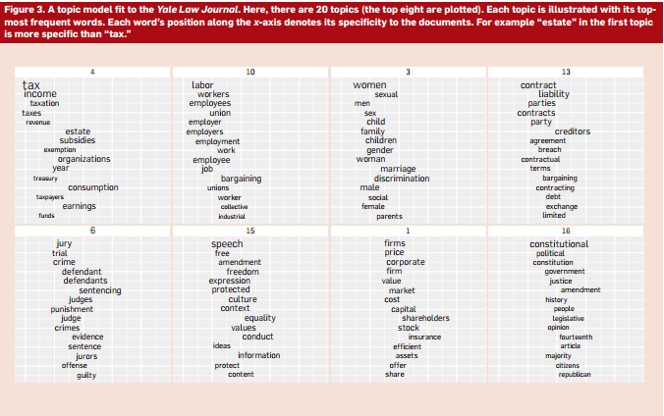

1. Describe the overall process to generate such topics from the corpus.
2. Draw a knowledge graph for Topic 3 in Yale Law Journal (The First Figure).
3. Describe the inference algorithm that was used in LDA.

