**M. Prathyusha mprathyusha17@gmail.com**

<https://www.linkedin.com/in/mprathyusha/> **+1 (346) 291 9831**

____________________________________________________________

**Summary:**

**UI- portfolio:** <https://mprathyu.github.io/>

* Over 7+ years of professional experience in **software development life cycle (SDLC)** and 4+ years in designing **User Interface (UI)** web applications by using UI authoring and web technologies.
* Extensive experience in developing and designing user Intereactive(**UI**) of Internet/Intranet applications using **HTML5, HTML, XML CSS, CSS3, JavaScript, jQuery** meeting **W3C** standards.
* Experience in web front end coding, mobile application, web development and web and multimedia designing.
* Designed and developed the client facing portal called Implementation Module using framework **Angular 2/6** and **Angular 8** along with HTML5, CSS3, and **Typescript**.
* Extensive knowledge of current Web Standards W3C , hand-coding of HTML5,XHTML,DHTML, XML parsing and CSS3, CSS based HTML Table less web layouts, JQuery, JavaScript, UI design, Print design, **e-commerce templates**, Online advertising, web analytics, social media, SEO, **Image optimization**, 508 compliance.
* Developed liquid web page layout, navigation, animation, buttons, icons and wireframe creation.
* Responsible for the design and development of web sites and web applications through the use of **Photoshop, Dreamweaver, Flash, Illustrator**.
* Responsible for quality assurance of finished websites including the validation of web forms and links, **W3C validation**, t**roubleshooting** and problem solving.
* Web page optimization of navigation, load times using Font-Awesome CSS-Sprites - W3C cross-platform and browser compliance.
* Implement DoubleClick and On-click floodlight tags.
* Designing professional UI web applications using front-end technologies like **HTML5, CSS3, JavaScript, TypeScript, XML, XHTML, jQuery , AJAX, JSON.**
* Customized portal for Hello Wallet application inside Key.com portal for Personal Banking
* Integration **Bing Maps** to pull nearest Bank branches with duties.
* Appointment Scheduler for in person meeting with a professional banker.
* Mortgage calculator for estimate of loan amount, is user interactive application.
* Implementing custom search functionality for different segments of key.com pages
* Created pixel perfect wireframes for fly out, in easy access tools.
* Implementation of full responsive using videos JWPlayer-6 with captions.
* Experience applying the latest software development approaches including **MVC**, event - driven applications using **AJAX**, **Object Oriented (OO) JavaScript**, **JSON** and **XML**.
* Experienced in various IDEs like Eclipse, Sublime, Notepad++ and Microsoft Visual.
* Expert in creating Templates, Web Interfaces, Layouts, and Flow of Future Pages.
* Expertise in designing and developing User Experiences for Web Applications using Web Authoring tools as **Adobe Dreamweaver** CS3, **Adobe Illustrator**.
* High level of expertise in CSS pixel-level layout, Consistency with browsers, Version and Platform Independence.
* Good knowledge in **Adobe Phonegap/Cordova Ionic (IOS, Android) hybrid** applications.
* Proficient with creating Logos, Banners, Buttons, Icons and Images using **Adobe Flash** and **Adobe Illustrator**.
* Expert in designing web applications and web contents utilizing various **Search Engine Optimization** **(SEO)** techniques.
* Expertise in analyzing the DOM Layout, Java Script functions, Cascading Styles across cross-browser using Fire Bug, Developer Tool Bar.
* Skilled at analyzing and solving browser compatibility challenges and possesses ability to maintain consistency and well commented HTML and CSS markup.
* Experience in working with Databases like SQL Server and proficiency in writing complex SQL, PL/SQL.
* Experience in **Agile methodologies** such as **Scrum**, Extreme Programming, **Waterfall Model** and **Test Driven Development(TDD).**
* Strong communication, collaboration & team building skills with proficiency in grasping new technical concepts quickly.

**Skill Set Tree:**

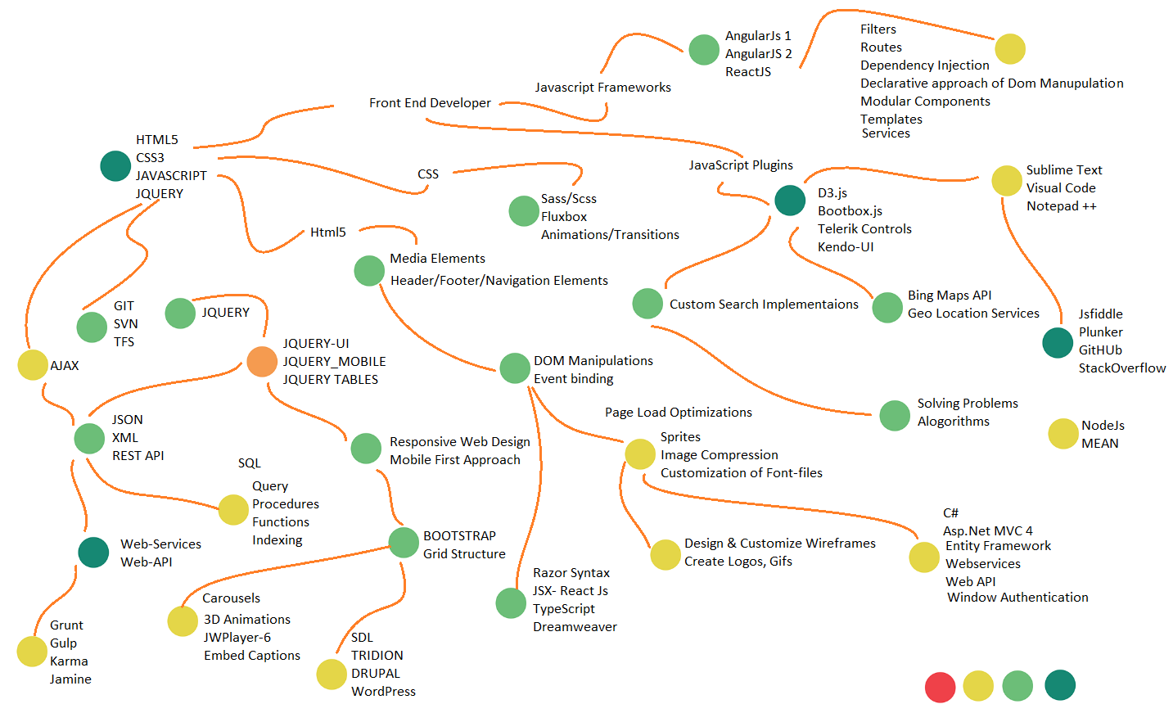

**Education:**

Master’s in **Computer Science** from Texas Southern University, Houston TX.

I have done my Bachelors in **Electronics and Communication Engineering** from JNTU Kakinada.

**Citi Group**

**Sr UI- Front End Developer**

Dec 2019 to Present

Description: **RUBY** system is Citi’s financial forecasting and interest rate risk management system. By using the input data sources, RUBY Forecast Engine generates 5-years, monthly forecasted balances. Ruby Risk Analytics Engine utilizes the data inputs in the system and generates Interest Rate Risk(IRR) metrics. Also it generates for Citi internal forecasting and CCAR submissions.

**Responsibilities:**

* **Successfully completed migrating from Angular2 to Angular 8 Ruby Project from scratch – till deployment to production Environment.**
* **Gathering all node modules and libraries, installing dependecies, creation development and production variable, user stories, tasks and Unit test cases**.
* Involved in designing the front end applications using web technologies **like HTML/HTML 5, XHTML**, and CSS/CSS3. Built responsive websites using **HTML5, CSS3, JavaScript**, **ECMA5, TypeScript** and **PrimeNG.**
* Working on Pagination, grids, nested tree in the dropdowns, mouse hover functionalities, navigation between pages.
* Constructed and automated the **build process** for production builds, via **Jenkins** pipeline and deploying through release management cycle.
* Wrote extensive **unit tests** by deploying automated test-driven development tasks.
* Rendered assistance during the **QA & UAT phases** to determine the root cause and provide the best resolution.
* Involved in writing application level code to interact with APIs, Web Services using REST, **JSON**.
* The portal is made responsive using **CSS3**, preprocessors like **SASS**, **Bootstrap**, and media queries to support desktop and tablets.
* Implementation of latest concepts of angular 8 like **Treeshaking**, **Lazy Loading** and **Ivy Redering Engine**.
* Writing tested, idiomatic, and documented JavaScript, HTML and CSS.
* Coordinating the workflow between the graphic designer, the HTML coder, and myself.
* Cooperating with the back-end developer in the process of building the **RESTful API**.
* Communicating with external **web services**.
* Ensuring a clear dependency chain, in regard to the app logic as well as the file system
* Extensive knowledge of CSS and JS methods for providing performant visual effects and keeping the framerate above 30fps at all times
* Validating user actions on the client side and providing responsive feedback
* Writing non-blocking code, and resorting to advanced techniques such as multi-threading, when needed
* Creating custom, general use modules and components which extend the elements and modules of core **Angular 8**
* Written modular, secure, and well-tested front-end code in **Typescript**, **HTML5** and **CSS3** using the latest web.
* Wrote jQuery function while implementing various UI Screens across the whole web application (both consumer facing as well as internal application).

**Skills used:** **Node JS 12.4.0, Webpack, Jira, GIT, Bitbucket, Jenkins, PrimeNG, Jasmine, Karma, SQL Developer, SonarQube, HTML5, CSS3, SCSS, Angular8, TypeScript, ES6, JQuery, Bootstrap, Adobe Photoshop, Illustrator, Sublime-text, Visual Studio-Code 1.5, JSFiddle, Plunker, JSON, Eclipse IDE.**

**Experience: **

**Elevate Financial Services**

**Sr UI-Front End Developer (Angular 7)**

Nov 2018 to Dec 2019

**Responsibilities:**

* Implemented underwriting for **RISE credit** application by using **Angular 7** framework along with **HTML5**, **CSS3**, **NodeJS**, **Javascript, Angular Material** and **Typescript** in **azure** environment.
* Successfully integrated **SmartyStreet** API’s to RISE application for validating addresses given by user.
* Creating and building state specific popups and generating documents from blob storage to UI by using butter **CMS** through content API’s.
* App made responsive using **CSS3**, preprocessors like **SASS** and media queries to support desktop, mobiles and tablets.
* Programmed interactive features: animations, navigation buttons, model popups, messaging systems, forum functions exclusively in **Javascript**, **CSS**, **TFS, GIT** and constructed CSS site using SASS.
* Build 20 to 30 responsive pages across the application which are highly user interactive.
* Coordinating the workflow between the graphic designer, the HTML coder, and myself.
* Cooperating with the back-end developer in the process of building the **RESTful API**.
* Communicating with external **web services**.
* Developed the **unit testing** on **Jasmine** test framework and **karma** test runner. BDD and TDD framework to maintain code quality and easy to refactor the design implementations.
* Successfully integrated **Acquire co-browse** for RISE web used by agents to view and interact with customer screens online in realtime troubleshooting on fly through navigation, monitoring user activities.
* Implemented **Recaptacha** for restricting bots using the application.
* Built **mobile-first** approach with responsive designed pages.
* Ensuring high performance on **mobile** and **desktop**.
* Developed single-page using Angular7, JavaScript for reusable web components.
* Extensively worked with Angular components, custom directives created through **angular CLI**, services, observables, routing & navigation, dependency injection, classes, modules, reactive forms and form validations.
* Working in **AGILE** based development environment,participating in sprint planning, business requirementgathering sessions, **SCRUM** and bi-weekly sprints.
* Implemented Aria Roles attributes and relations to meet **ADA** compliance – American Disability Act.

**Skills used:** **Node JS 10., Webpack, Microsoft Team Foundation Server(TFS), Azure cloud, CI/CD pipelines, GIT, Sourcetree, Bitbucket, HTML5, CSS3, SASS, Angular7, TypeScript, Angular-Material, Jasmine, Karma, ES6, Cosmos DB, Butter CMS Zeplin, Bootstrap, Stackblitz, REST, Adobe Photoshop, Illustrator, Sublime-text, JSFiddle, Plunker, JSON, Recaptcha, Visual Studio code, SCRUM, Agile Methodologies.**

**First Command, Fort Worth Texas** 

**UI- Front End Developer**

Aug 2017 to Oct 2018

**Responsibilities:**

* Involved in requirement gathering, designing, development, UI reviews, and maintenance.
* Involved in designing the front end applications using web technologies **like HTML/HTML 5, XHTML**, and CSS/CSS3. Built mobile-first, responsive websites using **HTML5, CSS3, JavaScript**, **ECMA6, TypeScript** and **Bootstrap**
* Built Web pages that are more **user-interactive** using **jQuery plugins**, **AJAX**.
* Involved in writing application level code to interact with APIs, Web Services using AJAX, **JSON**.
* Designed and developed the client facing portal called Implementation Module using framework **Angular 2/4** along with HTML5, CSS3, and **Typescript**.
* The portal is made responsive using **CSS3**, preprocessors like **SASS**, **Bootstrap**, and media queries to support desktop and tablets.
* Delivering a complete front-end application. Also worked on proof of concepts for **Angular 2/4** for registaration portal.
* Acted as **Scrum master**, responsible for better creativity and tries to improve the efficiency of the development.
* Writing tested, idiomatic, and documented JavaScript, HTML and CSS.
* Coordinating the workflow between the graphic designer, the HTML coder, and myself.
* Cooperating with the back-end developer in the process of building the **RESTful API**.
* Communicating with external **web services**.
* Ensuring a clear dependency chain, in regard to the app logic as well as the file system
* Ability to provide SEO solutions for single page apps
* Extensive knowledge of CSS and JS methods for providing performant visual effects and keeping the framerate above 30fps at all times
* Thorough understanding of the responsibilities of the platform, database, API, caching layer, proxies, and other web services used in the system
* Validating user actions on the client side and providing responsive feedback
* Writing non-blocking code, and resorting to advanced techniques such as multi-threading, when needed
* Creating custom, general use modules and components which extend the elements and modules of core **Angular 2/4**
* Written modular, secure, and well-tested front-end code in **Typescript**, **HTML5** and **CSS3** using the latest web.
* Wrote application level code to perform client side validation using jQuery and JavaScript.
* Wrote jQuery function while implementing various UI Screens across the whole web application (both consumer facing as well as internal application).
* Heavy use of knockout view models for separation of UI, data, and logic concerns.
* Technical expertise in working with HTML5, JavaScript, jQuery , AJAX and CSS projects and successfully finished projects in mobile platforms and **Responsive Web Design (RWD)** projects.
* Debug the application using Firebug to traverse the documents and manipulated the Nodes using DOM and **DOM** Functions. Worked on Backbone.js to create Models to represent data.
* Involved in writing and modifying procedures, Queries, views and triggers and calling them from JavaScript.
* Responsible for design and implementation of the family of web applications and web services that make up the Capitol Corp line.
* Web page optimization of navigation, load times using Font-Awesome CSS-Sprites - W3C cross-platform and browser compliance.
* Includes multiple **GUI** web applications as well as a **RESTful web service API** that publicly exposes the underlying operations.

**Skills used:** **Node JS 8, Gulp, Asana, Jira, GIT, Bitbucket, Jenkins, Angular-Material, Ng Primefaces, Jasmine, Karma, HTML5, CSS3, SASS, Angular 2, Angular 4, TypeScript, ES6, Invision, Bootstrap, AJAX, Sublime-text, VS-Code, JSFiddle, Plunker, JSON, Visual Studio.**

**Key Bank Limited, Cleveland, Ohio**

**UI- Front End Developer**

Jan 2017 to Jul 2017

**Responsibilities:**

* Built Web pages that are more user-interactive using HTML5, CSS3, AJAX and JavaScript.
* Participated in development of a well **responsive** **single page application** using Angular framework and JavaScript in conjunction with HTML5, CSS3 standards, with front end UI team.
* Created Typescript reusable components and services to consume REST API's using Component based architecture provided by angular 2.
* Implemented **HTTP** requests using **RxJs Observable** library to handle multiple values over time
* Used SVN for version control and JIRA for defect tracking.
* Many of the tasks have been framed with different user stories and have been working in 2 week sprint model covering up to 10 -12 user stories per iteration and getting the acceptance criteria for sign off.
* Define technical requirements based upon business requirements.
* Involved in **Agile** process, **monthly Sprints**, and **daily Scrums** to discuss the development of the application.
* Excellent User Interface Visual design in Adobe Photoshop/Fireworks
* Worked with Cross-Browser Compatible issues.
* Implemented JS/CSS combine and minify, Sprite generator, and resource aggregator to improve application performance.
* **Web page optimization** of navigation, load times using Font-Awesome, CSS-Sprites, W3C Standard and cross-platform/browser compliance.
* Build SPA with **AngularJs-2** component based architecture with **Type Script** **NodeJs** and PrimeNG
* Created Templates, Web Interfaces, Layouts, and Flow of Future Pages with Responsive Web Design.
* Heavy use of knockout view models for separation of UI, data, and logic concerns.
* Technical expertise in working with HTML5, JavaScript, jQuery , AJAX and CSS projects and successfully finished projects in mobile platforms and Responsive Web Design (RWD) projects.
* Interacted with java controllers (jQuery, Ajax, and JSON to write/read data from back end systems).
* Utilized current and upcoming industry trends and practices to create SiteWise and **SDL-Tridion CMS** websites.
* Developed and implemented an in-app message feature with **Angular, Node, Express, Mongo DB**
* Provided Queues for web page readers to make ADA standard.
* Implemented **W3C.ORG** standards for all the web pages.
* Used Thrift to call a piece of code in remote process **(RPC)** Remote Procedure Call.

**Skills used:** **Web Pack, Jenkins, Linux- Ubuntu, Angular-Material, Ng Primefaces, UrbanAirship, Mobile-SQLite, HTML5, CSS3, SASS, Angular 2,TypeScript, Adobe Photoshop, Apache Thrift, Illustrator, Sublime-text, VS-Code, Bing Maps, JSFiddle, Plunker, JSON, Visual Studio, Oracle server, Node Js 7.6.0, Dreamweaver CC.**

**Texas Southern University**

**Front End Developer, PHP**

Jan 2016 to Dec 2016

**Responsibilities:**

* Involved in requirement analysis, design and development of web based applications for Commercial Customers.
* Development & Testing of websites and APIs ensure highest quality.
* Support and maintenance of websites and incorporating changes based on requirements.
* Integration of **RESTful APIs** in PHP scripts for mobile applications.
* Involved in the analysis of the assigned support tickets including replicating the issue, analyzing the issue and updating the ticket with the appropriate information.
* Work on the development activities as part of issue resolution. Perform Unit Testing, assist user testing and closing the tickets.
* Defect tracking & Analysis in Quality Center with effective QA processes, to reduce defect count.
* Web application development using **Agile-Methodology** development-**rapid prototyping**.
* Involved in web development using open source e-commerce solutions like WordPress and MVC based rapid development framework

 **Skills Used:**  **PHP, WordPress, CSS, JavaScript, jQuery, HTML, WAMP, JavaScript, jQuery, AJAX**

**Mylan Limited**

**Offshore .Net Developer**

Jun 2013 to Apr 2015

**Responsibilities:**

* Involved in requirement analysis, design, development and deployment.
* Worked extensively on developing web services using **.Net Framework** 3.5, **Asp.Net**, **C#** advanced features, JavaScript, Ajax and Html.
* Involved in Web Services including REST based services.
* Involved in writing **stored procedures**, triggers, user-defined functions (UDFs), user-defined types (UDTs), and queries.
* Worked on Visual Studio 2010, SQL Server 2008 R2, Microsoft SQL Express.
* Basic jQuery front-end frameworks for web, responsive and mobile based web applications and websites, in an agile development environment.
* Code web applications utilizing programming languages including **PHP, JavaScript**, **jQuery**, **SQL** and **AJAX**.
* Developed web application using PHP, Classic ASP and JavaScript, jQuery.
* Used **SVN** for version control and **JIRA** for defect tracking.
* Extensively involved in code reviews, mentoring and knowledge sharing of team to ensure the delivery of high quality products.
* Used PL/SQL for writing queries and constructed Oracle packages, stored procedures to execute specific tasks on the database.
* Involved in Documentation, Coding, Unit testing, Debugging and fixing the bugs.
* Participate as part of a global development team to ensure successful and timely technical implementations and process adhesion related to analysis, designs, development, rollout, and support of **eCommerce applications** and systems globally
* Ensure adherence to **eCommerce** **web sites** quality control, change management, and compliance
* Implement dynamic, data driven eCommerce functionality using the Demandware developer platform and associated Third Party developer toolkits.
* Provide Level 2 End-User Technical Support of **eCommerce** application

**Skill Used**: .**NET Framework 3.5, MS Visual Studio 2010, WPF, C#, HTML, AJAX, XAML, Windows Server XP, SQL Server 2008 R2, ADO.NET, & Team Foundation Server.**

Couple of wire frames I have designed and Implement as template:

<https://www.key.com/kpb/index.jsp>

<https://www.key.com/personal/home-loans-lines/mortgage/index.jsp>

<https://www.key.com/personal/promotions/debt-consolidations-promotion.jsp>

<https://www.key.com/corporate/knowledge-center/index.jsp>

<https://www.key.com/corporate/treasury-management/treasury-management-online-banking.jsp>

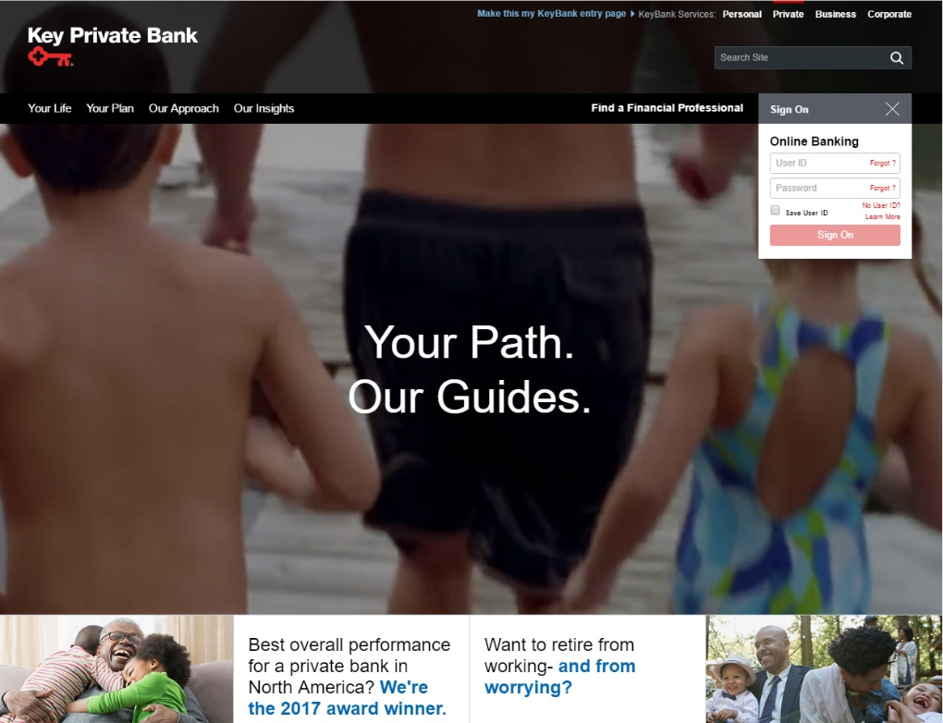

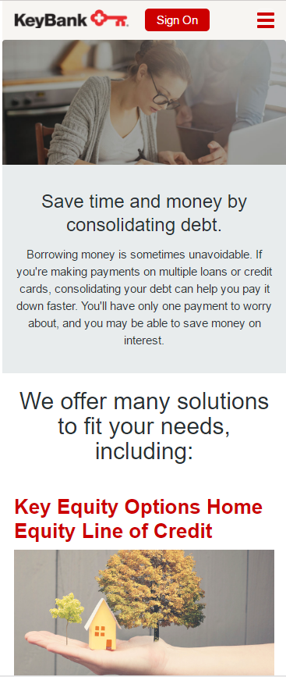<https://www.key.com/kpb/index.jsp>

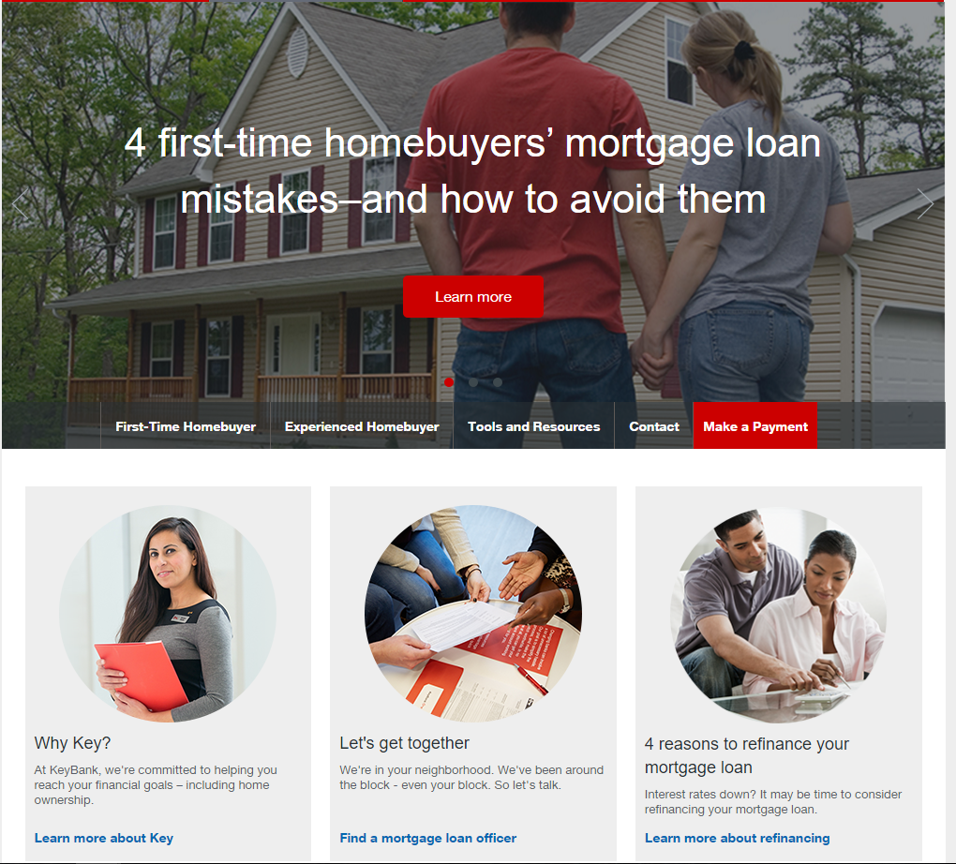

<https://www.key.com/personal/promotions/debt-consolidations-promotion.jsp>

<https://www.key.com/personal/home-loans-lines/mortgage/index.jsp>

