***Assignment 1 (****aboppana-sdasara-simang* ***)***

**Instructions for running the code:**

There are three files: grade.py, inject.py and extract.py.

The file: **basic_template.txt** has to be in the same folder as grade.py for it to run.

The input images should be in jpg format.

**Assumptions:**

* Grayscale input image was binarized with a threshold of 127.
* The image boxes will be parallel to each other with respect to both the axis
* The relative distance between any two boxes will be roughly same
* The horizontal distance between the boxes was assumed to be 40 pixels and the vertical distance was assumed to be 35 pixels.
* A box was selected as answer if the average intensity within that box is less than .65
* The detected bubbled marks by the student were shaded with grayish white pixels of intensity 200 in the output jpgs.
* To detect any input characters to the left of a question, a range of intensities were calculated and checked if the minimum among them is less than .9 (As, most of the part will be white)
* The bar code for the inject-extract module is placed with two circular marks on it’s either side. The scanned image is assumed to contain the barcode within those marks.

**Design Decisions and Methodology:**

***Template Matching:***

* A basic template was constructed from bank form, where almost all the boxes were of even shape and this information was used in detecting boxes in the test samples
* Template matching was carried out by comparing the edge of template to that of selected portion of the image. As, this will ensure there will be high similarity between template and boxes as both have same edge structure (square boundaries)
* We have selected all possible horizontal and vertical lines (with the help of coordinates of the template matching) if the similarity with template edges is greater than 70%
* Once all the possible horizontal and vertical lines are compiled, a threshold of minimum 8 and 12 occurrences were used to select most favourable horizontal and vertical lines as per image. As, there are more boxes in the vertical direction a relatively high threshold was used.
* Using these lines in sorted order (from top to bottom for horizon lines and from left to right for vertical lines), possible missing horizontal lines were imputed (As we know there has to a horizontal line in every 50~60-pixel distance).
* Finally, a list of horizontal and vertical coordinates was computed using lines and this will give us all coordinates of all the questions present in the sheet
* Once boxes were found, we have found the average box intensity and there by determined whether it was marked by student or not.
* Similarly, average intensity to the left of each question was calculated to check for presence of characters.
* Finally, saved the required image and text file
* Every test image takes ~100s

The image templates are arrays that have been manually subsetted from the image for each letter choice.

***Barcode detection:***

* Barcodes were generated using three random unique numbers between 0 and 9 which represent the width of each block in the barcode.
* The barcode was imposed at the bottom of the image along with two black circles at either of its scan-line corners.
* These three-digit codes were used as keys in a dictionary mapping to the answer key and were written out as a JSON object.
* When a scanned image is read, the two black circular artifacts are detected using template matching and a line is drawn with the two circles as the end points.
* This line is used correct the alignment of the image.
* Then the markers dots are searched for the new locations in the rotated image and the subarray containing the barcode is defined using relative position of the dots. Then the subarray is flattened using column means. A threshold is put to identify the black and white pixels. The string of back pixels is counted and divided by the fixed width to obtain the unique 3-digit code.
* The unique code is then looked up in the key diction from the json file and the answers are saved into the output.

This is an example of the injected barcode with code 5 8 8.

The first block is smaller and the next two blocks are of the same length.

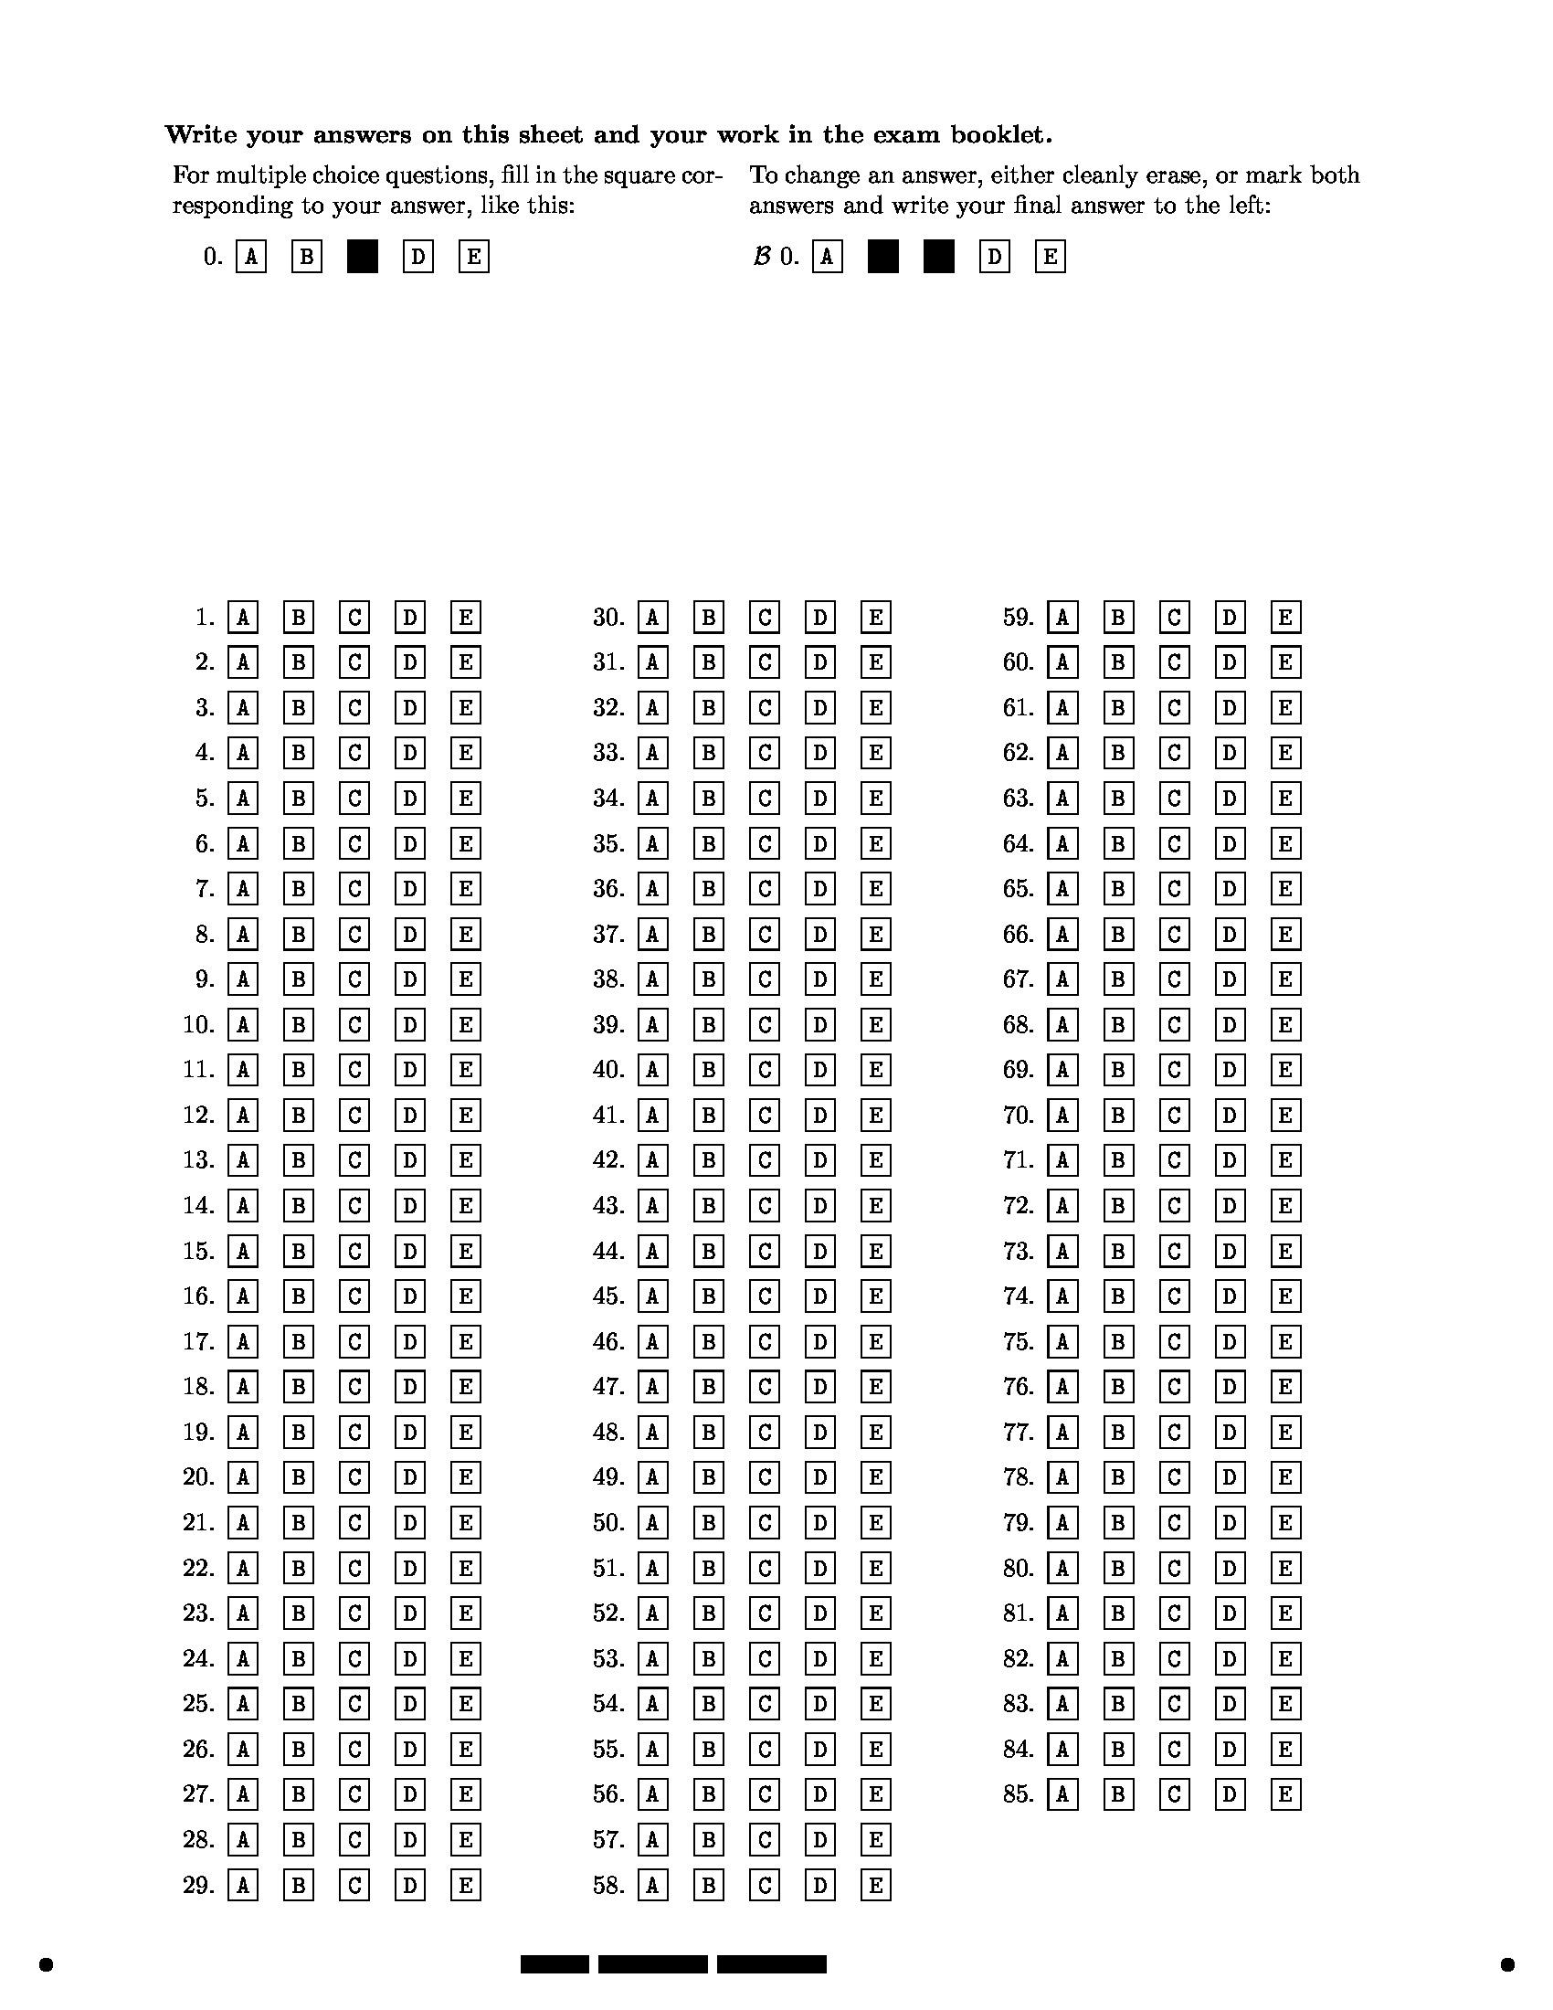

Bar code

Marker dots

**Accuracy on test images:**

Comparison of the output.txt for a-3 and a-27 test images with their ground truth yielded an **accuracy** of about **98%** in both the cases.

The program seems to detect the options shaded by the student quite well even in cases with very minor tilt.

Some outputs are shown below,

The options are coated with light gray pixels of intensity 200

**Output for a-3**

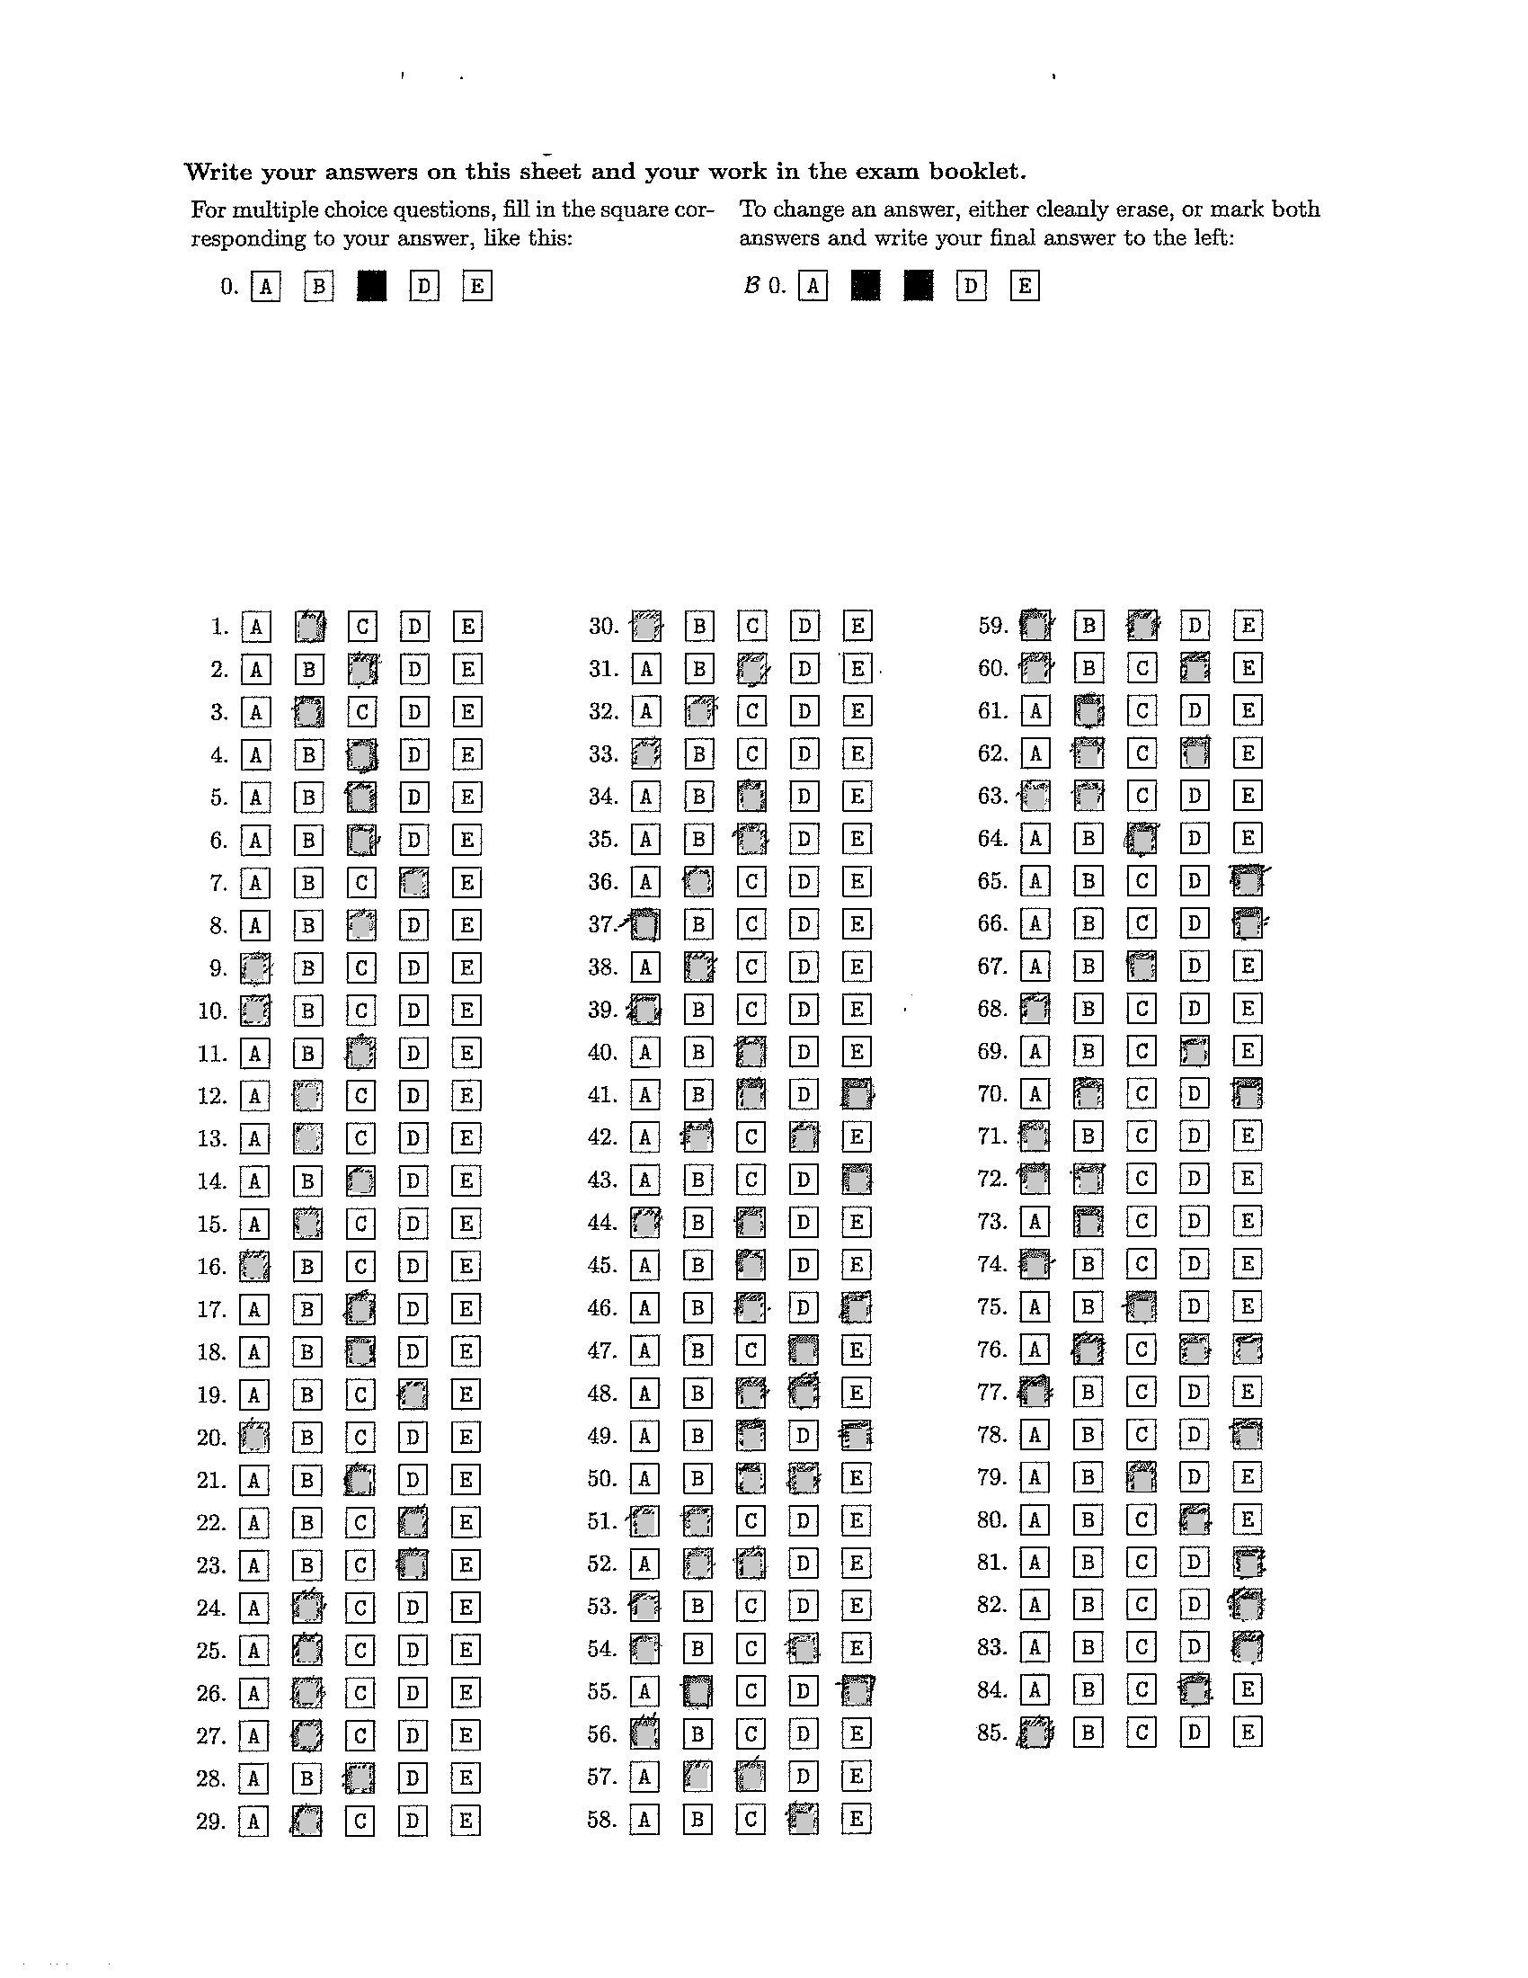

**Output for a-27**

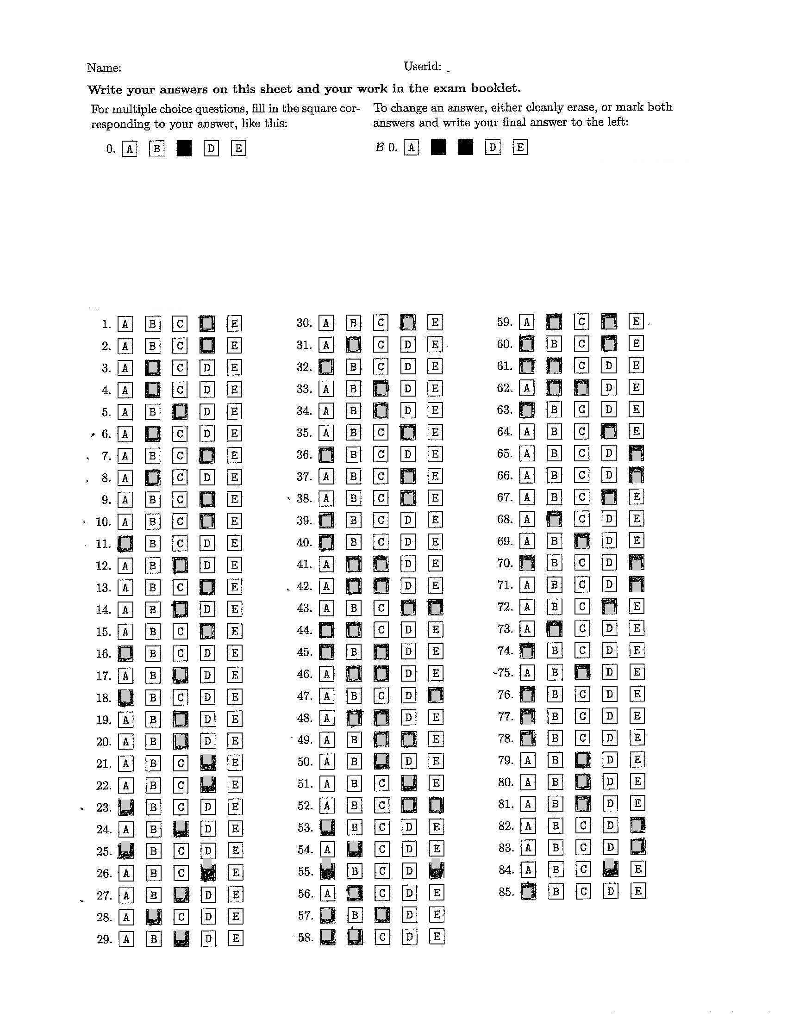

**Output for b-27**

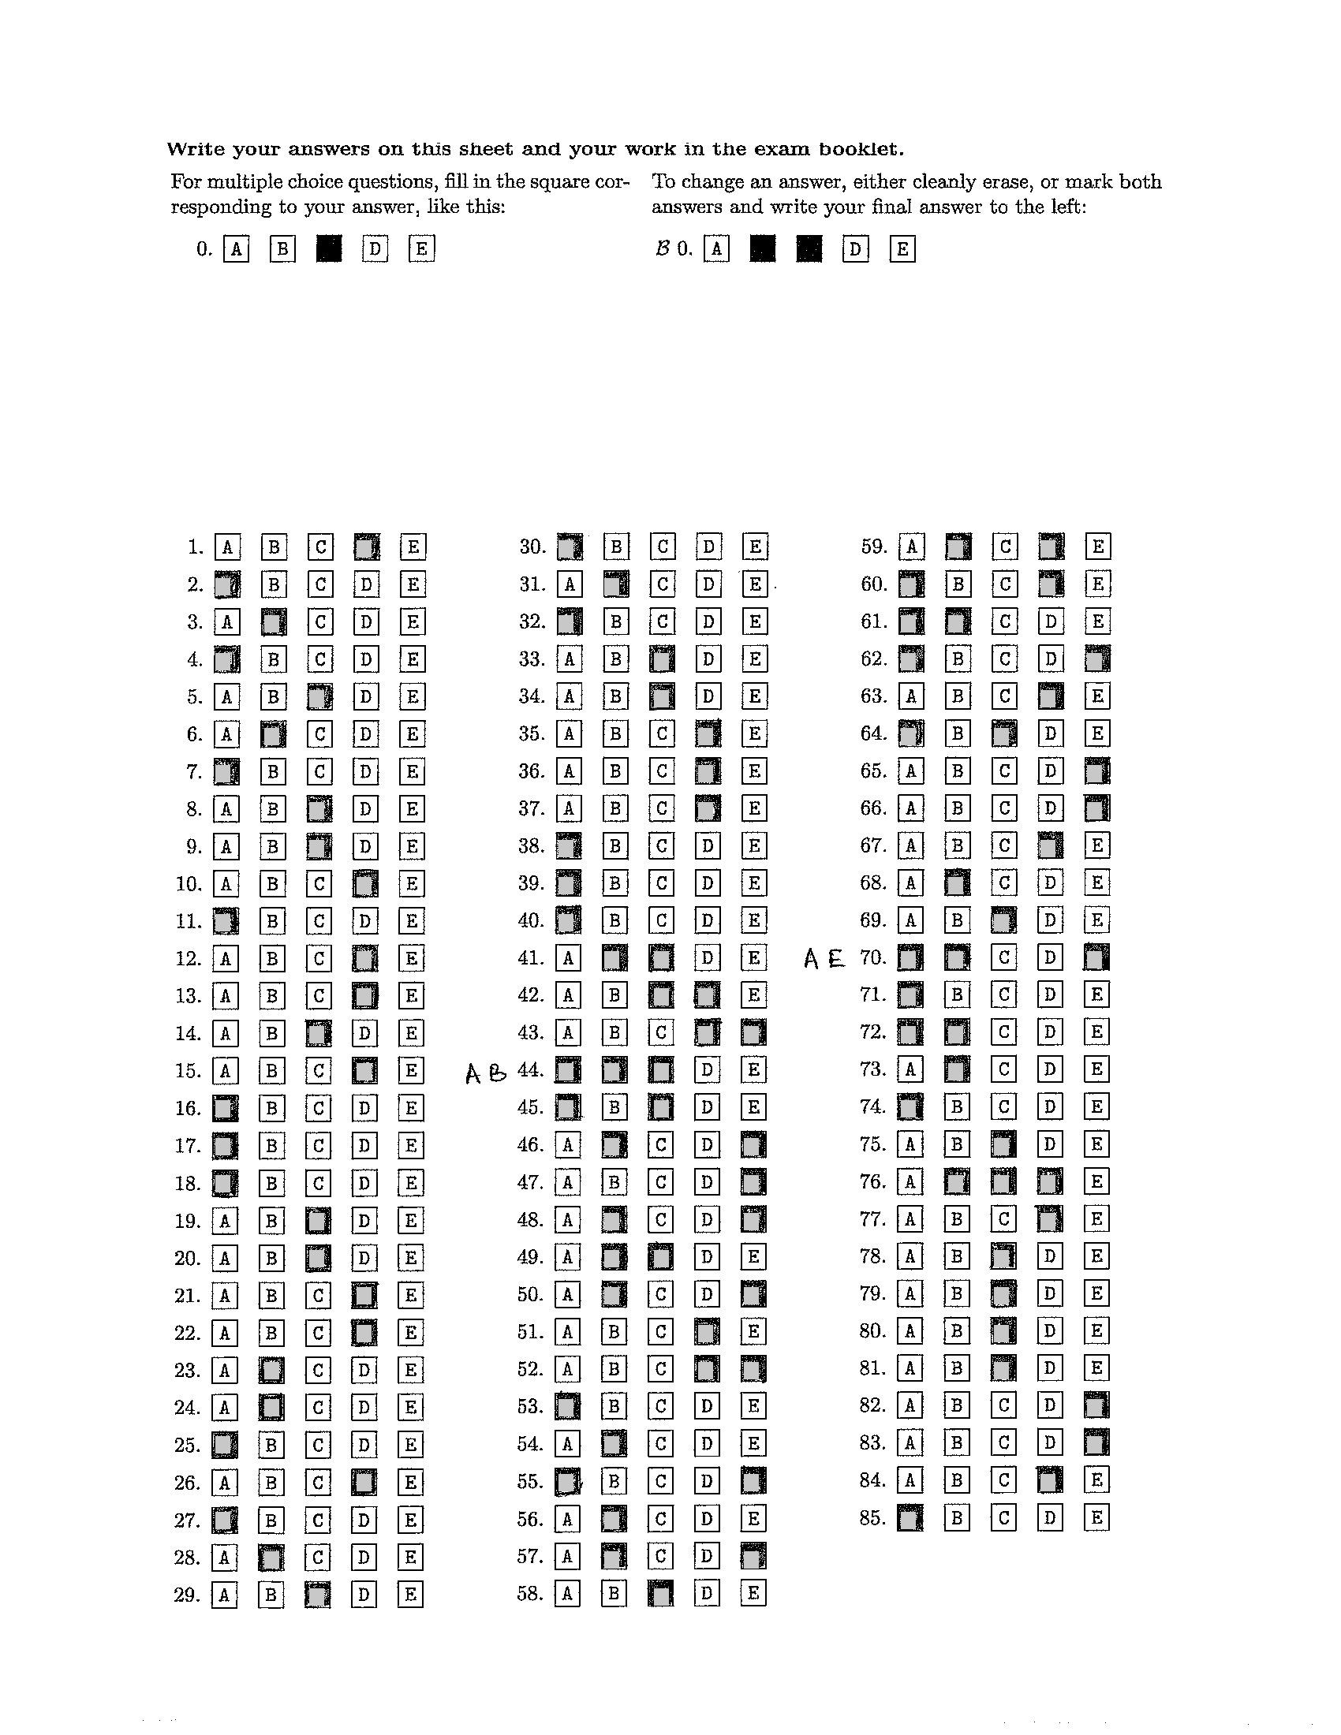

**Output for c-33**

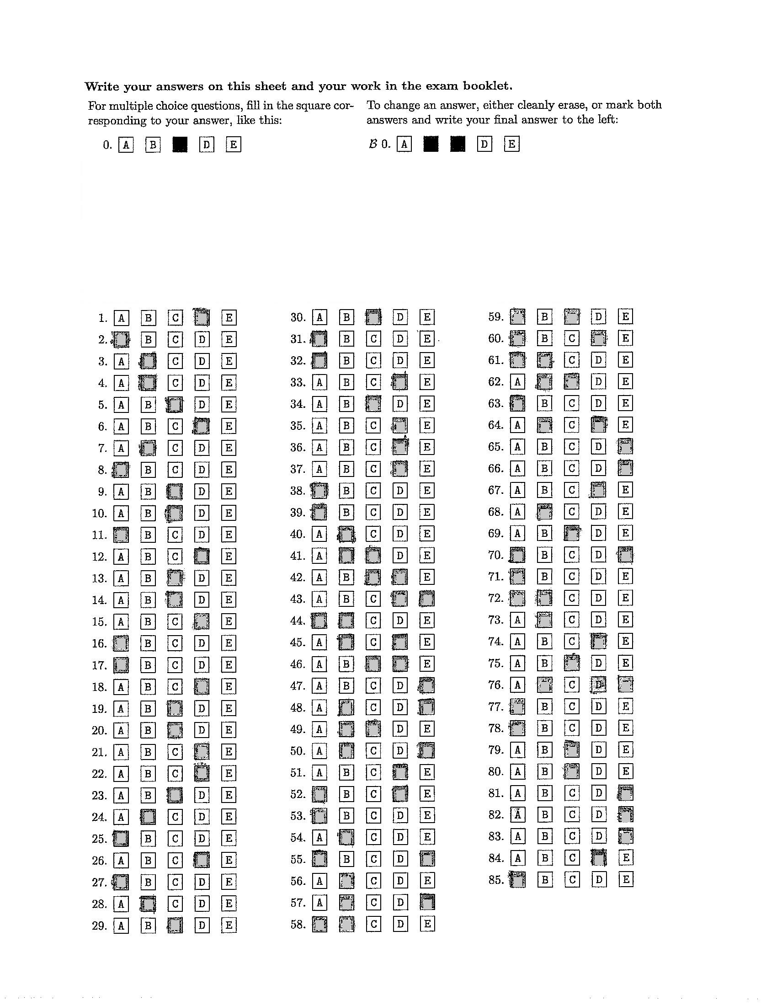

**Best Case Scenario:**

* The program works well when the images are nearly perfectly aligned.
* When there is no noise between the boxes.
* When the boxes are filled in completely.

**Accuracy of barcode scanner**

* The barcode scanner was tested on images that were manually scanned on a scanner.
* It was able to decode the barcode and then write the output for the five different orientations we have tried.

**Drawbacks:**

* Alignment issue is present. If there is substantial misalignment then the program will not perform properly.
* If the markers dots go missed form the image while scanning or the corners have dark edges then the extraction process fails

**Tried but failed:**

We have tried using Sobel operator for gradient detection and Hough line transform to detect the vertical and horizontal lines of the bounding boxes. However, we were unsuccessful in these approaches as no line were being detected.

**Further Improvements:**

* Further exploration is required for the issue for image orientation correction and more experimentation with Hough line and Canny Edge detection algorithms to find lines which can be used to correct image orientation.
* Scaling methods to ensure uniform scale of the boxes for effective template matching.