SIMATS ENGINEERING (SAVEETHA SCHOOL OF ENGINEERING)
Department of Computer Science and Engineering
CO2 ASSESSMENT TOOL 2 – Architecture Design Assignment

Course Code: | CSA10 / CSA1063 | Course Title: | Software Engineering
CO Assessed: | CO2 | Assessment: | Assessment Tool 2 – Architecture Design Assignment
Weightage: | 20% | Total Marks: | 25
CO2 Statement: | Perform detailed requirements analysis, design scalable architectures, and prioritize features with a focus on cross-disciplinary skills
Student Name: | SIVA SAI KODURU | Reg. No.: | 192325081
Date: |  | Duration: | 60 minutes

Code of Conduct
I _SIVA SAI KODURU(192325081)_ (Name / Reg No) certify that this submission is my original work and that I have adhered to the guidelines specified for this assessment. I understand that any violation of academic integrity rules will result in disciplinary action.
Signature of the Student: _______ SIVA SAI KODURU _
Annexure A – Architecture Design Assignment.
SMART RESTAURANT TABLE RESERVATION SYSTEM
Architecture Design Analysis
1. Analyze System Requirements
1.1 System Objectives
The Smart Restaurant Table Reservation System is designed to automate restaurant reservation management by providing an efficient, reliable, and user-friendly platform for customers and restaurant staff. The primary objective is to reduce waiting time, optimize table allocation, improve customer satisfaction, and enhance restaurant operations through intelligent reservation management and occupancy analytics.
The specific objectives are:
- Manage restaurant reservations efficiently.
- Optimize table allocation based on customer requirements and real-time availability.
- Reduce waiting time for customers.
- Predict customer demand during peak dining hours.
- Notify customers about reservation confirmations, cancellations, and table availability.
- Generate occupancy reports and customer analytics.
- Improve workforce planning.
- Increase restaurant revenue.
1.2 Functional Requirements
The system should provide the following functionalities:
Customer Module
- User Registration
- Secure Login
- Search Restaurants
- Check Table Availability
- Reserve Table
- Modify Reservation
- Cancel Reservation
- View Reservation History
- Receive Notifications
Restaurant Management Module
- Add and Manage Tables
- Update Table Status
- Manage Walk-in Customers
- Allocate Tables Automatically
- View Occupancy Dashboard
Analytics Module
- Generate Occupancy Reports
- Peak Hour Prediction
- Customer Visit Analysis
- Revenue Reports
Notification Module
- Reservation Confirmation
- Waiting Time Updates
- Reservation Cancellation Alerts
- Promotional Notifications
1.3 Non-Functional Requirements
Performance
The system should respond within 2 seconds and support multiple concurrent users.
Security
- Secure Login Authentication
- Password Encryption
- Role-Based Access Control
- HTTPS Communication
Reliability
- 99.9% uptime
- Automatic Backup
- Data Recovery
Usability
- User-friendly interface
- Mobile responsive design
- Easy navigation
Scalability
- Multi-branch restaurant support
- Cloud deployment
- Easy expansion
Maintainability
- Modular architecture
- Easy software updates
- API documentation
Availability
- 24 × 7 system availability
- Cloud hosting
- Failover support
1.4 Quality Attributes
The proposed architecture focuses on the following quality attributes:
- Scalability: Supports future restaurant branches and increased users.
- Maintainability: Modular design enables easier updates.
- Reliability: Prevents reservation conflicts and ensures continuous availability.
- Availability: Provides uninterrupted access using cloud infrastructure.
- Performance: Processes reservations with minimal response time.
- Security: Protects customer and restaurant data using encryption and authentication mechanisms.
2. Select a Suitable Software Architecture
Selected Architecture
Layered Architecture with MVC (Model–View–Controller) Pattern
The proposed system follows a Layered Architecture integrated with the MVC (Model–View–Controller) design pattern.
The architecture consists of four layers:
- Presentation Layer
- Business Logic Layer
- Data Access Layer
- Database Layer
Justification
The Layered MVC Architecture is the most suitable because it separates the user interface, business logic, and database into independent layers. This separation improves maintainability, scalability, security, testing, and overall software quality.
Advantages include:
- Easy maintenance
- Better scalability
- Secure data access
- Reusable business logic
- Simplified debugging
- Faster development
- Better performance
This architecture also supports future integration with online payment systems, AI-based recommendations, and multi-branch restaurant management.
3. Software Architecture Diagram
Architecture Diagram

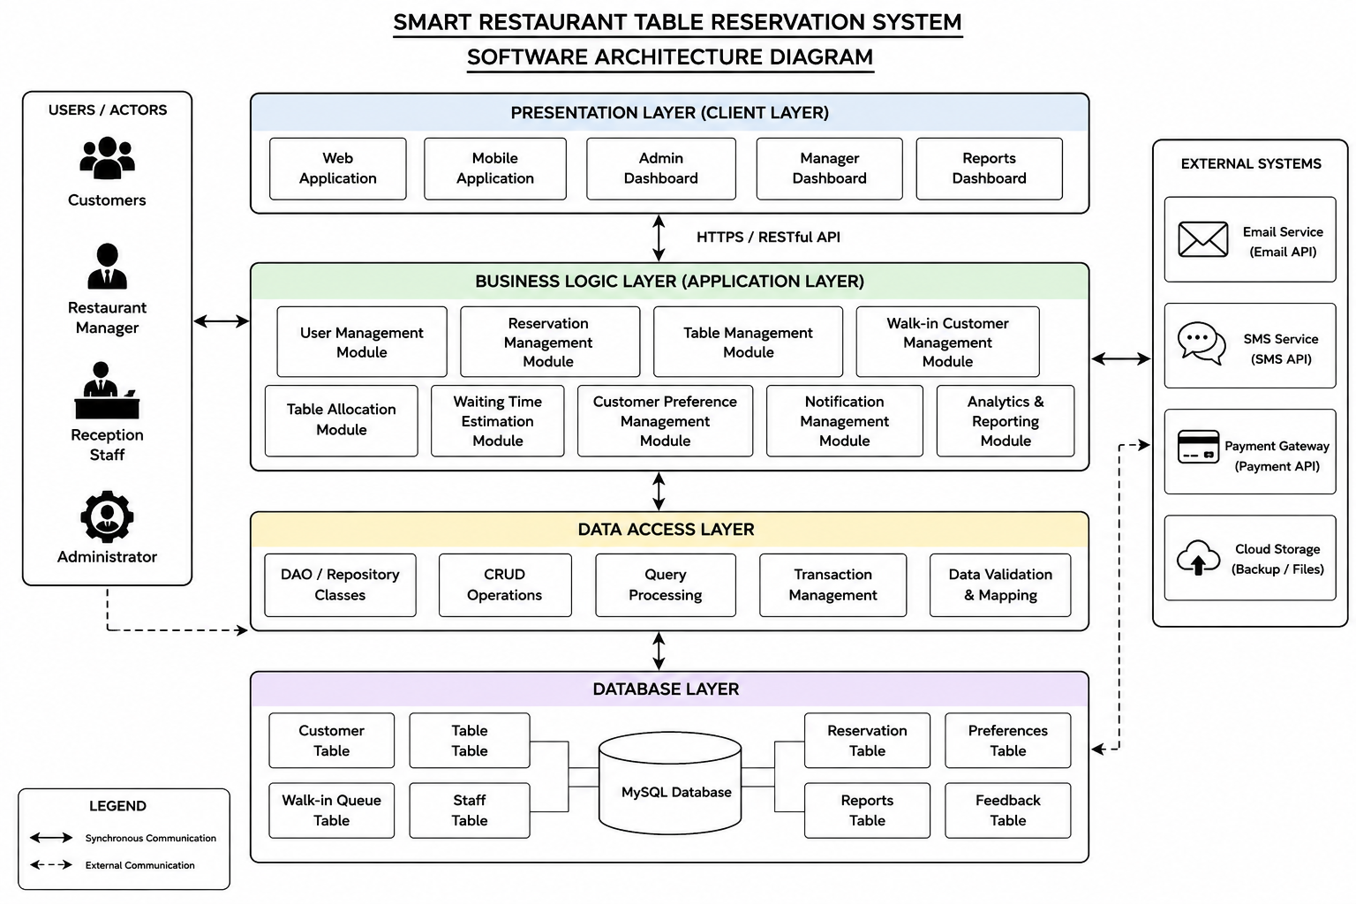
External Systems
- SMS API
- Email API
- Payment Gateway (Future Enhancement)
- Cloud Storage
Communication between components is carried out through secure REST APIs over HTTPS.
4. Explain Components and Their Interactions
Presentation Layer
This layer provides the graphical user interface for customers, restaurant managers, and reception staff. It collects user input and displays reservation details, notifications, and reports.
Business Logic Layer
This layer processes reservation requests, validates user inputs, allocates tables, estimates waiting times, predicts customer demand, and manages notifications.
Data Access Layer
The Data Access Layer performs database operations such as inserting, updating, deleting, and retrieving customer, reservation, and table information.
Database Layer
This layer securely stores customer details, reservation records, table information, reports, and analytics.
Workflow
- Customer logs into the application.
- Customer searches for available tables.
- Reservation request is sent to the Business Logic Layer.
- Business Logic validates availability.
- Data Access Layer updates the database.
- Reservation confirmation is generated.
- Notification is sent to the customer.
- Restaurant manager can view occupancy reports through the analytics dashboard.
5. Discuss Quality Attributes
Scalability
The layered architecture supports additional restaurant branches, cloud deployment, and increasing numbers of users without affecting system performance.
Security
The system uses secure authentication, encrypted passwords, HTTPS communication, and role-based access control to protect sensitive information.
Performance
Optimized database queries, automatic table allocation, and efficient business logic ensure reservation requests are processed within a few seconds.
Reliability
The architecture provides continuous availability through cloud deployment, automatic backups, and error recovery mechanisms.
Maintainability
Each layer operates independently, allowing developers to modify or upgrade individual components without affecting the entire system.
Availability
Cloud hosting, redundant servers, and failover mechanisms ensure that the system remains available 24×7 for customers and restaurant staff.
6. Justify Architectural Decisions
The Layered MVC Architecture was selected because it offers excellent separation of concerns, making the software easier to design, develop, test, and maintain. It improves software quality by separating user interface, business logic, and data access into independent modules.
Compared to monolithic architectures, the selected design provides better flexibility and maintainability. Although microservices offer higher scalability, they introduce additional deployment complexity and operational overhead, which is unnecessary for the current project scope. Therefore, Layered MVC Architecture provides the best balance between simplicity, scalability, performance, and maintainability.
Trade-offs Considered
- Simpler deployment than Microservices.
- Lower infrastructure cost.
- Easier debugging and maintenance.
- Slightly less scalable than a full microservices architecture, but sufficient for the current project.
Future Enhancements
The architecture can easily support:
- Online Payment Gateway
- AI-Based Table Recommendation
- QR Code Check-in
- Voice-Based Reservation
- Customer Loyalty Program
- Multi-Branch Restaurant Management
- Cloud-Based Analytics
- Integration with Food Delivery Platforms
Conclusion
The proposed Layered MVC Architecture provides a secure, scalable, reliable, and maintainable solution for the Smart Restaurant Table Reservation System. It satisfies all functional and non-functional requirements while supporting future enhancements and seamless integration with external services. The architecture ensures efficient reservation management, optimized table utilization, improved customer satisfaction, and enhanced restaurant operational performance, making it the most suitable architectural choice for this project.

