**TECHNICAL SPECIFICATION**

REPORTS

RICEFW ID - P2P_E_0006

Document Control Information

Document Information

|  |  |
| --- | --- |
| Document Identification | P2P_E_0006- Update to SRM POs |
| Document Name | Technical Specifications Document |
| Project Name | S/4 HANA Implementation |
| Client | Seaworld |
| Document Author | Resmi S |
| Document Version | V1 |
| Document Status | New |
| Date Released |  |
| Workstream Area | P2P |

Document Edit History

| Version | Date | Additions/Modifications | Prepared/Revised by |
| --- | --- | --- | --- |
| V1 | 08/28/2024 | INITIAL VERSION | Resmi S |
|  |  |  |  |

Document Review/Approval History

| Date | Name | Organization/Title | Comments |
| --- | --- | --- | --- |
|  |  |  |  |
|  |  |  |  |

Distribution of Final Document

The following people are designated recipients of the definitive version of this document:

| Name | Organization/Title |
| --- | --- |
| <Name> | <Organization/Title> |
|  |  |
|  |  |
|  |  |

*Table of Content*

1 Introduction 4

1.1 Overview 4

1.2 Assumptions 4

1.3 Dependencies 4

1.4 Links 4

2 Development Details 5

2.1 Entry Point in ECC / CRM / SRM etc (specify the system) 5

2.2 Selection Screen 5

2.2.1 Selection Texts / Labels 5

2.3 Input Validation 6

2.4 Authorizations 6

2.5 Data Selection and Error Handling 6

2.6 Process Flow Diagram 6

2.7 Report Output 6

2.8 Drilldown and follow-on activities 6

3 Usage 7

3.1 Cutover Considerations 7

3.2 Use in Batch Jobs / Refresh Schedule. 7

Appendix A - Custom objects created in ECC/ S/4HANA / CAR/ SRM etc. (specify the system) 8

1. Custom ABAP objects 8

2. Text Elements created for Program / Class xxx 9

3. Custom T100 messages created for this development. 9

4. Custom Exception Class texts created for this development. 9

# Introduction

## Overview

Businesses leverages tcode ZSUS to process PO Changes submitted by the vendor for F&B purchase Org. The changes include updates to the PO submitted via Idoc (Msg type: ORDRSP) for changes to quantity, price or date

## Assumptions

1. Vendor updates (quantity, price, delivery date) for the purchase order already posted in the system.

## Dependencies

## Links

# Development Details

## Entry Point in ECC / CRM / SRM etc (specify the system)

|  |  |
| --- | --- |
| Program Name | ZRM06ENBE_SUS |
| Transaction Code (if applicable) | ZSUS |

* Client’s ECC system uses Z-Program process PO Changes submitted by the vendor for F&B purchase Org.
* **“Lift and Shift”** of those programs to S/4 can be considered if it is feasible.

## Selection Screen

.

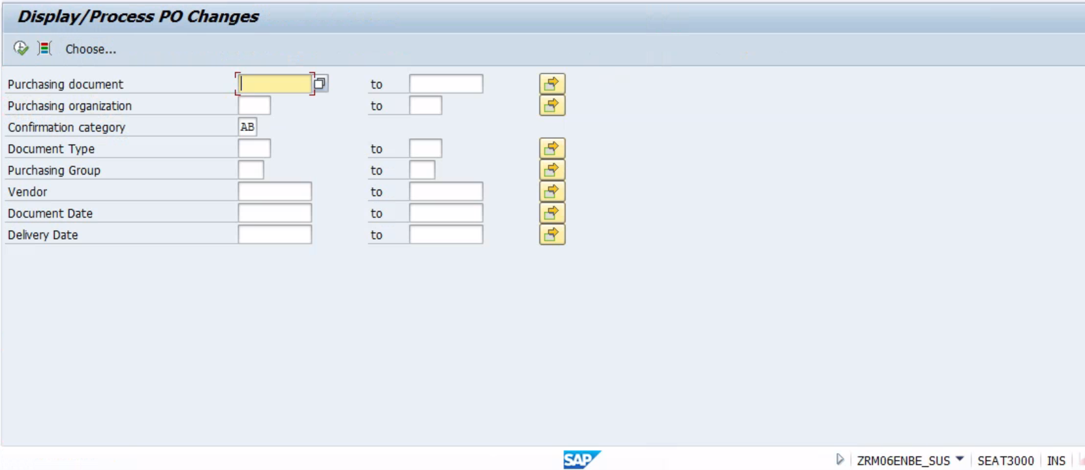

### Selection Texts / Labels

.

| **Select-option or Parameter** | **Text** |
| --- | --- |
|  |  |
|  |  |

## Input Validation

## Authorizations

## Data Selection and Error Handling

## Process Flow Diagram

## Report Output

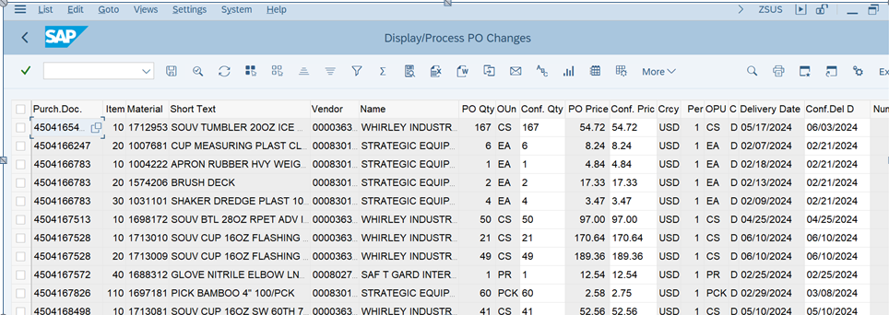

## Drilldown and follow-on activities

# Usage

## Cutover Considerations

List any cutover activities which are specifically required for this development in all systems – e.g. settings which are not transportable, and which need only one-time setup.

## Use in Batch Jobs / Refresh Schedule.

If the development is intended to be run in batch, then provide any known details here.

|  |  |
| --- | --- |
| Batch Job Name |  |
| Scheduled start time or trigger, and frequency |  |
| Any preceding steps |  |
| Any subsequent steps |  |
| Error Handling |  |
| Output method |  |

1. Custom objects created in ECC/ S/4HANA / CAR/ SRM etc. (specify the system)

This appendix may be used to record all the objects and texts created for this development. The appendix may be repeated if objects were created in more than one system.

## Custom ABAP objects

SAP recommends creating a separate package to hold the objects created for each development. If this has been done, then a developer would only have to open the Package to see all the objects created. Conversely, from an object, the Package could be found, which would give the development ID and enable the documentation. In this case just a screenshot of the objects from SE80 or Eclipse could be added here rather than completing the table. Do however also list out any ABAP objects which are not shown in SE80 / Eclipse, such as CMOD enhancements or SAP Scripts.

If the custom development objects were not created in a separate package, completing this inventory is strongly recommended. By completing the table with text rather than using a screenshot, then the object names will be search-able. This could be extremely helpful in the future for finding the documentation corresponding to a given development object.

| **Object Type** | **Object Name** | **Object Description** |
| --- | --- | --- |
|  |  |  |
|  |  |  |
|  |  |  |
|  |  |  |
|  |  |  |
|  |  |  |

## Text Elements created for Program / Class xxx

Repeat this section for each Program or Class created with text elements. Paste the text elements into the table below or provide a screenshot.

| **Text ID** | **Text** |
| --- | --- |
|  |  |
|  |  |

## Custom T100 messages created for this development.

Paste the message data into the table below or provide a screenshot.

| **Class** | **ID** | **Short Text** |
| --- | --- | --- |
|  |  |  |
|  |  |  |

## Custom Exception Class texts created for this development.

Paste the exception data into the table below or provide a screenshot.

| **Exception Class** | **Exception ID** | **Text** |
| --- | --- | --- |
|  |  |  |
|  |  |  |

* 1. **Unit Test Cases**

|  |  |  |  |  |  |
| --- | --- | --- | --- | --- | --- |
| **Test Case ID** | **Test Case Name** | **Description** | **Steps No** | **Steps** | **Expected results** |
| <TestCaseNo> | <TestCaseName> | <Description> | <Step_No> | <Step_description> |  |