OptiCrop: AI-Powered Smart Agricultural Production
Optimization System
Project Description:
OptiCrop is an intelligent Machine Learning-based agricultural decision support system designed to recommend the most suitable crop based on soil nutrients and environmental conditions. The application analyzes important agricultural parameters including Nitrogen (N), Phosphorus (P), Potassium (K), temperature, humidity, soil pH, and rainfall to predict the optimal crop for cultivation.
The system leverages supervised Machine Learning algorithms trained on agricultural datasets to provide accurate crop recommendations. Built using Flask and deployed as a web application, OptiCrop offers farmers, agricultural researchers, and policymakers a simple, fast, and reliable platform for improving agricultural productivity and promoting sustainable farming practices.
Scenarios

Scenario 1: Farmer Crop Selection
A farmer enters soil nutrient values (N, P, K), temperature, humidity, pH, and rainfall measured from his field. OptiCrop analyzes the inputs and recommends the most suitable crop for cultivation, helping maximize productivity.

Scenario 2: Agricultural Extension Officer
An agricultural officer uses OptiCrop to analyze soil reports collected from different villages. The system recommends suitable crops for each location, enabling region-specific agricultural planning.

Scenario 3: Agricultural Research
Researchers use OptiCrop to evaluate how different environmental conditions affect crop suitability. The system provides quick predictions that assist in crop planning and sustainable farming studies.

Technical Architecture

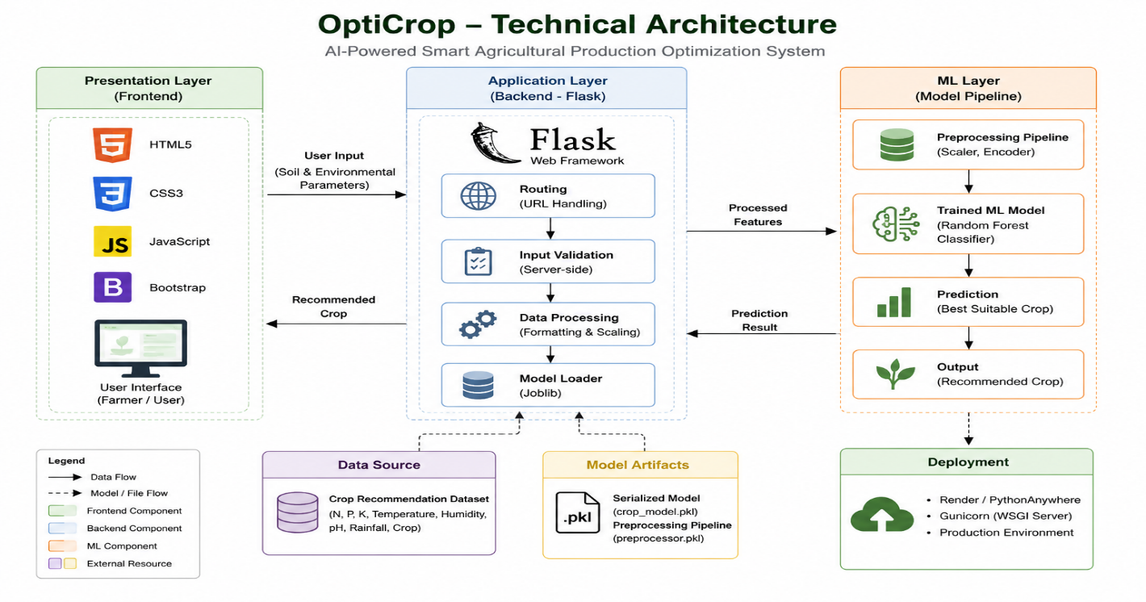

Description: OptiCrop follows a three-layer architecture consisting of the Presentation Layer, Application Layer, and Machine Learning Layer. The frontend collects soil and environmental parameters from users through a responsive web interface. The Flask backend validates the inputs, preprocesses the data, and communicates with the trained Machine Learning model. The Random Forest model analyzes the processed features and predicts the most suitable crop for cultivation. Finally, the prediction is displayed to the user through the web application, providing fast and accurate crop recommendations.

Pre-requisites:
- ● Python Programming Knowledge: Python Documentation
- ● Machine Learning Fundamentals: Scikit-learn Documentation
- ● Flask Framework Knowledge: Flask Documentation
- ● Pandas and NumPy Skills: Pandas & NumPy Documentation
- ● HTML, CSS, and JavaScript Skills: W3Schools HTML/CSS/JavaScript Tutorials
- ● Data Preprocessing Techniques: Scikit-learn Preprocessing Documentation
- ● Model Serialization using Joblib: Joblib Documentation
- ● Version Control with Git: Git Documentation
- ● Development Environment Setup: Python Virtual Environment & Flask Installation Guide
- ● Deployment Knowledge (Render/PythonAnywhere): Render & PythonAnywhere Documentation

Project Workflow

Milestone 1: Problem Definition, Dataset Collection, and System Architecture
- Activity 1.1: Identify the agricultural problem and define the objectives of the crop recommendation system.
- Activity 1.2: Collect and analyze the Crop Recommendation dataset containing soil nutrients and environmental parameters.
- Activity 1.3: Study the dataset features and design the system architecture, illustrating the interaction between the frontend, Flask backend, and Machine Learning model.
- Activity 1.4: Set up the development environment by installing Python, Flask, Scikit-learn, Pandas, NumPy, and other required libraries.

Milestone 2: Data Analysis
- Activity 2.1: Perform Exploratory Data Analysis (EDA) to understand the dataset structure, feature distributions, and statistical characteristics.
- Activity 2.2: Generate descriptive statistics, correlation analysis, and visualization plots to identify relationships among agricultural parameters.

Milestone 3: Data Preprocessing
- Activity 3.1: Handle missing values, remove duplicate records, and detect and treat outliers using the IQR method.
- Activity 3.2: Perform feature engineering and split the cleaned dataset into training and testing sets for model development.

Milestone 4: Machine Learning Model Development
- Activity 4.1: Train and evaluate Machine Learning models, including Logistic Regression and K-Means Clustering.
- Activity 4.2: Select the best-performing model, serialize it using Joblib, and prepare it for integration into the web application.

Milestone 5: Flask Web Application Development
- Activity 5.1: Develop the Flask backend to process user inputs, validate data, load the trained model, and generate crop recommendations.
- Activity 5.2: Design a responsive user interface using HTML, CSS, and JavaScript to display prediction results.

Milestone 6: Testing
- Activity 6.1: Perform automated testing, unit testing, integration testing, and manual testing to verify the dataset, model, prediction logic, Flask routes, input validation, and application performance.
- Activity 6.2: Validate prediction accuracy, error handling, and overall system reliability before deployment.

Milestone 7: Deployment
- Activity 7.1: Deploy the application locally using Flask and verify its functionality.
- Activity 7.2: Deploy the application on cloud platforms such as Render or PythonAnywhere and validate the live application.

Milestone 8: Conclusion
- Summarize the project outcomes, evaluate the effectiveness of the crop recommendation system, and discuss future enhancements such as fertilizer recommendation, crop disease detection, yield prediction, weather API integration, and AI-based agricultural advisory services.

Milestone 1: Problem Definition, Understanding, and Dataset Collection
Milestone 1 focuses on understanding the agricultural problem, defining the project objectives, collecting the dataset, and studying the requirements for building an AI-powered crop recommendation system. This phase establishes the foundation for developing an intelligent system that recommends the most suitable crop based on soil nutrients and environmental conditions.

Activity 1.1: Problem Definition
Agriculture is highly dependent on soil fertility and climatic conditions. Farmers often face challenges in selecting the most suitable crop due to variations in soil nutrients, temperature, humidity, pH, and rainfall. Incorrect crop selection can result in poor yield, inefficient resource utilization, and financial losses. OptiCrop aims to solve this problem by providing accurate crop recommendations using Machine Learning.

Activity 1.2: Business Requirements and Literature Survey
The business requirements and user needs are identified to develop a reliable crop recommendation system. A literature survey is conducted to study existing agricultural recommendation systems, Machine Learning techniques, and recent research on smart farming to understand current methodologies and identify opportunities for improvement.

Activity 1.3: Dataset Collection
The Crop Recommendation Dataset is collected from Kaggle and contains agricultural data used for training and evaluating the Machine Learning model.
Dataset Information
- Dataset Name: Crop Recommendation Dataset
- Source: Kaggle – Smart Agricultural Production Optimizing Engine
- File Name: Crop_recommendation.csv
- Format: CSV (Comma Separated Values)
The dataset includes seven input features:
- Nitrogen (N)
- Phosphorus (P)
- Potassium (K)
- Temperature
- Humidity
- Soil pH
- Rainfall
The target variable is Crop Label, which represents the recommended crop based on the given soil and weather conditions.
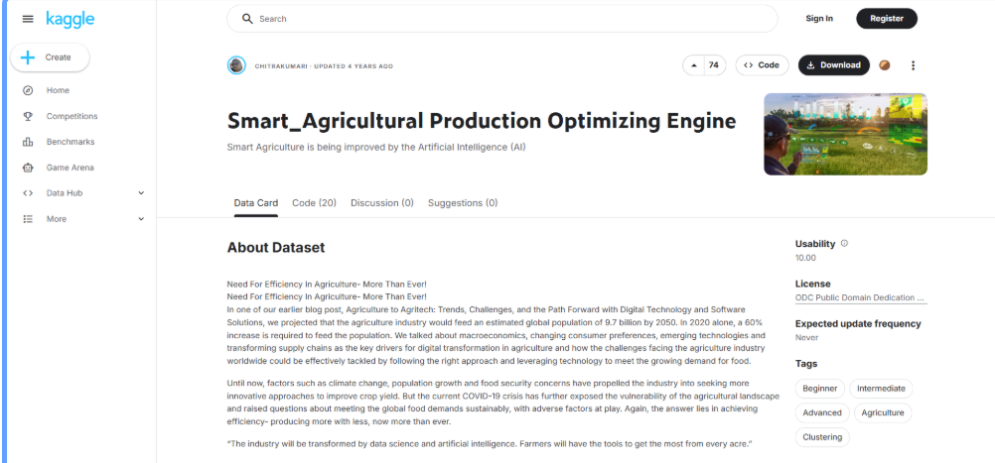
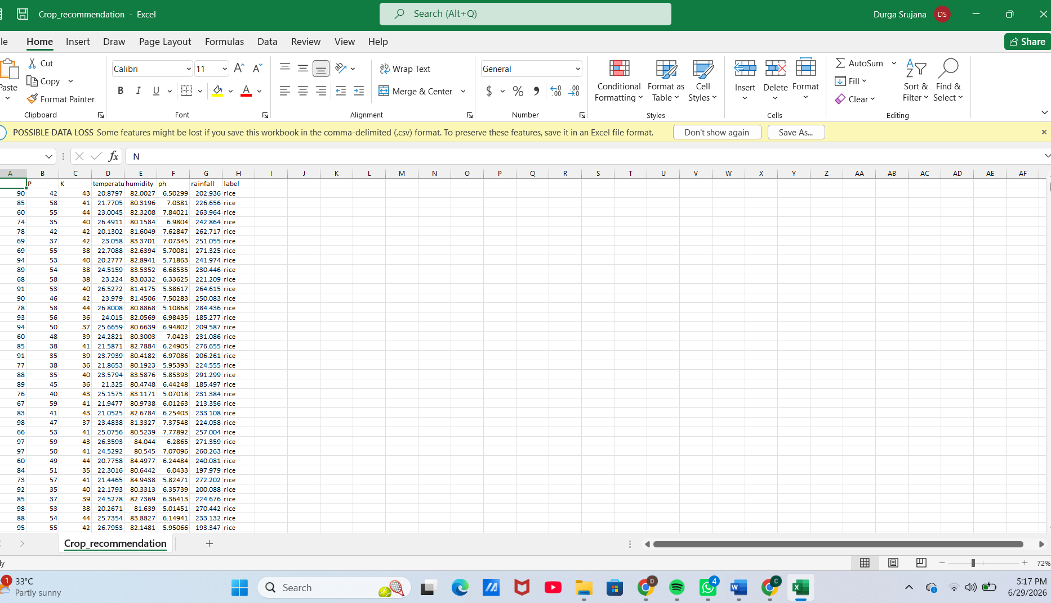

Activity 1.4: Development Environment Setup
The development environment is configured by installing Python, Flask, Pandas, NumPy, Scikit-learn, Joblib, and other required libraries. Git is used for version control, while Visual Studio Code is used as the primary development environment.
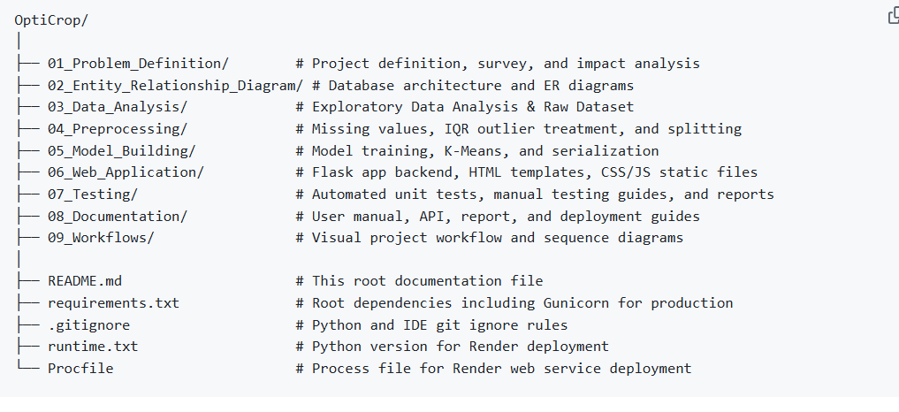

Milestone 2: Data Analysis
Milestone 2 focuses on performing production-quality Exploratory Data Analysis (EDA) on the Crop Recommendation dataset. The objective is to validate the dataset, understand its characteristics, compute descriptive statistics, identify relationships among features, and generate visualizations that provide meaningful insights for Machine Learning model development. The entire analysis is implemented as a modular Python package to ensure maintainability, reusability, and scalability.

Activity 2.1: Dataset Validation and Descriptive Analysis
The Crop Recommendation dataset is loaded into a Pandas DataFrame and validated to ensure data quality before model development. The validation process includes examining the dataset structure, verifying data types, checking for missing values and duplicate records, and generating descriptive statistics for all numerical features.
The analysis confirms that the dataset contains 2,200 records and 8 attributes, including seven input features and one target variable. Since no missing values or duplicate records are identified, the dataset is considered complete and suitable for further analysis.
During this stage, the following analysis artifacts are automatically generated:
- Dataset Information
- Dataset Summary
- Descriptive Statistics
- Missing Value Report
- Correlation Matrix
Figure 2.1: Dataset Information (dataset_info.txt or df.info() output)
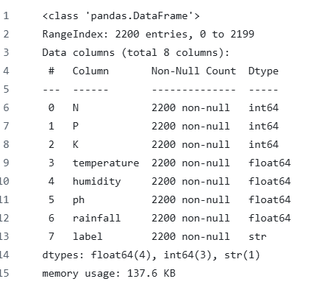

Activity 2.2: Exploratory Data Analysis (EDA)
A comprehensive Exploratory Data Analysis is performed to understand the statistical properties and relationships among agricultural parameters. Multiple visualization techniques are generated to analyze individual feature distributions, feature-to-target relationships, and multivariate interactions within the dataset.
The analysis includes:
- Univariate Analysis
- Bivariate Analysis
- Multivariate Analysis
- Correlation Analysis
Figure 2.2: Correlation Heatmap
(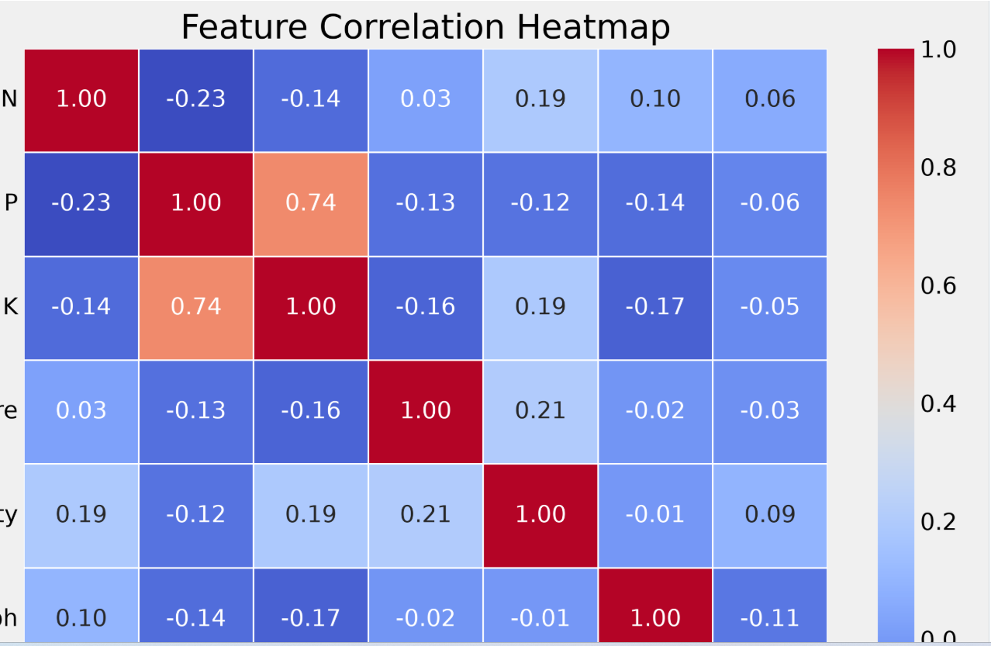

Figure 2.3: Pair Plot (or Pair Grid)
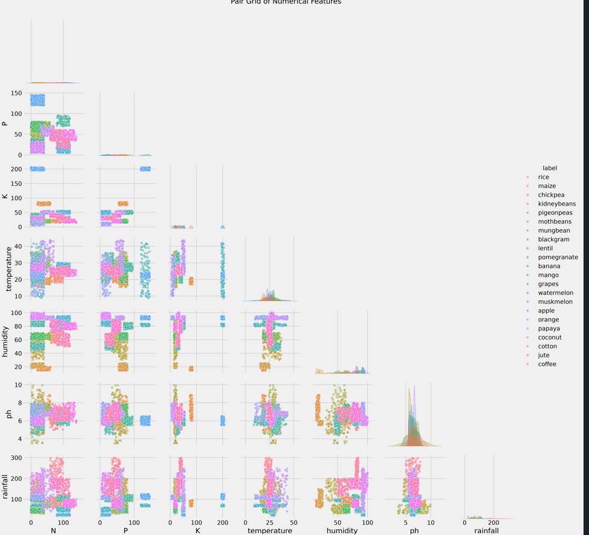

Figure 2.4: PCA Visualization with K-Means Clustering
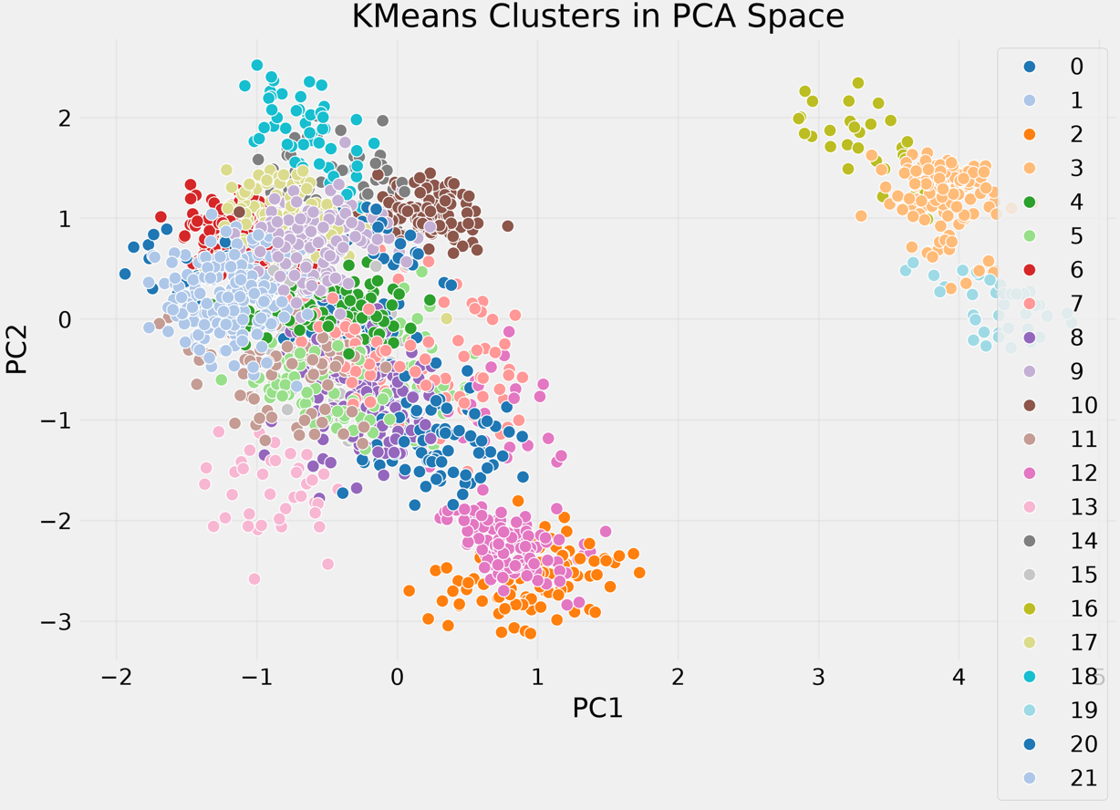

The generated statistical reports and visualizations provide valuable insights into the dataset by revealing feature distributions, correlations, and hidden patterns among soil nutrients and environmental parameters. These findings confirm that the dataset is suitable for Machine Learning model development and provide a strong foundation for the preprocessing stage.

Milestone 3: Data Preprocessing
Milestone 3 focuses on preparing the Crop Recommendation dataset for Machine Learning model development. The preprocessing pipeline is designed to improve data quality by validating the dataset, handling missing values, removing duplicate records, detecting and treating outliers, performing feature engineering, and splitting the cleaned dataset into training and testing sets. These preprocessing steps ensure that the dataset is clean, consistent, and suitable for building an accurate crop recommendation model.

Activity 3.1: Data Cleaning and Validation
The preprocessing pipeline begins by importing the required Python libraries, including Pandas, NumPy, Matplotlib, Seaborn, and Scikit-learn. The Crop Recommendation dataset is loaded and validated by examining its structure, dimensions, column names, and data types.
The dataset is inspected for missing values using the Pandas library. The analysis confirms that no missing values are present. Duplicate records are also checked, and any duplicate entries are removed to maintain data consistency.
Figure 3.1: Missing Values Analysis
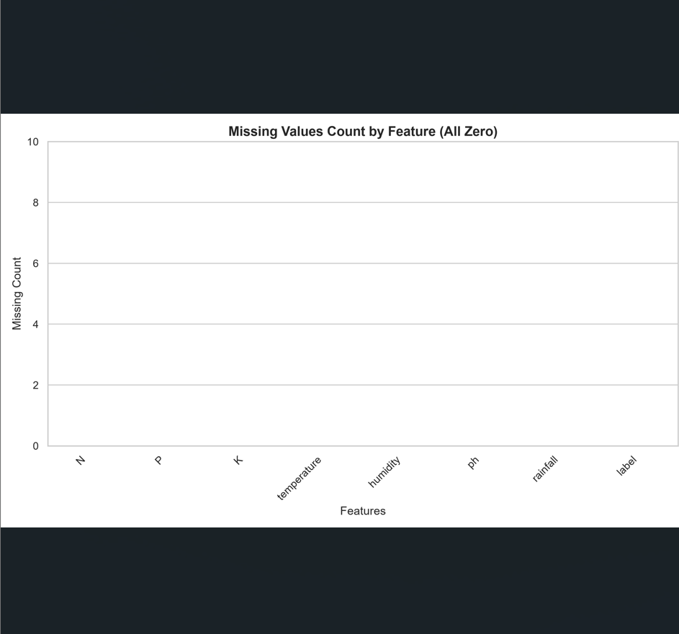

Activity 3.2: Outlier Detection and Treatment
Outliers are detected using the Interquartile Range (IQR) method for all numerical features, including Nitrogen (N), Phosphorus (P), Potassium (K), Temperature, Humidity, pH, and Rainfall. Values outside the acceptable IQR range are identified and removed to reduce noise and improve the reliability of the Machine Learning model.
A comparison of the dataset before and after outlier removal is generated using box plots to visualize the effectiveness of the preprocessing process.
Figure 3.2: Outlier Detection and Removal using IQR
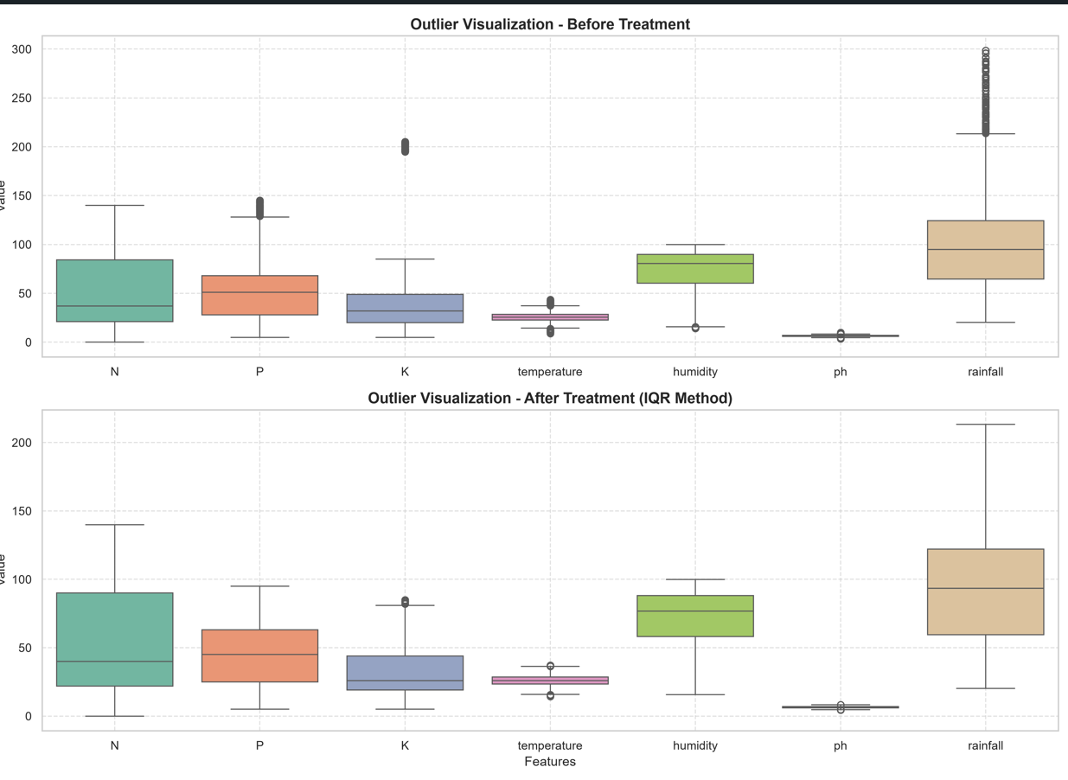

Activity 3.3: Feature Engineering and Train-Test Split
To improve the dataset, a new categorical feature named Season is created based on temperature values.
- Temperature < 20°C → Winter
- 20°C ≤ Temperature ≤ 30°C → Monsoon
- Temperature > 30°C → Summer
After feature engineering, the dataset is divided into input features (X) and the target variable (label). The cleaned dataset is then split into 80% training data and 20% testing data using the train_test_split() function with random_state=42 and stratification to preserve the class distribution.
The preprocessing pipeline generates the following output files:
- cleaned_dataset.csv
- train.csv
- test.csv
- preprocessing_report.txt
Figure 3.3: Cleaned Dataset with Season Feature
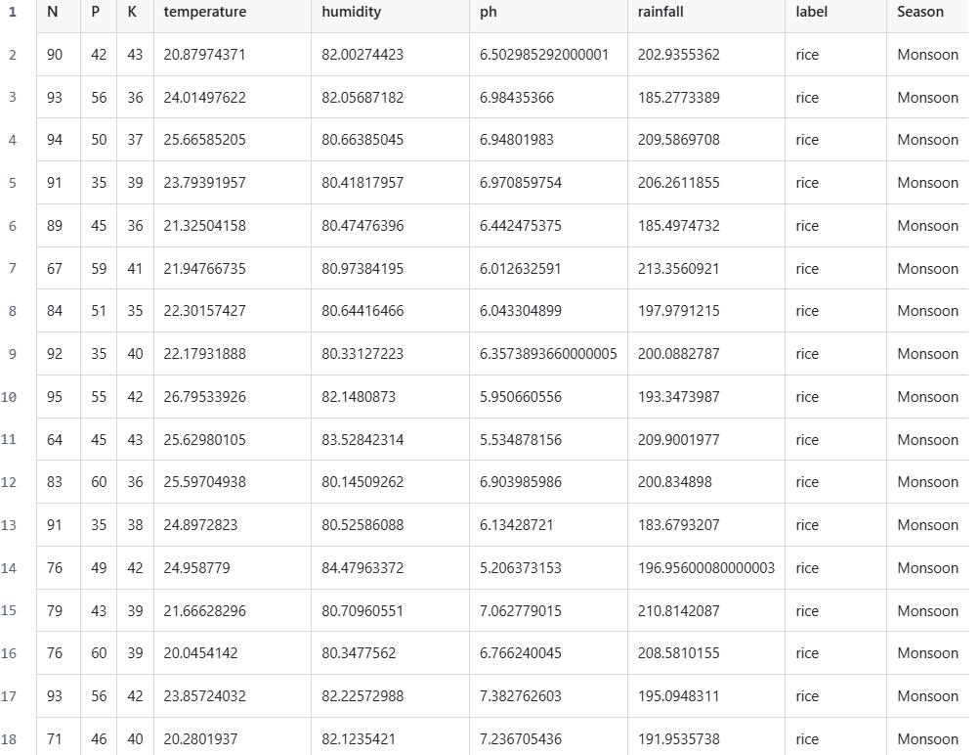

Figure 3.4: Training and Testing Dataset Split
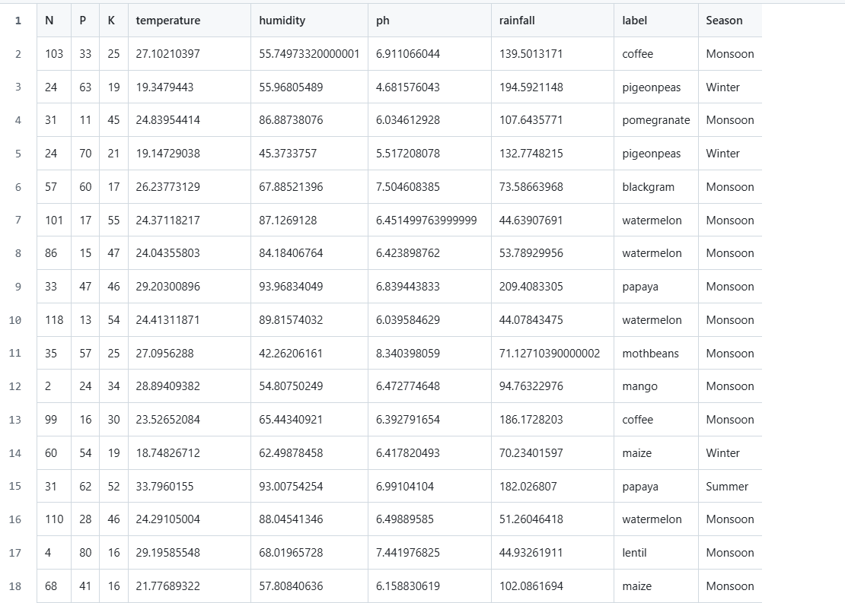
The preprocessing stage successfully transforms the raw agricultural dataset into a clean, structured, and Machine Learning-ready dataset. The generated artifacts provide a reliable foundation for training, evaluating, and deploying the crop recommendation model in the subsequent milestone.

Milestone 4: Model Building
Milestone 4 focuses on developing, training, and evaluating Machine Learning models to recommend the most suitable crop based on soil nutrients and environmental conditions. The cleaned dataset generated during preprocessing is used to train the models, evaluate their performance, and select the best-performing model for deployment in the OptiCrop web application.

Activity 4.1: Dataset Preparation and Model Training
The model-building pipeline loads the preprocessed dataset from 05_Preprocessing/cleaned_dataset.csv. If the cleaned dataset is unavailable or does not contain the target labels, the pipeline automatically falls back to the original dataset from 03_Data_Analysis/Crop_recommendation.csv.
The input features used for training are:
- Nitrogen (N)
- Phosphorus (P)
- Potassium (K)
- Temperature
- Humidity
- pH
- Rainfall
The target variable is label, which represents the recommended crop.
Two Machine Learning algorithms are implemented:
- Logistic Regression – Used as the supervised classification model for crop prediction.
- K-Means Clustering – Used for exploratory cluster analysis to identify patterns within the agricultural dataset.
The dataset is divided into 80% training data and 20% testing data before model training.
Figure 4.1: Model Building Workflow
( the workflow diagram showing Dataset → Train-Test Split → K-Means → Logistic Regression → Evaluation → Model Saving.)
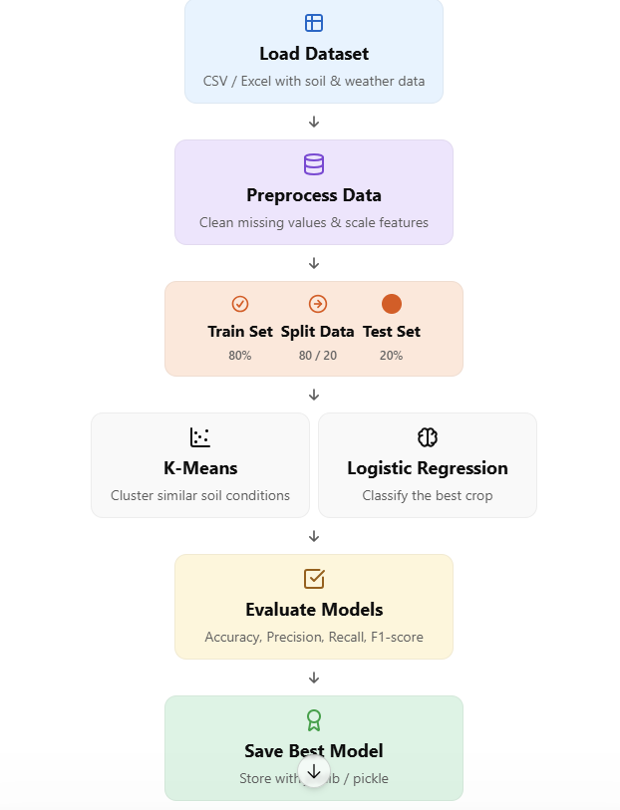

Activity 4.2: Model Evaluation
After training, the Logistic Regression model is evaluated using the testing dataset. Multiple evaluation metrics are generated to measure the model's performance and prediction accuracy.
The generated evaluation artifacts include:
- Accuracy Report
- Classification Report
- Confusion Matrix
- Model Summary
The evaluation results demonstrate the effectiveness of the trained model in predicting suitable crops based on soil and environmental conditions.
Figure 4.2: Confusion Matrix
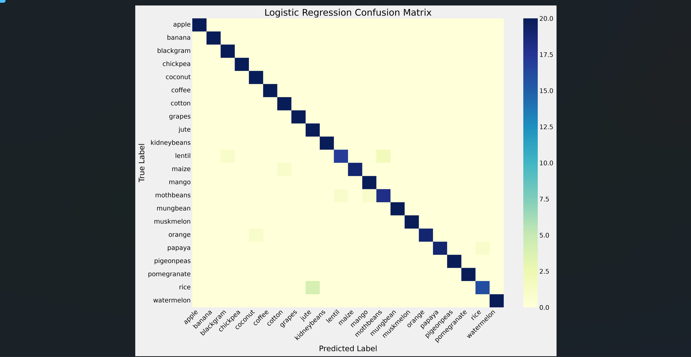

Activity 4.3: Model Serialization and Prediction
After evaluation, the trained Logistic Regression model is selected as the final deployment model because it is a supervised learning algorithm capable of accurately classifying crop categories. The model is serialized using the Joblib library and saved as crop_model.pkl.
Although K-Means Clustering is trained during the workflow, it is primarily used for exploratory analysis and visualization rather than deployment because it is an unsupervised learning algorithm.
The saved model is later loaded by the Flask application to generate real-time crop recommendations from user-provided agricultural parameters.
The following output files are generated during this stage:
- crop_model.pkl
- accuracy.txt
- classification_report.txt
- model_summary.txt
- confusion_matrix.png
- kmeans_clusters.png
Figure 4.3: K-Means Cluster Visualization
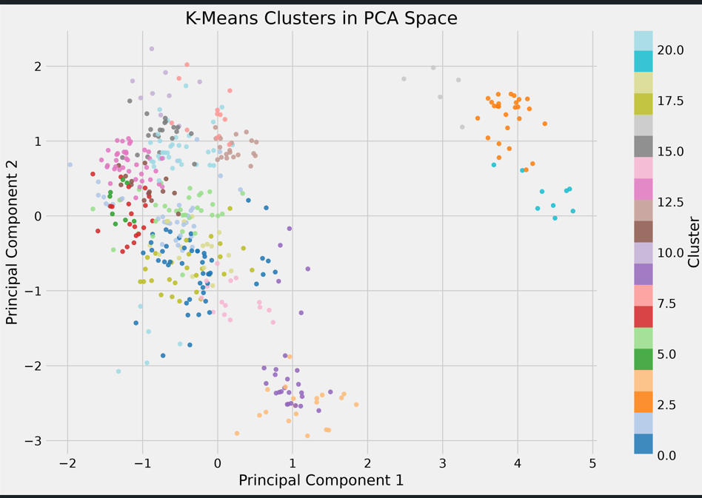

Figure 4.4: Model Summary or Accuracy Report
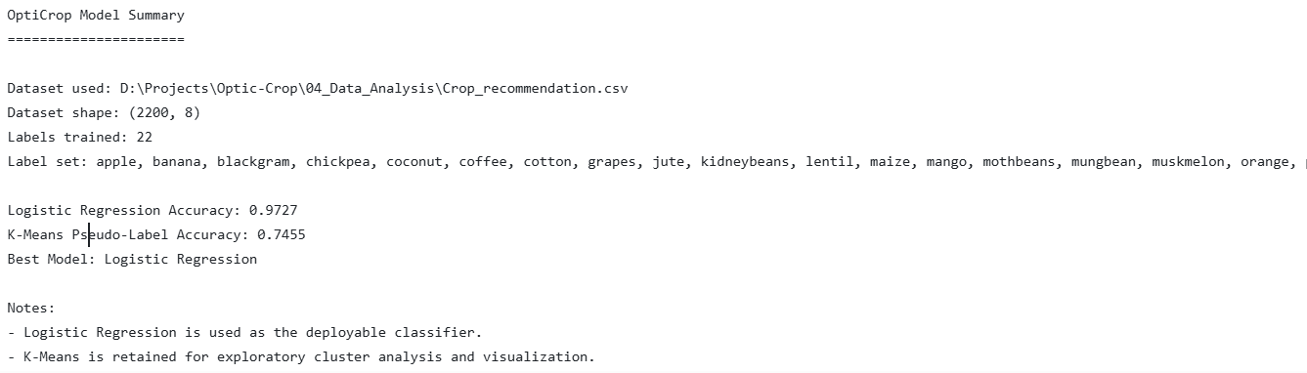
The completion of this milestone results in a trained, evaluated, and serialized Machine Learning model that forms the prediction engine of the OptiCrop system. The generated model is integrated into the Flask web application to provide fast and accurate crop recommendations based on soil nutrient and environmental conditions.

Milestone 5: Web Application Development
Milestone 5 focuses on developing the OptiCrop web application by integrating the trained Machine Learning model with a user-friendly web interface. The application is developed using the Flask framework for the backend and HTML5, CSS3, and JavaScript for the frontend. It enables users to enter soil nutrient and environmental parameters and instantly receive a recommended crop.

Activity 5.1: Backend Development
The backend of the OptiCrop application is implemented using the Flask framework. The application loads the pre-trained Machine Learning model (crop_model.pkl) and processes user inputs received through the web interface. After validating the input values, the backend performs crop prediction and sends the recommendation to the result page.
The backend is responsible for:
- Loading the trained Machine Learning model.
- Processing user input values.
- Performing server-side input validation.
- Predicting the recommended crop.
- Displaying the prediction results.
Figure 5.1: Flask Application Structure
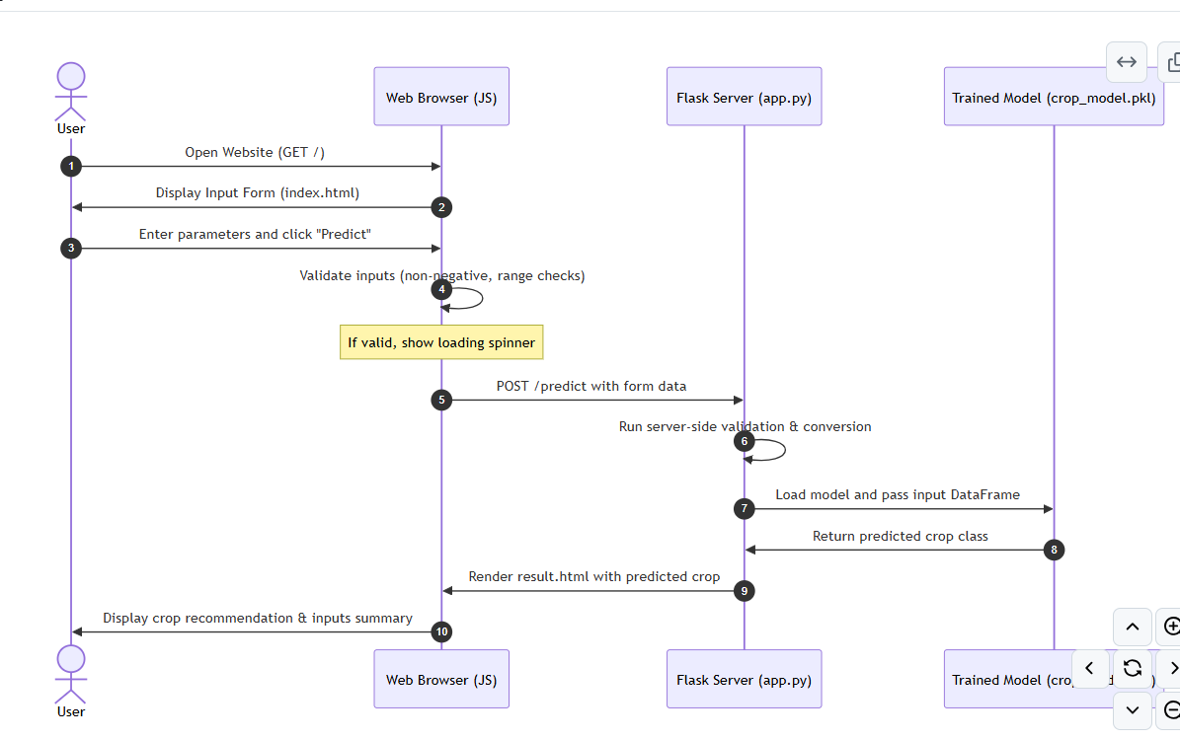

Activity 5.2: Frontend Development
The frontend is designed using HTML5, CSS3, and JavaScript with a premium Nature-Tech Glassmorphic theme. The interface provides an intuitive input form where users can enter soil nutrient values (N, P, K) and environmental parameters such as temperature, humidity, pH, and rainfall.
Client-side validation is implemented using JavaScript to ensure valid user input before submitting the prediction request. The application also includes responsive design, loading animations, and an attractive user interface for an improved user experience.
The web application consists of the following components:
- Home Page (index.html)
- Prediction Result Page (result.html)
- Custom CSS Styling (style.css)
- Client-side Validation (script.js)
Figure 5.2: OptiCrop Home Page
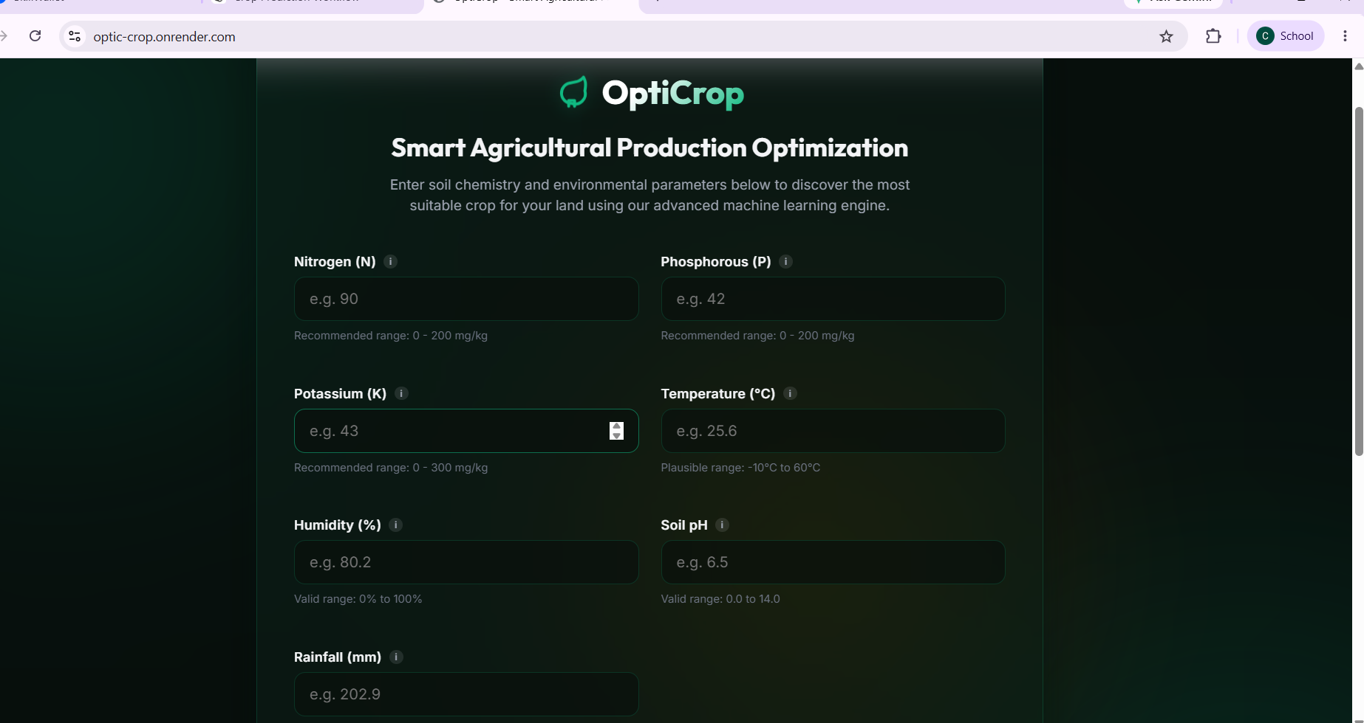

Activity 5.3: Model Integration and Prediction
The trained Machine Learning model is integrated into the Flask application using the Joblib library. Once the user submits the required soil and environmental parameters, the application loads the model, performs prediction, and displays the recommended crop within a few milliseconds.
The application workflow is as follows:
- User enters soil and environmental parameters.
- Client-side validation checks the input values.
- Flask receives the request.
- The trained Machine Learning model generates the prediction.
- The recommended crop is displayed on the result page.
Figure 5.3: Crop Recommendation Result
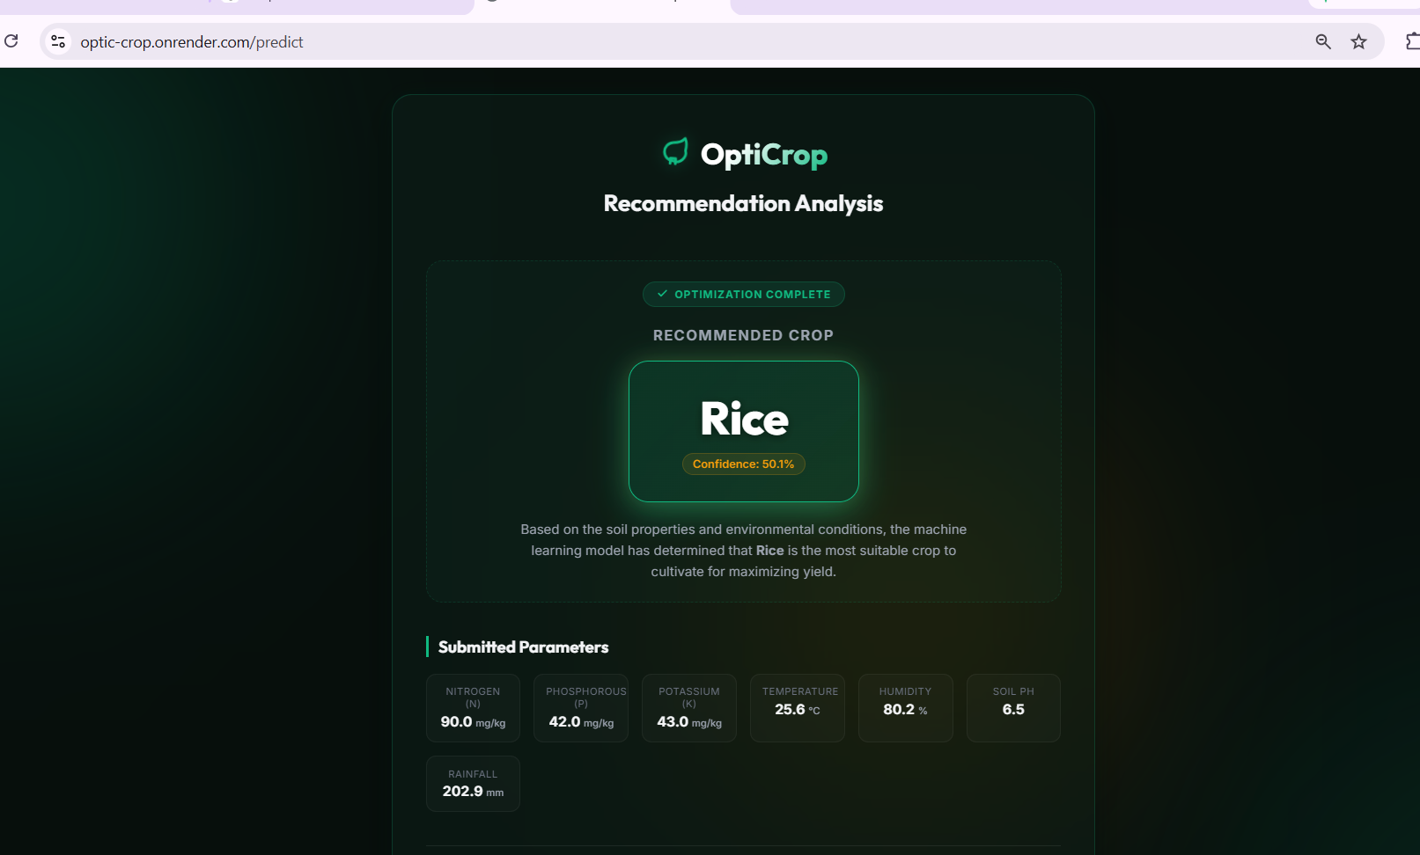

The successful completion of this milestone results in a fully functional web application that integrates Machine Learning with an interactive user interface. The OptiCrop system provides fast, accurate, and user-friendly crop recommendations, making it suitable for farmers, researchers, and agricultural professionals.

Milestone 6: Testing
Milestone 6 focuses on verifying the functionality, reliability, and performance of the OptiCrop system through automated and manual testing. The testing process ensures that the dataset, Machine Learning model, Flask web application, input validation mechanisms, and user interface function correctly and provide accurate crop recommendations. Both functional and performance testing are carried out to validate the overall system before deployment.

Activity 6.1: Automated Testing
An automated test suite is developed using Python's unittest framework and the Flask Test Client. The test suite validates each major component of the application, including the dataset, trained Machine Learning model, prediction logic, Flask routes, input validation, error handling, and system performance.
The automated testing covers the following modules:
- Dataset Validation
- Model Validation
- Prediction Logic
- Flask Route Testing
- Form Validation
- Error Handling
- Performance Testing
The automated test execution generates a comprehensive summary report that confirms the successful execution of all test cases.
Figure 6.1: Automated Test Execution
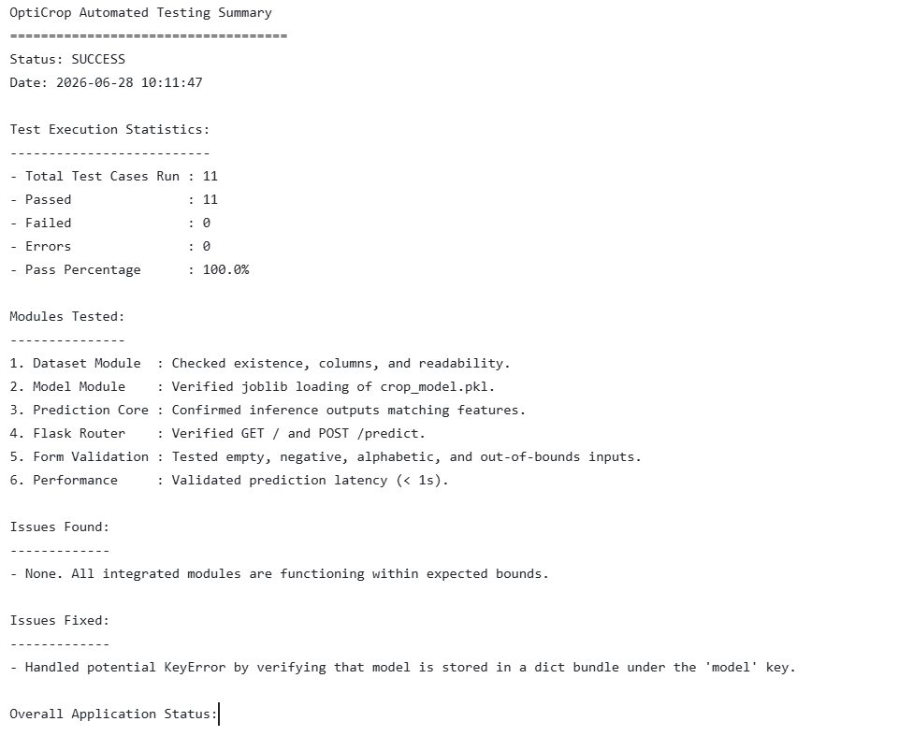

Activity 6.2: Manual Testing
Manual testing is performed to verify the application's graphical user interface, responsiveness, user interaction, and validation mechanisms. Different input scenarios are tested to ensure that valid inputs produce accurate crop recommendations, while invalid inputs display appropriate validation messages.
The manual testing process includes:
- Home Page Verification
- Valid Crop Prediction
- Invalid Input Validation
- Error Message Verification
- User Interface Responsiveness
Figure 6.3: Input Validation
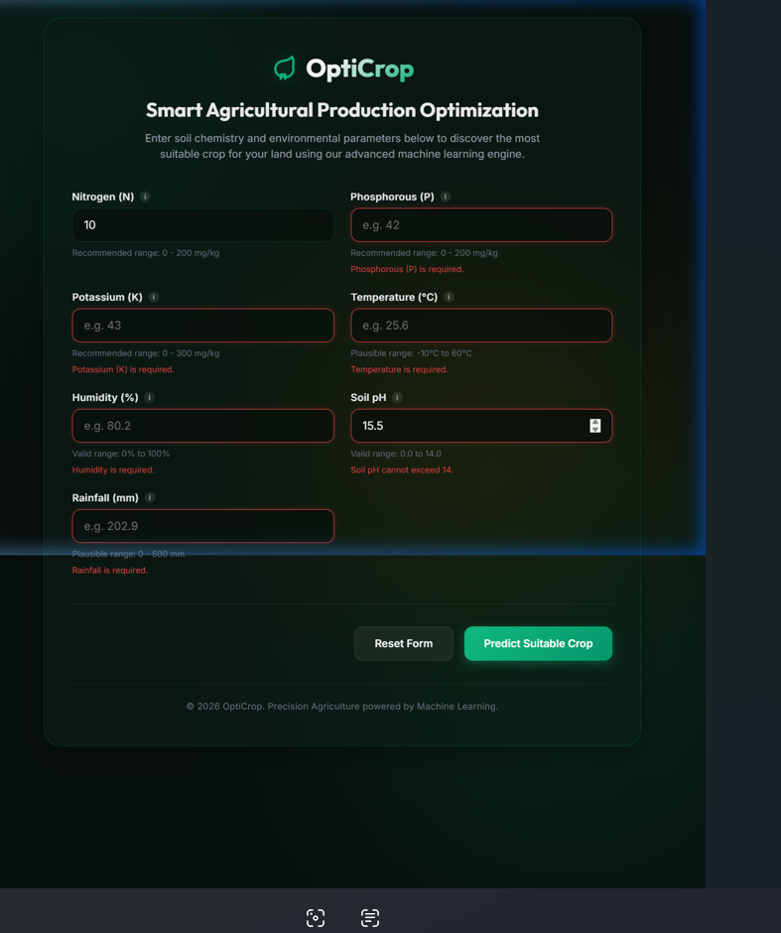

Activity 6.3: Performance Evaluation
Performance testing is conducted to evaluate the efficiency of the crop recommendation system. The Machine Learning model loading time and prediction latency are measured to ensure fast response times during user interaction.
The testing verifies:
- Successful model loading.
- Prediction response within acceptable time limits.
- Stable application performance under normal usage.
The testing module also generates the following artifacts:
- test_summary.txt
- test_report.md
- manual_testing.md
- test_cases.md
The successful completion of all automated and manual test cases confirms that the OptiCrop application is reliable, accurate, and ready for deployment in a production environment.

Milestone 7: Deployment
Milestone 7 focuses on deploying the OptiCrop application to make it accessible beyond the development environment. The application is first tested locally to ensure proper functionality and is then deployed to cloud platforms for public access. Deployment integrates the Flask web application, trained Machine Learning model, and frontend into a complete production-ready system.

Activity 7.1: Local Deployment
Before deploying the application to the cloud, the OptiCrop system is executed in a local development environment. All required dependencies are installed, and the Flask application is started using the following command:
python app.py
The application runs on the local development server and is accessed through:
http://127.0.0.1:5000
Local deployment is used to verify application functionality, validate predictions, and ensure all frontend and backend components work correctly.
Figure 7.1: Local Deployment
(Insert a screenshot of the terminal showing the Flask server running and/or the application opened in the browser.)

Activity 7.2: Production Deployment
After successful local testing, the application is deployed to cloud hosting platforms for public access. The deployment is configured using Gunicorn, Procfile, requirements.txt, and runtime.txt, enabling the Flask application to run efficiently in a production environment.
The OptiCrop application supports deployment on:
- Render
- PythonAnywhere
These cloud platforms host the application, allowing users to access the crop recommendation system through a web browser without requiring local installation.
Figure 7.2: Production Deployment
(Insert a screenshot of the Render Dashboard or PythonAnywhere Dashboard.)

Activity 7.3: Live Application Verification
After deployment, the live application is tested to verify that the Machine Learning model loads successfully, accepts user inputs, generates accurate crop recommendations, and responds efficiently in the production environment.
The deployment confirms:
- Successful hosting of the Flask application.
- Proper integration of the trained Machine Learning model.
- Real-time crop prediction.
- Responsive user interface.
- Stable application performance.
Figure 7.3: Live OptiCrop Application
(Insert a screenshot of the deployed application running in the web browser.)

The successful deployment of the OptiCrop system demonstrates that the application is fully operational in both local and production environments. The deployed system provides farmers, researchers, and agricultural professionals with an intelligent, web-based crop recommendation platform capable of delivering fast and accurate predictions based on soil nutrients and environmental conditions.

Conclusion
The OptiCrop – AI-Powered Smart Agricultural Production Optimization System successfully demonstrates the use of Machine Learning to recommend suitable crops based on soil nutrients and environmental conditions. The project covers the complete development lifecycle, including data analysis, preprocessing, model building, web application development, testing, and deployment.
The developed system provides accurate crop recommendations through a user-friendly Flask web application, helping improve agricultural decision-making and resource utilization. With its modular design, OptiCrop can be further enhanced by integrating features such as fertilizer recommendation, crop disease detection, weather forecasting, and yield prediction to support smarter and more sustainable farming practices.

