1 . Write a program to check if a number is positive, negative, or zero.

Input : get the input for the number.

Process : check the number is greater than zero n>0.

Outpuut : based on the condition the is printed.

#include <stdio.h>

void main()

{

int number;

printf("Enter a number: ");

scanf("%d", &number);

if (number > 0) {

printf("The number is Positive.\n");

} else if (number < 0) {

printf("The number is Negative.\n");

} else {

printf("The number is Zero.\n");

}

}

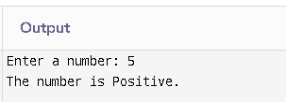

2 . Write a program to find the largest among three numbers.

Input : grt the input for the three numbers.

Process : use the if else condition to find the largest among three numbers.

Output : based on condition the output is printed.

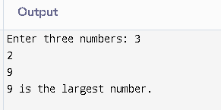

3 . Write a program to check if a year is a leap year.

Input : get the input for year.

Process : check the given year is divided by four .

Output : based on the condition the given output is give the year is leap year or not.

#include <stdio.h>

void main() {

int year;

printf("Enter a year: ");

scanf("%d", &year);

if ((year % 4 == 0 && year % 100 != 0) || (year % 400 == 0)) {

printf("%d is a Leap Year.\n", year);

} else {

printf("%d is Not a Leap Year.\n", year);

}

}

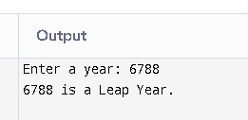

4 . Write a program to check whether a character is a vowel or consonant.

Input : get input for the character from the user .

Process : check the given character with the respective ASCII code using if condition.

Otput : based on the condition the output is printed.

#include <stdio.h>

void main() {

char ch;

printf("Enter a character: ");

scanf("%c", &ch);

if (ch == 'a' || ch == 'e' || ch == 'i' || ch == 'o' || ch == 'u' ||

ch == 'A' || ch == 'E' || ch == 'I' || ch == 'O' || ch == 'U') {

printf("%c is a Vowel.\n", ch);

} else if ((ch >= 'a' && ch <= 'z') || (ch >= 'A' && ch <= 'Z')) {

printf("%c is a Consonant.\n", ch);

} else {

printf("%c is not an alphabet character.\n", ch);

}

}

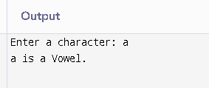

5 . Write a program to assign grades based on marks.

Input : get the input for the marks.

Process : set the condition for each grades.

Output : based on the condition the grade is printed.

#include <stdio.h>

void main() {

int marks;

printf("Enter the marks (0-100): ");

scanf("%d", &marks);

if (marks >= 90 && marks <= 100) {

printf("Grade A\n");

} else if (marks >= 75 && marks < 90) {

printf("Grade B\n");

} else if (marks >= 60 && marks < 75) {

printf("Grade C\n");

} else if (marks >= 50 && marks < 60) {

printf("Grade D\n");

} else if (marks >= 0 && marks < 50) {

printf("Fail\n");

} else {

printf("Invalid Marks Entered!\n");

}

}

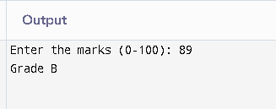

6 . Write a program to check whether a number is divisible by 5 and 11.

Input : get the input for the divident nuber .

Process : use the respective if condition.

Output : based on the condition the divident number is printed.

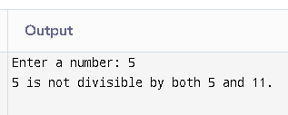

7 . Write a program to find the absolute value of a number.

Input : get input for the number.

Process : check the number with respective – number.

Output : based on the condition the absolute value is printed.

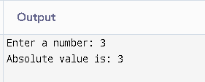

8 . Write a menu-driven program to perform +, -, *, / operations.

Input : get the input for the numbers.

Process : using switch case set the condition.

Output : based on case the output is printed.

#include <stdio.h>

void main() {

int choice;

float num1, num2, result;

printf("Select an operation to perform:\n");

printf("1. Addition (+)\n");

printf("2. Subtraction (-)\n");

printf("3. Multiplication (*)\n");

printf("4. Division (/)\n");

printf("Enter your choice (1-4): ");

scanf("%d", &choice);

printf("Enter two numbers: ");

scanf("%f %f", &num1, &num2);

switch (choice) {

case 1:

result = num1 + num2;

printf("Result = %.2f\n", result);

break;

case 2:

result = num1 - num2;

printf("Result = %.2f\n", result);

break;

case 3:

result = num1 * num2;

printf("Result = %.2f\n", result);

break;

case 4:

if (num2 != 0) {

result = num1 / num2;

printf("Result = %.2f\n", result);

} else {

printf("Error! Division by zero is not allowed.\n");

}

break;

default:

printf("Invalid choice!\n");

}

}

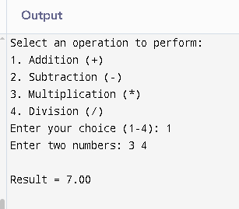

9 . Write a program to find roots of a quadratic equation.

Input : get the input for the roots.

Process : Find discriminant **D = b² - 4ac**, then compute roots using **(-b ± √D) / 2a** based on whether **D > 0 (real & distinct), D = 0 (real & equal), or D < 0 (complex roots)**.

Output : based one the condition the output is printed.

#include <stdio.h>

#include <math.h>

int main()

{

float a, b, c, d, root1, root2, realPart, imagPart;

printf("Enter coefficients a, b, c: ");  
scanf("%f %f %f", &a, &b, &c);  
  
d = b * b - 4 * a * c; // Discriminant  
  
if (d > 0) {  
 root1 = (-b + sqrt(d)) / (2 * a);  
 root2 = (-b - sqrt(d)) / (2 * a);  
 printf("Roots are real and distinct: %.2f and %.2f\n", root1, root2);  
} else if (d == 0) {  
 root1 = -b / (2 * a);  
 printf("Roots are real and equal: %.2f\n", root1);  
} else {  
 realPart = -b / (2 * a);  
 imagPart = sqrt(-d) / (2 * a);  
 printf("Roots are complex: %.2f + %.2fi and %.2f - %.2fi\n", realPart, imagPart, realPart, imagPart);  
}  
 }

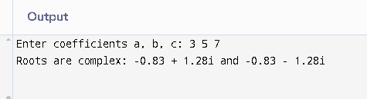

10 . Write a program to find the number of digits in a number.

Input : get the input for the number.

Process : using if else condition to check the inputs.

Output : based on the condition the output is printed.

#include <stdio.h>

int main() {

int number, count = 0;

printf("Enter a number: ");

scanf("%d", &number);

if (number == 0) {

count = 1; // Special case for 0

} else {

while (number != 0) {

number = number / 10; // Remove last digit

count++;

}

}

printf("Number of digits = %d\n", count);

}

