1. Write a C program to add two integers.

Input : Get two values from from the user.

Process : add the number one and two.

num 1 + num2

Output : get the added numbers as a output.

#include<stdio.h>

int main() {

int a, b, sum = 0;

scanf("%d%d", &a, &b);

sum = a + b;

printf("%d", sum);

return 0;

}

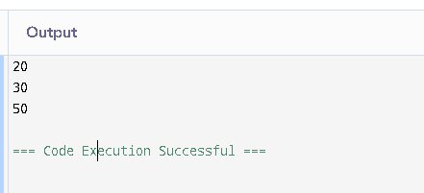

1. Write a program to swap two numbers using a temporary variable.

Input : input for a and b.

Process : swap the numbers a and b using swap.

Output: after swapping the number a assigned to b

#include<stdio.h>

int main() {

int a, b, temp;

scanf("%d%d", &a, &b);

temp = a;

a = b;

b = temp;

printf("%d\n%d", a, b);

return 0;

}

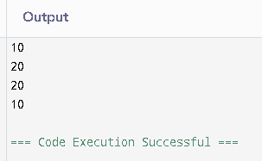

1. Write a program to swap two numbers without using a temporary variable.

Input : input for a and b.

Process : swap the numbers a and b without using swap.

Output: after swaoing the number a assined to b.

#include<stdio.h>

int main() {

int a, b;

scanf("%d%d", &a, &b);

a = a + b;

b = a - b;

a = a - b;

printf("%d\n%d", a, b);

return 0;

}

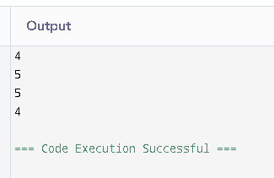

1. Write a program to find the ASCII value of a character.

Input : get char as a input.

Process : change the given character into ASCII code.

Output : print the char into the ASCII value.

#include<stdio.h>

int main() {

char ch;

scanf(" %c", &ch);

printf("%d", ch);

return 0;

}

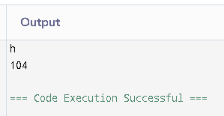

1. Write a program to calculate the area and perimeter of a rectangle.

Input : get the value of area and perimeter of the rectangle.

Process : calculate the values given

Output : priint the calculation of the given values.

#include<stdio.h>

int main() {

int l, b;

scanf("%d%d", &l, &b);

printf("%d\n%d", l\*b, 2\*(l+b));

return 0;

}

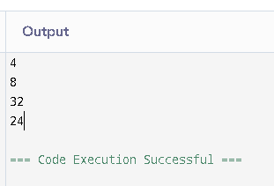

1. Write a program to compute the simple interest.

Input : get the principle and rate of intrest and time from the user

Process : make the calculation SI = p\*r\*t/100

Output : make the calculation for the given formula.

#include<stdio.h>

int main() {

float p, r, t;

scanf("%f%f%f", &p, &r, &t);

printf("%.2f", (p \* r \* t) / 100);

return 0;

}

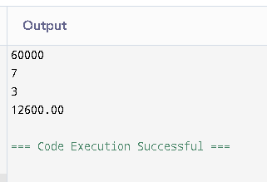

1. Write a program to convert temperature from Celsius to Fahrenheit.

Input : get input for celsius from user.

Process : convert the given celsius into fahrenheit using formula.

Output : from the formula change the celsius into fahrenheit.

#include<stdio.h>

int main() {

float c;

scanf("%f", &c);

printf("%.2f", (c \* 9/5) + 32);

return 0;

}

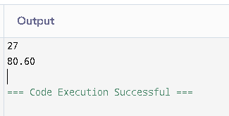

1. Write a program to find the quotient and remainder of two integers.

Input : get the input for two integers.

Process : change the integers into quotient and the remainder.

Output : print the quotient and remainder.

#include<stdio.h>

int main() {

int a, b;

scanf("%d%d", &a, &b);

printf("%d\n%d", a / b, a % b);

return 0;

}

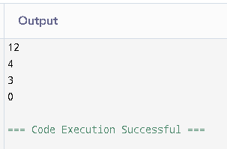

1. Write a program to check whether a number is even or odd.

Input : get input for the number

Process : check wheather the given number is odd or even by number%2==0

Output : based on the condition print the number is odd or even

#include<stdio.h>

int main() {

int n;

scanf("%d", &n);

if (n % 2 == 0) printf("Even");

else printf("Odd");

return 0;

}

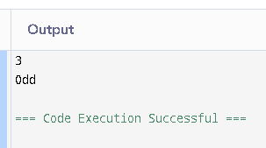

1. Write a program to calculate the square and cube of a number.

Input : get input for a number

Process : square=number\*number, cube=number\*number\*number.

Output : square of the number and cube of the number.

#include<stdio.h>

int main() {

int n;

scanf("%d", &n);

printf("%d\n%d", n \* n, n \* n \* n);

return 0;

}

