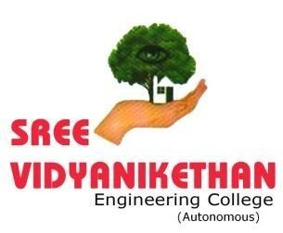

ORGAN DONATION AND TRANSPLANTATION SYSTEM USING FULL STACK DEVELOPMENT

*An Internship Report submitted to*

**The Principal, Sree Vidyanikethan Engineering College**

**(AUTONOMOUS)**

*in partial fulfilment of the requirements for the award of the degree of*

**MASTER OF COMPUTER APPLICATIONS**

***By***

**BUSETTI SIVAIAH**

## [21121F0016]

*IN*

***KARTHIKEYA SOFTWARE SOLUTIONS Pvt, Ltd.,***

SREE VIDYANIKETHAN ENGINEERING COLLEGE

(Autonomous)

(Affiliated to JNTUA, Anantapuramu)

Sree Sainath Nagar, A. Rangampet-517 102. Chittoor (Dist.)

**Certificate**



### This is to certify that this Internship work entitled

**‘‘**ORGAN DOONATION AND TRANSPLANTATION SYSTEM USING FULL STACK DEVELOPMENT”

### is a bona fide work done by

**BUSETTI SIVAIAH**

### [21121F0016]

in partial fulfilment of the requirements for the award of

**MASTER OF COMPUTER APPLICATIONS**

SREE VIDYANIKETHAN ENGINEERING COLLEGE

(Autonomous)

# A. Rangampet

**Head of the Department Dr. M. Lavanya**

***HOD, MCA Department***

(Internal Examiner) (External Examiner)

ACKNOWLEDGEMENTS

This acknowledgement transcends the reality of formality when i would like to express deep gratitude and respect to all those people behind the screen who guided, inspired and helped me for the completion of my project work.

I express my deep sense of gratitude to our beloved chairman **Dr. M. Mohan Babu** Padma Shri awardee for his encouragement throughout the course.

I owe my gratitude and special thanks to the Principal **Dr. B. M. Satish**, for his special encouragement and advice to shape ourselves for the future career.

I extremely thankful to **Dr. M. Lavanya**, HOD, Department of **Master of Computer Applications** for all provisions made and for her constant encouragement throughout my work.

I wish to express my deep sense of gratitude to my internship supervisor **Dr. M. Lavanya** Associate Professor and HOD, Department of MCA for extending her valuable co- operation, moral support, kind attention, guidance, suggestions and encouragement to complete my internship successfully.

I thank all my beloved **Faculty**, Department of MCA for giving his valuable suggestions and maximum co-operation.

I owe a deep sense of gratitude to my beloved **Parents** in extending their moral support in this Endeavour. I would like to thank all my **friends** who extended their help, encouragement and moral support either directly or indirectly in completing our project work.

DECLARATION

**I, BUSETTI SIVAIAH** hereby declare that, the internship “ORGAN DONATION SYSTEM USING FULL STACK DEVELOPMENT”done by me at **KARTHIKEYA SOFTWARE SOLUTIONS PVT LTD during the academic year 2022-2023** and submitted to the principal, **Sree Vidyanikethan Engineering College (Autonomous)** for partial fulfillment for the award of master of computer applications (MCA).

I also declare that the Internship is done by my own effort and that it has not been copied from any one and not been submitted by anybody in any of the university or institution or research centre.

Place: Date:

##### BUSETTI SIVAIAH (21121F0016)

ABSTRACT

Organ donation is defined as giving an organ or part of an organ to be transplanted into another person. Organ transplantation is the only option to save lives in patients affected by terminal organ failures and improve their quality of life. However, there is a disparity exists between the supply and demand of donated organs, leads to a loss of many lives. The number of organ transplantation have gradually increased in the last two decades and provide excellent results in children and young adults, and are challenging by the growing proportion of elderly transplant patients with co morbidity. The results of organ transplantation continue to improve, as a consequence of the innovations and the improvements in peri-operative management. This chapter describes organ donation and transplantation and its trends and challenges.

This would be facilitating the people to make and donate their organs and also donate money to the organ transplantation process. In this system have information about organ donation, importance of organ donation and Organ transplantation is one of the great advances in modern medicine. Unfortunately, the need for organ donors is much greater than the number of people who actually donate. Every day in the United States, 21 people die waiting for an organ and more than 107,380 men, women and children await life-saving organ transplants.

##### DEPARTMENT OF MASTER OF COMPUTER APPLICATIONS PROGRAM EDUCATIONAL OBJECTIVES (PEOS)

*After few years of completion of the Program, the graduates of MCA would be:*

**PEO1:** Enrolled or completed higher education/research studies in the core and allied areas of computer science.

**PEO2:** Successful entrepreneurs and professionally excelled in diverse application skills in the core or allied area of computer science of societal importance.

**PEO3:** Professionals in industry, academia and organizations with ability to adapt to evolving technologies in the core and allied areas of computer science.

**PROGRAM OUTCOMES (POs)**

*After completion of the program, a successful student will be able to:*

**PO1.** Apply knowledge of computing fundamentals, computing specialization, mathematics, and domain knowledge appropriate for the computing specialization to the abstraction and conceptualization of computing models from defined problems and requirements. (**Computational Knowledge**)

**PO2.** Identify, formulate, research literature, and solve complex computing problems reaching substantiated conclusions using fundamental principles of mathematics, computing sciences, and relevant domain disciplines. **(Problem Analysis)**

**PO3.** Design and evaluate solutions for complex computing problems, and design and evaluate systems, components, or processes that meet specified needs with appropriate consideration for public health and safety, cultural, societal, and environmental considerations.

##### (Design /Development of Solutions)

**PO4.** Use research-based knowledge and research methods including design of experiments, analysis and interpretation of data, and synthesis of the information to provide valid conclusions.

##### (Conduct Investigations of Complex Computing Problems)

**PO5.** Create, select, adapt and apply appropriate techniques, resources, and modern computing tools to complex computing activities, with an understanding of the limitations. (**Modern Tool Usage**)

**PO6.** Understand and commit to professional ethics and cyber regulations, responsibilities, and norms of professional computing practices. (**Professional Ethics**)

**PO7.** Recognize the need, and have the ability, to engage in independent learning for continual development as a computing professional. (**Life-long Learning**)

**PO8.** Demonstrate knowledge and understanding of the computing and management principles and apply these to one’s own work, as a member and leader in a team, to manage projects and in multidisciplinary environments. (**Project management and finance**)

**PO9.** Communicate effectively with the computing community, and with society at large, about complex computing activities by being able to comprehend and write effective reports, design documentation, make effective presentations, and give and understand clear instructions.

##### (Communication Efficacy)

**PO10.** Understand and assess societal, environmental, health, safety, legal, and cultural issues within local and global contexts, and the consequential responsibilities relevant to professional computing practices. (**Societal and Environmental Concern**)

**PO11.** Function effectively as an individual and as a member or leader in diverse teams and in multidisciplinary environments. (**Individual and Team Work**)

**PO12.** Identify a timely opportunity and using innovation to pursue that opportunity to create value and wealth for the betterment of the individual and society at large. (**Innovation and Entrepreneurship**

**PROGRAM SPECIFIC OUTCOMES (PSOs)**

*On successful completion of Program, MCA graduates will be able to:*

**PSO1:** Design, implement and test applications for complex computing problems for desired specifications through modern tool usage, appropriate technologies and programming skills.

**PSO2:** Use managerial and domain Skills of Information Management to model an application’s data requirements using domain specific modeling tools, Transaction & Query processing, Indexing & Searching techniques, and extract information for interpreting the datasets for Decision Making.

**PSO3:** Apply suitable techniques and algorithms to Integrate Operating System, Services, Network devices, Security mechanisms and Infrastructure to meet the requirements for the deployment of an application and to communicate on computer networks.

**MCA III-SEMESTER** (20MC30133) **INTERNSHIP COURSE OUTCOMES**

*After successful completion of the course, the students will be able to:*

**CO1:** Analyze latest tools, and technologies that are used in industry to solve complex computing problems following relevant standards, codes, policies and regulations.

**CO2:** Analyze safety, health, societal, environmental, legal, economical and managerial factors considered in industry in solving complex computing problem relevant to professional computing practices.

**CO3:** Perform individually or in a team besides communicating effectively in written, oral and graphical forms on computing practices.

**­­Table of Contents**

1. Introduction 1
2. Literature survey 2
3. Problem Definition 3
4. Data Collection 4
5. System Analysis 5
   1. Proposed system 5
   2. Modules 6

5.3 System architecture 7

1. System Environment 8
   1. Hardware Requirements 8
   2. Software Requirements… 8
2. System Design………………………………………………………………………….9
   1. UML DIAGRAMS 10
      1. Use case diagram… 10
      2. Class diagram… 11
      3. Sequence diagram 12
      4. Collaboration diagram… 13
      5. Activity diagram… 14
      6. State chart diagram 15
      7. Component diagram… 16
      8. Deployment diagram… 17
3. Implementation 18
   1. Description of technology 18

8.2. Screen shots 29

1. System Testing 37
   1. Introduction 37

9.1.Types of Tests 37

1. Conclusion 40
   1. Future Enhancement 40

BIBLIOGRAPHY 41

**List of Figures**

* + 1. Use case diagram… 11
    2. Class diagram… 12
    3. Sequence diagram 13
    4. Collaboration diagram… 14
    5. Activity diagram… 15
    6. State chart diagram 16
    7. Component diagram… 17
    8. Deployment diagram… 18

**List of Screenshots**

1. 8.2.1: Home Page 29
2. 8.2.2: Recipient Register Page 30
3. 8.2.3: About Us Page 31
4. 8.2.4: Services Page 32
5. 8.2.5: Funds Donation Page 33
6. 8.2.6: Contact Page 34
7. 8.2.7: Make Donation Page 35
8. 8.2.8: Confirmation Page 36

# INTRODUCTION

An Organ donation and transplantation system using full stack development is software developed to not only simplify the task of registration for organ donation but also help people to awareness on organ donation. The application provides an effective on motivate people for donating organs. The system is user-friendly as well as providing information about organ donation and transplantation. it’s easy to register for donation, People simply click on make donation button and fill the all the details in that required then click on submit button. In this system also provide option to donate funds to the organ transplantation process, in this have three options to donate money they are Bank transfer, UPI (Unified Payment Interface) and money order.

Organ donation is the process of surgically removing an organ or tissue from one person (the organ donor) and placing it into another person (the recipient). Transplantation is necessary because the recipient’s organ has failed or has been damaged by disease or injury .

Organ transplantation is one of the great advances in modern medicine. Unfortunately, the need for organ donors is much greater than the number of people who actually donate. Every day in the United States, 21 people die waiting for an organ and more than 107,380 men, women and children await life-saving organ transplantation.

# LITERATURE SURVEY

Organ Donation and Transplantation System Using Full Stack Development can be used in providing awareness on organ donation and help the people to register for organ donation. People get information on organ donation and transplantation process. If people want to donate money to the transplantation process the system provide that service also. The services are hard to gather the information and also preparing the system. There is no age limit for organ donation. It can be started at as young as six weeks. The only essential thing is the health and condition of your organs. You can donate all your organs and tissues – heart, kidneys, lungs, corneas, pancreas etc. Even living organ transplants are feasible, especially in the case of kidneys where it’s possible to lead a healthy life even with a single kidney.

Organ donations from just one person have the potential to save up to eight lives and impact countless others when you consider the families and friends desperately praying for the lifesaving help their loved ones need. Two donated lungs can take two patients off a wait list. A donated liver can be divided to help two patients receive the second chance they’ve been waiting for. Two kidneys can free two people from dialysis treatments. A donated heart and pancreas can help two more patients regain health and live strong, happy lives.

##### System provides facilities like…

* People register for organ donation user requirements.
* People donate money to organ transplantation.
* People ask any queries on organ donation.
* People get information about organ donation and transplantation process.

##### Various operations done in the system are as follows…

* Registering for donating organs.
* Funds donation.
* Access information about organ donation process.
* Post queries on organ donation.

The goal of this article is to demonstrate a data model for a simple e-commerce application that focuses on a couple of key structures contained in typical e-commerce system

# PROBLEM DEFINITION

The world of transplantation has gone through major changes and progress over many years, with superb methods to enhance our organ preservation and surgical and immunologic pharmacologic therapeutic abilities. However, the major burden on transplantation across the world is shortage of organs, which critically depends on the agreement of the public to organ transplantation. As a global society we should ban organ trafficking and organ selling worldwide and act against this phenomenon. At the same time, we should continue our efforts to optimize our regional and national organ transplantation programs, increase public awareness of organ donation, encourage public opinion and religious leaders towards acceptance, and educate our medical community, to reach a goal where the majority of eligible patients consent to organ donation.

Organ transplantation currently depends on the availability of human organs. Their scarcity means that there is a waiting list of almost 63,000 in the European Union, over 200,000 people in India and over 100,000 people in the United States according to the recent survey.

The Organ Donation System act as bridge between organ doner and organ recipient.

# DATA COLLECTION

##### By Questioner Method

* + What are the laws for organ donation?

**Transplantation of Human Organs Act (THOA) 1994** was enacted to provide a system of removal, storage and transplantation of human organs for therapeutic purposes and for the prevention of commercial dealings in human organs. THOA is now adopted by all States except Andhra and J&K, who have their own similar laws.

* + What organs and tissues can be transplanted?

The human tissues that can be donated and used in many surgical applications include corneas, tendons, heart valves, veins, skin, musculoskeletal tissue, and nerves.

* + What is organ donation and transplantation?

Organ transplantation is a medical procedure in which an organ is removed from one body and placed in the body of a recipient, to replace a damaged or missing organ. The donor and recipient may be at the same location, or organs may be transported from a donor.

* + Who can be an organ donor?

There is no age limit for becoming an organ donor. The decision about whether some or all organs or tissue are suitable for transplant is always made by medical specialists at the time of donation, taking into account your medical, travel and social history.

* + If I need an organ or tissue transplant, what do I need to do?

If you need a transplant, you need to get on the national waiting list. To get on the list, you need to visit a transplant hospital. To find a transplant hospital near you, visit the Scientific Registry of Transplant Recipients (SRTR) and use the search function on the top of the page.

* + What organization actually manages the distribution of organs?

National Network division of NOTTO would function as apex centre for all India activities of coordination and networking for procurement and distribution of organs and tissues and registry of Organs and Tissues Donation and Transplantation in country.

* + What's involved with becoming a living organ donor?

In nondirected living-donor organ donation, also known as good Samaritan or altruistic donation, the donor does not name the recipient of the donated organ. The match is based on medical need and blood type compatibility. In some cases, the donor may choose not to know the organ recipient.

# SYSTEM ANALYSIS

##### Proposed System

The proposed system tries to aware about the importance of organ donation. The main objective of the proposed system is to provide information about organ donation and motivation the people register donation. The main objective is to make the DEVELOPMENT OF AN ORGAN DONATION AND TRANPLANTATION SYSTEM USING FULL STACK DEVELOPMENT details more efficient. This system should maintain registration for organ donation and awareness on organ donation. The application provides an effective on motivate people for donating organs. The system is user-friendly as well as providing information about organ donation and transplantation.

##### Advantages of Proposed System:

* + - **Planned approach towards working:** - The working of the system will be well planned and organized. The data will be stored properly in data stores, which will help in retrieval of information as well as its storage.
    - **Accuracy:** - The level of accuracy in the proposed system will be higher. All operation would be done correctly and it ensures that whatever information is coming from the system is accurate.
    - **Reliability:** - The reliability of the proposed system will be high due to the above stated reasons. The reason for the increased reliability of the system is that now there would be proper storage of information.
    - **No redundancy:** - In the proposed system utmost care would be that no information is repeated anywhere, in storage or otherwise. This would assure economic use of storage space and consistency in the data stored.
    - **Immediate Retrieval of Information:** - The main objective of proposed system is to provide for a quick and efficient retrieval of information. Any type of information would be available whenever the user requires.
    - **Immediate storage of information:** - In manual system there are many problems to store & update the large amount of information.
    - **Easy to operate:** - The system should be easy to operate and should be such that it can be easily understood by anew user.

**5.2. Modules**

* **Home Module**

This module contain information about organ donation and transplantation, number of peoples has been registered for donation and number of transplantations has done.

#### Services Module

In the services module have the information of our system providing services. The services are encourage organ donation, We gather the funds for helping organ transplantation, We conduct Health awareness programs in various places in the country and We conduct Medical campaign in various places in the country.

#### Funds donation Module

In funds donation module have various types of funds transfer for organ donation and transplantation like Bank Account transfer, UPI transfer and money order.

## System architecture

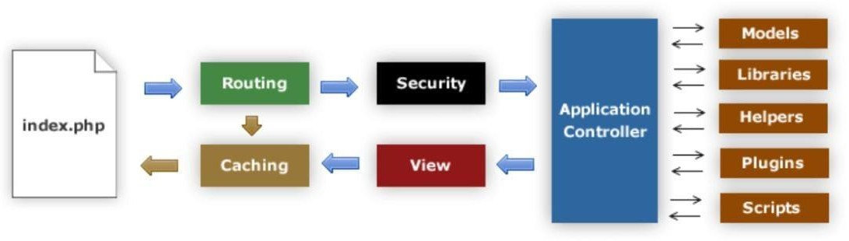

##### Figure 5.3.1: Architecture of CodeIgniter

The above figure 5.3.1 describes the system architecture of CodeIgniter. CodeIgniter is designed to deliver maximum performance in less time within a clean environment. To achieve this, each developing process is designed in a simplified way. which contains

* + - File **index.php** is the default file of CodeIgniter. It initializes the base resources.
    - The **Router** decides what should be done with the information.
    - If requested **cache** file exists, then the information is passed directly to the browser ignoring the further processes.
    - Before loading Application Controller, the HTTP request and submitted data is passed under **Security** check.
    - The Application Controller loads Models, Libraries, Helpers, Plugins and Scripts needed according to the request.
    - The final page will come to **View** and then sent to the web browser. If View page is not cached then it will be cached first for future requests.

# SYSTEM ENVIRONMENT

##### Hardware Requirements

1. System : Intel Core i3.

ii. Hard Disk : 256 GB.

1. Ram : 4 GB.

##### 6.2 Software System Configuration

* + 1. Operating system : Windows 10.
    2. IDE & Tools : Eclipse.

iii. Database : MYSQL

1. API Tool : REST API

**7.SYSTEM DESIGN**

##### 7.1 UML Diagrams

UML stands for Unified Modeling Language. UML is a standardized general-purpose modeling language in the field of object-oriented software engineering. The standard is managed, and was created by, the Object Management Group.

The goal is for UML to become a common language for creating models of object-oriented computer software. In its current form UML is comprised of two major components: a Meta- model and a notation. In the future, some form of method or process may also be added to; or associated with, UML.

The Unified Modeling Language is a standard language for specifying, Visualization, Constructing and documenting the artifacts of software system, as well as for business modeling and other non-software systems.

The UML represents a collection of best engineering practices that have proven successful in the modeling of large and complex systems.

The UML is a very important part of developing object-oriented software and the software development process. The UML uses mostly graphical notations to express the design of software projects.

##### 7.1.1 Use Case Diagrams

A use case diagram in the Unified Modeling Language (UML) is a type of behavioral diagram defined by and created from a Use-case analysis. Its purpose is to present a graphical overview of the functionality provided by a system in terms of actors, their goals (represented as use cases), and any dependencies between those use cases. The main purpose of a use case diagram is to show what system functions are performed for which actor. Roles of the actors in the system can be depicted.

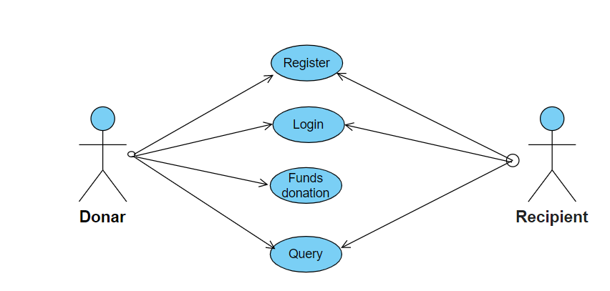

##### Figure: Use case Diagram

##### Class Diagram

In software engineering, a class diagram in the Unified Modeling Language (UML) is a type of static structure diagram that describes the structure of a system by showing the system's classes, their attributes, operations (or methods), and the relationships among the classes. It explains which class contains information.

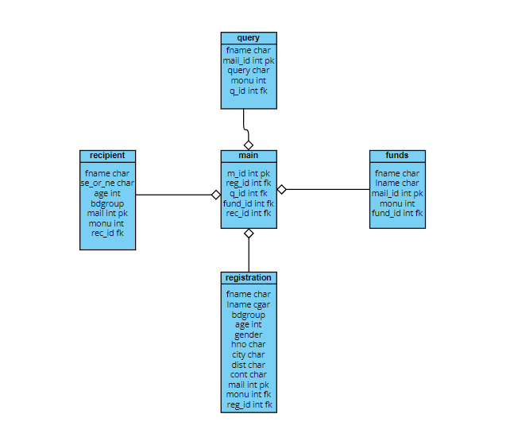

##### Figure: Class Diagram

##### Sequence Diagram

A sequence diagram in Unified Modelling Language (UML) is a kind of interaction diagram that shows how processes operate with one another and in what order. It is a construct of a Message Sequence Chart. Sequence diagrams are sometimes called event diagrams, event scenarios, and timing diagrams.

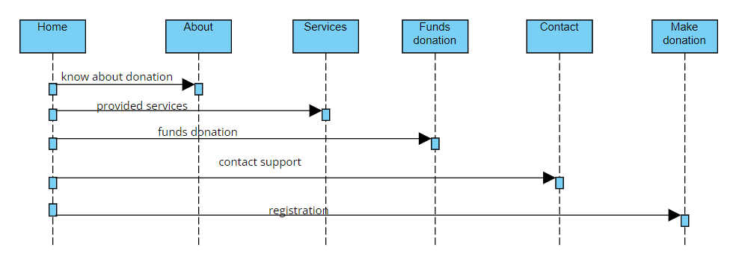

##### Figure: Sequence Diagram

##### Collaboration Diagram

In collaboration diagram the method call sequence is indicated by some numbering technique as shown below. The number indicates how the methods are called one after another. We have taken the same order management system to describe the collaboration diagram. The method calls are similar to that of a sequence diagram. But the difference is that the sequence diagram does not describe the object organization whereas the collaboration diagram shows the object organization.

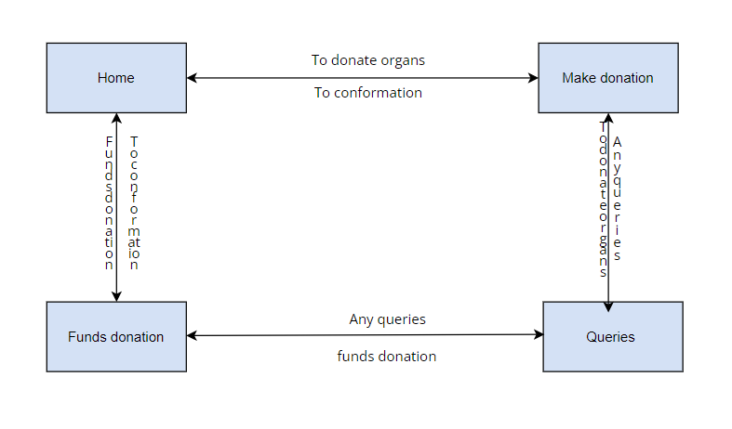

##### Figure: Collaboration Diagram

##### Activity Diagram

Activity diagrams are graphical representations of workflows of stepwise activities and actions with support for choice, iteration and concurrency. In the Unified Modelling Language, activity diagrams can be used to describe the business and operational step-by-step workflows of components in a system. An activity diagram shows the overall flow of control.

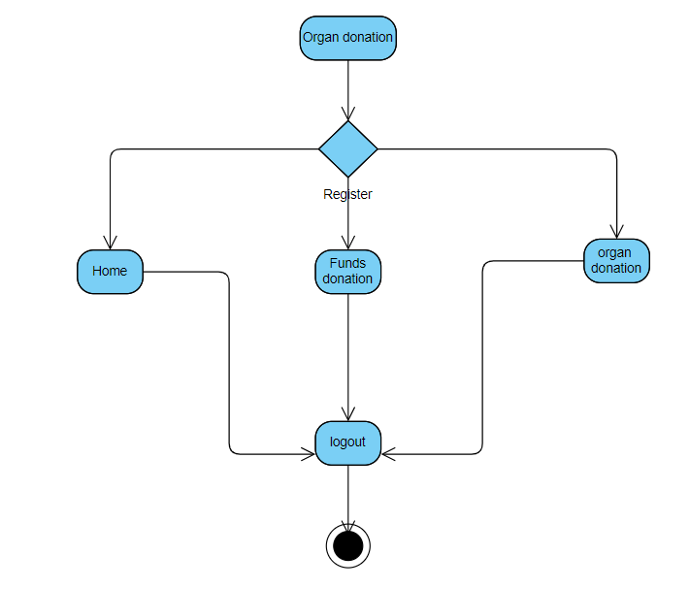

##### Figure: Activity Diagram

* + 1. **State Chart Diagram**

State chart diagram is used to find out the state of the object and we can define state chart diagram is define flow of states from one object to another object.

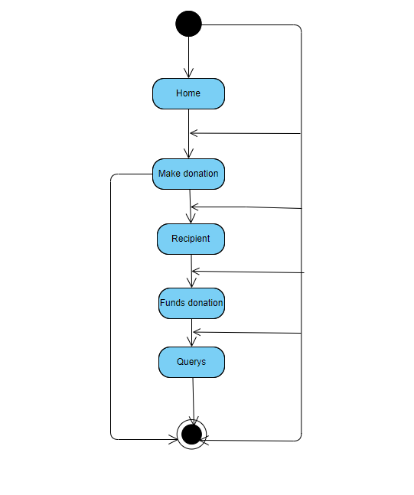

##### Figure: State chart Diagram

* + 1. **Component Diagram**

Component diagrams are used to describe the physical artifacts of a system. This artifact includes files, executables, libraries etc. So, the purpose of this diagram is different, Component diagrams are used during the implementation phase of an application. But it is prepared well in advance to visualize the implementation details. Initially the system is designed using different UML diagrams and then when the artifacts are ready component diagrams are used to get an idea of the implementation.

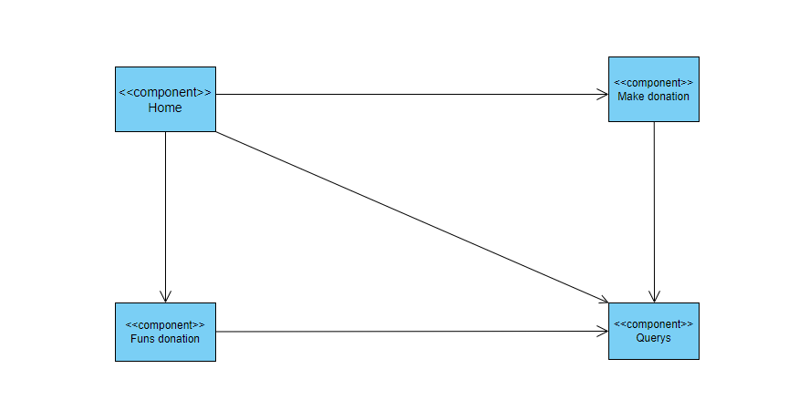

##### Figure: Component Diagram

* + 1. **Deployment Diagram**

Deployment diagram represents the deployment view of a system. It is related to the component diagram. Because the components are deployed using the deployment diagrams. A deployment diagram consists of nodes. Nodes are nothing but physical hardwires used to deploy the application.

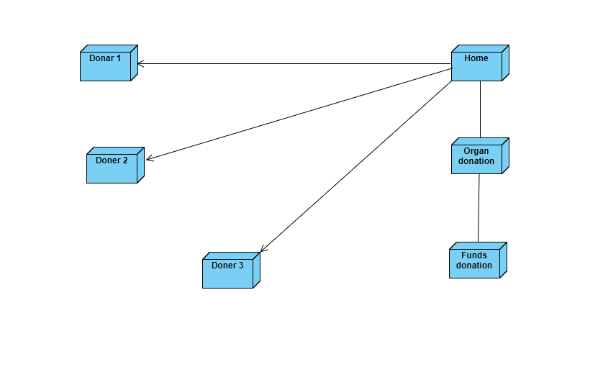

* + 1. **Figure: Deployment Diagram**

# 8.IMPLEMENTATION

##### Description of technology:

**CodeIgniter**

CodeIgniter is an Application Development Framework - a toolkit - for people who build web sites using PHP. Its goal is to enable you to develop projects much faster than you could if you were writing code from scratch, by providing a rich set of libraries for commonly needed tasks, as well as a simple interface and logical structure to access these libraries. CodeIgniter lets you creatively focus on your project by minimizing the amount of code needed for a given task. Where possible, CodeIgniter has been kept as flexible as possible, allowing you to work in the way you want, not being forced into working any certain way. The framework can have core parts easily extended or completely replaced to make the system work the way you need it to. In short, CodeIgniter is the malleable framework that tries to provide the tools you need while staying out of the way.

##### Server Requirements

* + - [PHP](https://www.php.net/) version 7.3 or newer is required, with the [* intl * extension](https://www.php.net/manual/en/intl.requirements.php) and [*mbstring* extension](https://www.php.net/manual/en/mbstring.requirements.php) installed.
    - The following PHP extensions should be enabled on your server: php-json, php-mysqlnd, php-xml.
    - In order to use the [CURL Request,](https://www.codeigniter.com/user_guide/libraries/curlrequest.html) you will need [libcurl](https://www.php.net/manual/en/curl.requirements.php) installed.

A database is required for most web application programming. Currently supported databases are:

* + - MySQL (5.1+) via the *MySQLi* driver
    - PostgreSQL via the *Postgre* driver
    - SQLite3 via the *SQLite3* driver
    - MSSQL via the *SQLSRV* driver (version 2005 and above only)

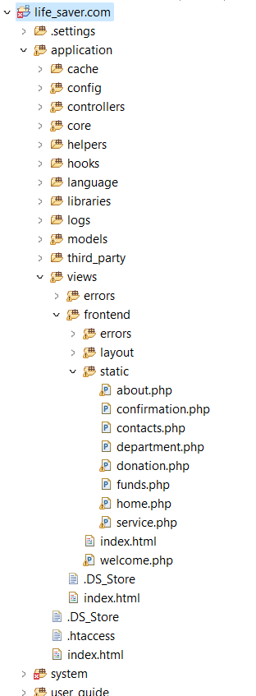

##### Routing:

$route['default_controller'] = 'frontend/welcome';

$route['about-us'] = 'frontend/welcome/about_us';

$route['service'] = 'frontend/welcome/service';

$route['department'] = 'frontend/welcome/department';

$route['contacts'] = 'frontend/welcome/contacts';

$route['donation'] = 'frontend/welcome/donation';

$route['confirmation'] = 'frontend/welcome/confirmation';

$route['funds'] = 'frontend/welcome/funds';

$route['404_override'] = '';

##### $route['translate_uri_dashes'] = FALSE;

##### Controller:

Create a file at **life_saver.com/application/Controllers/Welcome.php** with the following code.

<?php

*defined*('BASEPATH') OR **exit**('No direct script access allowed');

**class** Welcome **extends** CI_Controller {

**function** general()

{

$data['layout'] = 'frontend/layout/layout';

$data['header'] = 'frontend/layout/header';

$data['banner'] = 'frontend/layout/banner';

$data['footer'] = 'frontend/layout/footer';

**return** $data;

}

**function** index()

{

$data = $this->general();

$data['pageName'] = "home";

$data['pageTitle'] = '';

$data['metaDesc'] = '';

$data['metaKey'] = '';

$data['content'] = "frontend/static/home";

$this->load->view('frontend/welcome',$data);

}

**function** about_us()

{

$data = $this->general();

$data['pageName'] = "about_us";

$data['pageTitle'] = '';

$data['metaDesc'] = '';

$data['metaKey'] = '';

$data['content'] = "frontend/static/about";

$this->load->view('frontend/welcome',$data);

}

**function** service()

{

$data = $this->general();

$data['pageName'] = "service";

$data['pageTitle'] = '';

$data['metaDesc'] = '';

$data['metaKey'] = '';

$data['content'] = "frontend/static/service";

$this->load->view('frontend/welcome',$data);

}

**function** department()

{

$data = $this->general();

$data['pageName'] = "department";

$data['pageTitle'] = '';

$data['metaDesc'] = '';

$data['metaKey'] = '';

$data['content'] = "frontend/static/department";

$this->load->view('frontend/welcome',$data);

}

**function** funds()

{

$data = $this->general();

$data['pageName'] = "funds";

$data['pageTitle'] = '';

$data['metaDesc'] = '';

$data['metaKey'] = '';

$data['content'] = "frontend/static/funds";

$this->load->view('frontend/welcome',$data);

}

**function** contacts()

{

$data = $this->general();

$data['pageName'] = "contacts";

$data['pageTitle'] = '';

$data['metaDesc'] = '';

$data['metaKey'] = '';

$data['content'] = "frontend/static/contacts";

$this->load->view('frontend/welcome',$data);

}

**function** donation()

{

$data = $this->general();

$data['pageName'] = "donation";

$data['pageTitle'] = '';

$data['metaDesc'] = '';

$data['metaKey'] = '';

$data['content'] = "frontend/static/donation";

$this->load->view('frontend/welcome',$data);

}

**function** confirmation()

{

$data = $this->general();

$data['pageName'] = "confirmation";

$data['pageTitle'] = '';

$data['metaDesc'] = '';

$data['metaKey'] = '';

$data['content'] = "frontend/static/confirmation";

$this->load->view('frontend/welcome',$data);

}

}

?>

You have created a class named Pages, with a view() method that accepts one argument named

$page. It also has an index() method, the same as the default controller found in

**app/Controllers/Home.php**; that method displays the CodeIgniter welcome page.

##### Model Updating

The only thing that remains is ensuring that your model is set up to allow data to be saved properly. The save() method that was used will determine whether the information should be inserted or if the row already exists and should be updated, based on the presence of a primary key. In this case, there is no id field passed to it, so it will insert a new row into it’s table, **news**.

<?php

namespace App\Models; use CodeIgniter\Model;

class NewsModel extends Model

{

protected $table = 'news';

protected $allowedFields = ['title', 'slug', 'body'];

}

##### Features

* + - **Free to use:** It is licensed under MIT license, so it is free to use.
    - **Follows MVC Pattern:** It uses Model-View-Controller which basically separates logic and presentation parts. Request comes to controller, database action is performed through model and output is displayed through views. But in normal PHP scripting, every page represents MVC which increases complexity.
    - **Light weight** It is extremely light-weighted. CodeIgniter core system requires very small library, other libraries may be added upon dynamic request based upon your needs. That is why it is quite fast and light weighted.
    - **Generate SEO friendly URLs:** URLs generated by CodeIgniter are search-engine friendly and clean. It uses a segment based approach rather than standard query based approach.
    - **Built-in libraries:** It comes with full packet libraries that enable all the web needed tasks like database, form validation, sending email, manipulating images, sending emails, etc.

##### PHP

PHP is an open-source, interpreted, and object-oriented scripting language that can be

executed at the server-side. PHP is well suited for web development. Therefore, it is used to develop web applications (an application that executes on the server and generates the dynamic page.).

PHP was created by **Rasmus Lerdorf in 1994** but appeared in the market in 1995. **PHP 7.4.0** is the latest version of PHP, which was released on **28 November**.

* + - PHP stands for Hypertext Preprocessor.
    - PHP is an interpreted language, i.e., there is no need for compilation.
    - PHP is faster than other scripting languages, for example, ASP and JSP.
    - PHP is a server-side scripting language, which is used to manage the dynamic content of the website.
    - PHP can be embedded into HTML.
    - PHP is an object-oriented language.
    - PHP is an open-source scripting language.
    - PHP is simple and easy to learn language.

##### Features

PHP is very popular language because of its simplicity and open source. There are some important features of PHP given below:

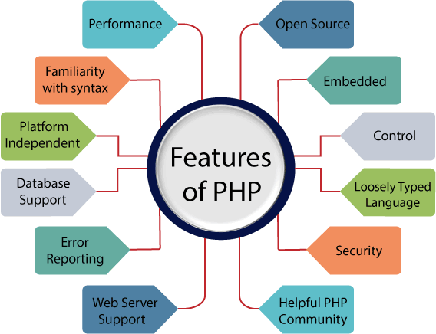

**8.1.1 figure: Features of PHP**

* + - **Performance:** PHP script is executed much faster than those scripts which are written in other languages such as JSP and ASP. PHP uses its own memory, so the server workload and loading time is automatically reduced, which results in faster processing speed and better performance.
    - **Open Source:** PHP source code and software are freely available on the web. You can develop all the versions of PHP according to your requirement without paying any cost. All its components are free to download and use.
    - **Familiarity with syntax:** PHP has easily understandable syntax. Programmers are comfortable coding with it.
    - **Embedded:** PHP code can be easily embedded within HTML tags and script.
    - **Platform Independent:** PHP is available for WINDOWS, MAC, LINUX & UNIX operating system. A PHP application developed in one OS can be easily executed in other OS also.
    - **Database Support:** PHP supports all the leading databases such as MySQL, SQLite, ODBC, etc.
    - **Error Reporting:** PHP has predefined error reporting constants to generate an error notice or warning at runtime. E.g., E_ERROR, E_WARNING, E_STRICT, E_PARSE.
    - **Loosely Typed Language:** PHP allows us to use a variable without declaring its datatype. It will be taken automatically at the time of execution based on the type of data it contains on its value.
    - **Web servers Support:** PHP is compatible with almost all local servers used today like Apache, Netscape, Microsoft IIS, etc.
    - **Security:** PHP is a secure language to develop the website. It consists of multiple layers of security to prevent threads and malicious attacks.
    - **Control:** Different programming languages require long script or code, whereas PHP can do the same work in a few lines of code. It has maximum control over the websites like you can make changes easily whenever you want.

##### How to run PHP programs in XAMPP

How to run PHP programs in XAMPP PHP is a popular backend programming language. PHP programs can be written on any editor, such as - Notepad, Notepad++, Dreamweaver, etc. These programs save with **.php** extension, i.e., filename.php inside the htdocs folder.

**For example** - p1.php.

As I'm using window, and my XAMPP server is installed in D drive. So, the path for the htdocs directory will be "D:\xampp\htdocs".

PHP program runs on a web browser such as - Chrome, Internet Explorer, Firefox, etc.

**Default URL:** $config['base_url'] = '<http://localhost/life_saver.com/';>

##### MYSQL

MySQL is a relational database management system based on the Structured Query Language, which is the popular language for accessing and managing the records in the database. MySQL is open-source and free software under the GNU license. It is supported by **Oracle Company**.

MySQL is currently the most popular database management system software used for managing the relational database. It is open-source database software, which is supported by Oracle Company. It is fast, scalable, and easy to use database management system in comparison with Microsoft SQL Server and Oracle Database. It is commonly used in conjunction with [PHP](https://www.javatpoint.com/php-tutorial) scripts for creating powerful and dynamic server-side or web-based enterprise applications.

It is developed, marketed, and supported by **MySQL AB, a Swedish company**, and written in [C](https://www.javatpoint.com/c-programming-language-tutorial) [programming language](https://www.javatpoint.com/c-programming-language-tutorial) and C++ programming language. The official pronunciation of MySQL

is not the My Sequel; it is ***My Ess Que Ell****. However, you can pronounce it in your way.* Many small and big companies use MySQL. MySQL supports many Operating Systems like [Windows](https://www.javatpoint.com/windows), [Linux,](https://www.javatpoint.com/linux-tutorial) MacOS, etc. with C, C++, and [Java languages.](https://www.javatpoint.com/java-tutorial)

MySQL is a [Relational Database Management System](https://www.javatpoint.com/what-is-rdbms) (RDBMS) software that provides many things, which are as follows:

* + - It allows us to implement database operations on tables, rows, columns, and indexes.
    - It defines the database relationship in the form of tables (collection of rows and columns), also known as relations.
    - It provides the Referential Integrity between rows or columns of various tables.
    - It allows us to updates the table indexes automatically.
    - It uses many SQL queries and combines useful information from multiple tables for the end-users.

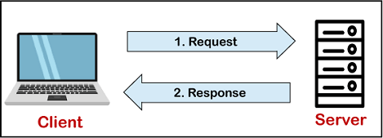MySQL follows the working of **Client-Server Architecture**. This model is designed for the end-users called clients to access the resources from a central computer known as a server using network services. Here, the clients make requests through a graphical user interface (GUI), and the server will give the desired output as soon as the instructions are matched. The process of MySQL environment is the same as the client-server model.

**8.1.2 figure: Client-Server Architecture**

The core of the MySQL database is the MySQL Server. This server is available as a separate program and responsible for handling all the database instructions, statements, or commands. The working of MySQL database with MySQL Server are as follows:

1. MySQL creates a database that allows you to build many tables to store and manipulate data and defining the relationship between each table.
2. Clients make requests through the GUI screen or command prompt by using specific SQL expressions on MySQL.
3. Finally, the server application will respond with the requested expressions and produce the desired result on the client-side.

##### Features

* + - **Easy to use**: MySQL is easy to use. We have to get only the basic knowledge of SQL. We can build and interact with MySQL by using only a few simple SQL statements.
    - **It is secure**: MySQL consists of a solid data security layer that protects sensitive data from intruders. Also, passwords are encrypted in MySQL.
    - **Client/ Server Architecture**: MySQL follows the working of a client/server architecture. There is a database server (MySQL) and arbitrarily many clients (application programs), which communicate with the server; that is, they can query data, save changes, etc.
    - **Free to download**: MySQL is free to use so that we can download it from MySQL official website without any cost.
    - **It is scalable**: MySQL supports multi-threading that makes it easily scalable. It can handle almost any amount of data, up to as much as 50 million rows or more. The default file size limit is about 4 GB. However, we can increase this number to a theoretical limit of 8 TB of data.
    - **Speed**: MySQL is considered one of the very fast database languages, backed by a large number of the benchmark test.
    - **High Flexibility**: MySQL supports a large number of embedded applications, which makes MySQL very flexible.
    - **Compatible on many operating systems**: MySQL is compatible to run on many operating systems, like Novell NetWare, Windows* Linux*, many varieties of UNIX* (such as Sun* Solaris*, AIX, and DEC* UNIX), OS/2, FreeBSD*, and others. MySQL also provides a facility that the clients can run on the same computer as the server or on another computer (communication via a local network or the Internet).
    - **Allows roll-back**: MySQL allows transactions to be rolled back, commit, and crash recovery.
    - **Memory efficiency**: Its efficiency is high because it has a very low memory leakage problem.
    - **High Performance**: MySQL is faster, more reliable, and cheaper because of its unique storage engine architecture. It provides very high-performance results in comparison to other databases without losing an essential functionality of the software. It has fast loading utilities because of the different cache memory.
    - **High Productivity:** MySQL uses Triggers, Stored procedures, and views that allow the developer to give higher productivity.
    - **Platform Independent**: It can download, install, and execute on most of the available operating systems.
    - **Partitioning**: This feature improves the performance and provides fast management of the large database.

##### Database Connectivity:

$db['default'] = array( 'dsn' => '',

'hostname' => 'localhost', 'username' => 'root', 'password' => '', 'database' => 'thevin', 'dbdriver' => 'mysqli', 'dbprefix' => '', 'pconnect' => FALSE,

'db_debug' => (ENVIRONMENT !== 'production'), 'cache_on' => FALSE,

'cachedir' => '', 'char_set' => 'utf8',

'dbcollat' => 'utf8_general_ci', 'swap_pre' => '',

'encrypt' => FALSE, 'compress' => FALSE, 'stricton' => FALSE, 'failover' => array(), 'save_queries' => TRUE

);

##### Screenshots

**8.2.1: Home Page**

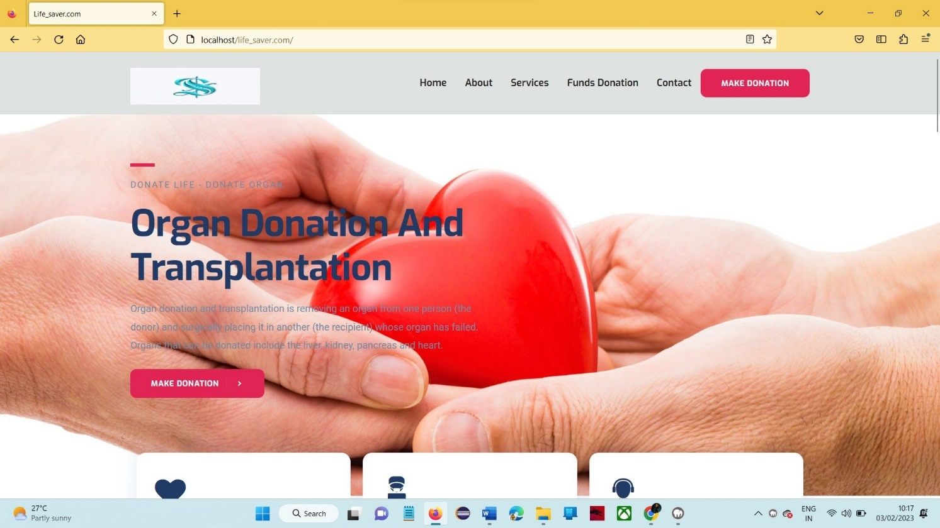

**Screen 8.2.1: Home Page**

In this page contain of basic information on organ donation and transplantation.

##### 8.2.2: Recipient Register page

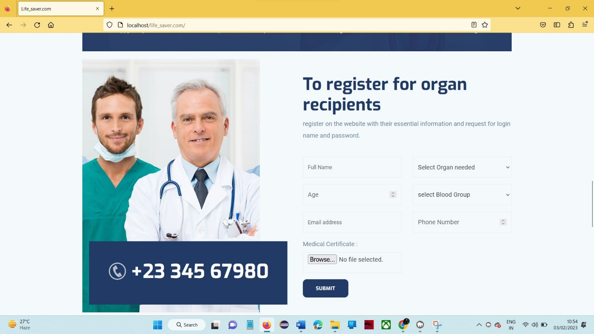

**Screen 8.1.2.1** **Recipient Register Page**

In this page register on the website with their essential information and request for login name.

##### 8.2.3: About Us Page

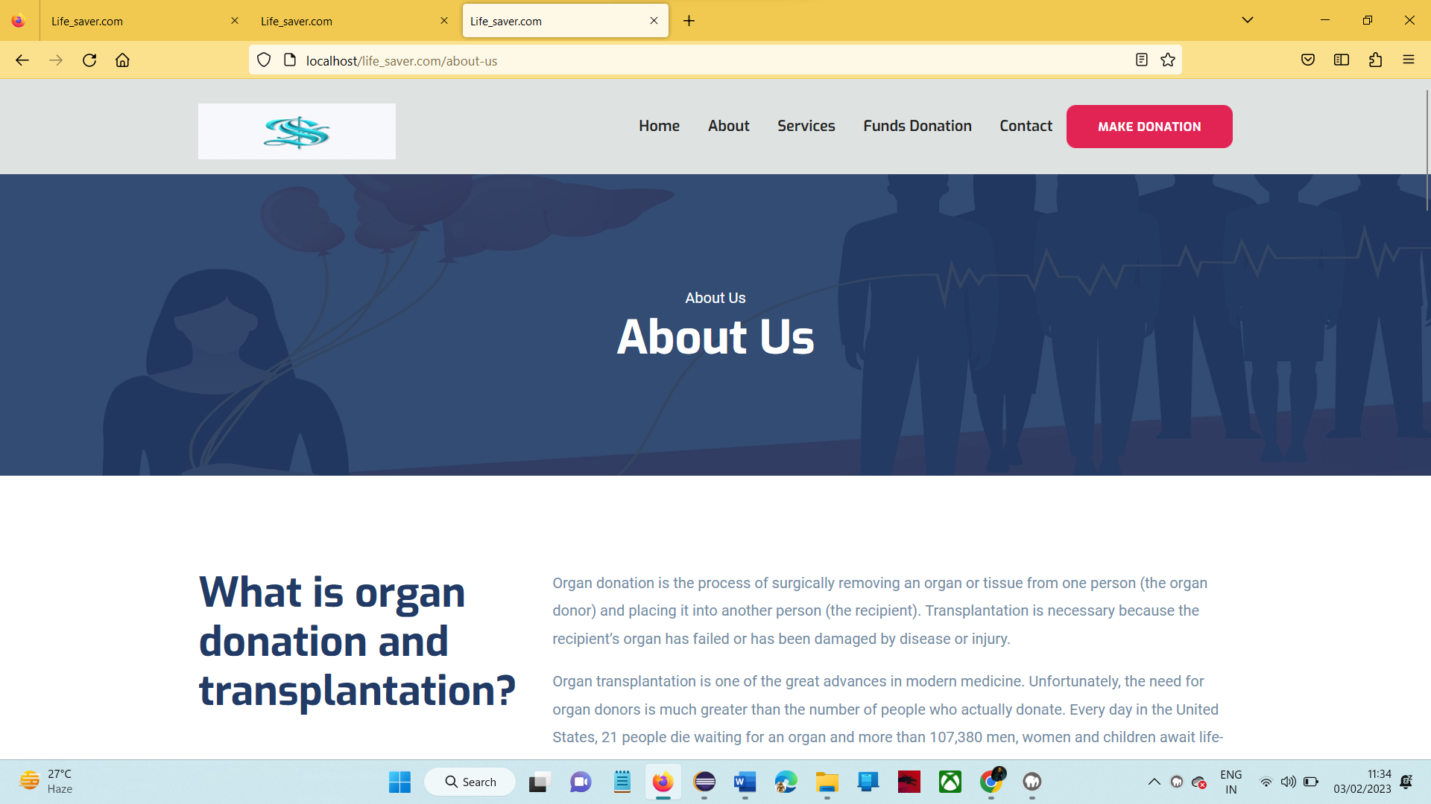

**Screen 8.2.3** **About Us Page**

In this page contain detail information about organ donation and transplantation.

##### 8.2.4: Services Page

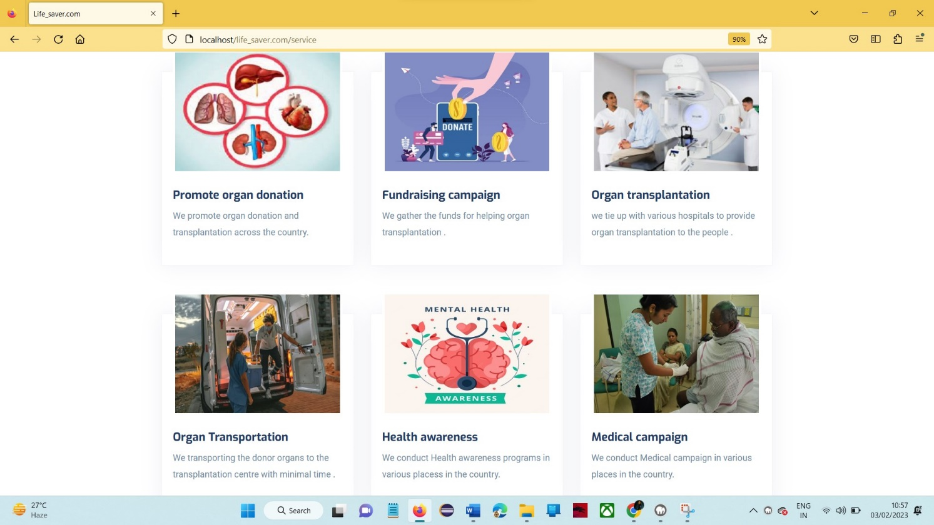

**Screen 8.2.4 Services Page**

#### In this page provide various services of the system like Promote organ donation, Fundraising campaign.

##### 8.2.5: Funds Donation page

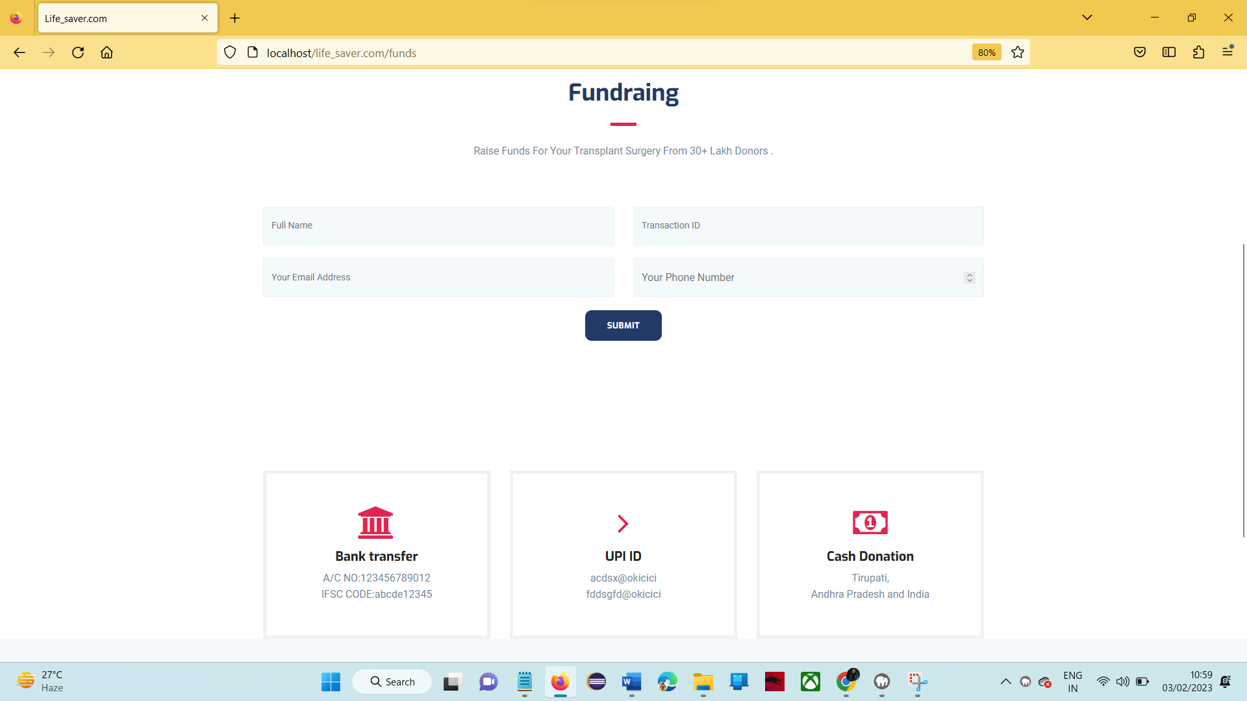

**Screen 8.2.5 Funds Donation page**

This page provide option to donate money to the people for organ transplantation.

##### 8.2.6: Contact page

##### 

**Screen 8.2.6 Contact Page**

This page provide contact details and option to send message about any queries on organ donation.

##### 8.2.7: Make Donation page

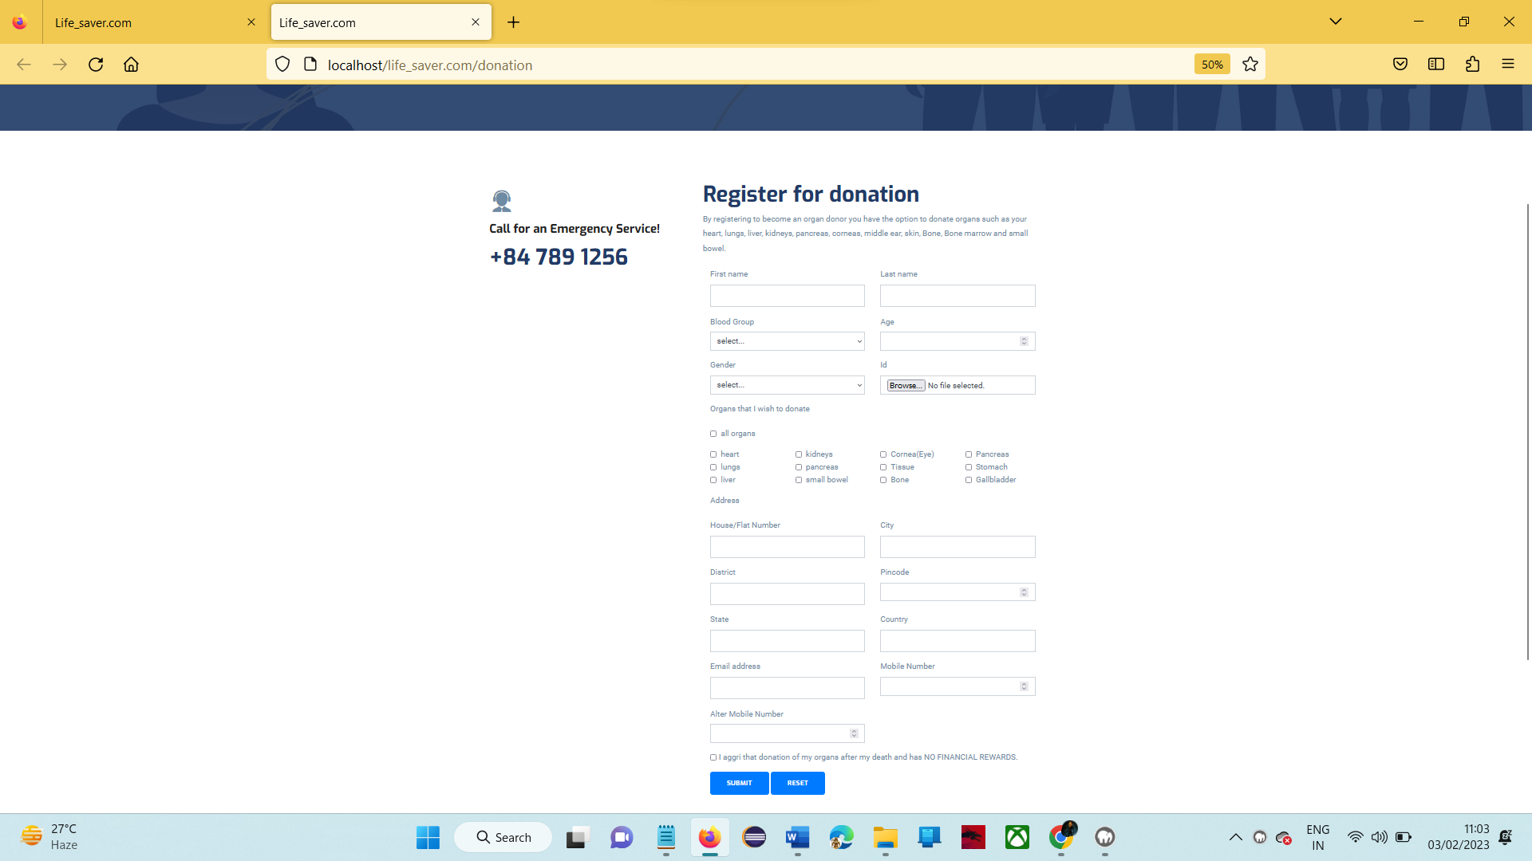

**Screen 8.2.7 Make Donation Page**

This page provide option to register for organ donation.

##### 8.2.8: Confirmation Page

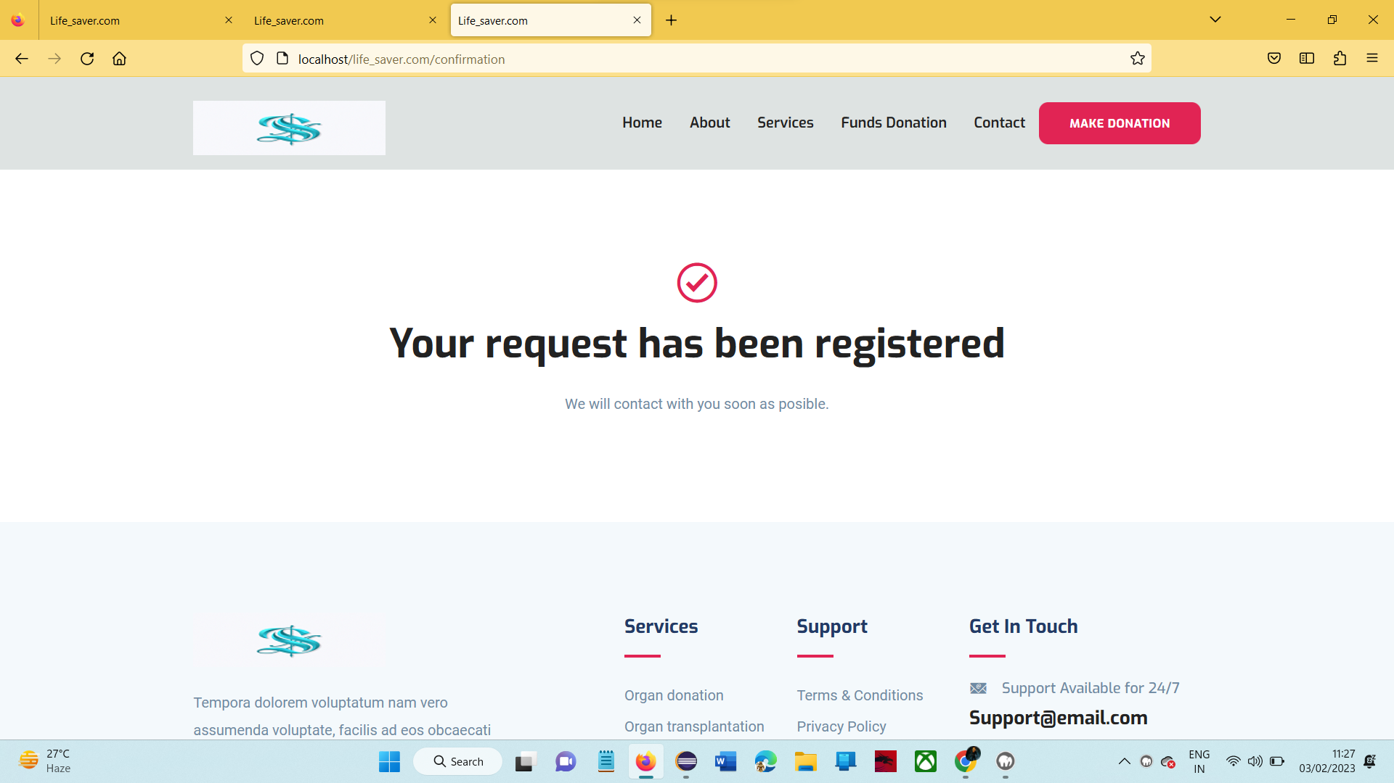

**Screen 8.2.8 Confirmation Page**

This page provides the conformation of registration.

# SYSTEM TESTING

##### Introduction

The purpose of testing is to discover errors. Testing is the process of trying to discover every conceivable fault or weakness in a work product. It provides a way to check the functionality of components, sub-assemblies, assemblies and/or a finished product It is the process of exercising software with the intent of ensuring that the

Software system meets its requirements and user expectations and does not fail in an unacceptable manner. There are various types of tests. Each test type addresses a specific testing requirement.

##### TYPES OF TESTS

* + 1. **Unit testing**

Unit testing involves the design of test cases that validate that the internal program logic is functioning properly, and that program inputs produce valid outputs. All decision branches and internal code flow should be validated. It is the testing of individual software units of the application .it is done after the completion of an individual unit before integration. This is a structural testing, that relies on knowledge of its construction and is invasive. Unit tests perform basic tests at component level and test a specific business process, application, and/or system configuration. Unit tests ensure that each unique path of a business process performs accurately to the documented specifications and contains clearly defined inputs and expected results.

##### Integration testing

Integration tests are designed to test integrated software components to determine if they actually run as one program. Testing is event driven and is more concerned with the basic outcome of screens or fields. Integration tests demonstrate that although the components were individually satisfaction, as shown by successfully unit testing, the combination of components is correct and consistent. Integration testing is specifically aimed at exposing the problems that arise from the combination of components.

##### Functional test

Functional tests provide systematic demonstrations that functions tested are available as specified by the business and technical requirements, system documentation, and user manuals.

Organization and preparation of functional tests is focused on requirements, key functions, or special test cases. In addition, systematic coverage pertaining to identify Business process flows; data fields, predefined processes, and successive processes must be considered for testing. Before functional testing is complete, additional tests are identified and the effective value of current tests is determined.

##### System Test

System testing ensures that the entire integrated software system meets requirements. It tests a configuration to ensure known and predictable results. An example of system testing is the configuration-oriented system integration test. System testing is based on process descriptions and flows, emphasizing pre-driven process links and integration points.

##### White Box Testing

White Box Testing is a testing in which in which the software tester has knowledge of the inner workings, structure and language of the software, or at least its purpose. It is purpose. It is used to test areas that cannot be reached from a black box level.

##### Black Box Testing

Black Box Testing is testing the software without any knowledge of the inner workings, structure or language of the module being tested. Black box tests, as most other

kinds of tests, must be written from a definitive source document, such as specification or

requirements document, such as specification or requirements document. It is a testing in which the software under test is treated, as a black box. you cannot “see” into it. The test provides inputs and responds to outputs without considering how the software works.

* 1. **Test Case**

|  |  |
| --- | --- |
| Tested By: | BUSETTI SIVAIAH |
| Test Type | Block Box testing |
| Test Case Number | 01 |
| Test Case Name | Donating organs |
| Test Case Description | Donating Organs, Donating Funds |
| Items to be tested | |
| 1 | Donating organs |
| Specifications | |
| Input | Expected output or results |
| Enter the valid details | Register Successfully |
| Procedural Step | |
| 1 | Thank you |

# 10.CONCLUSION

The Organ Donation and Transplantation System is one of the most fantastic systems for the people who want to become an Organ doner and also who needed organs. this system act as bridge between Organ doner and Organ recipient. This system is also provided option to donate funds to organ transplantation and solve any query on organ donation.

# BIBILOGRAPHY

[1]. [Learning PHP, MySQL, JavaScript, and CSS: A Step-by-Step Guide to Creating](https://www.cloudways.com/blog/best-php-books-to-help-you-learn/#creating-dynamic-websites) [Dynamic Websites – by **Robin Nixon**](https://www.cloudways.com/blog/best-php-books-to-help-you-learn/#creating-dynamic-websites)

[2]. [Programming PHP – by Kevin Tatroe, Peter MacIntyre & Rasmus Lerdorf “Foreword](https://www.cloudways.com/blog/best-php-books-to-help-you-learn/#michael-bourque) [By: **Michael Bourque”**](https://www.cloudways.com/blog/best-php-books-to-help-you-learn/#michael-bourque)

[3]. [PHP & MySQL Web Development – by **Luke Welling & Laura Thompson**](https://www.cloudways.com/blog/best-php-books-to-help-you-learn/#luke-laura)

[4]. [PHP & MySQL: The Missing Manual – by **Brett McLaughlin**](https://www.cloudways.com/blog/best-php-books-to-help-you-learn/#brett-mclaughlin)

[5]. [Learn PHP & MySQL – Zero to Hero Programming Crash Course – by **Paul Madoff**](https://www.cloudways.com/blog/best-php-books-to-help-you-learn/#paul-madoff)

[6]. https://www.codeigniter.com/user_guide/intro/index.html

[7]. https://developer.wordpress.org/coding-standards/inline-documentation-standards/php/

[8]. https://www.javatpoint.com/php-tutorial

[9]. MySQL Reference Manual 8.0 (includes NDB Cluster 8.0 (GA))

[10]. MySQL Reference Manual 5.7 (includes NDB Cluster 7.5 (GA), NDB Cluster 7.6 (GA))

[11]. https://www.javatpoint.com/mysql-tutorial