**Restaurnt Finder**

**Use case diagram:**

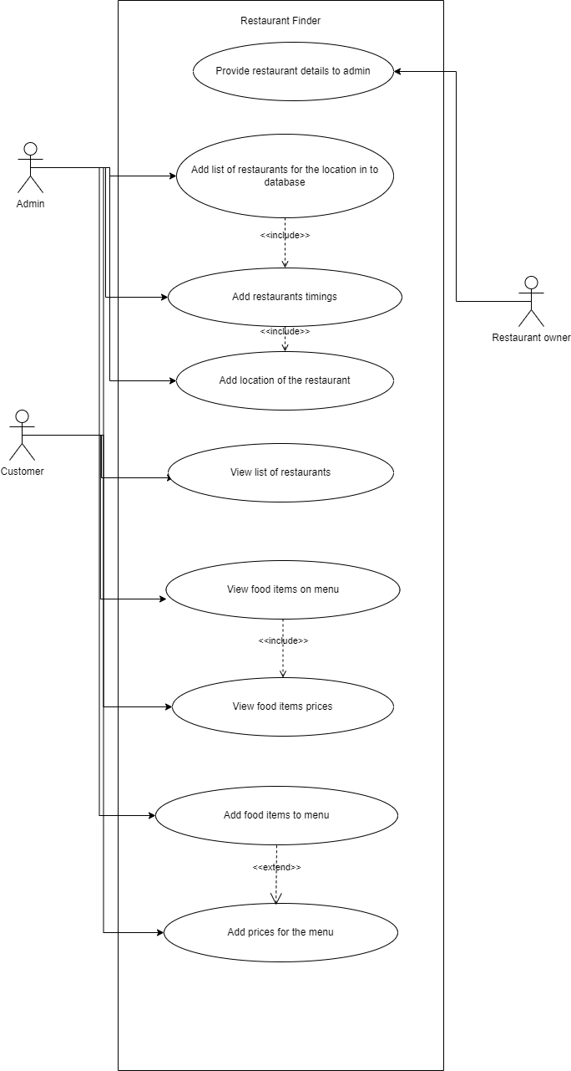

Activity Diagram:

