Integrating Artifactory with Jenkins

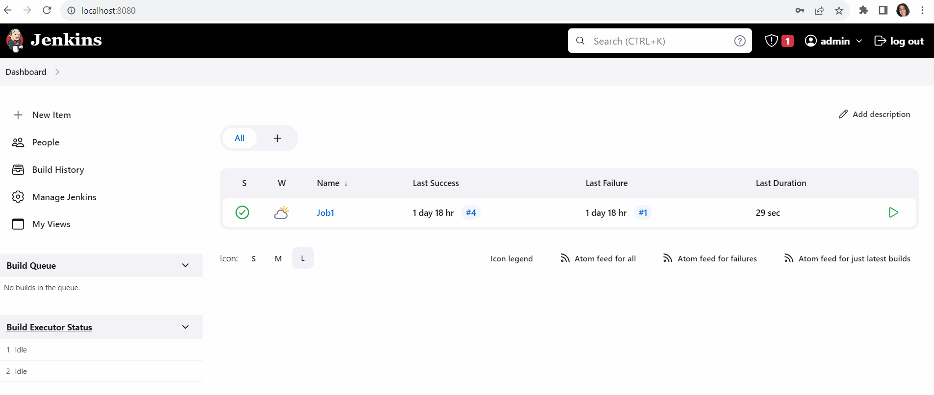

Click on plugin section to download Artifactory plugin

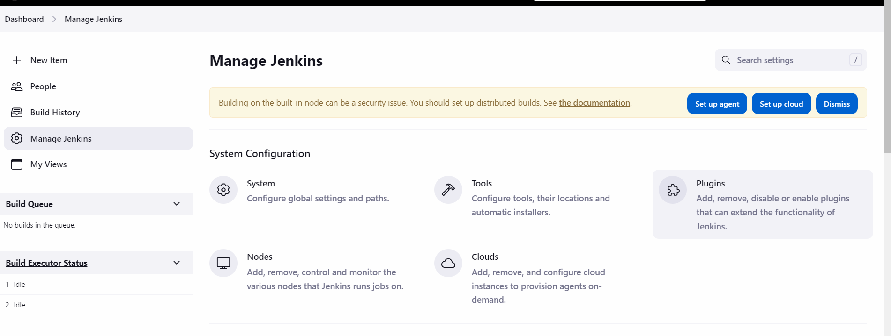

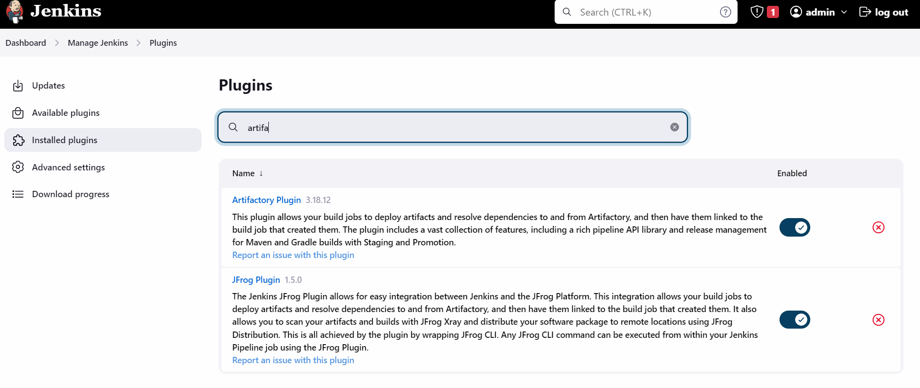

Once plugins have been installed, you will configure Jenkins to integrate with Artifactory

GO to managejenkins > System > scroll down to Jfrog section

