Aim : To perform the alert handle in webdriver

Code :

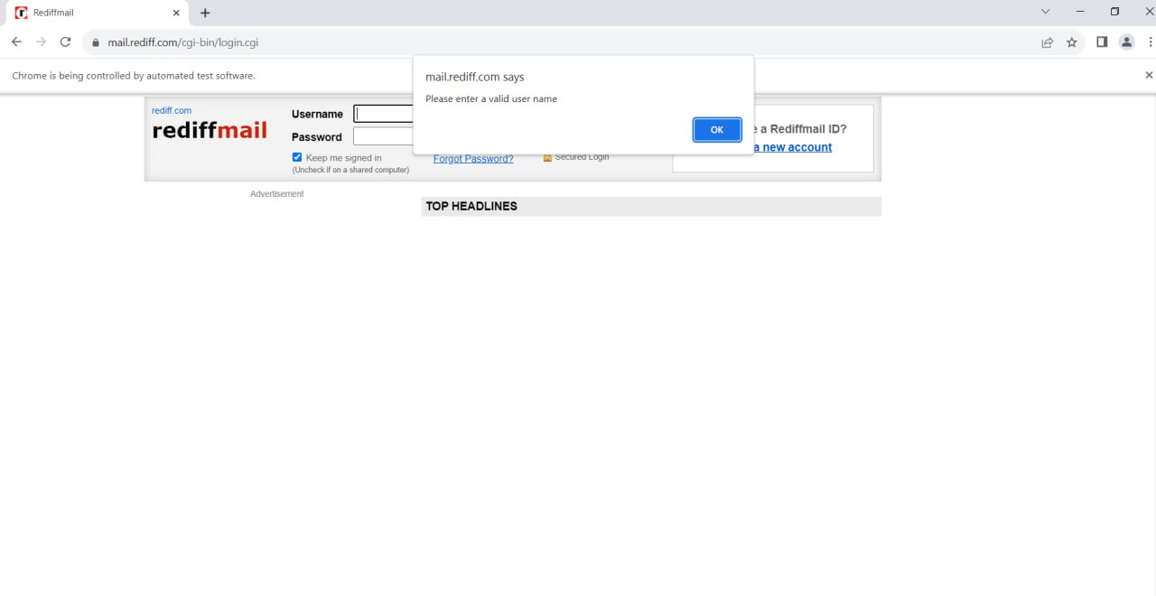package seleniumscripts;  
import org.openqa.selenium.Alert;  
import org.openqa.selenium.By;  
import org.openqa.selenium.WebDriver;  
import org.openqa.selenium.chrome.ChromeDriver;  
public class AlertsDemo {  
  public static void main(String[] args) throws InterruptedException {  
    WebDriver driver = new ChromeDriver();      
    driver.manage().window().maximize();      
    driver.get("https://mail.rediff.com/cgi-bin/login.cgi");  
    driver.findElement(By.xpath("//input[@type='submit']")).click();      
    Thread.sleep(1500);  
    Alert a = driver.switchTo().alert();  
    String alertText= a.getText();  
    System.out.println(alertText);      
    a.accept();  
    driver.findElement(By.id("login1")).sendKeys("admin");    
    driver.findElement(By.id("password")).sendKeys("admin");    
  }  
  
}

Output :

