1

AIM : set up and Configure GitHub Account following steps

CODE :

1) first step to create github account

2) email id and unique username and password

3) after the verification we can signin

4) after complete the sign in process we can create new repository

OUTPUTS :

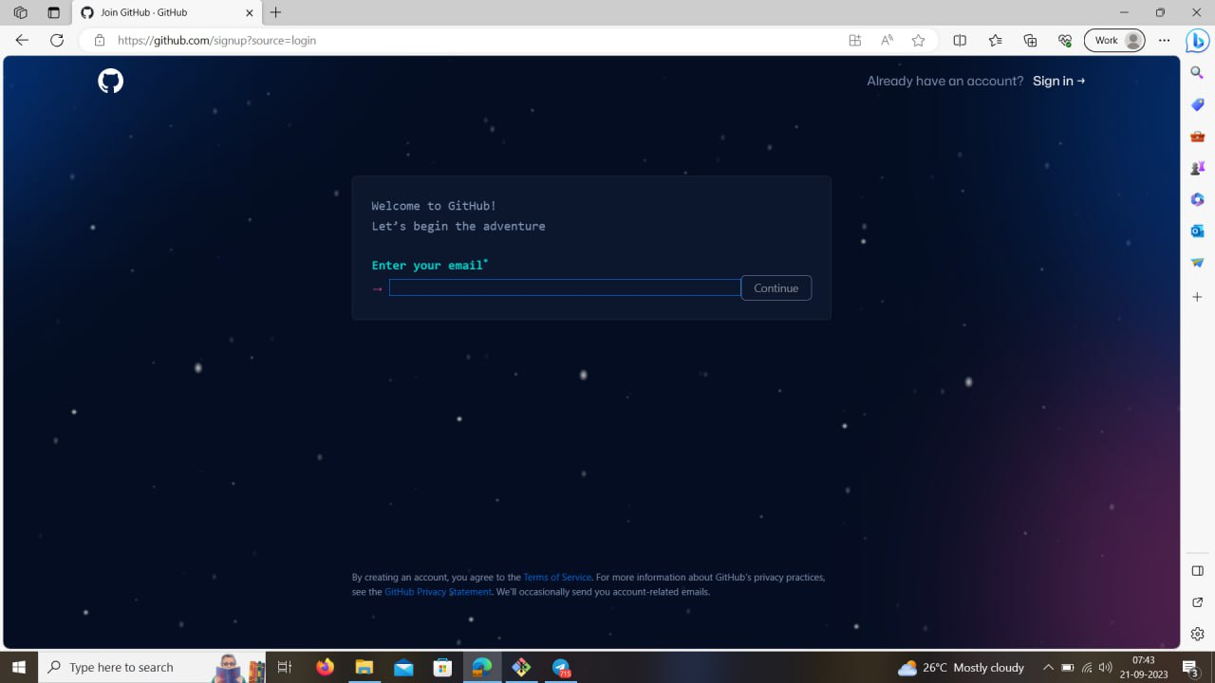

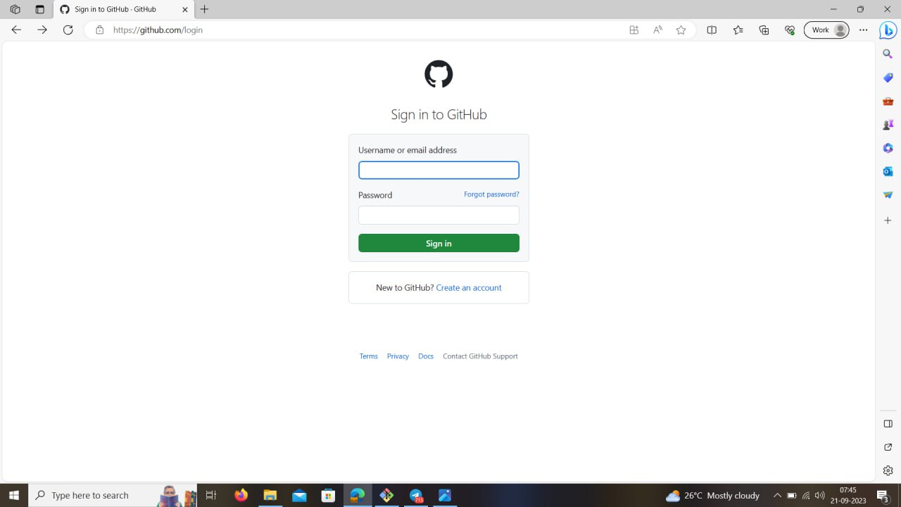

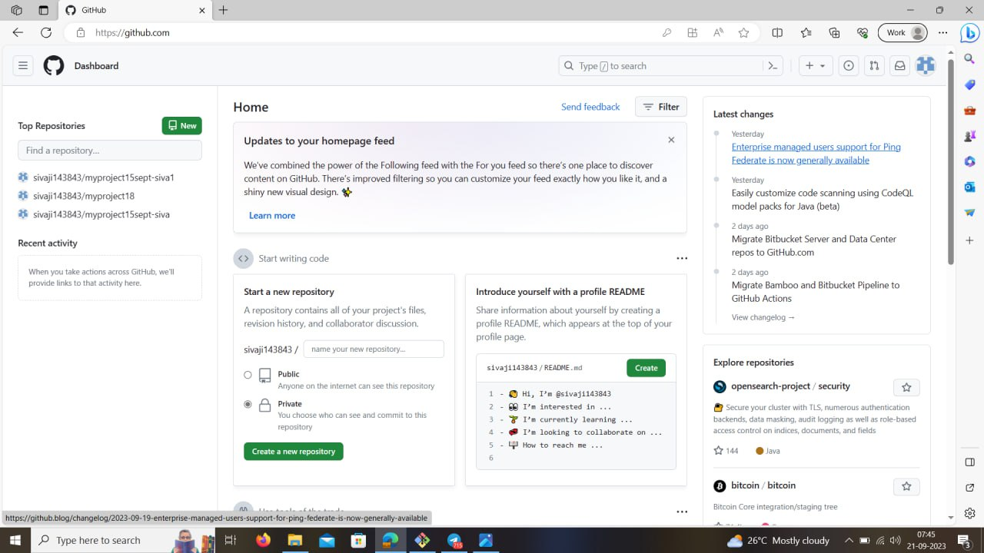

3 AIM : set up and create a git Repository

CODE :

1) first we login in github account

2) after login in process

3) we can see home page in top most right corner "+" is visible and click it

4) create a new repository to give name

5) to set default in public click it

6) to select it Add a README file it can see any one only read it it cannot changes file

7) After that click on Create repository

OUTPUTS :

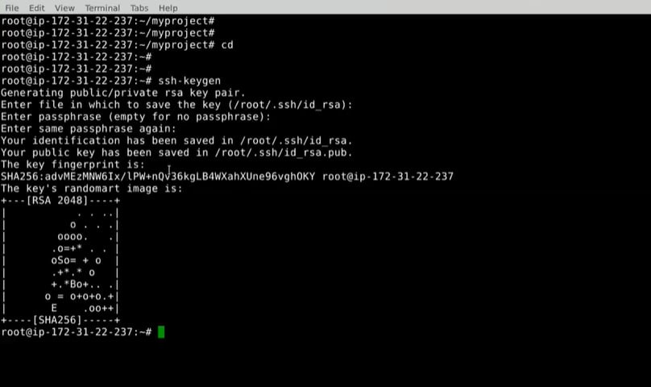

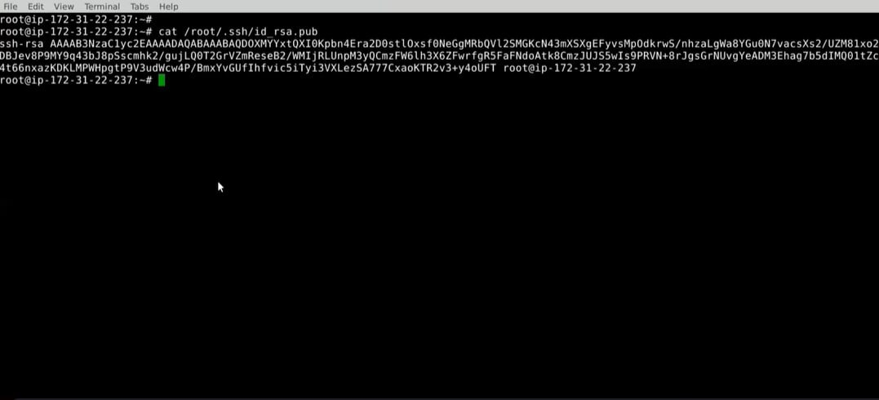

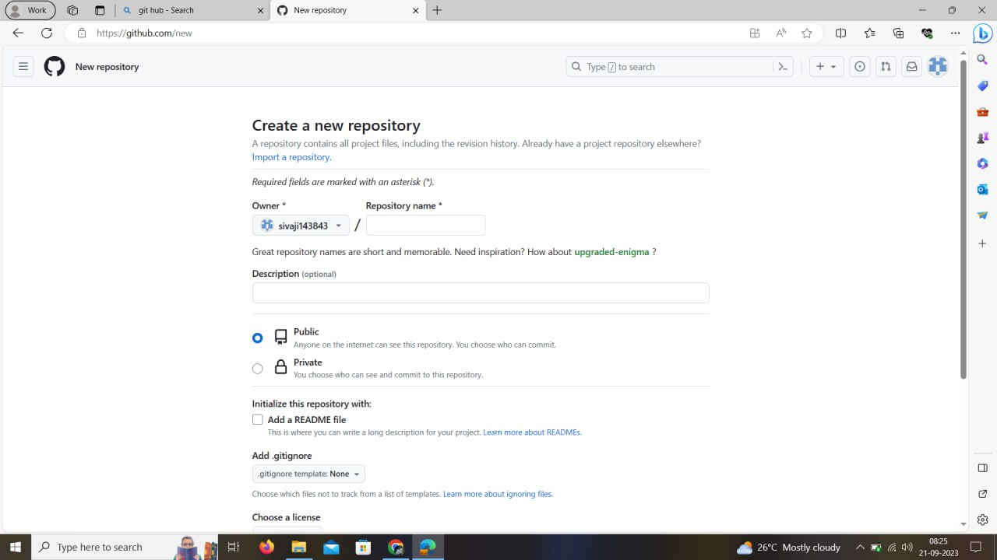

2

AIM : CRUD operations on github create, read, update, delete operations

Code

sudo so -

mkdir myproject

cd myproject

touch file1.java file2.java

git init

git config --global user.name siva

git config --global user.email sivaji@gmail.com

git status

git add .

git commit -m "added file file1 and file2"

nano file1.java

git status

git log

git log --oneline

git ls-files

git rm file1.java

git ls-files

ls

git commit -m "deletion of file"

git log --oneline

git revert id

git ls-files

ls

touch file.txt file2.xml file3.log file4.class

git status

nano .gitignore

git status

git add .

git commit -m "done .gitignore"

cd

ssh-keygen

cat /root/.ssh/id_rsa.pub

git branch

git branch feature1

git branch

git checkout feature1

touch feature1file featurefile2

git add .

git commit -m "done on feature1"

git branch -d fetaure1

git log --oneline

git reset --hard id

git status

git add .

git commit -m "done"

git log --oneline

OUTPUTS :

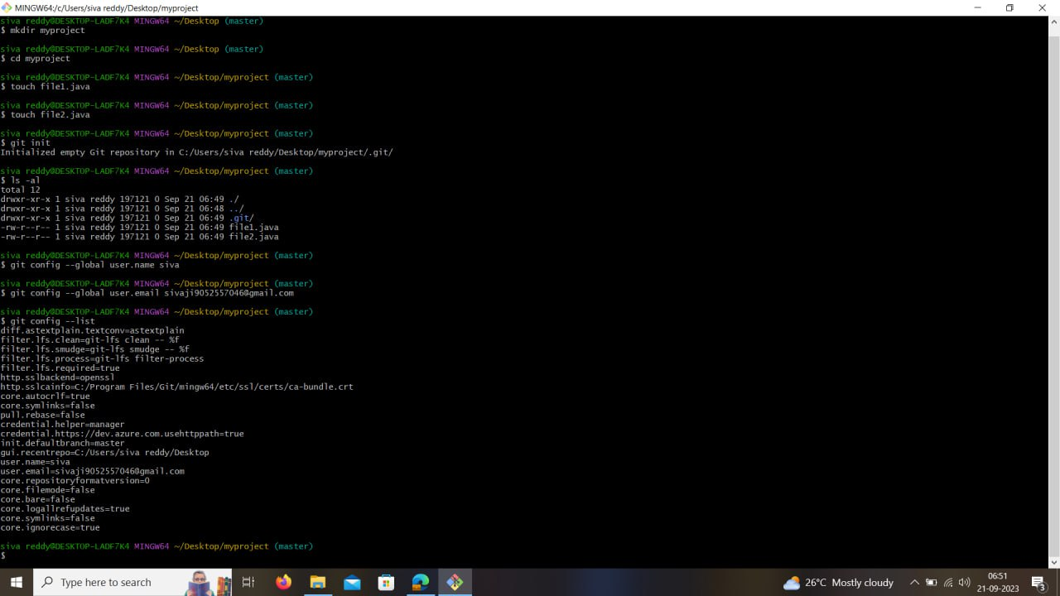

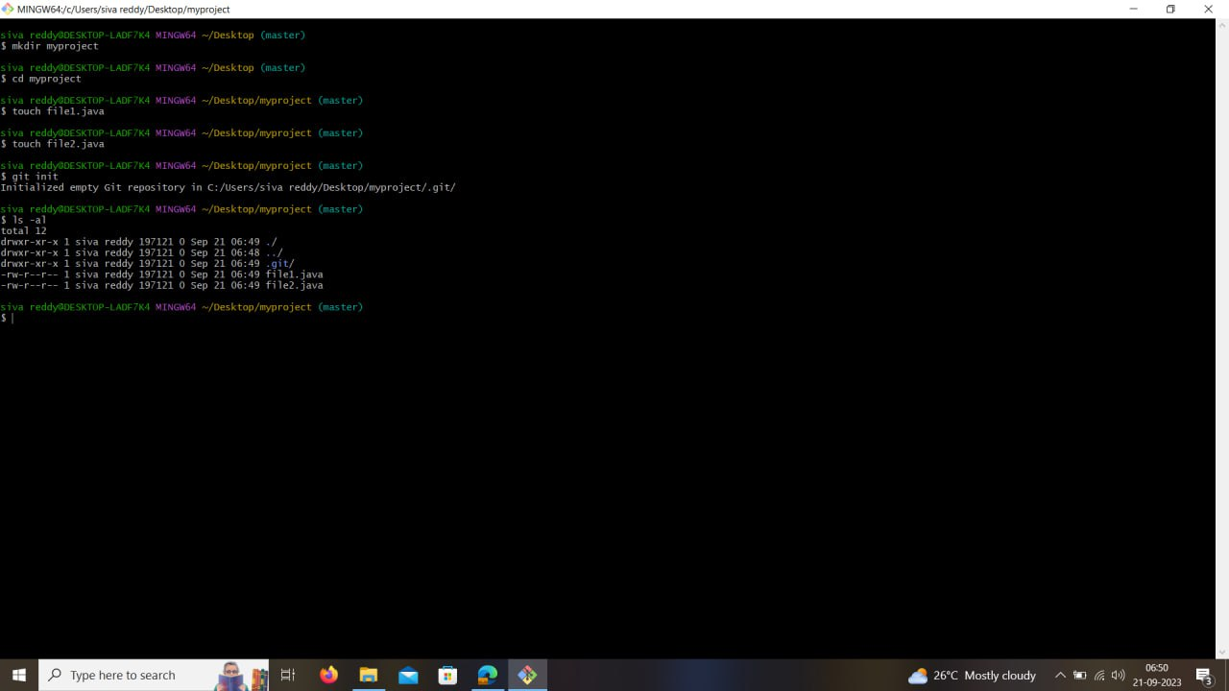

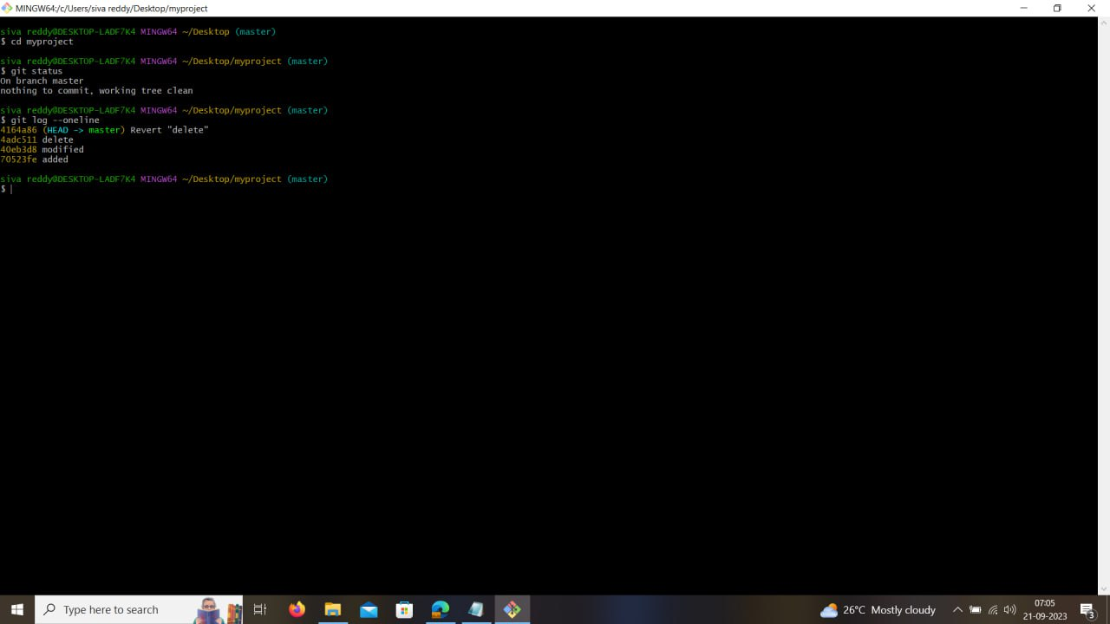

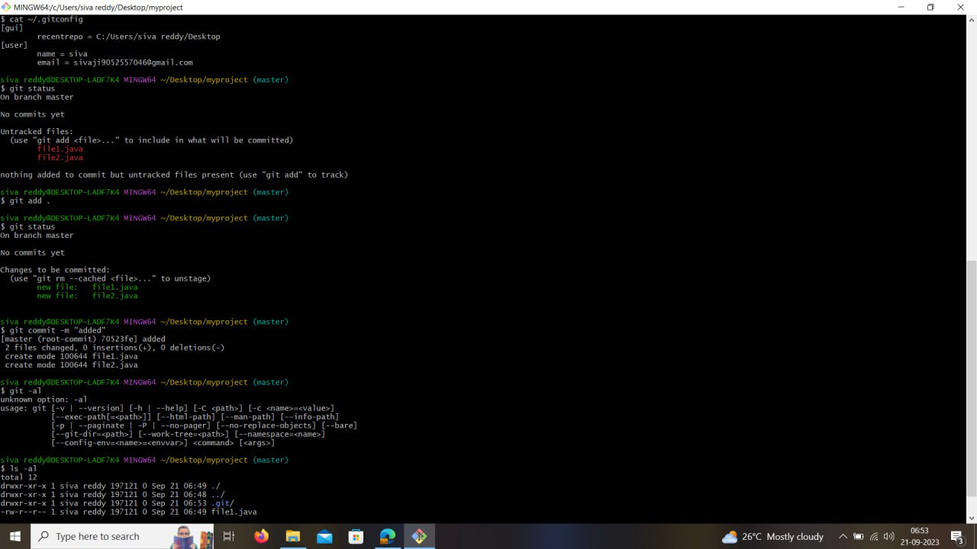

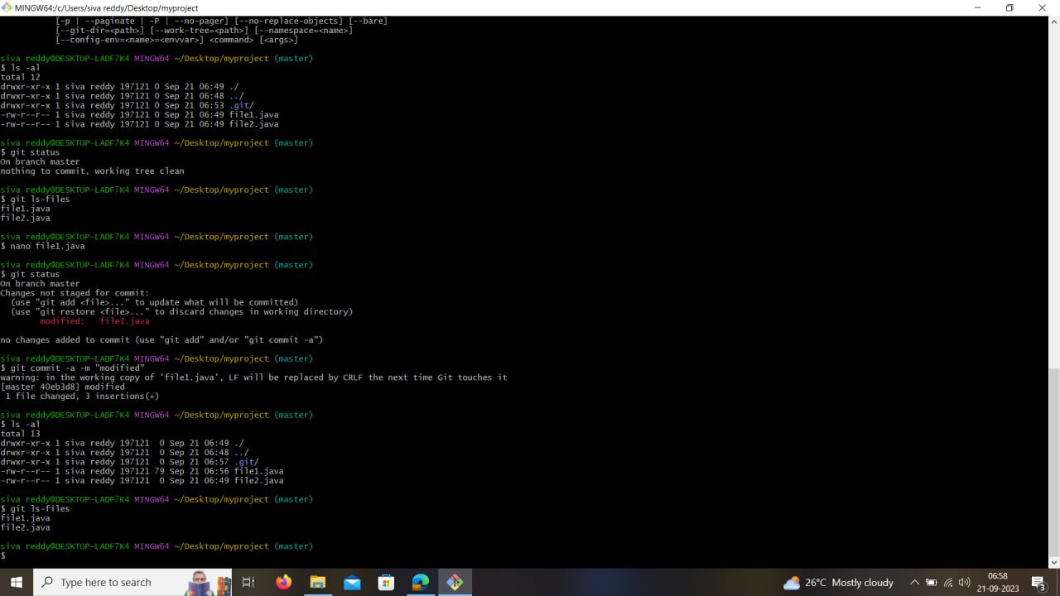

4

AIM : Angular application of GitHub

Codes :

sudo su –

mkdir myproject

cd myproject

git init

touch index.js index.html index.java angularcli.json component.js

git status

git add .

git commit -m “add”

nano .gitiginore

git status

git remote add origin [link for repository]

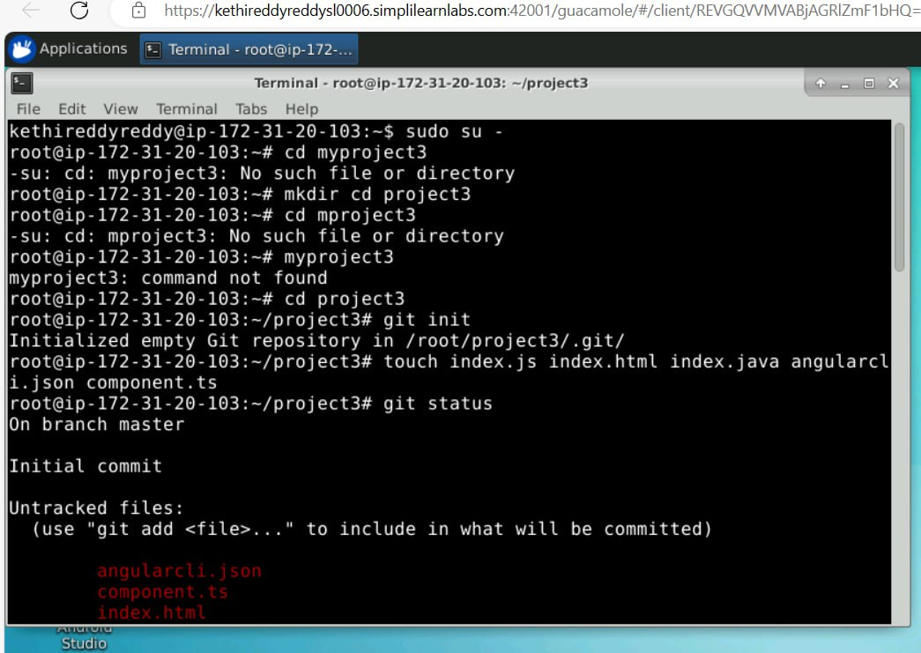git push origin master

Outputs :

