Description:
As a part of tutorial2 we have used a free weather API to display the temperature information of a given location in both degrees and Celsius. This is helpful to our increment 1 of the project as we are required to display the temperature information requested by the passenger.
Weather API Provider: wunderground
Base URL Structure: http://api.wunderground.com/api/00e83aeb00e951db/conditions/q/MO/Kansas_city.json
Screen Shot 1:
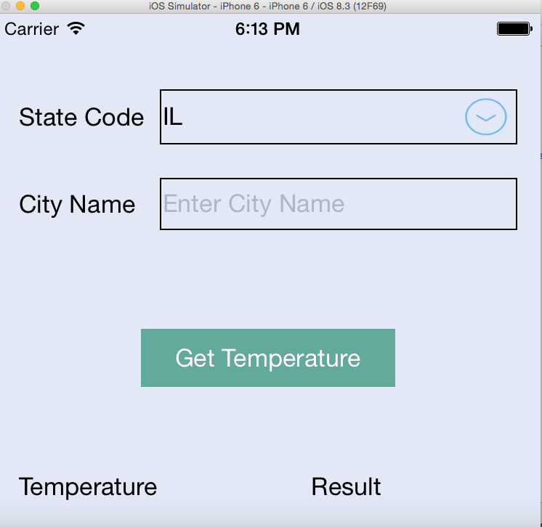

Screen Shot 2:
