# SecureProperties:

### create one folder under src/main/resouces-->evn

1. under **evn** folder create one file---->**property-dev.yaml**
2. In file write --->

#### 

1. In **Implementation flow** top right search ---> **searchExchange**-----> search **SecureProperties-**-->add
2. Create one new **commonConfigurationXml** file under **src/main/mule ---->**click **GlobalElements --**-->create ---> search **SecureProperties--->**ok
3. Click **SecureProperties --->** add **file and key values** ex**::**
4. 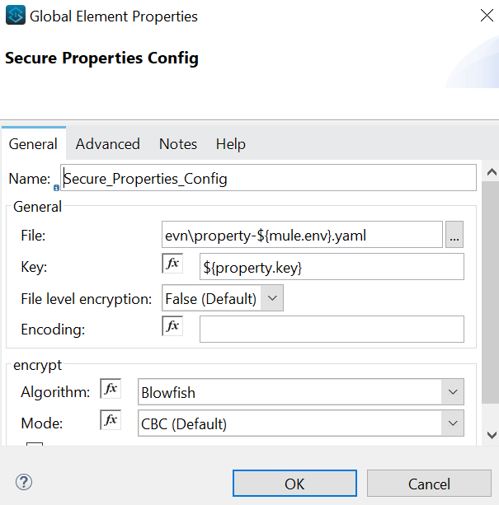
5. **Note**::In File dev = ${mule.env}
6. Click-----> HTTP Listener --> add SecureProperties Ex:- host: ${secure::http.host} , port: ${secure::http.port}
7. Now save the project and Run---> DebugConfiguration-----> add Arguments in Vm Arguments--->Ex:- **-Dmule.env=dev & -Dproperty.key=sivanjaneyuluk12---->** name ur choice
8. Secure **Encrypt and Decrypt**::: **<https://secure-properties-api.us-e1.cloudhub.io/> ====>use this link for code encrypt purpose(here mention key::** property.key(sivanjaneyuluk12) value **and Value::** password or port **etc)**

# Unit::

1. add **Files and** save**.json**  under **src/test/resources**

**Ex:-a) Response.json**

**b)FinalResponse.json**

**c)Request.json**

2)In Implementation Flow ---> in flow right click -->m-unit---->add Mock When , Set Event, Assert that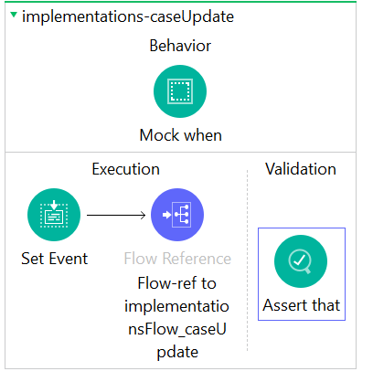

**Note::**

a) **Mock When** ====> pic the **processer**(only Third party dataEx:-salesforce , request )

Add Value**::** **#[MunitTools::getResourceAsString('caseUpdateFinalResponse.json')]**

mediaType:: **application/json**

b)**Set Event** ======> write in paload:::**#[MunitTools::getResourceAsString('caseUpdateRequest.json')]**

**C) Assert that** =====> add in **Is:**

**MunitTools::equalTo((readUrl("classpath://caseUpdateResponse.json", "application/json")))**  ========>(In this compare the data b/w finalResponse(MockWhen)data and ResponseData(AssertThat) Both data map in datawave and paste the transeform message replace of payload in implementation flow).

Ex:-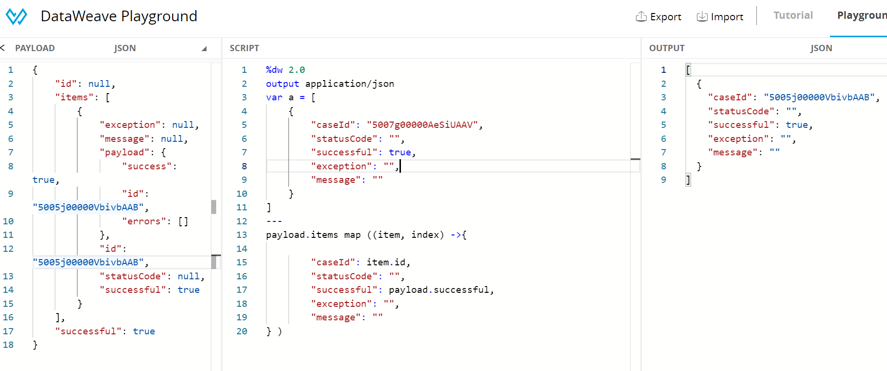

**3)**In Top Implementation flow click add two flows like mainflow and implementationflow Ex:-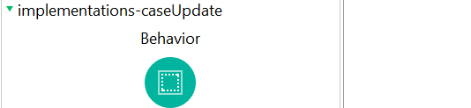

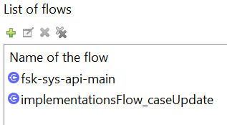

1. Run Munit test

# **OAuth2.0 Policies**

### 1)