## **How to Download Jenkins?**

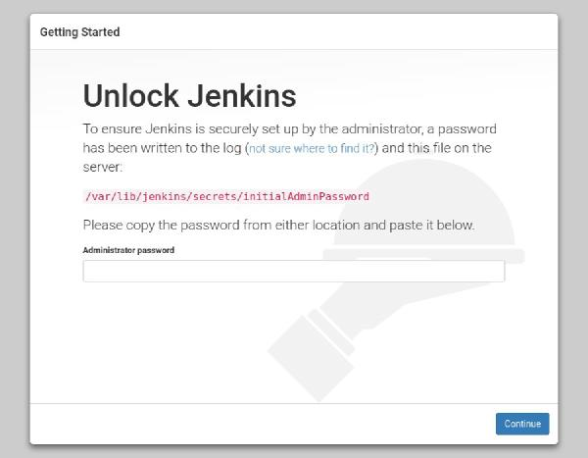

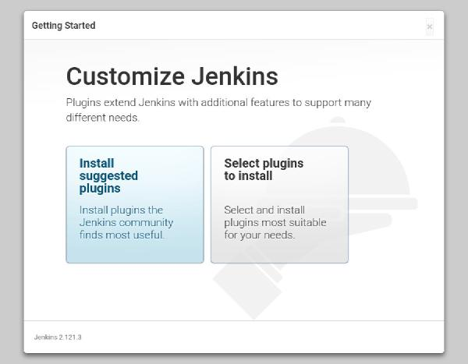

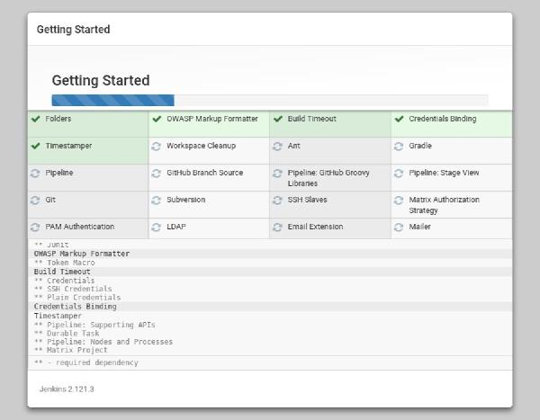

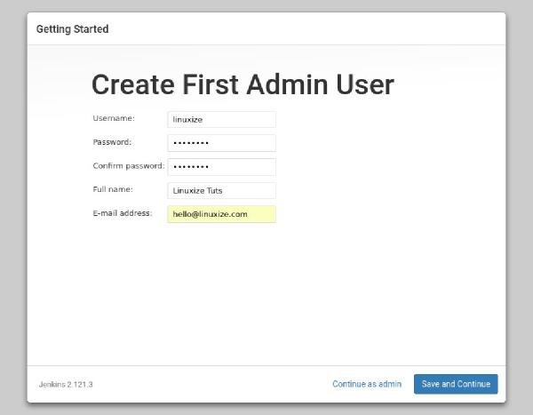

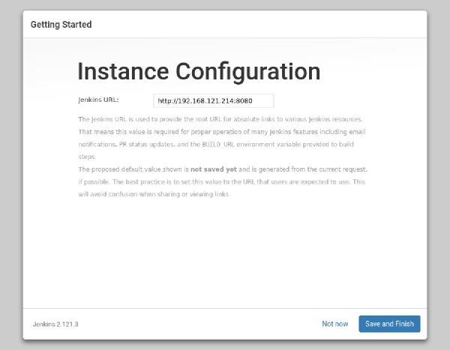

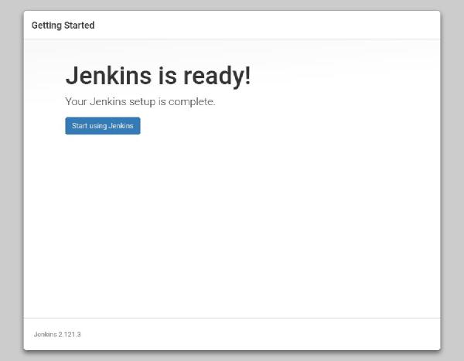

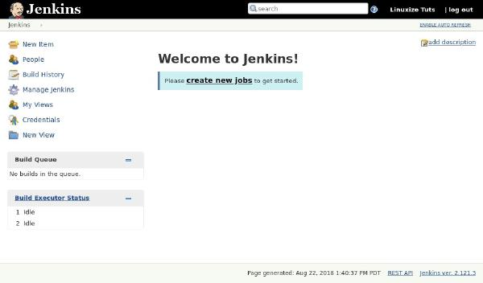

Following steps should be followed so that to install Jenkins successfully:

**Step 1)** Got to <https://jenkins.io/download/> and select the platform. In our case Windows

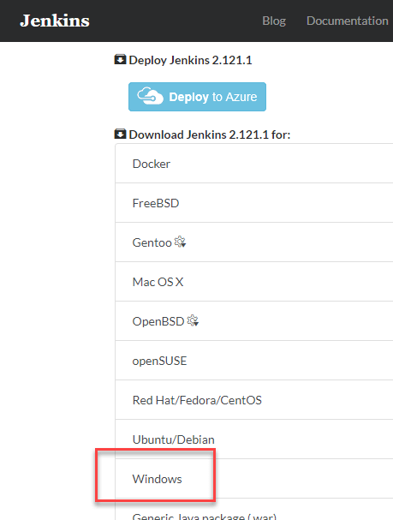

**Step 2)** Go to download location from local computer and unzip the downloaded package. Double-click on unzipped **jenkins.msi**

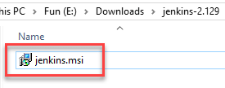

**Step 3)** In the setup screen, click Next.

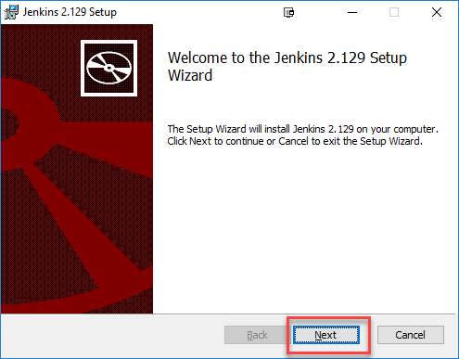

**Step 4)** Choose the location where you want to have the Jenkins instance installed (default location is C:\Program Files (x86)\Jenkins), then click on **Next** button.

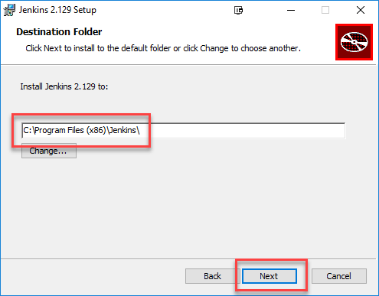

**Step 5)**Click on the Install button.

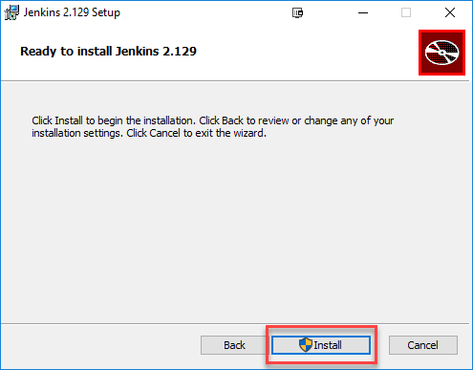

**Step 6)** Once install is complete, click Finish.

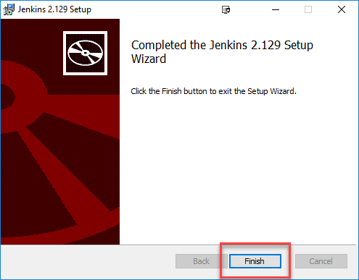

**Step 7)** During the installation process an info panel may pop-up to inform the user that for a complete setup, the system should be rebooted at the end of the current installation. Click on OK button when the Info panel is popping-up:

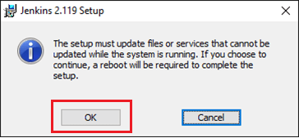

## **How to Unblock Jenkins?**

After completing the Jenkins installation phase, you should proceed further and start its configuration. Next steps will guide you how you can unblock Jenkins application:

**Step 1)** After completing the Jenkins installation process, a browser tab will pop-up asking for the initial Administrator password. To access Jenkins, you need to go to browse the following path in your web browser.

http://localhost:8080

If you can access the above URL, then it confirms that Jenkins is successfully installed in your system.

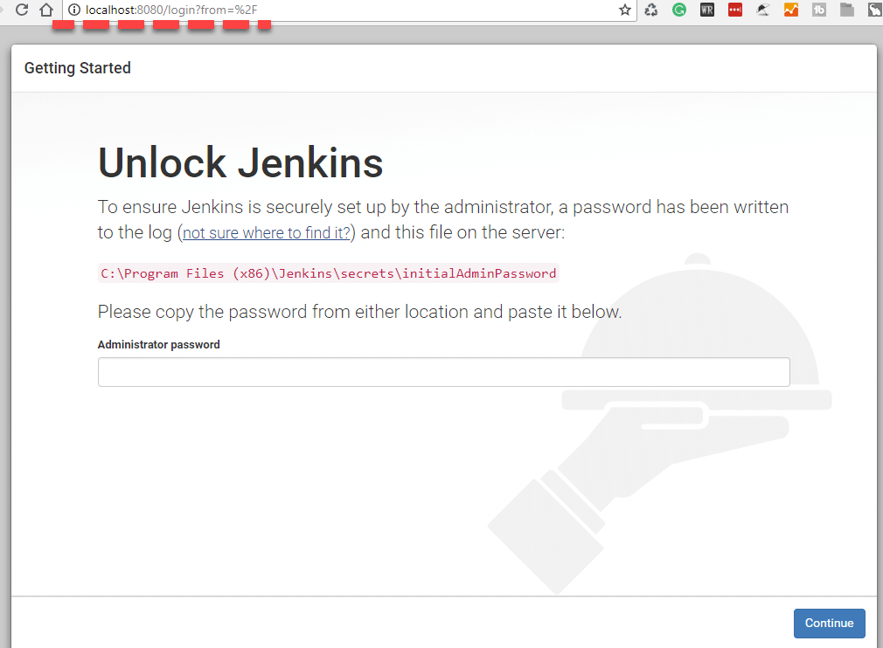

**Step 2)** The initial Administrator password should be found under the Jenkins installation path (set at Step 4 in Jenkins Installation).

For default installation location to C:\Program Files (x86)\Jenkins, a file called **initialAdminPassword** can be found under C:\Program Files (x86)\Jenkins\secrets.

However, If a custom path for Jenkins installation was selected, then you should check that location for **initialAdminPassword** file.

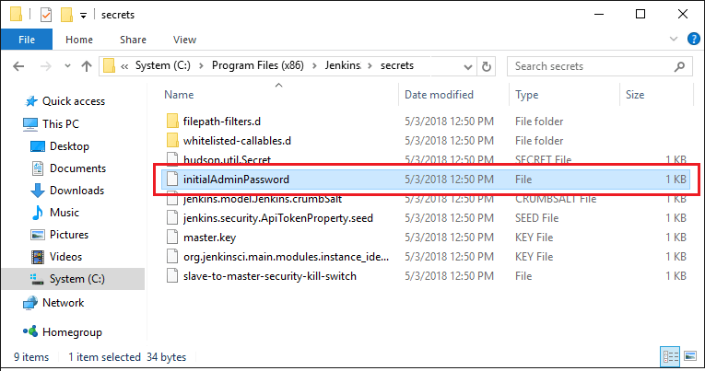

**Step 3)**Open the highlighted file and copy the content of the **initialAdminPassword** file.

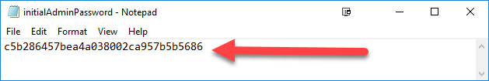

**Step 4)** Paste the password it into browser's pop-up tab (<http://localhost:8080/login?form=%2F>) and click on Continue button.

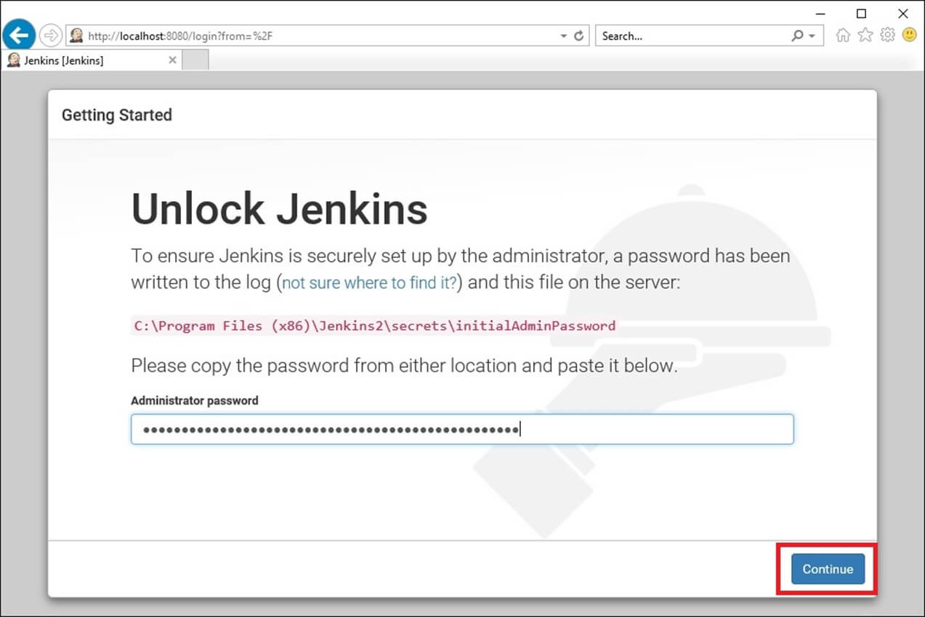

**Customize Jenkins**

You can also customize your Jenkins environment by below-given steps:

**Step 1)** Click on the "Install suggested plugins button" so Jenkins will retrieve and install the essential plugins

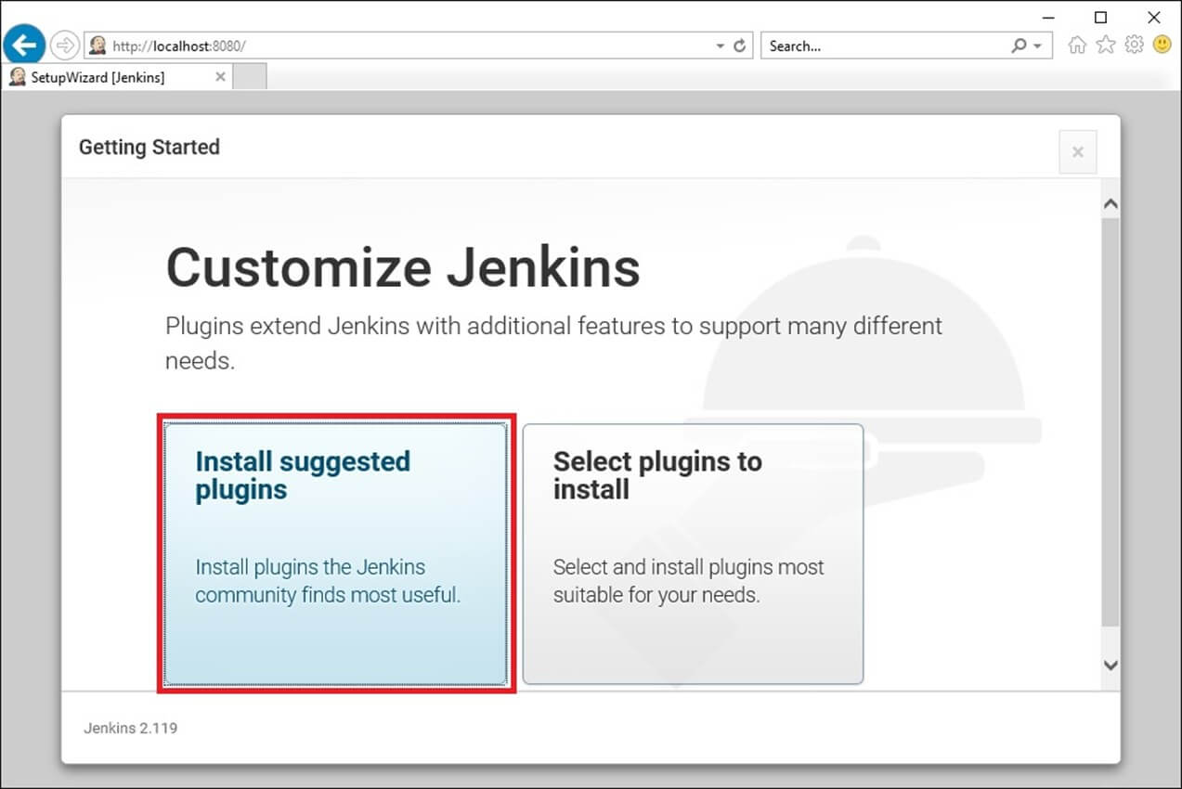

Jenkins will start to download and install all the necessary plugins needed to create new Jenkins Jobs.

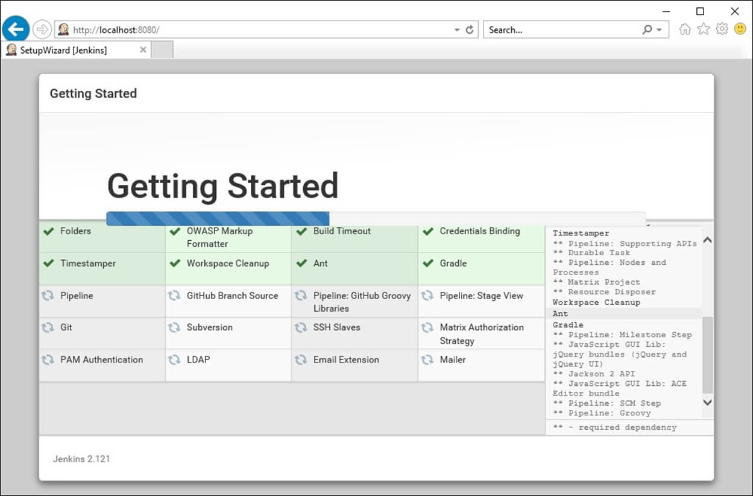

**Note**: You can choose the Option "Select Plugins to Install" and select the plugins you want to install

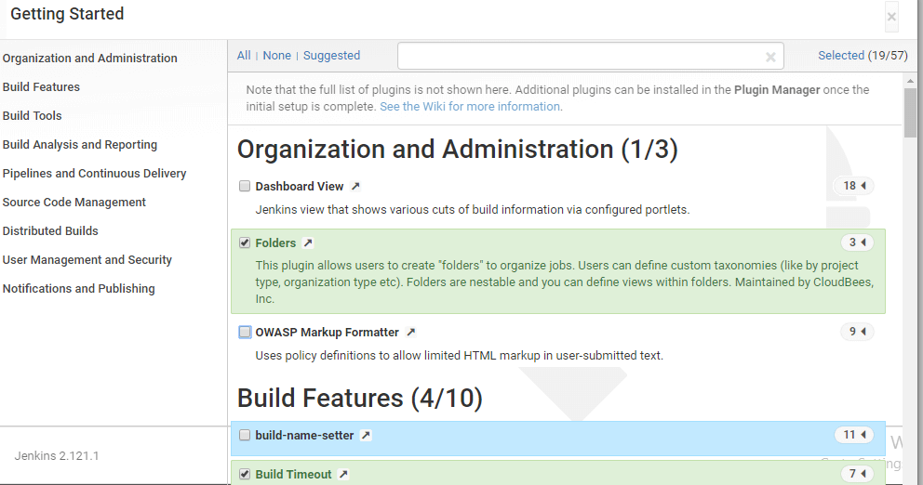

**Step 2)** After all suggested plugins were installed, the "Create First Admin User" panel will show up. Fill all the fields with desired account details and hit the "**Save and Finish**" button.

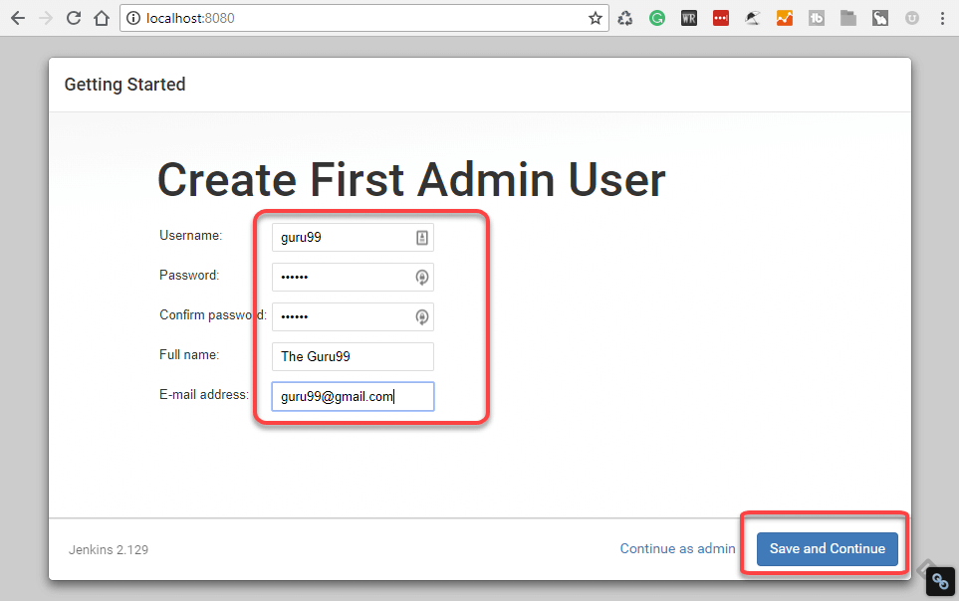

**Step 3)**Once you have filled the above data, finally it will ask for URL information where you can configure the default instance path for Jenkins. Leave it as it is to avoid any confusions later. However, if another application is already using 8080 port, you can use another port for Jenkins and finally save the settings, and you are done with installation of Jenkins. Hit the "**Save and Continue**" button:

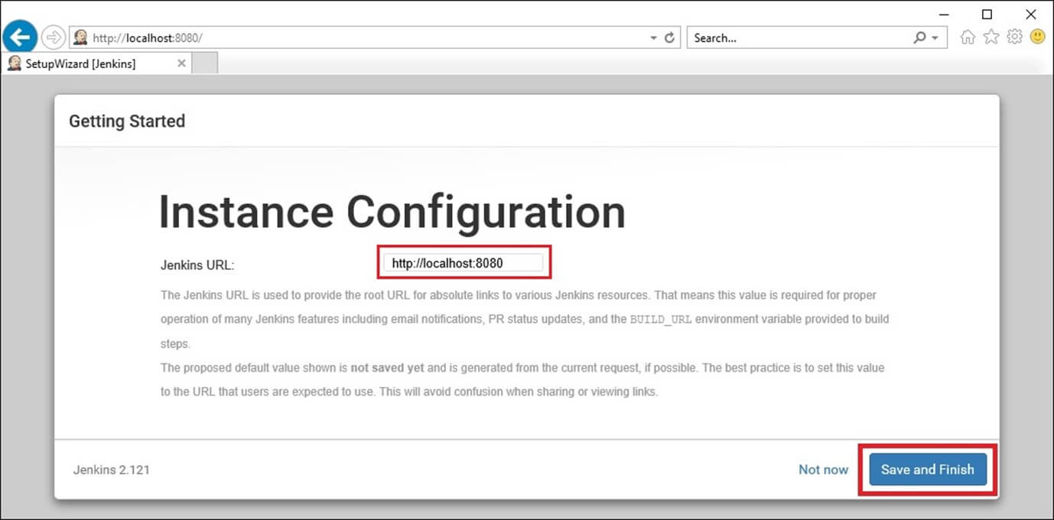

Congratulations! We have successfully installed a new Jenkins Server. Hit the "Start using Jenkins" button.

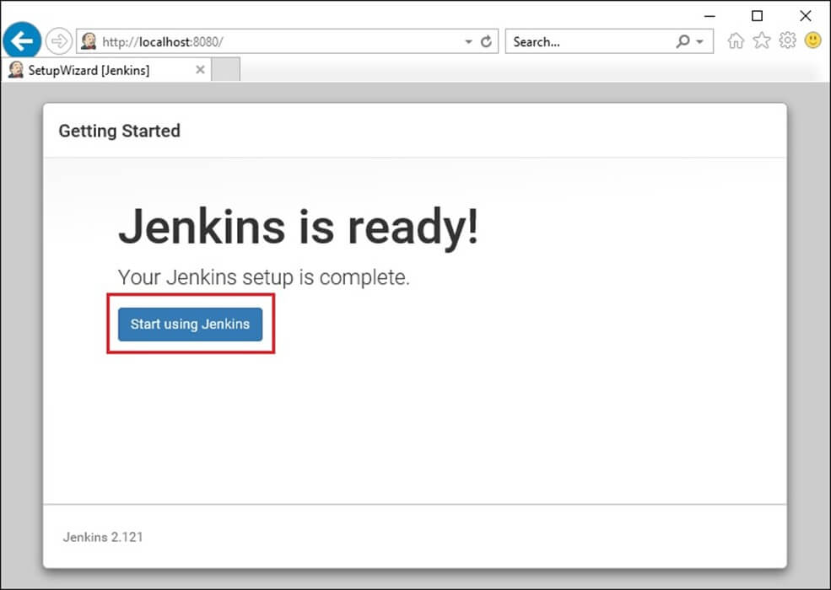

Below you can find the Jenkins instance up and run, ready to create first Jenkins jobs:

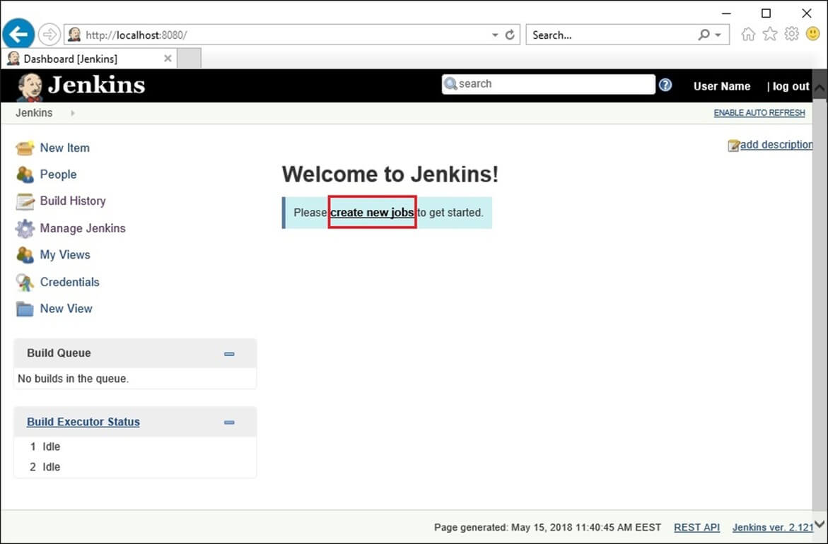

**Installation in Linux**

## **[Installing Jenkins](https://linuxize.com/post/how-to-install-jenkins-on-centos-7/" \l "installing-jenkins)**

To install Jenkins on your CentOS system, follow the steps below

1. Jenkins is a Java application, so the first step is to install Java. Run the following command to install the OpenJDK 8 package:

sudo yum install java-1.8.0-openjdk-devel

Copy

The current version of Jenkins does not support Java 10 (and Java 11) yet. If you have multiple versions of Java installed on your machine [make sure Java 8 is the default Java version](https://linuxize.com/post/install-java-on-centos-7/" \l "set-the-default-version).

1. The next step is to enable the Jenkins repository. To do that, import the GPG key using the following [**curl**](https://linuxize.com/post/curl-command-examples/) command:

curl --silent --location http://pkg.jenkins-ci.org/redhat-stable/jenkins.repo | sudo tee /etc/yum.repos.d/jenkins.repo

Copy

And add the repository to your system with:

sudo rpm --import https://jenkins-ci.org/redhat/jenkins-ci.org.key

Copy

1. Once the repository is enabled, install the latest stable version of Jenkins by typing:

sudo yum install jenkins

Copy

After the installation process is completed, start the Jenkins service with:

sudo systemctl start jenkins

Copy

To check whether it started successfully run:

systemctl status jenkins

Copy

You should see something similar to this:

● jenkins.service - LSB: Jenkins Automation Server

Loaded: loaded (/etc/rc.d/init.d/jenkins; bad; vendor preset: disabled)

Active: active (running) since Thu 2018-09-20 14:58:21 UTC; 15s ago

Docs: man:systemd-sysv-generator(8)

Process: 2367 ExecStart=/etc/rc.d/init.d/jenkins start (code=exited, status=0/SUCCESS)

CGroup: /system.slice/jenkins.service

Copy

Finally enable the Jenkins service to start on system boot.

sudo systemctl enable jenkins

Copy

jenkins.service is not a native service, redirecting to /sbin/chkconfig.

Executing /sbin/chkconfig jenkins on

Copy

## **[Adjust the Firewall](https://linuxize.com/post/how-to-install-jenkins-on-centos-7/" \l "adjust-the-firewall)**

If you are installing Jenkins on a remote CentOS server that is [protected by a firewall](https://linuxize.com/post/how-to-setup-a-firewall-with-firewalld-on-centos-7/)you need to port **8080**.

Use the following commands to open the necessary port:

sudo firewall-cmd --permanent --zone=public --add-port=8080/tcpsudo firewall-cmd --reload

Copy

## **[Setting Up Jenkins](https://linuxize.com/post/how-to-install-jenkins-on-centos-7/" \l "setting-up-jenkins)**

To set up your new Jenkins installation, open your browser and type your domain or IP address followed by port **8080**:

http://your_ip_or_domain:8080

Copy

A screen similar to the following will appear, prompting you to enter the Administrator password that is created during the installation:

Use the following command to print the password on your terminal:

sudo cat /var/lib/jenkins/secrets/initialAdminPassword

Copy

You should see a 32-character long alphanumeric password as shown below:

2115173b548f4e99a203ee99a8732a32

Copy

Copy the password from your terminal, paste it into the Administrator password field and click **Continue**.

On the next screen, you will be asked whether you want to install the suggested plugins or to select specific plugins. Click on the **Install suggested plugins** box, and the installation process will start immediately.

Once the installation is complete, you will be prompted to set up the first administrative user. Fill out all required information and click **Save and Continue**.

On the next page, you will be asked to set the URL for the Jenkins instance. The URL field will be populated with an automatically generated URL.

To complete the setup confirm the URL by clicking on the **Save and Finish** button.

Finally, click on the **Start using Jenkins** button and you will be redirected to the Jenkins dashboard logged in as the admin user you have created in one of the previous steps.

If you’ve reached this point, you’ve successfully installed Jenkins on your CentOS system.