instant-ttc-fusion
Architecture Status & Remaining Work Summary
Generated 24 September 2026

This document summarizes what has been built so far in the instant-ttc-fusion project (a real-time Time-to-Collision estimation pipeline fusing LiDAR, radar, and camera on the nuScenes-mini dataset), organized by architectural layer, and lists exactly what remains to complete the project.

Architecture Flowchart
Data flows top to bottom through the pipeline; the foundation layer on the left underpins every stage. Box color shows build status.
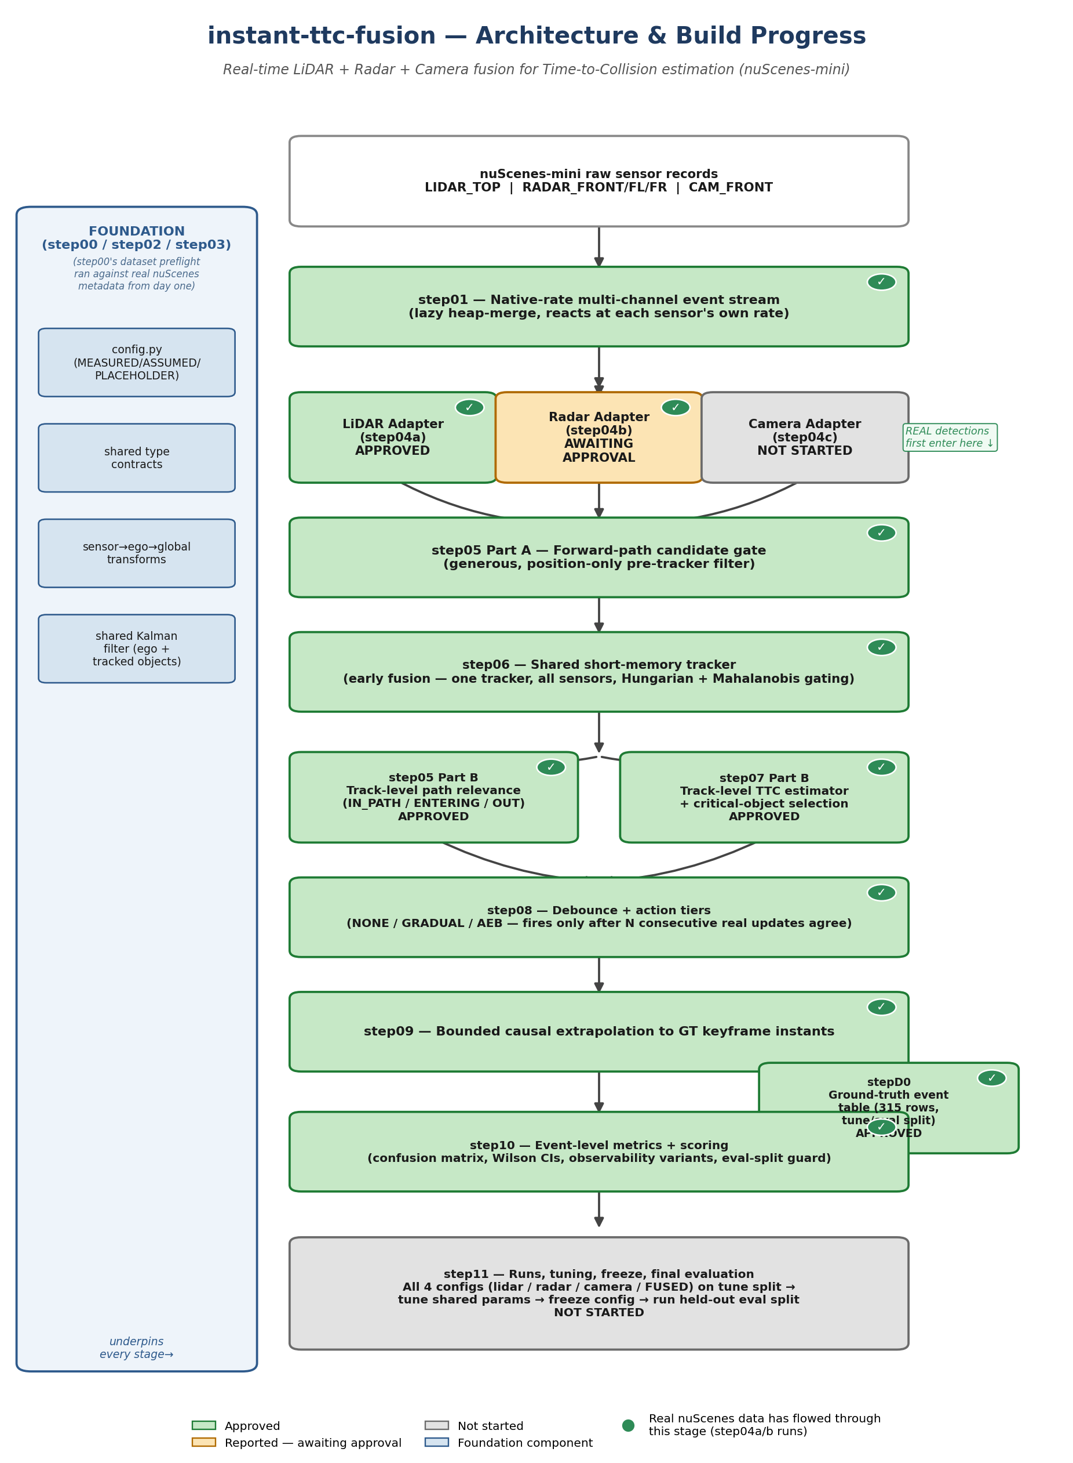

1. Architecture Covered So Far

1.1 Foundation (single source of truth)
- Config discipline: Every tunable constant lives in one config file, each tagged MEASURED / ASSUMED / PLACEHOLDER with a stated reason. Nothing is MEASURED yet -- two candidates (LiDAR's and radar's own sensor-noise values) cleared the measurement threshold but were deliberately kept ASSUMED (see section 1.4).
- Shared type contracts: The shared data contracts every pipeline stage passes between each other: raw sensor events, detections, track snapshots, TTC results, action decisions.
- Coordinate frames: sensor to ego to global coordinate transforms, one single implementation, every step required to use its own event's own timestamp and pose -- never borrow another sensor channel's.
- Shared Kalman filter: One shared Kalman filter design used identically for both ego-vehicle state estimation and every tracked object -- one implementation, not two.

1.2 Core Math & Geometry (built and proven before any real sensor existed)
- TTC math: Closing speed, distance, and time-to-collision, including deadbands and explicit reason codes for why an estimate isn't usable.
- Forward-path corridor geometry: The vehicle's forward driving corridor, plus a deliberately generous "candidate" pre-filter so an object about to enter the corridor is not missed.
- GT event table: The ground-truth "answer key" -- 315 real event rows across 10 nuScenes-mini scenes, split into a 5-scene tuning set and a 5-scene held-out evaluation set (fixed once committed; all 5 real AEB events deliberately placed on the evaluation side).

1.3 The Event-Driven Pipeline
- Event stream: Native-rate, multi-channel event stream -- reacts to whichever sensor has new data right now, at that sensor's own real rate, not a fixed synchronized tick.
- Shared tracker: One shared short-memory tracker -- every sensor writes into the same set of tracks (early fusion), with proper multi-detection assignment and statistically principled gating. No persistent lifetime identity -- tracks only remember a short recent window.
- Track-level path relevance: Classifies each tracked object as already in the path, about to enter it, or not relevant.
- Track-level TTC + critical-object selection: Computes TTC per track and selects the single most urgent object to act on.
- Debounce + action tiers: Action tiers (GRADUAL / AEB) only fire after several consecutive real updates agree -- the standard defense against a single noisy reading.
- Bounded causal extrapolation: Projects the system's belief forward to exactly the ground-truth's own measurement instants, so system output and ground truth can be compared fairly.
- Event-level metrics + reporting: Confusion-matrix scoring, statistically sound confidence intervals on every rate, sensor-blind-spot-aware scoring variants, and a hard code-level guard that refuses to score the held-out evaluation scenes without an explicit "final" flag and a matching frozen-configuration signature.

1.4 Real Sensor Adapters (current phase)
LiDAR adapter -- APPROVED. Turns raw LiDAR point clouds into object detections via ground-plane removal and clustering. A genuine sensor artifact (the vehicle's own roof mount reflecting the beam back at point-blank range) was found and fixed during development. First real, end-to-end LiDAR-only run completed on the tuning split.
Radar adapter -- reported, awaiting approval. Same clustering approach adapted for radar's sparser returns; radar's own instantaneous-velocity capability (Doppler) is deliberately left unused for this conservative first baseline. First real radar-only run completed, including one false alarm that was fully traced to its physical cause (a real, stationary construction barrier that the evaluation's ground truth doesn't count as a scoreable hazard).

Note: both adapters produced a sensor-noise measurement that cleared the project's own "trustworthy" threshold, but both were deliberately kept at their assumed starting values rather than promoted -- the measurement method has known limitations and this would be the project's first-ever "measured" value, which has broad downstream effects on how the tracker gates detections.

2. What's Left
# | Step | What it still needs to build
16 | step04c -- Camera adapter | The third and last sensor adapter (single-sensor only at this stage) -- turns camera frames into detections the same way LiDAR and radar were turned into detections.
17 | step11 -- Runs, tuning, freeze, final evaluation | The final step: run all four configurations (lidar-only, radar-only, camera-only, and fused) on the tuning split, tune the shared parameters using only tuning-split data, freeze the configuration with a cryptographic signature, then unlock and run the held-out evaluation split for the real, final numbers. This is also where the four-run comparison table gets built, and where "can fusion actually beat a single sensor?" gets a real, evidence-backed answer.

Two steps remain: one more sensor adapter, then the single big tuning/fusion/final-evaluation step that everything else in this project has been built toward.

