instant-ttc-fusion
Multi-Sensor Time-to-Collision Fusion — Project Summary
Prepared for Siva | 2026-09-21 | Steps completed: 00, 02, 03, 07-A, 05-A, D0, 01, 06, 05-B

This document explains, in plain language, everything built so far in this project: what you asked for, what was suggested along the way, how the system is designed, what every file does, how the math actually works, how the system will be graded, what was found (including real bugs caught and fixed), how this differs from the two earlier attempts at this problem, what's left to do, and the honest, still-open question of whether combining sensors actually beats using the best one alone. Every acronym is expanded the first time it's used.

Contents
- 1. Your requirements — what this project is actually for
- 2. Suggestions made along the way, and why
- 3. New pipeline steps and architecture
- 4. Every file created, and what it does
- 5. How the system works, end to end
- 6. The logic and math used, explained simply
- 7. Evaluation criteria — how this will be graded
- 8. Findings so far (real bugs caught, real numbers measured)
- 9. Old V1 vs. old V2 vs. this new project — what changed and why
- 10. How to take this forward
- 11. Can fusion actually beat a single sensor? (honest answer)
- 12. Glossary, open questions, and anything worth understanding deeper

1. Your requirements — what this project is actually for
In plain terms: give a self-driving (or driver-assist) vehicle a trustworthy, constantly-updated answer to one question — "if nothing changes, how many seconds until I hit whatever is in front of me?" — called TTC (Time-To-Collision) — using three kinds of sensors together (fusion) so the answer is more reliable than any single sensor could give alone, so the vehicle (or the driver) can act: steer, brake hard (AEB — Automatic Emergency Braking), brake gently, or do nothing.
This is a deliberate, scoped-down rebuild of an earlier, much bigger attempt (called V1, and its rebuild V2) at a related but different problem: full MOT (Multi-Object Tracking) — keeping track of every object in a scene, by a persistent identity, for the whole ~20-second clip. This project explicitly does NOT need that. It only needs to know, right now, whether the thing currently in the vehicle's path is closing in dangerously fast — not "is this still the same car #7 as 100 frames ago."

What the project must do
- Work out distance to whatever's ahead, right now.
- Work out closing speed — needs at least two linked sightings of the same object (the one unavoidable piece of "tracking" this project can't get around, since a rate needs two points to compute).
- Combine LiDAR (Light Detection And Ranging — a spinning laser scanner that measures distance directly), Radar (Radio Detection And Ranging — bounces radio waves off objects), and Camera, so the combined answer beats any one sensor's own blind spots and noise.
- Do this continuously, frame after frame, for as long as something is in the vehicle's path.
- Prove fusion is actually worth it by running the identical pipeline four times — LiDAR-only, Radar-only, Camera-only, and all-combined — and reporting all four side by side, honestly, even if fusion doesn't win.

What the project explicitly does NOT need to do
- Keep one persistent identity for an object across an entire 20-second scene.
- Survive long gaps where an object is hidden from view (occlusion).
- Tell every individual person in a crowd apart for their whole time on screen.
- Score itself using full-track accuracy metrics (MAE/RMSE averaged over a whole object's lifetime) or MOT-style identity metrics (IDF1, MOTA, ID-switch counts) — all of these measure identity persistence over time, which this project doesn't need.
Source: CLAUDE_Instant TTC Fusion.md (the project's own mission document) and README_MASTER.md, both already in the project folder — this section restates them in plain language, it doesn't change them.

2. Suggestions made along the way, and why
Every build step in this project has a set of open "decisions" (labelled DEC-1, DEC-2, etc.) that needed your explicit sign-off before code was written. For each one, a recommendation was presented first — here is every recommendation made, and the reasoning behind it.
Decision | What was recommended | Why
DEC-1  Distance definition | Nearest-surface-to-ego (the closest point of an object's body to the vehicle), not centre-to-centre. | A partially-seen vehicle's visible centre can be biased 1-2m from its true box centre; nearest-surface is what TTC physically needs and stays consistent across sensors and between predictions and ground truth.
DEC-2  Class policy | Record each object's class (car/pedestrian/etc.) but never use it to decide which detections compete for tracking, in ANY of the four runs. | Only the camera naturally produces a class label — if class filtering were allowed in the fused run but not the LiDAR/radar-only runs, the four-way comparison would not be a fair, apples-to-apples test.
DEC-3  Active sensors | LIDAR_TOP + the 3 front-facing radars + the front camera only (not all 12 sensor channels on the vehicle). | This is a forward-collision system — side and rear sensors have no role in that decision.
DEC-4  How results are counted | Score at the level of each annotated instant ("keyframe"); the main results only cover instants where something real was actually in the path; instants with nothing in the path are counted separately as "phantom brake" candidates. | Mixing in the (many) boring instants with nothing happening would dilute the one number that actually matters.
DEC-5  How much "memory" a track keeps | A track only remembers which sensors touched its last 4 real updates — not a full lifetime history. | This project's whole design principle is short memory; keeping a full lifetime sensor history is exactly the kind of long-memory bookkeeping the earlier, bigger project needed and this one doesn't.
DEC-8  Which scenes to tune on vs. test on | Presented only after actually counting how many dangerous moments each of the 10 available scenes contains — split so the handful of truly dangerous moments are not all on one side. | Deciding this blind (before seeing the counts) risks accidentally putting every hard case in one bucket, wrecking either the tuning or the final report.
DEC-9  Starting values for every tunable number | A full table of starting values, each explicitly labelled as a guess (not yet measured from real data). | Every number needs an honest label from day one, or it becomes impossible later to tell a real measurement from an assumption.

Other working-process suggestions
- Check the two earlier attempts (V1 and V2) before building anything new. For every step, the old project's code was read first, and each piece of it was explicitly sorted into "correctness fix worth reusing" versus "only made sense for the bigger, harder problem V1/V2 was solving" — reported to you either way, every single step.
- Keep a single running status file (docs/project_status.md) summarizing every step's outcome in one place, instead of only having the information scattered across many individual reports.
- Fix the instructions file itself when a real error was found in it. step07's own formula, read literally, contradicted its own worked example — the fix was verified numerically and the instructions file was corrected (with your approval), not silently worked around.
- Build an environment/deployment reference document (deployment-architecture-reference.md) once you shared a system-architect document about taking this to real deployment, adapted specifically for your stated target of SAE Level 2 through Level 4 automation (explained in section 12's glossary) rather than the document's original assumption of Level 1-2 only.

3. New pipeline steps and architecture
The build order is deliberately NOT the same as the file numbering. The reason: the ground-truth "answer key" (step D0) needs ego velocity, the TTC formula, and the corridor geometry to already exist before it can be built — so those come first, even though their file numbers (03, 07, 05) suggest otherwise. The sensor adapters (turning raw LiDAR/radar/camera files into usable detections) come almost last, on purpose — there is no point feeding real, messy sensor data into a pipeline that hasn't been proven correct on clean, synthetic data first.
# | Step | What it builds | Status
1 | step00 | Dataset check, the one shared settings file, shared data shapes | DONE
2 | step02 | Sensor -> vehicle -> world coordinate conversion | DONE
3 | step03 | The one shared Kalman filter + the vehicle's own derived speed | DONE
4 | step07-A | Pure Time-to-Collision math (no tracking yet) | DONE
5 | step05-A | The forward-driving-corridor shape + a wide early filter | DONE
6 | stepD0 | The ground-truth "answer key" table + tune/test split | DONE
7 | step01 | One merged, real-time-ordered stream of sensor events | DONE
8 | step06 | The shared object tracker (synthetic data only so far) | DONE
9 | step05-B | Track-level "is this about to enter my path" check | DONE
10 | step07-B | Wiring the TTC math to real tracks | NEXT
11 | step08 | Debounce (don't act on one noisy frame) + action tiers | not started
12 | step09 | Matching tracks to ground truth at the right instant | not started
13 | step10 | Turning results into the final scorecards | not started
14 | step04-a | LiDAR adapter (first real sensor data run) | not started
15 | step04-b | Radar adapter | not started
16 | step04-c | Camera adapter | not started
17 | step11 | Four-way run, tuning, one final honest scorecard | not started

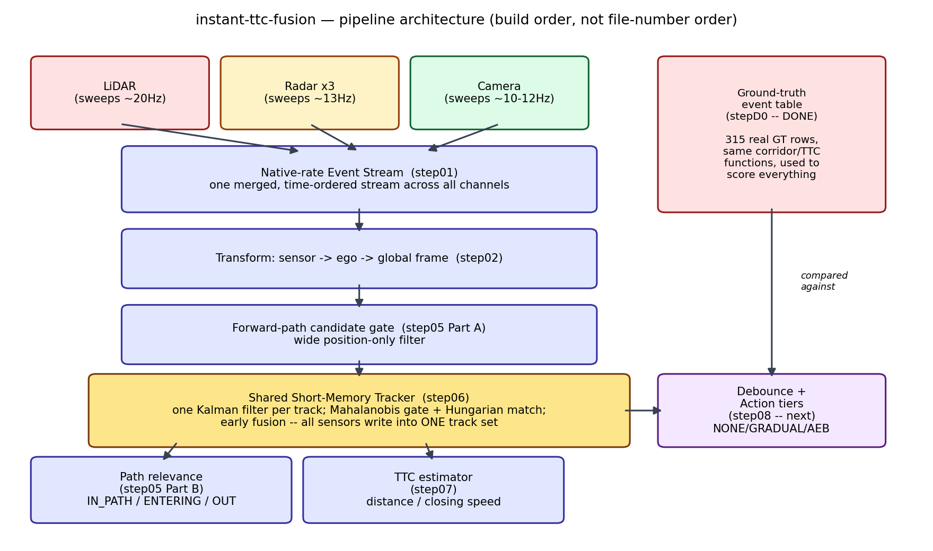
How data flows through the finished pipeline. Boxes already built are shown; step08 (debounce/action) is next.

Two ideas that shape everything else
- Early fusion, not late fusion. All three sensors write into ONE shared set of tracked objects from the very start. The earlier V1 project instead ran three separate trackers and merged their outputs afterward — and an audit found only about 35% of what it called "fused" output was ever a genuine multi-sensor merge. Early fusion structurally avoids that problem rather than patching it after the fact.
- Event-driven, not frame-synchronized. Instead of waiting for all sensors to agree on a shared 2Hz tick, the system reacts to whichever sensor has new information right now, at that sensor's own real speed (LiDAR ~20 times/second, radar ~13 times/second, camera ~10-12 times/second). This means the system can react roughly twice as fast as a synchronized design.

4. Every file created, and what it does
All real pipeline code lives under src/ttcf/ ("ttcf" = the project's own short name, instant-Time-To-Collision-Fusion). Every file below is real, working, tested code — none of it is a stub.

Core library (src/ttcf/)
File | Step | What it does
config.py | 00 | The ONE place every tunable number lives, each tagged MEASURED / ASSUMED / PLACEHOLDER so nobody can mistake a guess for a real measurement.
types.py | 00 | The shared data shapes every step passes to the next (a raw sensor reading, a detection, a track snapshot, a TTC result, an action decision).
geometry/transforms.py | 02 | Converts a point from a sensor's own viewpoint, to the vehicle's viewpoint, to the world's viewpoint — the single most load-bearing utility in the whole project.
geometry/corridor.py | 05-A | Defines the rectangular "driving corridor" ahead of the vehicle and checks whether a point (or a whole object outline) falls inside it.
filtering/kalman.py | 03 | The one shared Kalman filter (explained in section 6) used for both the vehicle's own speed and, later, every tracked object's speed.
filtering/ego_state.py | 03 | Derives the vehicle's own speed and heading from its raw position readings (which have no speed field built in).
ttc/ttc_math.py | 07-A | The pure Time-to-Collision formula — distance divided by closing speed, with the two safety deadbands explained in section 6.
gt/gt_events.py | D0 | Builds the ground-truth "answer key" table directly from the dataset's human-made annotations.
data/event_stream.py | 01 | Merges all active sensors into one single, real-time-ordered stream of lightweight "something happened" events.
tracking/tracker.py | 06 | The shared object tracker: decides which new detections belong to which existing tracked object, and updates them.
tracking/relevance.py | 05-B | Decides, for an actual tracked object (which now has a velocity), whether it's already in the driving corridor or clearly about to enter it.

Scripts (scripts/) — run directly, not imported
File | Purpose
preflight_dataset.py | Confirms the dataset on disk is really what the project assumes before any code depends on it.
build_gt_events.py | Runs the ground-truth builder over every scene and produces every chart/table for the step D0 report.
event_stream_evidence.py | Produces the real-data timing evidence (the raster chart, timing tables) for step 01's report.
synthetic_scenarios.py | Reusable fake-object-and-sensor generators, used by the tracker's tests and meant to be reused by every later test too.

Tests (tests/) — 72 automated checks, all passing
Every module above has its own test file (test_config.py, test_transforms.py, test_kalman.py, test_ego_state.py, test_ttc_math.py, test_corridor.py, test_gt_events.py, test_event_stream.py, test_tracker.py, test_relevance.py). Nothing is considered "done" until its tests exist and pass — the current total is 72 out of 72 passing.

Reports, learning notes, decisions log
- reports/ — one detailed report per build step (what was built, what was tested, what real numbers came out, anything surprising).
- docs/learning/ — one plain-language teaching note per step, written so you can explain it to someone else.
- docs/decisions.md — every DEC-numbered decision, your answer, and the reasoning, in one running log.
- docs/project_status.md — the single rolling summary of every step's status.

5. How the system works, end to end
Follow one single sensor reading through the whole pipeline as it exists today (everything up to and including step 05-B):
- A sensor fires. Say LiDAR completes one spin. That becomes one "event" carrying only a timestamp and a pointer to the file on disk — no actual data is loaded yet (this keeps the system fast: expensive work only happens for events that turn out to matter).
- The event stream places it in time order alongside whatever the radars and camera are doing at their own independent rates — nothing waits for anything else.
- The position gets converted from "relative to the LiDAR unit itself" to "relative to the vehicle" to "a fixed spot in the real world" — this step matters enormously: get it wrong and a parked car looks like it's moving at the vehicle's own speed.
- A wide, cheap first filter throws away anything obviously nowhere near the vehicle's driving corridor, before any expensive matching work happens.
- The tracker decides: does this new position belong to an object already being tracked, or is it something new? It compares the new position against every existing track's PREDICTED position (predicted using that track's own last known speed) and only accepts a match if it's close enough, accounting honestly for how uncertain both the prediction and the new reading are.
- If matched, the existing track's Kalman filter is corrected using the new reading (this is where the object's speed estimate actually improves). If not matched, a brand new, tentative track is started.
- Old, unrefreshed tracks quietly expire (currently: no update for more than 0.3 seconds) — there is no separate "is this still the same clip" bookkeeping; short memory makes that unnecessary.
- For each live track, a relevance check runs: is it already inside the tight driving corridor right now (IN_PATH)? Is it outside but clearly heading in, based on its own measured velocity relative to the vehicle (ENTERING)? Or neither (OUT)?
- (Next step, not yet built) For every IN_PATH or ENTERING track, the TTC formula runs, a debounce check confirms the danger has held for several real updates in a row (not just one noisy frame), and an action tier gets chosen.
Everything above runs identically no matter which sensor(s) are switched on — the same tracker, the same corridor check, the same TTC formula are used for the LiDAR-only run, the radar-only run, the camera-only run, and the fused run. That sameness is what makes the eventual four-way comparison fair.

6. The logic and math used, explained simply

The Kalman filter (KF) — a smart way to guess position and speed
A Kalman filter keeps two things alive at once: a best guess of where something is and how fast it's moving, and a number representing how UNSURE it is about that guess. Every time a moment passes with no new reading, the guess moves forward using the last known speed, and the uncertainty grows a little (you trust an old guess less). Every time a real reading arrives, the guess gets nudged toward that reading — how hard it gets nudged depends on how much the reading is trusted versus how much the existing guess is trusted.
Two numbers control this trust: R (how noisy this particular sensor reading is expected to be) and Q, built from a single number called sigma_a (how much the tracked thing's own motion might unpredictably change — braking, swerving). P is the filter's own running uncertainty about its current guess.
Why not just do (position now minus position before) divided by (time now minus time before)? Because that simple approach has no way to know how much of the apparent movement is real motion versus sensor noise — a 5cm position error over a 0.05-second gap already implies a spurious 1 metre/second of fake speed. This exact shortcut was found and had to be fixed FOUR separate times in the two earlier project attempts, so this project treats "never do this" as a hard rule, checked by name in every step.
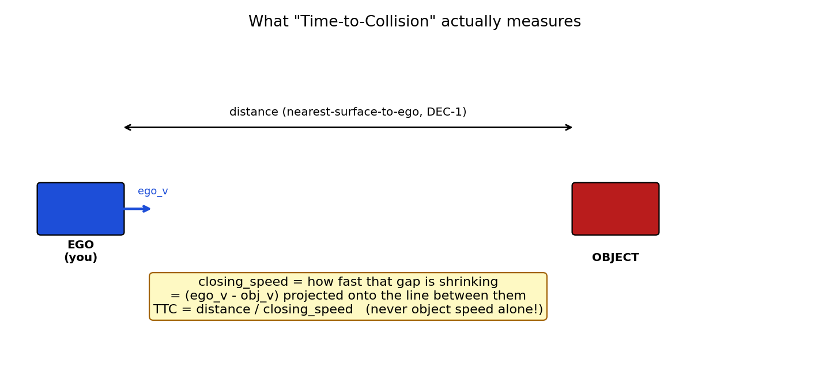

Mahalanobis distance and the chi-square gate — deciding if two things match
When a new sensor reading arrives, the tracker must decide: does it belong to an existing track, or is it something new? A simple fixed circle around the predicted position ("anything within 3 metres counts") either misses fast-moving objects (too tight) or accepts the wrong nearby object (too loose). Instead, the system measures how far the new reading is from the prediction IN UNITS OF COMBINED UNCERTAINTY — called the Mahalanobis distance — using BOTH the track's own uncertainty AND the new reading's own sensor noise added together. This combined number is called S.
A real worked example from this project's own tests: after a track had been updated twice by a very precise sensor, its own uncertainty (P) was tiny — about 0.05. A much noisier sensor (uncertainty 2.25) then reported a position 1.2 metres away. Scored against the track's uncertainty ALONE, that comes out to roughly 29 — comfortably above the cutoff (about 9.2), so a naive check would reject a perfectly good match. Scored the CORRECT way (against the combined uncertainty, 0.05 + 2.25), it comes out to about 0.6 — clearly accepted. The earlier V1 project actually shipped the wrong version of this check for a while, and it measurably fragmented tracks from its most precise sensors worst of all — exactly backwards from what you'd want.

Hungarian assignment — matching many readings to many tracks at once
When a single sensor scan reports several objects at once, and several tracks already exist, the system can't just greedily grab the nearest match for each track one at a time — an early greedy pick can lock out a better overall pairing. Instead it solves the whole matching problem at once, guaranteeing the globally best total set of pairings (using a well-known algorithm called the Hungarian algorithm), while never allowing a pairing that fails the Mahalanobis/chi-square gate above, no matter how "good" it would otherwise look.

Time-to-Collision (TTC) — the core formula
TTC = distance ÷ closing speed. Two things make this trickier than it sounds:
- Closing speed must be RELATIVE, not the object's raw speed. Two cars driving side by side at the same 60km/h are not "closing" on each other at all, even though both are moving fast. The formula uses (the vehicle's own velocity minus the object's velocity), projected onto the line between them.
- A tiny closing speed must not produce a giant, meaningless TTC. An object closing at 0.001 m/s from 50 metres away gives a TTC of 50,000 seconds — technically correct, practically useless, and in the earlier V2 project this exact issue once produced a computed TTC of about 190 MILLION seconds. This project uses a deliberate cutoff (a "deadband"): below a minimum closing speed, TTC is reported as infinite/not-applicable rather than a nonsense large number.

The driving corridor and "nearest surface" distance
The corridor is a straight rectangle ahead of the vehicle (currently about 1.2 metres to each side, up to 60 metres ahead) — deliberately simple, and explicitly NOT trying to handle curves or intersections (documented as a known, accepted limitation rather than half-solved). Distance to any object is measured to its NEAREST point to the vehicle, not its centre — a large vehicle's near edge can be 2+ metres closer than its centre, which matters a lot for a fast-approaching truck or bus.

7. Evaluation criteria — how this will be graded
The ground-truth (GT — the human-made, trusted "answer key") table was built BEFORE any detector or tracker existed, specifically so the grading rules could never be quietly adjusted after seeing how well (or badly) the system performs.

The headline metric: event-level, not full-track
Unlike the earlier V1/V2 projects (which scored average position error over an object's ENTIRE tracked life), this project scores each real moment independently: for every annotated instant where a real object was in the vehicle's path, was the system's action (no action / gentle brake / hard brake) the correct one given what ground truth says was really happening? This is reported as three rates:
- Correct-action rate — how often the system's tier matched what should have happened.
- False-brake rate — braking when nothing actually needed it.
- Missed-brake rate — NOT braking when something actually did need it.

The four-way comparison — the whole point of this project
The identical pipeline runs four times: LiDAR-only, Radar-only, Camera-only, and all three fused together. All four are reported side by side, always — never just the fused number on its own. If fusion doesn't beat the best single sensor, that gets reported plainly (see section 11).

Honesty safeguards already built in
Safeguard | What it prevents
Tune / test scene split, fixed once approved | Tuning thresholds on the same scenes used for the final report — numbers tuned and reported on the same data don't mean what they look like they mean.
"Indicative only" labelling below a minimum count (currently 10 events) | Treating a rate built on a handful of events as if it were as solid as one built on hundreds.
Observability flags per sensor (was this object even physically visible to LiDAR / radar / camera at that instant?) | Penalizing a sensor for "missing" an object it could never have seen in the first place (e.g. behind another car).
Symmetric class policy | Letting the camera's easy access to class labels quietly give the fused run an advantage the single-sensor runs don't get.
Same distance/TTC formula for ground truth and the live system | Comparing two different definitions of "distance" against each other by accident and calling the mismatch an error.

What the real dataset actually contains so far
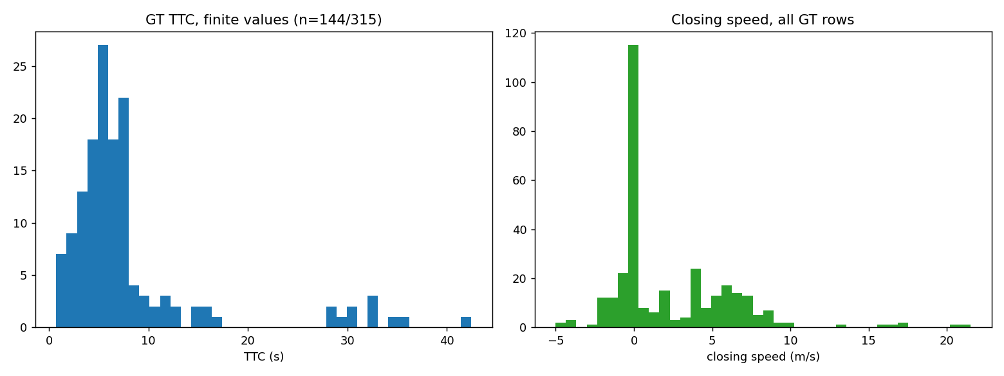
Ground-truth TTC and closing-speed distributions across all 315 real ground-truth rows — both look physically plausible (TTC concentrated 3-10 seconds; closing speed clustered near zero, with a spread out to about 20 m/s).

315 ground-truth rows exist across the 10 available scenes; only 11 of them (3.5%) are genuinely dangerous moments. This is expected for this small a dataset (called "nuScenes-mini") and is stated plainly rather than dressed up — see section 8 and 11.

8. Findings so far (real bugs caught, real numbers measured)
Every step's report includes a "surprising numbers" section, because a project rule states: a surprising result is treated as a likely bug FIRST, and only accepted once actually investigated. Here is every real finding to date, worst/most-interesting first.

Real bugs found and fixed (not glossed over)
Step | What looked wrong | What was actually true
step07-A  (TTC formula) | The written instructions' own formula, followed exactly, gave the OPPOSITE sign of the answer the instructions' own worked example required. | Verified by hand, confirmed against the earlier project's already-correct version, and the instructions file itself was corrected at your request.
step03  (vehicle speed) | A real-data test failed with an impossible negative time gap of about -0.0000012 seconds. | The filter's internal clock was accumulating tiny rounding errors over many updates; fixed by switching it to exact whole-microsecond bookkeeping.
step03  (performance) | A real-data test that should take seconds was still running after 3+ minutes. | A part of the code was needlessly re-doing all of its past work on every single query; fixed with a proper running cache — 43 seconds afterward.
step02  (coordinate transform) | A test meant to prove a parked car doesn't appear to move failed by 2 metres. | The transform code was actually correct (proven against the dataset's own trusted position record, to 15 decimal places); the REAL cause was one dataset object wrongly labelled "parked" while its recorded position was moving at 5.4 m/s — a labelling issue in the data itself, not in the code.
stepD0  (report charts) | A chart meant to show a dangerous scene rendered successfully but showed nothing at all. | The code that picked which moment to draw, and the chart's zoom level, both happened to exclude the one object that mattered — fixed; it could easily have been mistaken for "nothing dangerous happened here" if not checked.
step06  (tracker) | A test built to demonstrate two nearby people/vehicles getting confused with each other didn't show any confusion at first. | The test scenario wasn't actually reproducing the real failure case; redesigned it to match the real mechanism, and found something MORE interesting: not "two tracks become one," but a track's IDENTITY silently jumping onto the wrong object while the total count still looked correct.

Real numbers measured
Measurement | Result
Filter self-consistency check (NEES — Normalized Estimation Error Squared; should equal 4 if the filter's own confidence matches its actual error) | 3.964 across 300 simulated trials — very close to ideal.
Coordinate transform accuracy vs. the dataset's own trusted values | Exact match to 15 decimal places.
Sensor native update rates (measured, not assumed) | LiDAR ~20 times/sec, each radar ~13 times/sec, camera ~10-12 times/sec (genuinely variable, not a fixed number).
Timing spread within one nominal "synchronized" instant | Up to about 52 milliseconds between the earliest and latest sensor in the same nominal moment — confirms sensors truly are NOT simultaneous.
Real dangerous-moment rate in the available data | 11 out of 315 in-path moments (3.5%).
Correct gating math vs. the wrong (older) approach, worked example | Correct: score 0.6, accepted. Wrong: score 29, incorrectly rejected. (See section 6.)

9. Old V1 vs. old V2 vs. this new project — what changed and why
V1 was the original, full Multi-Object-Tracking project. V2 was an async rebuild of V1 that fixed several real correctness bugs but kept the same overall goal (persistent identity across a whole scene). This project keeps V1/V2's genuine correctness fixes and drops everything that only existed to serve the harder, bigger MOT goal.
Aspect | V1 (original) | V2 (async rebuild) | This project (new)
Main goal | Track every object, keep its identity, for a whole ~20s scene | Same goal as V1, rebuilt more carefully | Just: is what's ahead of me closing in dangerously, right now?
Fusion style | Late fusion — 3 separate trackers, merged afterward (only ~35% of "fused" output was a real merge) | Early fusion — one shared track set | Same as V2: early fusion, one shared track set
How long a track survives with no update | Long timers (1-2+ seconds) | Same long-timer style (MAX_MISSED_SECONDS ~1.5s) | Short: 0.3 seconds — tracks are meant to be short-lived by design
Object speed calculation | Sometimes a raw two-point difference (found & fixed 4 times) | Always through the shared Kalman filter | Same as V2: always through the shared Kalman filter, everywhere, including the vehicle's own speed
Ground-truth object speed (for scoring) | Raw two-point difference | STILL a raw two-point difference (a known leftover gap) | The dataset's own official, more careful velocity estimator (never hand-rolled)
Matching new readings to tracks | Fixed-radius circle | Confidence-scaled (Mahalanobis) gate, but with a bug (forgot to include the NEW reading's own noise) that fragmented precise sensors worst | Same confidence-scaled gate, WITH the incoming reading's own noise correctly included from day one
Scene-boundary handling | Explicit reset logic between clips | Explicit reset logic between clips | No special-case code needed at all — short-lived tracks naturally can't survive across a scene boundary
Scoring method | Average position error over a track's WHOLE life (MAE/RMSE), MOT-style identity metrics | Same as V1 | Event-level: was each individual dangerous moment handled correctly?
Distance definition | Box centre | Box centre | Nearest surface to the vehicle (DEC-1)
Camera depth (for a camera-only baseline) | Sometimes secretly borrowed LiDAR depth (an unfair "camera" baseline) | Fixed — camera_mono, genuinely camera-only | Genuinely camera-only from the start (ground-plane geometry, no LiDAR borrowing)
Fused result vs. best single sensor (V1's own measured finding) | Fused was WORSE than LiDAR and camera alone | n/a — V2 stopped before finishing a full 4-way comparison | Not yet known — this is exactly what step 11 will determine, honestly (section 11)

Sources for the V1/V2 columns above: F:\Sensor fusion Research (the old project folder), specifically src/geometry.py, v2/kalman_track.py, v2/gating.py, v2/central_tracker.py, v2/evaluate.py, and this project's own knowledge/lessons-from-v1-v2.md — read directly during this project's precedent checks, not from memory.

10. How to take this forward

Immediate next steps (in order)
- step07 Part B — wire the already-built TTC formula to real tracks: eligibility rules (has this track been seen enough times, and is its speed estimate trustworthy enough to act on), and picking the single most urgent object to react to.
- step08 — debounce (require a danger condition to hold for several real updates in a row, not just one noisy frame) and the action tiers (no action / gentle brake / hard brake).
- step09 — match live tracks to the ground-truth answer key at the exact right instant (the tracker runs faster than the 2Hz ground truth, so this needs careful, forward-only extrapolation).
- step10 — turn all of the above into the actual scorecards (the three rates from section 7).
- step04-a/b/c — the sensor adapters: this is where real LiDAR points, radar returns, and camera images finally enter the pipeline for the first time. Everything before this point has only used clean, synthetic (fake but realistic) data on purpose.
- step11 — the big one: run all four versions (LiDAR/Radar/Camera/Fused), tune thresholds properly, freeze the configuration, and produce the one final, honest four-way scorecard.

Things worth re-checking as the project continues
- The vehicle's own process-noise number (sigma_a_ego) was reported as looking neither too smooth nor too jittery, but was never independently re-measured against a second source — worth a second look once a real tracker is comparing against it.
- All 5 of the dataset's most dangerous (AEB-tier) moments happen to sit in exactly one scene. That scene was deliberately placed on the "final testing" side (not the "tuning" side) so the final scorecard isn't empty for the most severe category — but it also means the tuning side currently has zero severe examples to tune against. Worth keeping in mind at step 11.
- The camera's real recording rate turned out to vary scene-by-scene (measured between about 10 and 11.6 times/second, not a single fixed number) — worth double-checking this doesn't quietly bias the camera-only baseline once step04-c is built.
- The known, accepted "two nearby objects can be confused" limitation (section 8) is not being fixed in this project's current scope — worth deciding, once real pedestrian-crowd data is being processed, whether that decision still holds.

11. Can fusion actually beat a single sensor? (honest answer)
Short answer: not yet known — and that is by design, not an oversight.
This entire project is built around treating "fusion is better" as a CLAIM TO PROVE, not something to assume. The very first architectural task once real sensor data starts flowing (step 04 onward) is exactly this question, and step 11 is the step that will actually answer it, honestly, with all four results reported side by side — including if the answer turns out to be "no."

What the earlier V1 project already found
This isn't a hypothetical risk — it already happened once. In the earlier V1 project, the fused result was measurably WORSE than the LiDAR-only and camera-only results on their own. The likely causes were already partly diagnosed at the time:
- A very high rate (~71%) of single-sensor detections passing straight through without any real multi-sensor benefit.
- Radar tracks breaking apart into short fragments (median length only about 2 frames) instead of staying as one continuous track.
- TTC values allowed to run up to an unbounded, unrealistic 60-second cap, diluting the accuracy numbers with meaningless large values.

Why this project has a genuinely better starting position
Several of V1's specific, diagnosed causes are already structurally addressed by decisions already made and built in this project, before step 11 even runs:
V1's diagnosed problem | What this project already does differently
Late fusion diluted the benefit (~35% real merges) | Early fusion from the start — one shared track set, no separate merge step to dilute.
Wrong gating math fragmented precise sensors worst | Correct combined-uncertainty gating built in and tested from day one (section 6).
Unbounded TTC values (up to 190 million seconds seen in V2) polluted the numbers | A hard closing-speed deadband built into the TTC formula itself from day one.
Camera baseline sometimes secretly used LiDAR depth | Camera-only baseline will use only ground-plane geometry — enforced as an explicit rule, not a hope.
Fusion's benefit was assumed, not measured | Structurally impossible to skip — the four-way comparison is a required deliverable, not an optional extra.

What could still make fusion lose
- This dataset is small (only 10 scenes, 11 truly dangerous moments total) — even a real, genuine improvement could be statistically indistinguishable from noise at this scale (see the "indicative only" rule in section 7).
- Radar's own known strength (directly measuring speed via Doppler) is deliberately switched OFF for this phase of the project (a scoped, intentional simplification) — meaning radar is competing without its biggest natural advantage, which will need to be stated honestly if radar underperforms.
- The camera-only baseline depends on a ground-plane depth estimate that has never been measured against real data yet — it could turn out to be considerably noisier than LiDAR or radar.
Bottom line to carry forward: there is a real, defensible reason to expect a BETTER outcome than V1's, because several of V1's own root causes are already fixed by design — but that is a reason for cautious optimism, not a promise. The project's own rules require reporting the true result either way.

12. Glossary, open questions, and anything worth understanding deeper

Glossary — every short form expanded
Term | Full name / meaning
TTC | Time-To-Collision — seconds until impact if nothing changes.
KF | Kalman Filter — the predict/update position-and-speed estimator explained in section 6.
GT | Ground Truth — the trusted, human-annotated "correct answer" data.
LiDAR | Light Detection And Ranging — a spinning laser scanner measuring distance directly.
Radar | Radio Detection And Ranging — bounces radio waves off objects; naturally measures speed too (currently unused in this project, on purpose — see section 11).
MOT | Multi-Object Tracking — keeping a persistent identity for every object across a whole scene; the bigger problem this project deliberately does NOT solve.
AEB | Automatic Emergency Braking — the hard-brake action tier.
DEC-n | Decision number n — this project's numbered list of choices needing your sign-off.
NEES | Normalized Estimation Error Squared — a filter self-consistency check; should equal the number of tracked quantities (4, here) if the filter isn't over- or under-confident.
Mahalanobis distance | A "how far apart, accounting for uncertainty" measurement, used to decide if a new reading plausibly belongs to an existing track.
Chi-square gate | The statistical cutoff value the Mahalanobis distance is compared against.
R, P, Q (in Kalman-filter terms) | R = how noisy a sensor reading is; P = the filter's own current uncertainty; Q = how much unpredictable real-world motion to expect between updates.
Hungarian algorithm | A method for finding the single best overall way to pair up a list of new readings with a list of existing tracks, considered all at once.
Deadband | A cutoff below which a technically-nonzero value is treated as zero/not-applicable, to avoid reacting to noise.
Corridor | The rectangular "driving path" zone directly ahead of the vehicle.
Sigma_a | A single number describing how unpredictably a tracked thing's motion might change.
Early fusion / Late fusion | Early = all sensors write into one shared set of tracks from the start. Late = separate per-sensor tracks, combined afterward (this project uses early fusion).
SAE Levels (mentioned in the deployment reference document) | The official 0-5 scale for how much a vehicle drives itself: Level 2 = driver-assist (human still fully responsible), Level 3 = the system drives but a human can be asked to take over, Level 4 = the system must be able to safely stop itself with no human fallback at all, within its approved conditions.
ODD | Operational Design Domain — the specific conditions (roads, weather, speeds) a self-driving system is actually approved to operate in.
ASIL | Automotive Safety Integrity Level — a required safety-rigor rating for real automotive systems, higher for functions with worse consequences if they fail.

Open questions still waiting on you
- Confirm (or ask to re-measure) the vehicle's own process-noise number, sigma_a_ego, once real tracking comparisons are available.
- Decide, once real crowd/pedestrian data is being processed later, whether the "two nearby objects can be confused" limitation (section 8, section 9) needs revisiting.
- Decide the target automation level (Level 2 near-term vs. architecting for Level 3/4 without committing yet) referenced in the separate deployment-architecture-reference.md document, if/when real deployment planning starts — this is beyond the current research-prototype scope and was not asked to be decided yet.

A few more real-data pictures, for reference
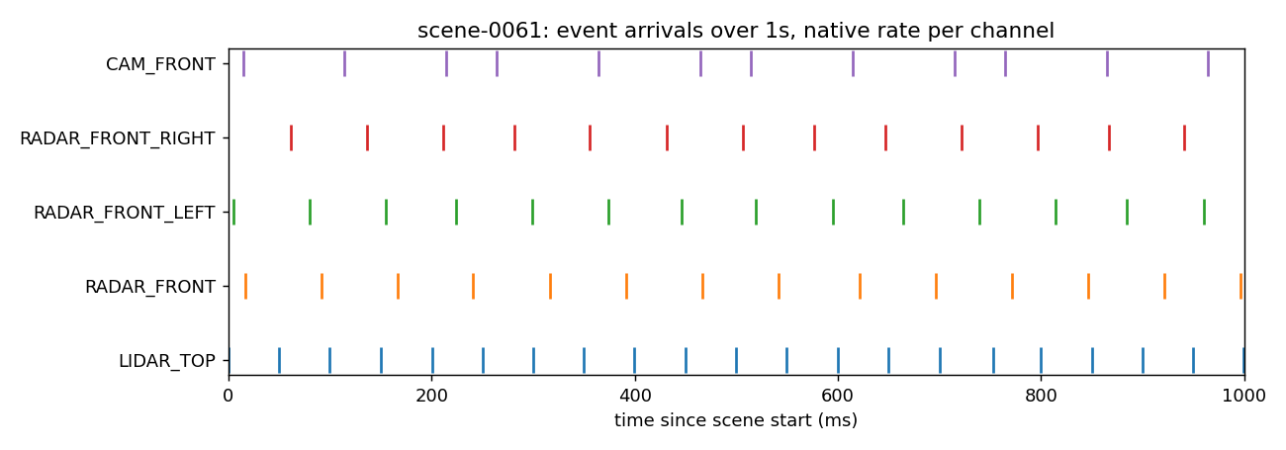
Real event timing over 1 second — LiDAR (bottom row) fires roughly twice as often as the camera (top row); no two sensors ever fire at exactly the same instant.

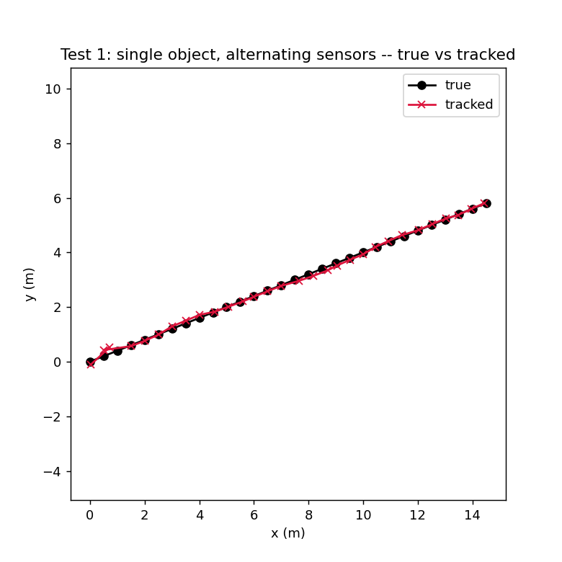
The tracker (synthetic test): true path in black, the tracker's own estimate in red — converges closely despite three different sensors reporting with three different noise levels.

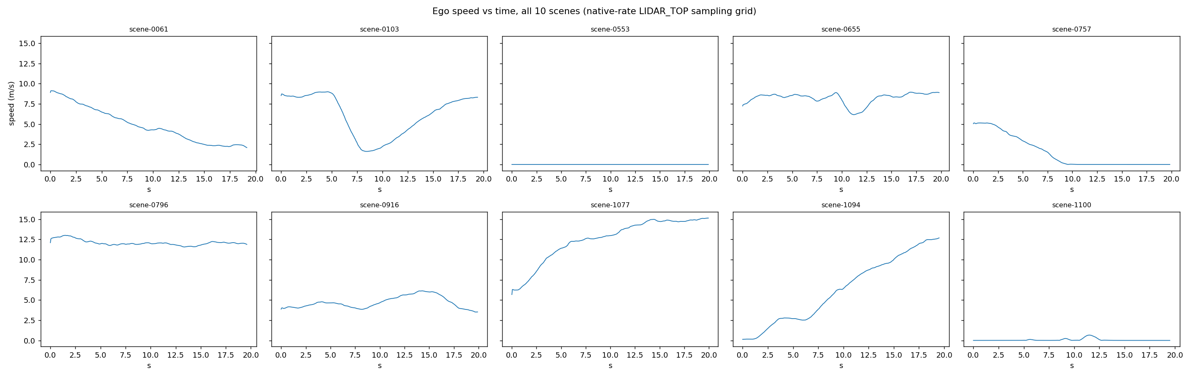
The vehicle's own derived speed across all 10 real scenes — smooth, physically plausible, and correctly flat at zero for the one scene where the car is stopped the whole time.

— End of summary. Every claim above traces back to a specific file already in the project folder; ask and the exact source can be pointed to for anything.

