V1 → V2 → V3
How instant-ttc-fusion Compares to Its Predecessor Projects
Generated 25 September 2026

This document compares three generations of the same underlying idea: V1, the original notebook-based multi-object-tracking project; V2, an async rebuild of V1 with the same scope; and V3 (instant-ttc-fusion), a deliberate rescope into a real-time collision-warning system, evaluated honestly on the question that actually matters &mdash; does fusing sensors beat using the best one alone.

At a glance
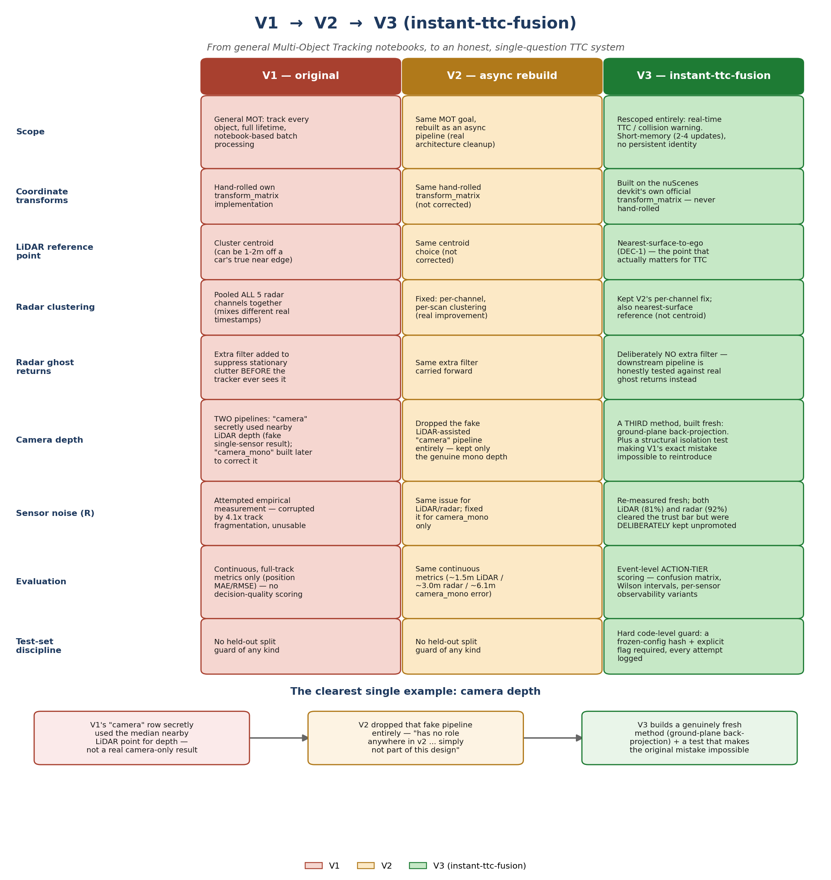

1. Scope: what each project was actually trying to do
This is the single biggest difference of the three, and it explains almost everything else downstream. V1 and V2 were both scoped as general Multi-Object Tracking (MOT) systems: track every object in the scene, for its whole lifetime, and score with MOT-style metrics (ID switches, track length, positional accuracy). V3 deliberately rescoped away from that entirely.
- V1 — General MOT: track every object in the scene, for its full lifetime, using notebook-based batch processing.
- V2 — The same MOT goal, rebuilt as an async pipeline &mdash; a real architectural cleanup, but the underlying scope never changed.
- V3 — Rescoped entirely to a single question: is something closing on the ego vehicle right now. No persistent track identity, no appearance re-identification, short memory (2-4 real updates) by design.
A collision-warning system doesn't need to know “is this the same car I saw 30 seconds ago three blocks back” &mdash; it needs to know, right now, whether anything ahead is closing fast enough to require braking. Dropping MOT's hardest problems (long-horizon identity, re-ID) let V3 focus entirely on doing the TTC question well.

2. Per-sensor technical choices

LiDAR
- V1 and V2 both used the cluster centroid as the reference point for a detected object.
- V3 uses the nearest-surface-to-ego point instead (DEC-1) &mdash; a centroid can sit 1-2 metres behind a car's actual near bumper, exactly the margin a braking threshold lives or dies on.
- V3 found and fixed a real bug neither V1 nor V2 documented: the LiDAR's own roof mount reflecting its beam back at point-blank range, producing a 9,805-point phantom “object.”

Radar
- V1 pooled all 5 radar channels together before clustering, mixing detections from different real timestamps. V2 fixed this to per-channel, per-scan clustering &mdash; a real, stated improvement V3 kept.
- V1 added an extra filter to suppress stationary-clutter “ghost” returns before its tracker ever saw them; V2 carried this forward unchanged. V3 deliberately does NOT filter ghost returns upstream, so the downstream pipeline (corridor, tracker, debounce) gets honestly tested against them instead of having the problem hidden. V3's first real run found and fully traced one false alarm to an actual construction barrier.
- Radar's instantaneous velocity (Doppler) is not fed into the tracker in either V2 or V3 &mdash; a conservative rule V2 established that V3 also follows.

Camera &mdash; the clearest single example
V1's most serious documented mistake lived here. It had two camera pipelines: one labelled “camera” that secretly used the median nearby LiDAR point for depth &mdash; so its “camera-only” result was actually LiDAR+camera fusion wearing a camera label &mdash; and a second, “camera_mono,” built later specifically to correct that mistake using genuine similar-triangles depth (an assumed object height).
- V2 dropped the fake LiDAR-assisted pipeline entirely, keeping only the genuine mono depth.
- V3 uses a third, different method with zero precedent in either V1 or V2: ground-plane back-projection (tracing the detected box's bottom pixel down to an assumed flat road). It also adds a structural isolation test that statically scans the camera code for any reference to the other sensors &mdash; making V1's exact mistake mechanically impossible to reintroduce, not just something a person has to remember not to do.

3. Foundations: coordinate transforms & sensor noise
- Both V1 and V2 hand-rolled their own coordinate transform implementation. V3 builds directly on the nuScenes devkit's own official function &mdash; never reimplemented.
- V1 tried to measure each sensor's own noise (R) empirically and got a corrupted result &mdash; its own tracks were 4.1x more fragmented than the real object count, making the residuals meaningless. V2 partially fixed this, but only for camera_mono.
- V3 re-measured fresh for its own adapters: both LiDAR (81.2% inlier rate) and radar (92.0%) actually cleared the trust threshold this time &mdash; but were still deliberately kept at their literature-typical assumed values rather than auto-promoted, since this would have been the project's first-ever “measured” constant, with effects across the entire tracker.

4. Evaluation philosophy — the biggest gap of all
V1 / V2 | V3 (instant-ttc-fusion)
Continuous, full-track metrics only: average position error (MAE/RMSE). V2 reported roughly 1.5m (LiDAR), 3.0m (radar), 6.1m (camera_mono). No decision-quality scoring existed at all. | Event-level action-tier scoring: did the system correctly decide NONE / GRADUAL / AEB at each real moment, with a full confusion matrix, 95% confidence intervals on every rate, and separate scoring restricted to what each sensor could plausibly see.
No held-out test-set guard of any kind on either project. | A hard, code-level guard: scoring the held-out eval scenes requires an explicit flag AND a cryptographic hash match against a frozen configuration file. Every attempt, successful or refused, is permanently logged.

This entire evaluation layer &mdash; the confusion matrix, the confidence intervals, the observability-restricted variants, the frozen-config guard &mdash; has no precedent in either V1 or V2. It was built fresh because a collision system should be judged on the decisions it makes, not on how many centimetres off its position estimate was.

5. The bottom line
V1 → V2 was mostly an architectural cleanup (notebooks → async pipeline, a handful of real bug fixes) within the same MOT scope. V2 → V3 is a conceptual rescope: a narrower, honestly-scored, decision-focused system with a documented reason behind essentially every number, culminating in an answer neither V1 nor V2 ever actually produced — a rigorous, investigated, held-out test of whether fusion beats a single sensor.
On this dataset, it didn't — LiDAR alone scored best — and V3 can say exactly why, with the evidence to back it up.

