LEARN-2 VAR, CONST, LET 27-02-25

Index.html
<!DOCTYPE html>
<html lang="en">
<head>
<meta charset="UTF-8">
<meta name="viewport" content="width=device-width, initial-scale=1.0">
<title>Document</title>
</head>
<body>
<h1>In this lecture we will learn how to build frontend project</h1>
<script src="lecture.js"></script>
</body>
</html>

1.VAR lecture.js
console.log("Hello Welcome")
// var const let

var name="Siva kalyan";
console.log("name"); //outpur: name
console.log(name); //output:Siva kalyan

// var can re-declared variable
var _coursse="MERN"; //using(_),start variable
var rating= 55;
console.log(name,_coursse,rating); //Siva kalyan MERN 55
var id;
console.log(id); //undefined
console.log(name,id,_coursse,rating); //Siva kalyan undefined MERN 55

coursse="FULL STACK";
console.log(name,coursse,rating); //Siva kalyan FULL STACK 55

RULES : -
// Rules to write variables names
/*
1. You cannot start your variable name with number.
2. You can start your varible name with underscore (_),letters, $
3. Variable names are case sensitive Car,car are different variable
*/

// Most widely used programming variable case types

/*
1. camelCase
2. kabab-case
3. snake_case
4. PascalCase
*/
2.CONST:-

// *****CONST***** //
const marks = 97;
console.log(marks); //output: 97
//marks = 100;
//console.log(marks); //output: Uncaught TypeError: Assignment to constant variable.
//You cannot redeclare const variable
const list = [10,20,30,40];
console.log(list);
/* output:-
(4) [10, 20, 30, 40]
0: 10
1: 20
2: 30
3: 40
length: 4
[[Prototype]]: Array(0)
*/
list.push(50);
console.log(list);
/* output:-
(5) [10, 20, 30, 40, 50]
0: 10
1: 20
2: 30
3: 40
4: 50
length: 5
[[Prototype]]: Array(0)
*/
// list=[10,20,30,40,50,60];
// console.log(list);
//output: Uncaught TypeError: Assignment to constant variable.
//You cannot redeclare const variable

3.LET:-
// *****LET***** //

var car="TATA MOTOR";
console.log(car); // output: TATA MOTOR

{
let car="LAND_ROVER";
console.log(car); // output: LAND_ROVER
}

console.log(car); //output: TATA MOTOR

OUTPUT:-


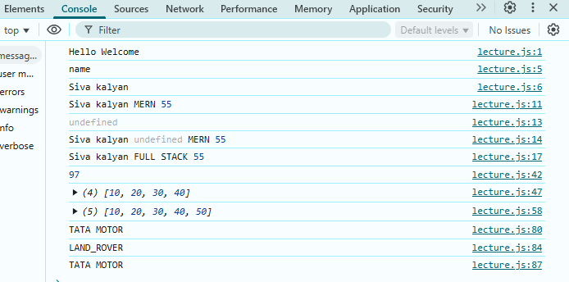

LEARN-3 DATA-TYPE 27-02-25

Index.html
<!DOCTYPE html>
<html lang="en">
<head>
<meta charset="UTF-8">
<meta name="viewport" content="width=device-width, initial-scale=1.0">
<title>Document</title>
</head>
<body>
<h1>learn on data types</h1>
<script src="type.js">
</script>
</body>
</html>
Type.js
// console.log("This is tutorial on data types");

// Primitive type
/*
1. String
2. Number
3. Boolean
4. Null
5. Undefined
*/

// 1.String
let name ="siva kalyan";
console.log("My Name is "+name+" HI");
console.log(typeof name);

// 2.Number
let mark = 99;
console.log("Mark is "+mark);
console.log(typeof mark);

// 3. Boolean

let gender = true;
console.log("this best one"+gender);
console.log(typeof gender);

// 4. Null

let test1 = null;
console.log(test1);
console.log(typeof test1);

// 5. Undefined

let test2 =undefined;
console.log(test2);
console.log(typeof test2);

// Reference type
/*
1.Array
2.Object Literals
3. functions
4. Dates
*/

// 1. Array
let list=[10,20,30,40,50];
console.log(list)
console.log(typeof list);
let list1=[10,"20",undefined,null,false];
console.log(list1)
console.log(typeof list1);

// 2. Object Literals

let student = {
Jack : 90,
John : 95
}
console.log(student);
console.log(typeof student);
// to display tubalur format
console.table(student);
console.log(typeof student);

OUTPUT:
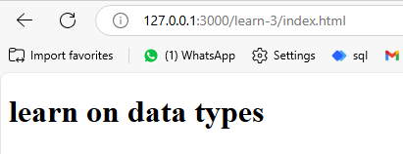

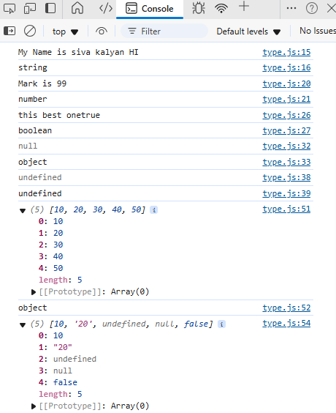
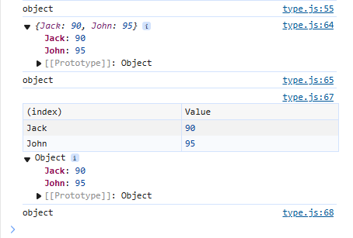

Learn-4 Conversion&Coercion 28-02-25

<!DOCTYPE html> index.html
<html lang="en">
<head>
<meta charset="UTF-8">
<meta name="viewport" content="width=device-width, initial-scale=1.0">
<title>Document</title>
</head>
<body>
<h1> Conversion & coercion </h1>
<script src="script.js"></script>
</body>
</html>

Script.js
console.log("This lecture is for type conversion and coertion");

// Type Conversion
// ***** Number to String*****
let vari1=100;
vari1=String(120)
console.log(vari1,(typeof vari1));

// small trick is adding quotion
let vari2="100";
console.log(vari2,(typeof vari2));
// ***** True as boolean to string*****
let vari3;
vari3 = String(true)
console.log(vari3,(typeof vari3));

// ***** Date to srting****
let vari4;
vari4=String(new Date());
console.log(vari4,(typeof vari4));

// ***** Array (object) to String *****
let vari5=String([1,2,3,4,5]);
console.log(vari5,(typeof vari5));

let vari6=prompt("enter number");
vari6=String(vari6)
console.log(vari6,(typeof vari6))

// *****String to Number *****
let x=parseInt("83.5676");
let y=parseFloat("83.5677");
console.log(x,y.toFixed(2),(typeof x),(typeof y));

// Type Coercion

let a="hello ";
let b="welcome";
console.log(a+b);

let a1="hello "
let b1=10;
console.log(a1+b1);

let a2=10;
let b2=10;
console.log(a2+b2);

output:
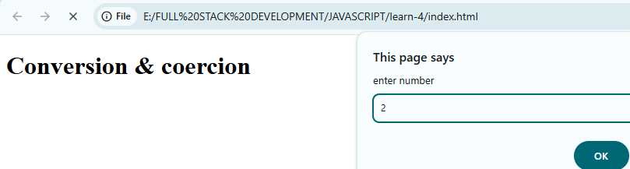
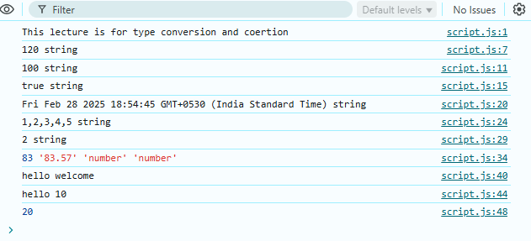

Learn-5 String types 28-02-25

<!DOCTYPE html> index.html
<html lang="en">
<head>
<meta charset="UTF-8">
<meta name="viewport" content="width=device-width, initial-scale=1.0">
<title>Document</title>
</head>
<body>
<h1>String</h1>
<script src="string.js"></script>
</body>
</html>

String.js
console.log("All about Strings in JavaScript");
// *****String*****
let vari1="hello";
let vari2="welcome";
// 1 way
console.log(vari1+" "+vari2);
// 2-way
let vari3=vari1.concat(" ",vari2);
console.log(vari3);
// 3-way
vari1=vari1.concat(" this "+vari2);
console.log(vari1)

let html=`<h1> Hello </h1> <p> Welcome <p>`;
console.log(html);
console.log(html.length);

console.log(html.toLowerCase());
console.log(html.toUpperCase());
console.log(html[2]+" "+html[5,9]);//********
console.log(html.indexOf('>'))
console.log(html.charAt(6))
console.log(html.endsWith('>'));
console.log(html.includes('>'));
console.log(html.substring(1,6));
console.log(html.slice(0,10));
console.log(html.split('>'));
console.log(html.replace('Hello','world'))

let i1='android';
let i2='ios';
let html2= `hi ${i1} hello ${i2}`;
console.log(html2);
document.body.innerHTML=html2;

Output:-
