**Clinical Management System**

**📋 Project Overview**

The Clinical Management System is a simple Java Swing-based desktop application that allows users to manage clinical activities such as managing patients, doctors, and appointments.

It provides a graphical interface with buttons and icons to navigate between different sections.

**🛠️ Technologies Used**

Java (JDK 8 or later)

Java Swing for GUI development

**🏃 How to Run the Project**

Install Java Development Kit (JDK) if not installed.

Place all .java files and the resources/ folder correctly inside your project directory.

Compile and run the project using your favorite IDE (Eclipse, IntelliJ IDEA, NetBeans) or from the terminal.

**📸 Screenshots**

**Home page**

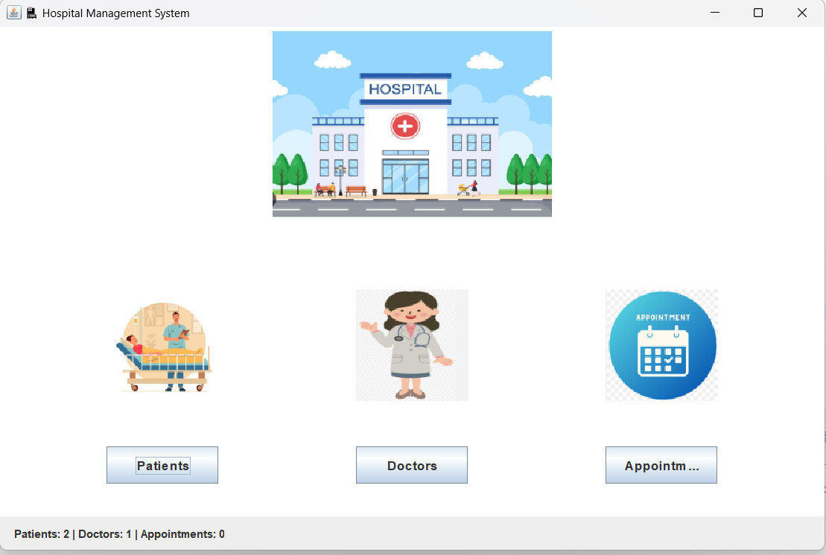

**Patient Page**

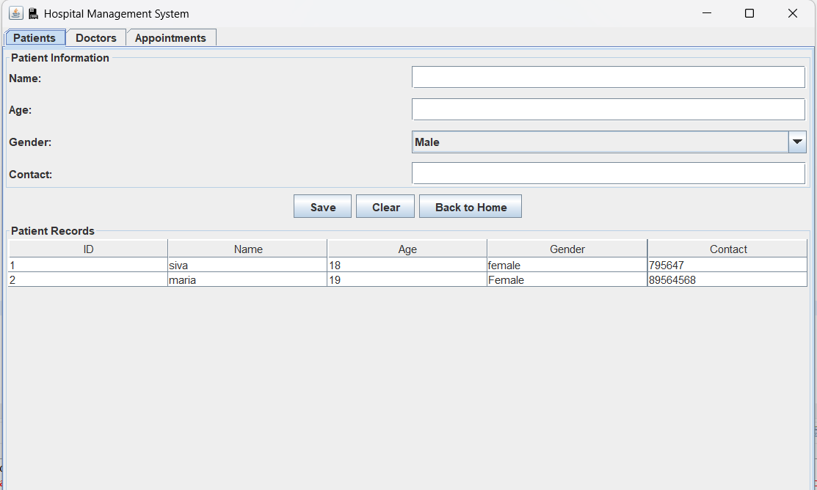

**Doctor Page**

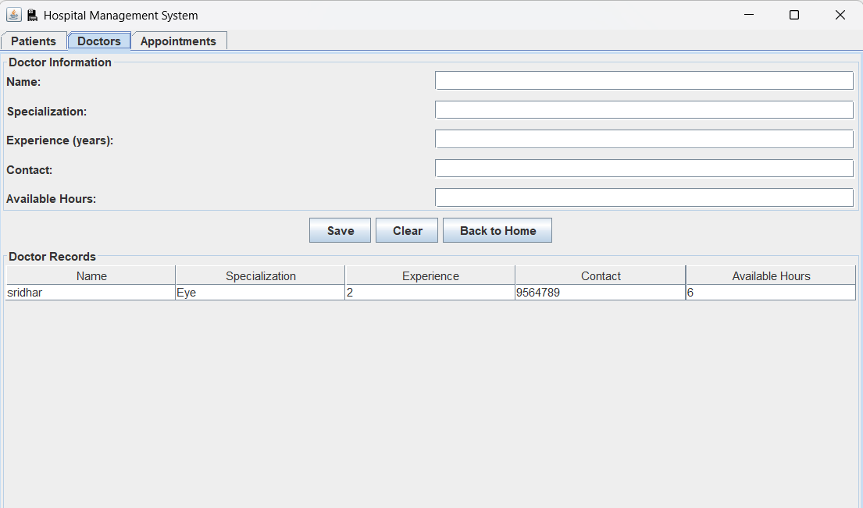

**Appointments Page**

