HIGH LEVEL DESIGN DOCUMENT
Intelligent Retail Product Detection &
Inventory Management System

Project | Retail AI — Capstone Project
Team | Moorthy, Nikhil, Sivakanth, Surabi
Version | 1.0
Date | June 2026
Status | In Development
Tech Stack | FastAPI, YOLOv8, GPT-4o, PostgreSQL, Redis, React

1. Executive Summary
This document provides a comprehensive high-level design for the Retail AI Inventory Management System. The system combines computer vision (YOLOv8), transfer learning, and large language model capabilities (GPT-4o) to automate product detection on retail shelves, maintain real-time inventory, and provide a natural language business intelligence interface.

Key Objectives
- Automate product detection from shelf images using multi-stage AI pipeline
- Maintain real-time inventory with automated low-stock alerting
- Enable non-technical users to query inventory data in plain English via GPT-4o
- Deliver enterprise-grade security with JWT authentication, RBAC, and prompt injection prevention
- Provide analytics dashboards for business decision-making

2. System Architecture Overview
The system follows a layered, microservice-inspired architecture with four primary tiers: Presentation, Application/API, AI/ML Pipeline, and Data. Each tier has clear responsibilities and communicates through well-defined interfaces.

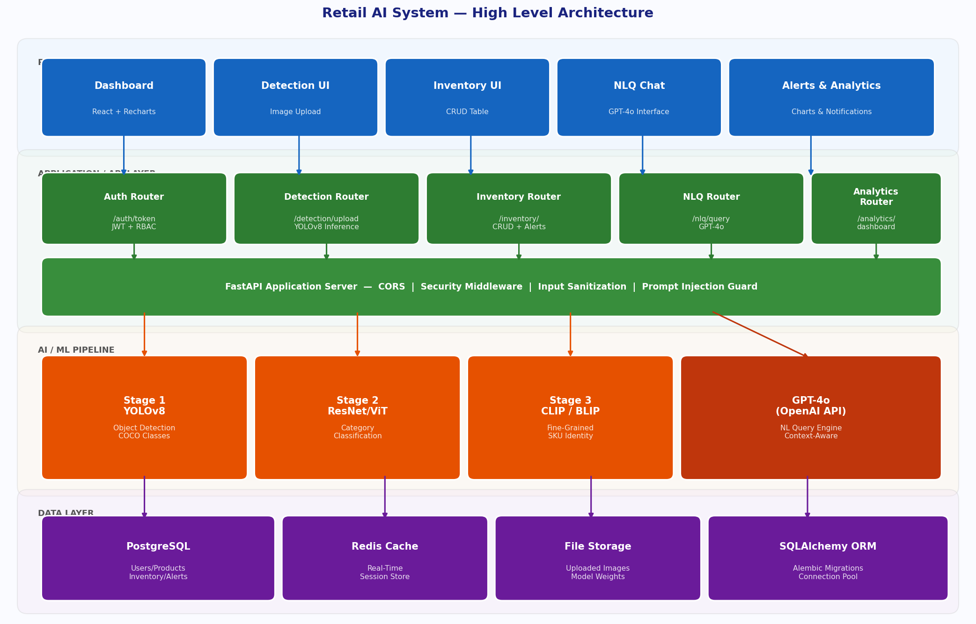
Figure: High-Level System Architecture — All Layers & Components

2.1 Architecture Layers
Presentation Layer | React.js SPA with Recharts — Login, Dashboard, Detection, Inventory, NLQ Chat, Alerts
Application Layer | FastAPI (Python) REST API — handles routing, auth, business logic, orchestration
AI / ML Pipeline | YOLOv8 detection + ResNet classifier + CLIP embeddings + GPT-4o NLQ interface
Data Layer | PostgreSQL (persistent store) + Redis (real-time cache) + file storage for images

2.2 Technology Stack
Component | Technology | Purpose
Object Detection | YOLOv8 (Ultralytics) | Detect products in shelf images — COCO pre-trained
Classification | ResNet / EfficientNet / ViT | Hierarchical category classification
Vision-Language | CLIP / BLIP / Florence | Fine-grained SKU identity, embedding similarity
LLM Interface | GPT-4o (OpenAI API) | Natural language inventory queries
Backend API | FastAPI (Python 3.11) | REST API, business logic, orchestration
ORM / Migrations | SQLAlchemy + Alembic | Database models and schema migrations
Primary Database | PostgreSQL 17 | Persistent storage — products, inventory, users
Cache / Sessions | Redis 7 | Real-time caching, session management
Frontend | React 18 + Recharts | SPA dashboard — charts, tables, chat UI
Authentication | JWT (python-jose) | Stateless token-based authentication
Containerisation | Docker + Docker Compose | Service orchestration for deployment

3. End-to-End Request Flow
The system supports two primary user flows: (1) Image upload for product detection and inventory update, and (2) Natural language query for business intelligence. Both flows pass through the same security middleware layers before reaching their respective processing engines.

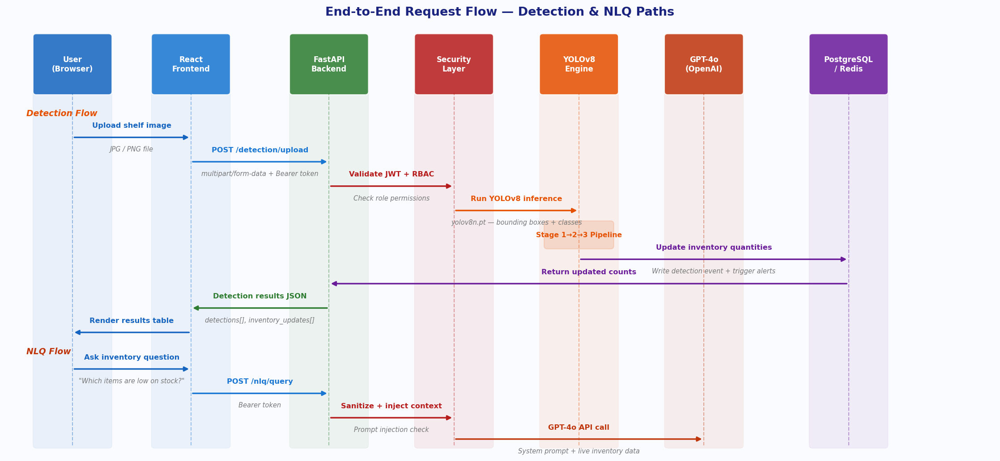
Figure: End-to-End Request Flow — Detection & NLQ Paths

3.1 Detection Flow (Step by Step)
Step | Actor | Action
1 | User (Browser) | Drags & drops shelf image onto Detection page
2 | React Frontend | Sends POST /detection/upload with image + JWT Bearer token
3 | FastAPI Middleware | Validates JWT, checks RBAC role, sanitizes file input
4 | Security Layer | Validates file type (image/*), enforces 20MB size limit
5 | YOLOv8 Engine | Runs inference — returns bounding boxes, class names, confidence scores
6 | Detection Router | Maps detected classes to product categories, triggers inventory update
7 | PostgreSQL | Writes DetectionEvent, updates Inventory quantities, creates Alert if low stock
8 | Response | Returns detection results JSON — total count, bbox list, inventory_updates[]
9 | React Frontend | Renders results table and inventory update summary

3.2 Natural Language Query Flow
Step | Actor | Action
1 | User | Types question: "Which products are running low on stock?"
2 | React Frontend | Sends POST /nlq/query with query text + JWT token
3 | Security Layer | Sanitizes input — strips HTML, checks 12 prompt injection regex patterns
4 | NLQ Router | Fetches live inventory context from PostgreSQL (all products, quantities, thresholds)
5 | NLQ Router | Constructs system prompt: role + guardrails + live inventory data
6 | OpenAI GPT-4o | Returns structured natural language answer based on real inventory data
7 | Output Sanitizer | Scans response for credential leakage, redacts sensitive terms
8 | React Frontend | Displays answer in chat bubble UI

4. AI Detection Pipeline
The detection pipeline uses a cascaded three-stage approach: universal object detection, hierarchical category classification, and fine-grained SKU identification. Each stage builds on the previous, narrowing from broad object detection to specific product identity.

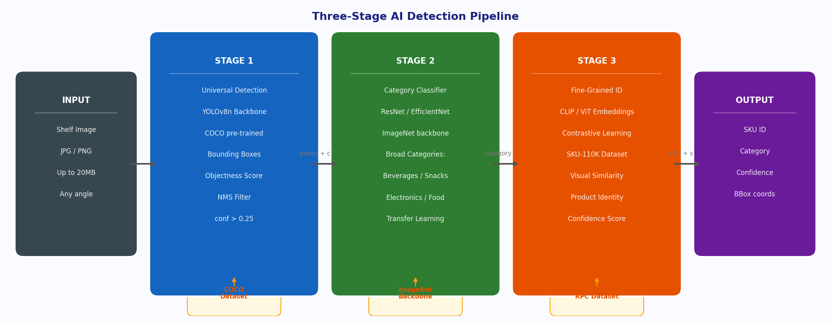
Figure: Three-Stage AI Detection Pipeline

4.1 Stage Details
Stage 1 — Universal Detection | YOLOv8 backbone (CSPDarknet, ImageNet pre-trained) detects all objects as bounding boxes. Trained on COCO for robust general object detection. Outputs: bbox coordinates, objectness score, raw class label. NMS applied at conf > 0.25.
Stage 2 — Category Classification | ResNet/EfficientNet classifier narrows detections into retail categories (Beverages, Snacks, Electronics, etc.). Uses ImageNet backbone weights for transfer learning. Maps COCO class names to retail-specific taxonomy.
Stage 3 — Fine-Grained SKU ID | CLIP / ViT embeddings identify specific product variants using contrastive learning. Fine-tuned on SKU-110K dataset for dense retail shelf environments. Handles visual similarity between competing SKUs.
Training Datasets | ImageNet (backbone init) → COCO (detection mechanics) → SKU-110K + RPC (retail domain fine-tuning). Progressive fine-tuning from general to domain-specific.

4.2 Technical Challenges Addressed
Challenge | Description | Solution
High Object Density | Hundreds of products per shelf image | YOLOv8 anchor-free head + NMS suppression
Visual Similarity | Products share similar packaging | Contrastive learning + CLIP embedding distance
Partial Occlusion | Products hidden by other items | Multi-scale detection + data augmentation
Scale Variance | Small candy to large boxes in same image | YOLOv8 FPN multi-scale feature pyramid
Lighting Variation | Inconsistent retail store lighting | Augmentation during training (brightness, contrast)

5. Database Design
The system uses a relational PostgreSQL database with five core tables managed via SQLAlchemy ORM. Alembic handles schema migrations. Redis provides real-time caching for session tokens and frequently-read inventory data.

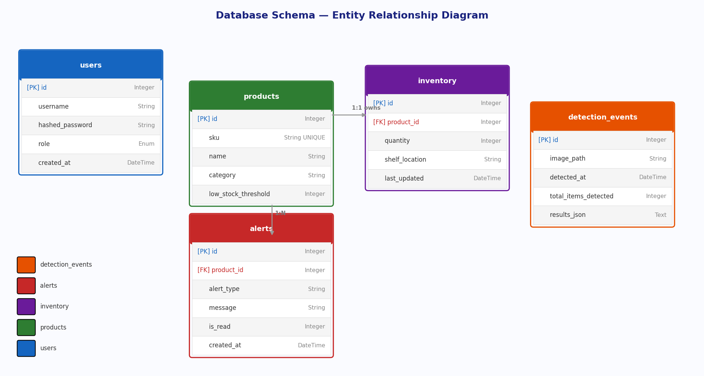
Figure: Database Schema — Entity Relationship Diagram

5.1 Table Descriptions
Table | Rows / Purpose | Key Columns
users | System users with role-based access | id, username, hashed_password, role (Enum), created_at
products | Product catalogue — all SKUs | id, sku (UNIQUE), name, category, low_stock_threshold
inventory | Real-time stock levels (1:1 with products) | id, product_id (FK), quantity, shelf_location, last_updated
alerts | Auto-generated low-stock notifications | id, product_id (FK), alert_type, message, is_read, created_at
detection_events | Audit log of all shelf scans | id, image_path, detected_at, total_items_detected, results_json

5.2 Data Flow — Inventory Update
When a shelf image is scanned: (1) A DetectionEvent row is created with the full results JSON. (2) Detected class categories are mapped to products. (3) Inventory.quantity is updated to the detected count. (4) If quantity < low_stock_threshold, an Alert row is inserted. All operations occur within a single database transaction.

6. Security Architecture
The system implements defence-in-depth with five security layers applied to every inbound request. Special attention is given to LLM-specific threats including prompt injection and output leakage, which are unique challenges in AI-powered systems.

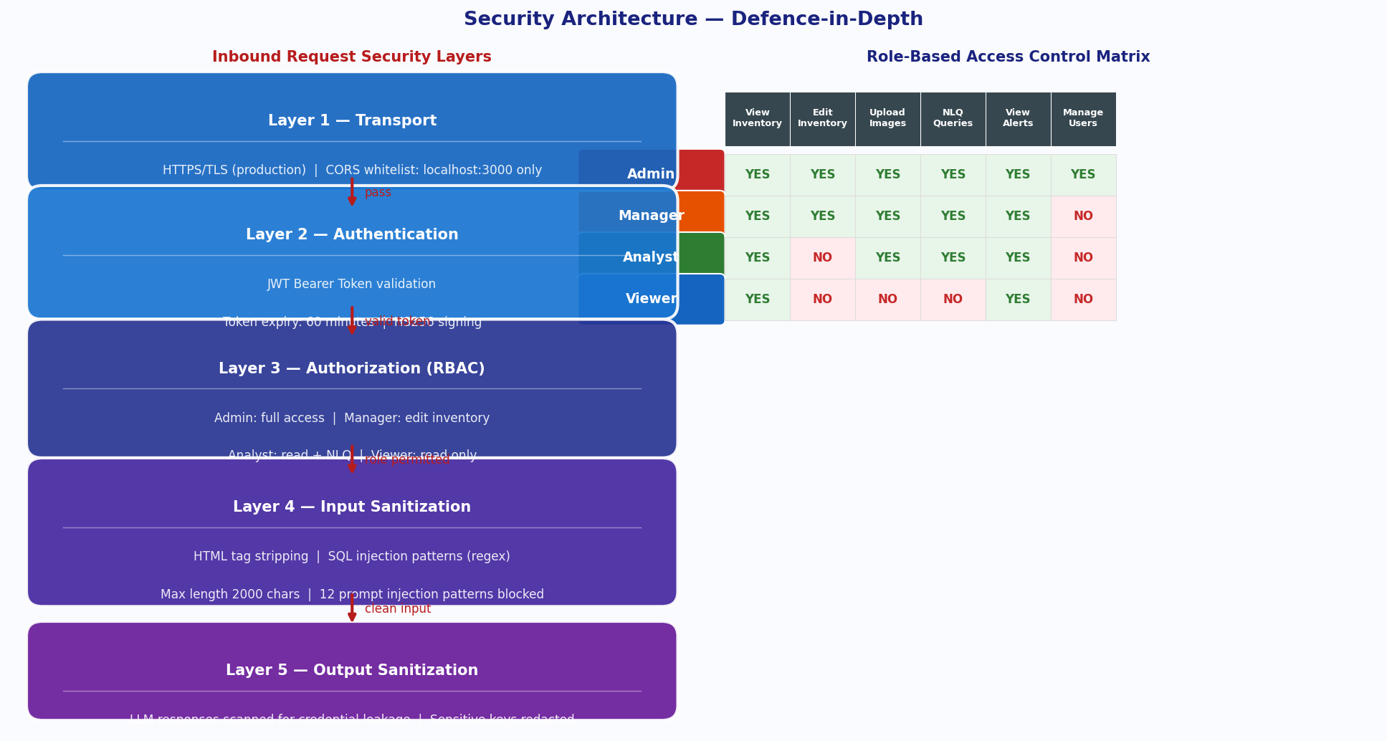
Figure: Security Architecture — Defence-in-Depth Layers & RBAC Matrix

6.1 Security Layers
Layer | Mechanism | Implementation
1 — Transport | HTTPS/TLS in production, CORS origin whitelist | FastAPI CORSMiddleware — allow_origins: [localhost:3000]
2 — Authentication | JWT Bearer tokens, HS256 signing, 60-min expiry | python-jose, OAuth2PasswordBearer, /auth/token endpoint
3 — Authorization | Role-based access control (Admin/Manager/Analyst/Viewer) | require_role() dependency injected per route
4 — Input Sanitization | HTML stripping, SQL injection regex, prompt injection guard | sanitize_input() — 12 regex patterns, 2000 char limit
5 — Output Sanitization | LLM response scanning for credential leakage | _sanitize_llm_output() — redacts sensitive key names

6.2 RBAC Permissions Summary
Role | View Inventory | Edit Inventory | Upload Images | NLQ Queries | Manage Users
Admin | YES | YES | YES | YES | YES
Manager | YES | YES | YES | YES | NO
Analyst | YES | NO | YES | YES | NO
Viewer | YES | NO | NO | NO | NO

6.3 LLM-Specific Security Guardrails
- Prompt Injection Prevention: 12 regex patterns detect and block attempts to override system instructions (e.g. "ignore previous instructions", "jailbreak", SQL injection patterns)
- Context Isolation: Live inventory data is injected as structured context, not user-controlled. The system prompt explicitly forbids revealing SQL, code, or internals
- Output Redaction: GPT-4o responses are scanned post-generation. Any occurrence of SECRET_KEY, DATABASE_URL, password, or similar terms is replaced with [REDACTED]
- Input Length Cap: Queries capped at 2000 characters to prevent token flooding attacks

7. API Design

7.1 REST Endpoints
Method | Endpoint | Description | Min. Role
POST | /auth/token | Login — returns JWT access token | Public
GET | /auth/me | Get current user info | Any
POST | /detection/upload | Upload shelf image — YOLOv8 inference + inventory update | Any
GET | /detection/history | List past detection events | Any
GET | /inventory/ | List all products with stock levels | Any
GET | /inventory/summary | Category-level stock summary | Any
PUT | /inventory/{id} | Update product quantity/location | Manager+
POST | /inventory/products | Create new product | Manager+
GET | /inventory/alerts | Get low-stock alerts | Any
PUT | /inventory/alerts/{id}/read | Mark alert as read | Any
POST | /nlq/query | Submit NL query — returns GPT-4o answer | Any
GET | /nlq/suggestions | Get pre-built query suggestions | Any
GET | /analytics/dashboard | Dashboard metrics + chart data | Any

7.2 Authentication Flow
All API routes (except /auth/token and /health) require a JWT Bearer token in the Authorization header. Tokens are obtained via POST /auth/token with username/password form data (OAuth2 password flow). The token encodes the username as the subject claim and expires after 60 minutes.

8. Frontend Architecture
The React SPA uses React Router v6 for client-side routing. All API calls go through a centralized Axios instance (api.js) that automatically attaches the JWT token and handles 401 redirects to the login page. No global state library is used — each page manages its own state with useState/useEffect.

8.1 Page Components
Page / Component | Route | Description
Login.jsx | /login | JWT login form with role demo hints
Dashboard.jsx | / | Summary stats + Recharts bar/line charts
Detection.jsx | /detection | Drag & drop image upload, YOLOv8 results table, inventory update display
InventoryPage.jsx | /inventory | Searchable product table, inline qty/location editing (role-gated)
NLQPage.jsx | /nlq | Chat interface for GPT-4o queries with suggested prompts
AlertsPage.jsx | /alerts | Low-stock alert list with mark-as-read, unread filter
App.jsx | (root) | Sidebar navigation, route definitions, auth state management
api.js | (service) | Axios instance — auto JWT header, 401 redirect, all API methods

8.2 State & Data Flow
- Authentication state stored in localStorage (token + user object). Cleared on logout or 401 response
- Each page fetches its own data on mount via useEffect — no shared global store
- All mutations (inventory edit, alert read) immediately re-fetch data to keep UI in sync
- Recharts components receive chart data directly from /analytics/dashboard API response

9. Deployment Architecture

9.1 Local Development (VS Code)
Backend | uvicorn main:app --reload on port 8000. Virtual environment with venv. Auto-reloads on file save.
Frontend | npm start on port 3000. package.json proxy routes /api/* to localhost:8000.
Database | PostgreSQL 17 as Windows Service on port 5432. Redis as Windows Service on port 6379.
LLM | OpenAI GPT-4o via API — requires OPENAI_API_KEY in backend/.env

9.2 Docker Compose
The docker-compose.yml defines four services: postgres (PostgreSQL 15 with health check), redis (Redis 7 Alpine), backend (FastAPI with hot-reload volume mount), and frontend (React dev server). Ollama is NOT containerized — it runs on the host machine to access GPU resources, and is reachable from the backend container via host.docker.internal.

9.3 Production Deployment (Phase 5 — AWS/GCP)
Component | Target Service | Notes
Backend API | AWS ECS Fargate / GCP Cloud Run | Containerized FastAPI — horizontal scaling
Frontend | AWS S3 + CloudFront / GCP Firebase | Static React build with CDN
Database | AWS RDS PostgreSQL / GCP Cloud SQL | Managed DB — automated backups, failover
Cache | AWS ElastiCache Redis / GCP Memorystore | Managed Redis cluster
LLM | OpenAI API (external) | No hosting needed — API key based
Container Registry | AWS ECR / GCP Artifact Registry | Store Docker images
Secrets | AWS Secrets Manager | Store DB credentials, API keys

10. Project Timeline & Phases
Phase | Activities | Duration | Status
Phase 1 — Research & Data | Project kickoff, literature review, dataset collection (SKU-110K, RPC, COCO), EDA | 3 weeks | In Progress
Phase 2 — Model Development | YOLOv8 baseline training, classifier training, transfer learning & backbone optimisation | 4 weeks | Upcoming
Phase 3 — Integration | LLM NLQ interface, real-time inventory tracking engine | 2 weeks | Upcoming
Phase 4 — Security & Testing | RBAC implementation, analytics dashboard, E2E integration testing | 3 weeks | Upcoming
Phase 5 — Deployment | Pilot deployment, UAT, final documentation | 2 weeks | Upcoming

11. Glossary
YOLOv8 | You Only Look Once v8 — real-time single-pass object detection model by Ultralytics
COCO | Common Objects in Context — 330K image dataset for general object detection pre-training
SKU-110K | Dataset of 110,000+ retail shelf images for dense object detection fine-tuning
CLIP | Contrastive Language-Image Pre-training — OpenAI model for cross-modal embeddings
FastAPI | Modern Python web framework for building REST APIs with automatic OpenAPI docs
JWT | JSON Web Token — compact, URL-safe token for stateless authentication
RBAC | Role-Based Access Control — permissions granted based on user role, not individual identity
NLQ | Natural Language Query — querying a database using plain English instead of SQL
NMS | Non-Maximum Suppression — post-processing step to remove duplicate bounding boxes
SQLAlchemy | Python ORM (Object Relational Mapper) for database abstraction
Redis | In-memory data store used for caching and real-time session management
GPT-4o | OpenAI's multimodal large language model used for the NLQ interface

