AI EXTENSION IN PLAYWRIGHT / TYPESCRIPT
Prompt :
In ASK mode :
Prompt : Analyse the entire codebase and understand the implementation for Java/Selenium page class generation logic.
Extend the extension's capabilities to generate equivalent page classes for Playwright and TypeScript.
This new option should mirror the functionality currently available for Java/Selenium.
List all the impacted files.

Prompt 2 :
Agent mode : Step by Step, Implement for Playwright/TypeScript, with the exact same logic that is present for Java selenium
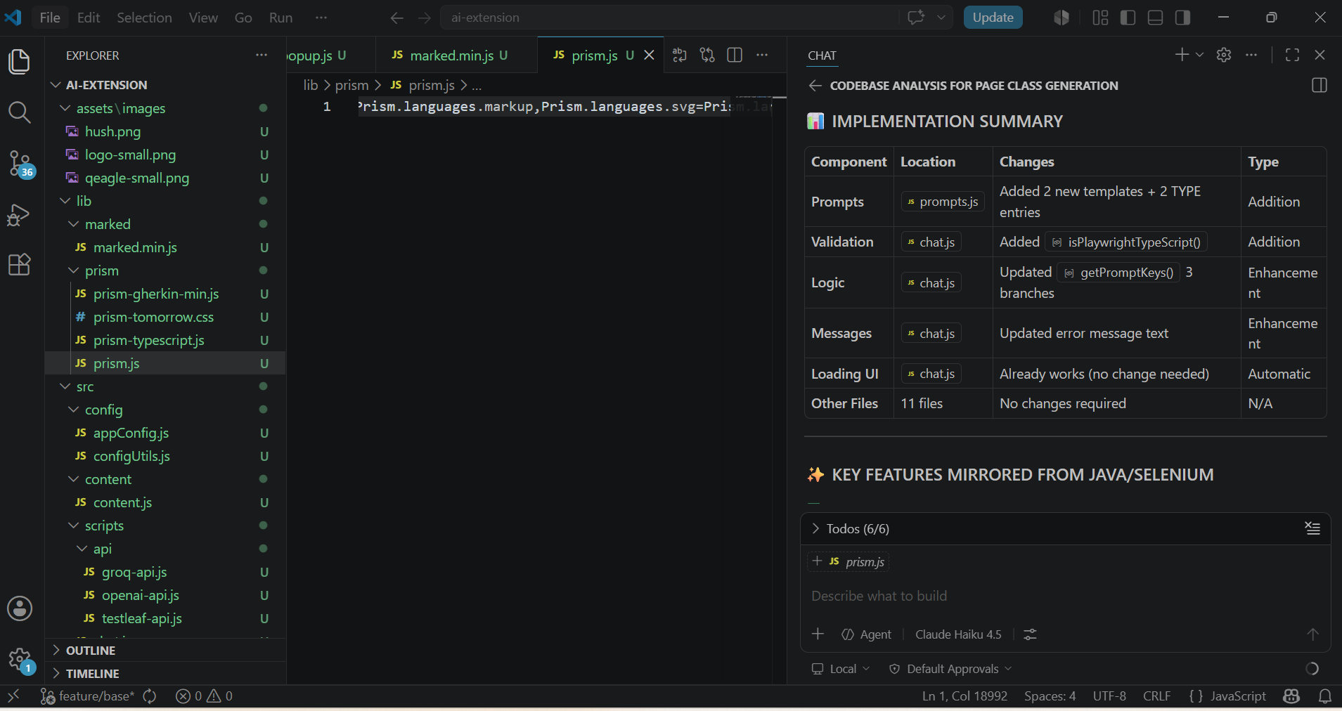

Typescript and Playwright Selected :
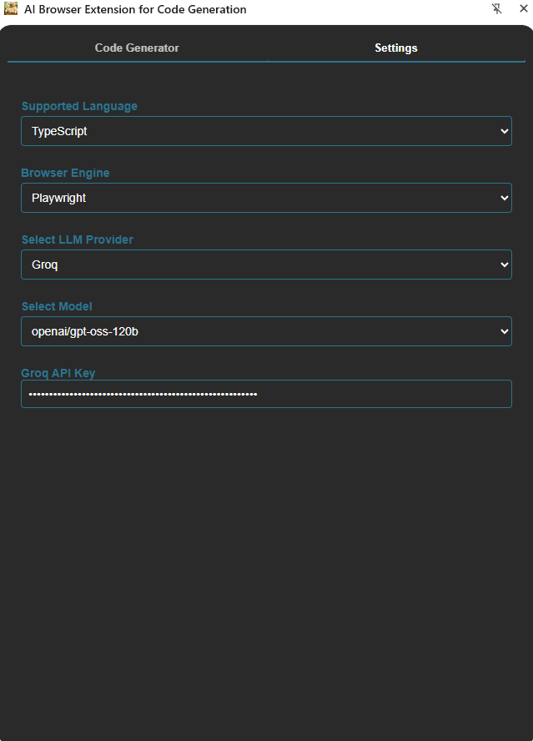

Feature File Only :

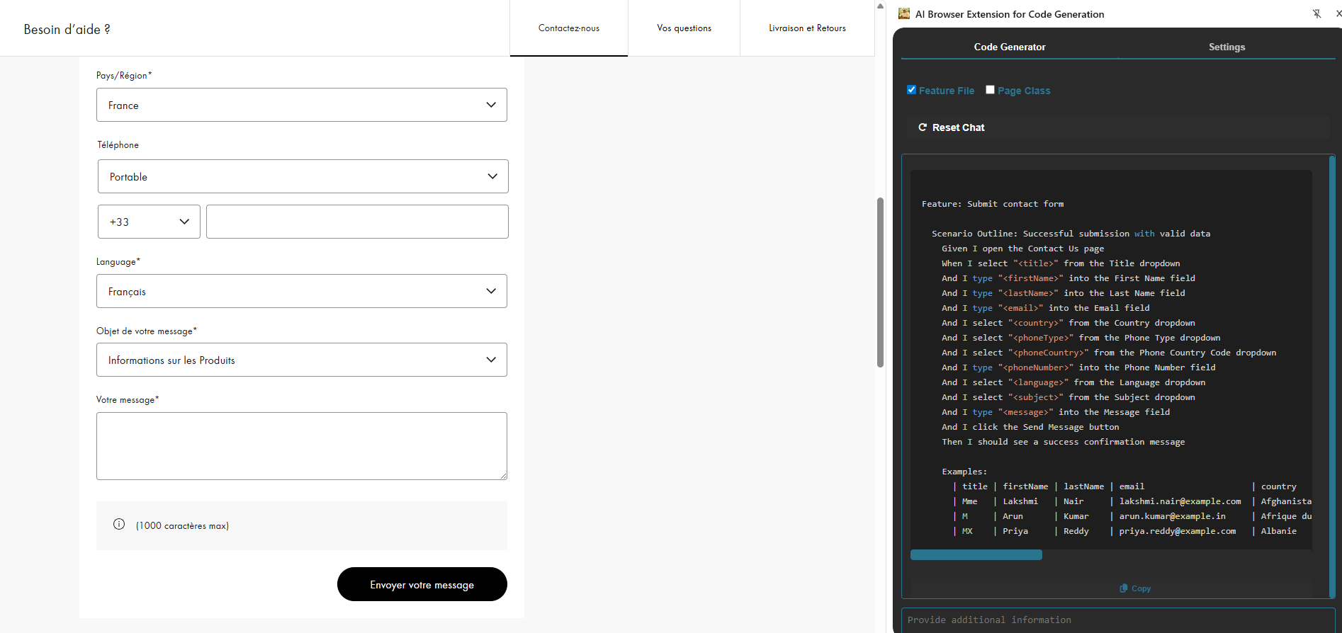

Page Class Only Selected:
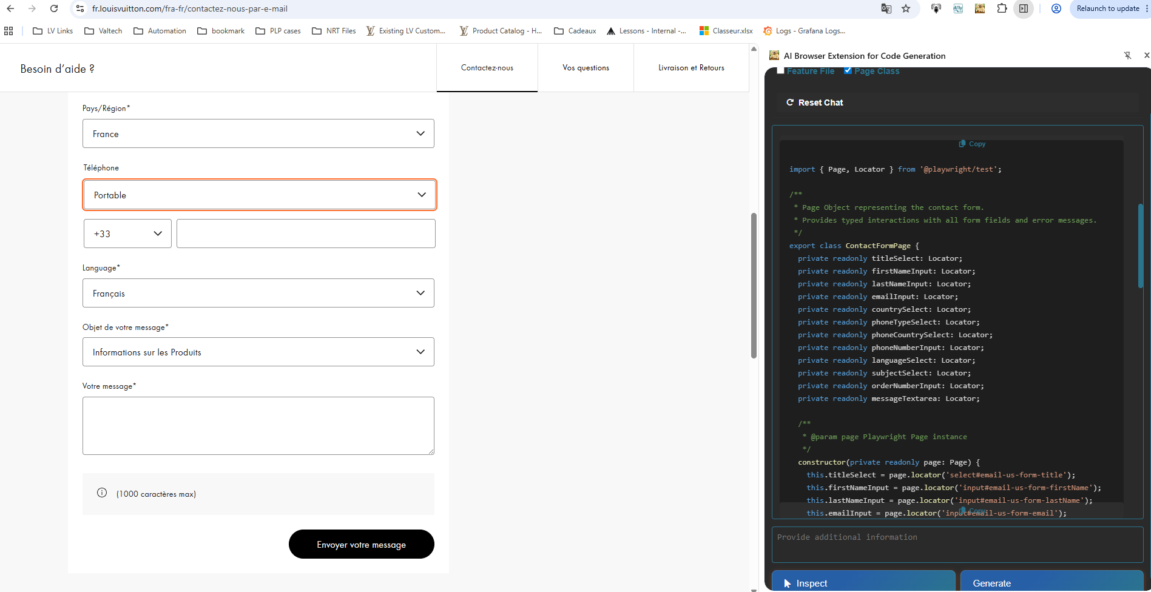

Feature file and Page Class Selected :
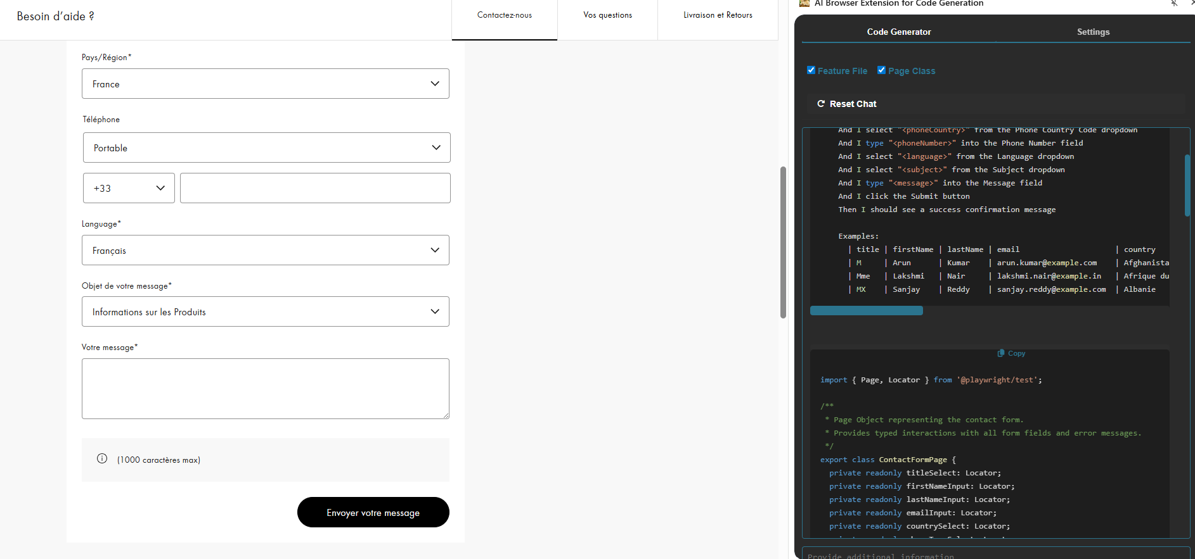

Feature: Submit contact form
Scenario Outline: Successful submission of the contact form with valid data
Given I open the contact form page
When I select "<title>" from the Title dropdown
And I type "<firstName>" into the First Name field
And I type "<lastName>" into the Last Name field
And I type "<email>" into the Email field
And I select "<country>" from the Country dropdown
And I select "<phoneType>" from the Phone Type dropdown
And I select "<phoneCountry>" from the Phone Country Code dropdown
And I type "<phoneNumber>" into the Phone Number field
And I select "<language>" from the Language dropdown
And I select "<subject>" from the Subject dropdown
And I type "<message>" into the Message field
And I click the Submit button
Then I should see a success confirmation message

Examples:
| title | firstName | lastName | email | country | phoneType | phoneCountry | phoneNumber | language | subject | message |
| M | Arun | Kumar | arun.kumar@example.com | Afghanistan | Portable | +1 (US) | 9876543210 | Deutsch | Informations sur les Produits | Bonjour, je souhaite obtenir des informations sur les produits disponibles. |
| Mme | Lakshmi | Nair | lakshmi.nair@example.in | Afrique du Sud | Domicile | +1 (CA) | 9123456789 | Português| Service Après-Vente | Bonjour, j'ai besoin d'aide pour la réparation de mon appareil. |
| MX | Sanjay | Reddy | sanjay.reddy@example.com | Albanie | Bureau | +7 | 9988776655 | Östrich | Commandes en ligne | Bonjour, je souhaite passer une commande en ligne. |

Page class :
import { Page, Locator } from '@playwright/test';

/**
* Page Object representing the contact form.
* Provides typed interactions with all form fields and error messages.
*/
export class ContactFormPage {
private readonly titleSelect: Locator;
private readonly firstNameInput: Locator;
private readonly lastNameInput: Locator;
private readonly emailInput: Locator;
private readonly countrySelect: Locator;
private readonly phoneTypeSelect: Locator;
private readonly phoneCountrySelect: Locator;
private readonly phoneNumberInput: Locator;
private readonly languageSelect: Locator;
private readonly subjectSelect: Locator;
private readonly orderNumberInput: Locator;
private readonly messageTextarea: Locator;

/**
* @param page Playwright Page instance
*/
constructor(private readonly page: Page) {
this.titleSelect = page.locator('select#email-us-form-title');
this.firstNameInput = page.locator('input#email-us-form-firstName');
this.lastNameInput = page.locator('input#email-us-form-lastName');
this.emailInput = page.locator('input#email-us-form-email');
this.countrySelect = page.locator('select#email-us-form-country');
this.phoneTypeSelect = page.locator('select#email-us-form-phone-phoneNumberType');
this.phoneCountrySelect = page.locator('select#email-us-form-phone-phoneNumberCountry');
this.phoneNumberInput = page.locator('input#email-us-form-phone-phoneNumber');
this.languageSelect = page.locator('select#email-us-form-language');
this.subjectSelect = page.locator('select#email-us-form-subject');
this.orderNumberInput = page.locator('input#email-us-form-orderNumber');
this.messageTextarea = page.locator('textarea#email-us-form-text');
}

/** Select a title (e.g., "Mme", "M", "MX") */
async selectTitle(value: string): Promise<void> {
await this.titleSelect.selectOption({ value });
}

/** Fill the first name field */
async fillFirstName(firstName: string): Promise<void> {
await this.firstNameInput.fill(firstName);
}

/** Fill the last name field */
async fillLastName(lastName: string): Promise<void> {
await this.lastNameInput.fill(lastName);
}

/** Fill the e-mail field */
async fillEmail(email: string): Promise<void> {
await this.emailInput.fill(email);
}

/** Select a country by its option value (e.g., "FRA", "US") */
async selectCountry(value: string): Promise<void> {
await this.countrySelect.selectOption({ value });
}

/** Select phone type (e.g., "mobile", "home", "work") */
async selectPhoneType(value: string): Promise<void> {
await this.phoneTypeSelect.selectOption({ value });
}

/** Select phone country code (e.g., "CA", "US", "RU") */
async selectPhoneCountry(value: string): Promise<void> {
await this.phoneCountrySelect.selectOption({ value });
}

/** Fill the phone number field */
async fillPhoneNumber(number: string): Promise<void> {
await this.phoneNumberInput.fill(number);
}

/** Select a language by its option value (e.g., "FRA", "POR") */
async selectLanguage(value: string): Promise<void> {
await this.languageSelect.selectOption({ value });
}

/** Select a subject by its option value */
async selectSubject(value: string): Promise<void> {
await this.subjectSelect.selectOption({ value });
}

/** Fill the hidden order number field */
async fillOrderNumber(orderNumber: string): Promise<void> {
await this.orderNumberInput.fill(orderNumber);
}

/** Fill the message textarea */
async fillMessage(message: string): Promise<void> {
await this.messageTextarea.fill(message);
}

/**
* Retrieve the error message associated with a given field.
* @param fieldId The base id of the field (e.g., "title", "firstName")
* @returns The error text or null if not visible
*/
async getFieldError(fieldId: string): Promise<string | null> {
const errorLocator = this.page.locator(`#${fieldId}-error-message`);
if (await errorLocator.isVisible()) {
return await errorLocator.textContent();
}
return null;
}
}

