Technical Design Document

Project name: **ABC Loan Service.**

* Sivaramakrishnan (46022103)

**Introduction:**

ABC Loans is created to meet the needs of Customers of ABC Bank to apply a Loan online Instantly. The architecture implemented is Spring Boot services.

**Functional Requirements:**

The functional requirements of the project are:

* Login/Register
* View Profile
* Edit Profile
* Apply Loan
* Show Balance
* Calculate EMI
* Pay EMI
* Foreclose
* Print Transactions

**Service**

Loan Service in this project is:

* + - Register - Create an Account in ABC Bank.
    - Apply Loan - To Apply a Loan with an ABC Bank Account.
    - Show Balance - To Get balance details of a Customer.
    - Calculate EMI - To Calculate EMI for the existing Loan Account (or)

To calculate EMI for customized parameters.

* + - Pay EMI - To Pay EMI for the Existing Loan Account.
    - Foreclose - To foreclose the pending Loan account.
    - Payment Interface - To deposit, Pay EMI, Foreclose loan with transaction

Password verification.

* + - Print Transactions - To Print all the Transactions made by the customer.

**Overall Architecture Diagram:**

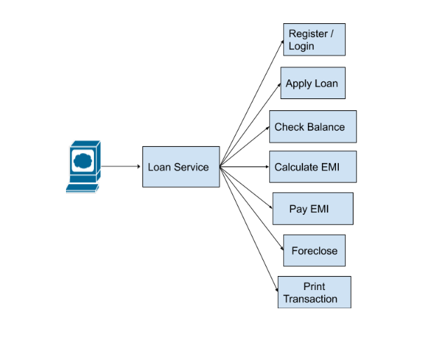

**Overall Entity Relationship Diagram:**

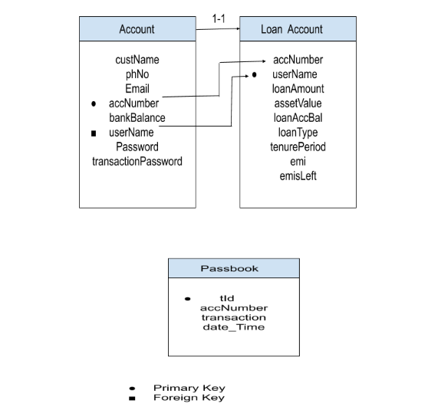

**Class Diagram :**

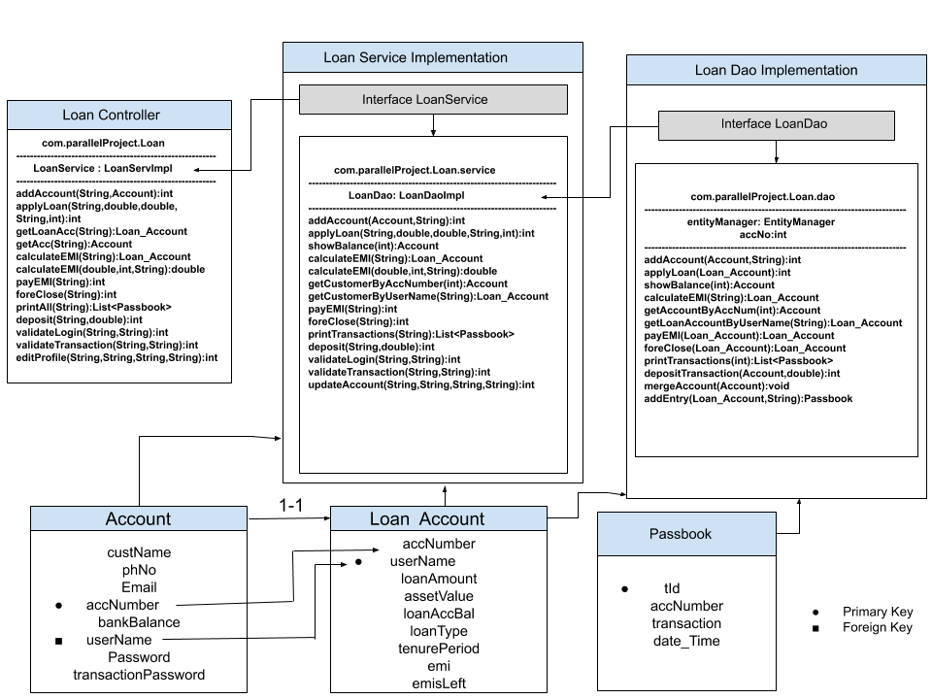

**Activity Diagrams:**

**Login:**

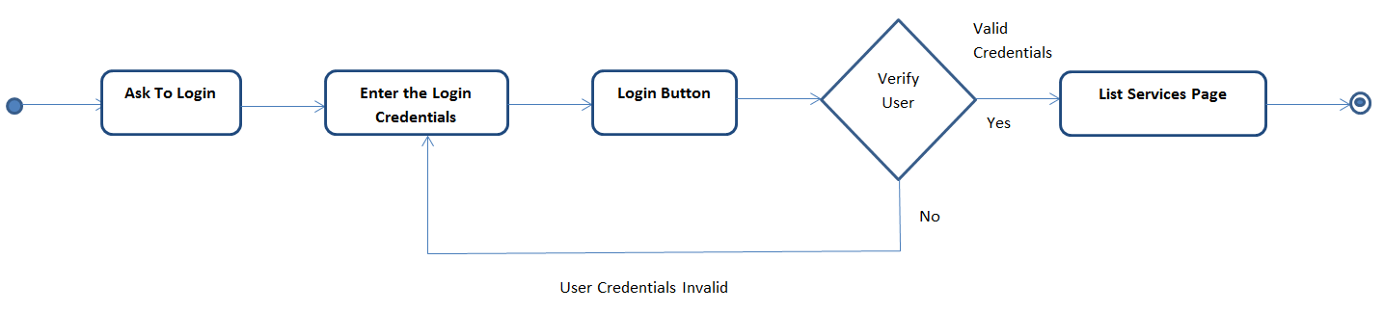

**Register/Sign Up:**

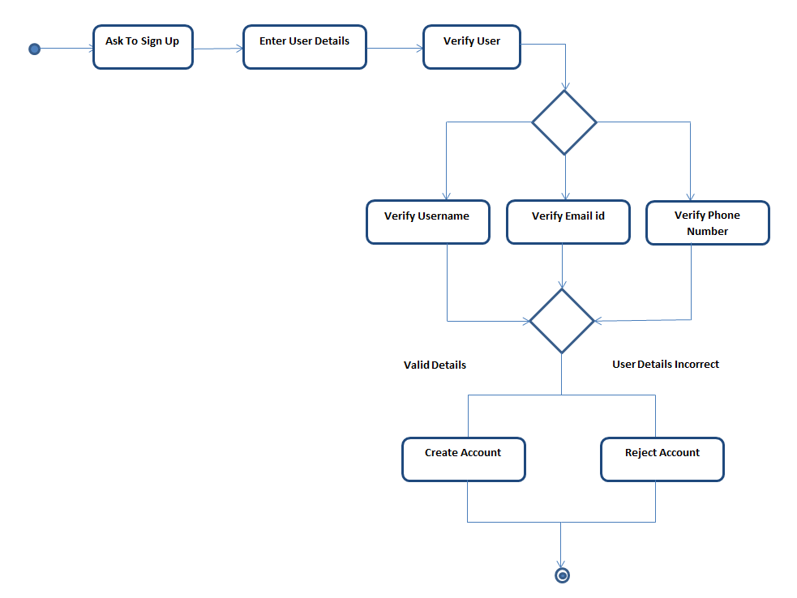

**Apply Loan:**

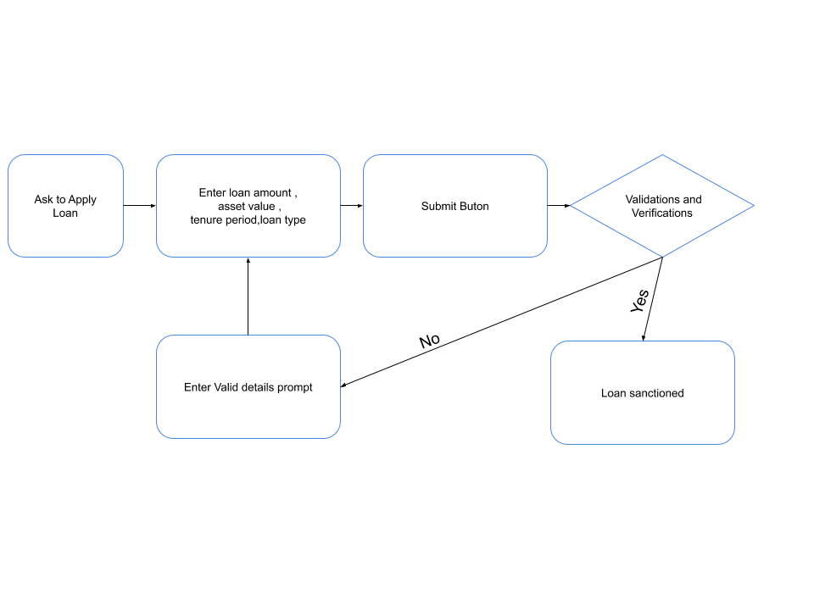**Check Account Balance:**

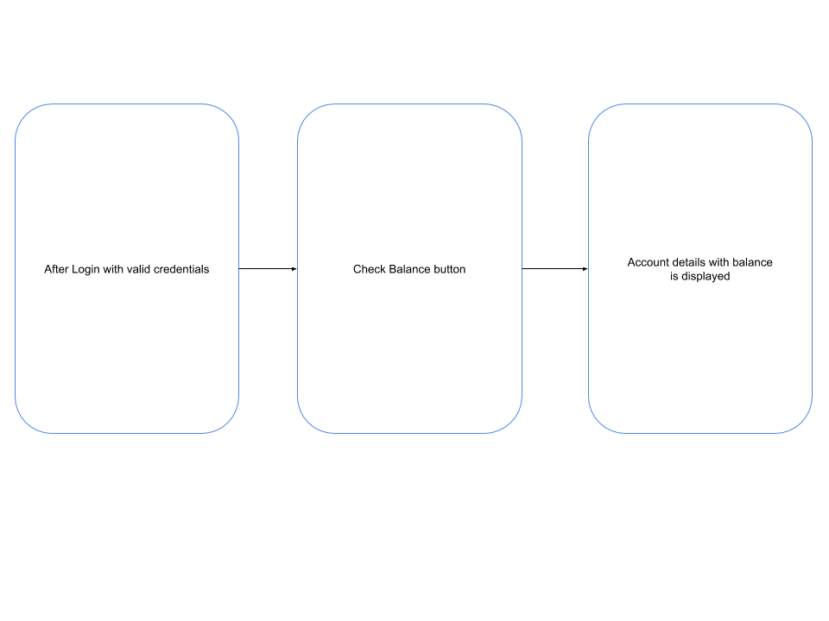

**Deposit:**

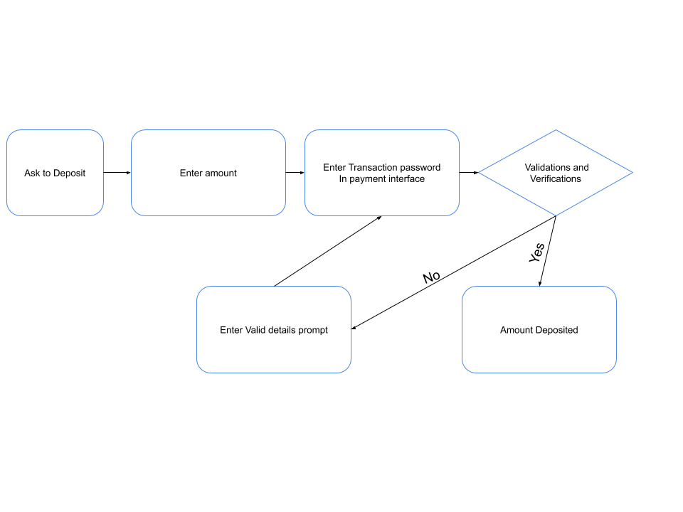**Foreclose:**

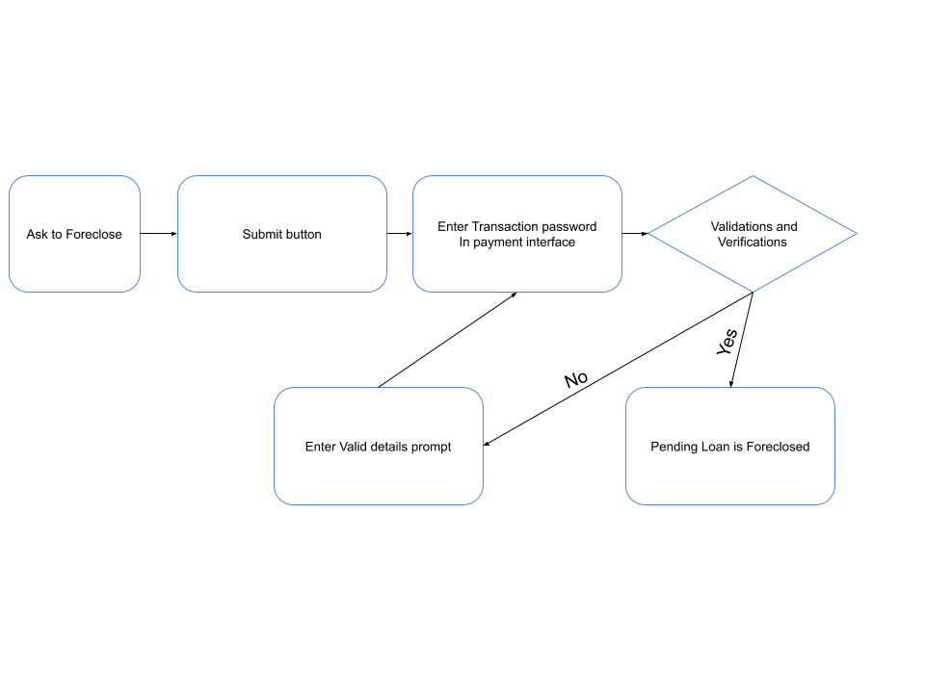

**Print Transactions :**

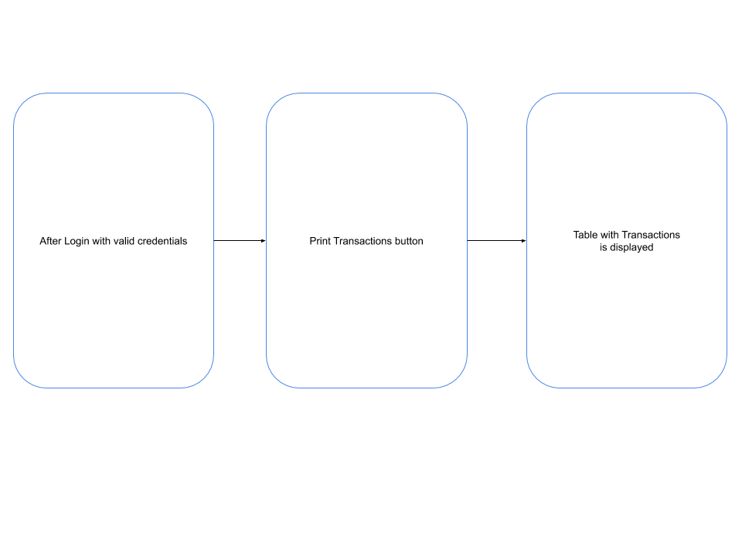**Calculate EMI:**

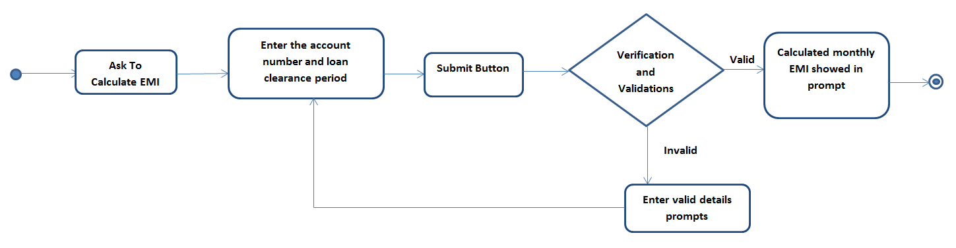

**Pay EMI:**

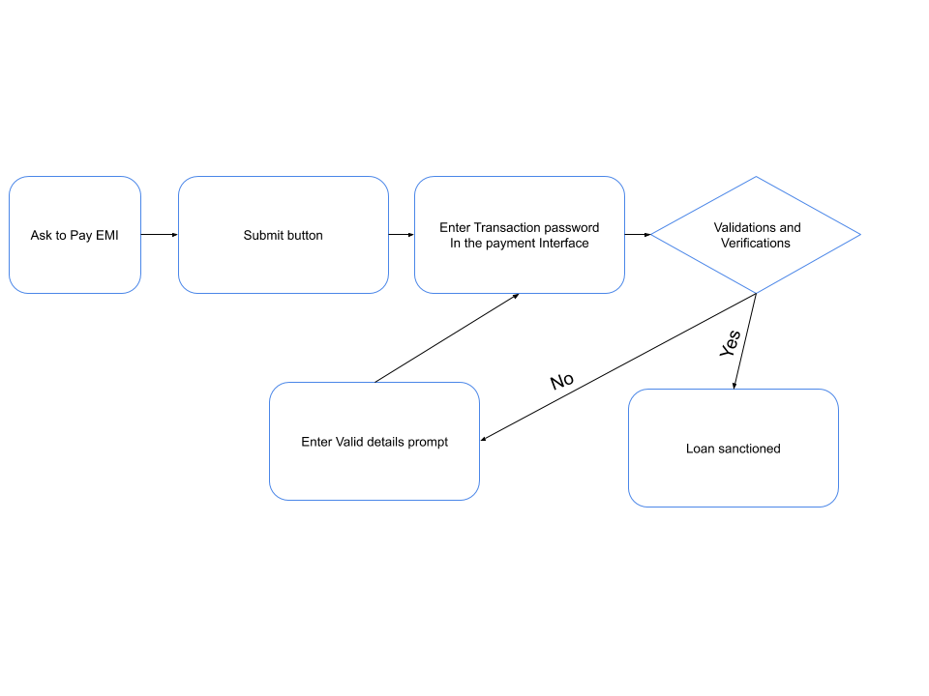

**WIREFRAMES:**

**Home Page:**

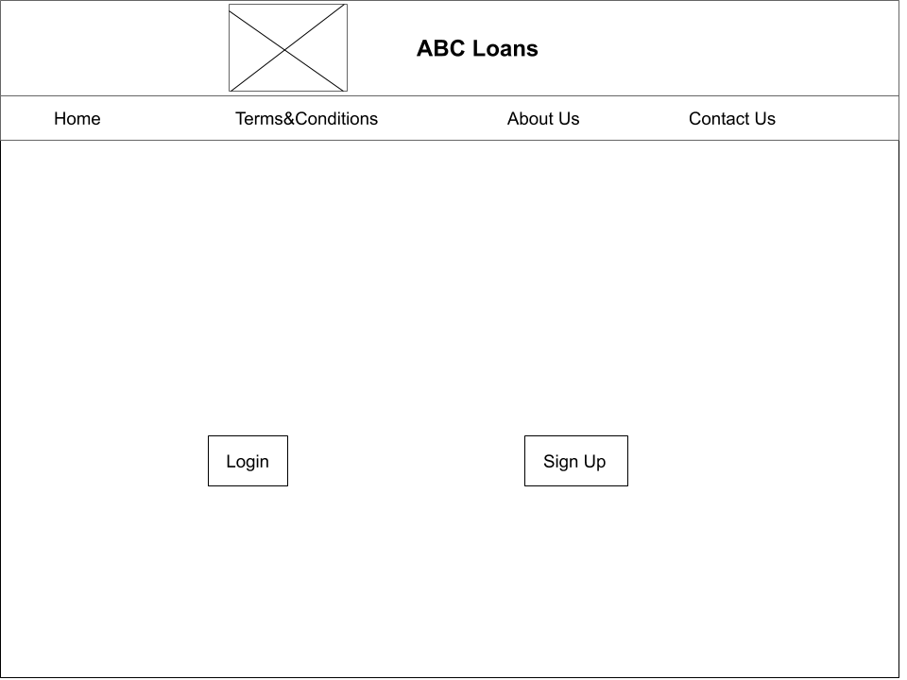

**LOGIN:**

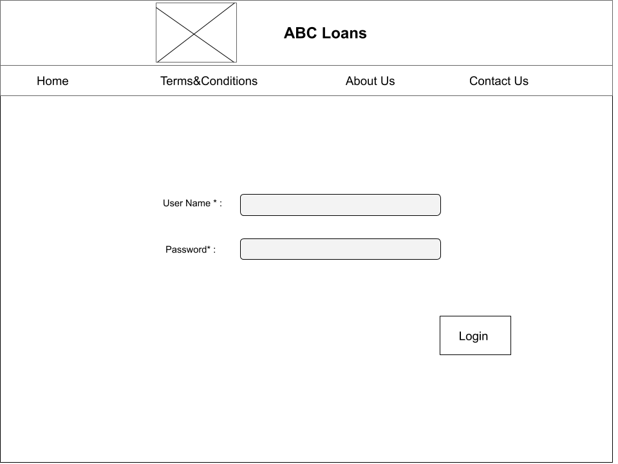

**SIGN UP:**

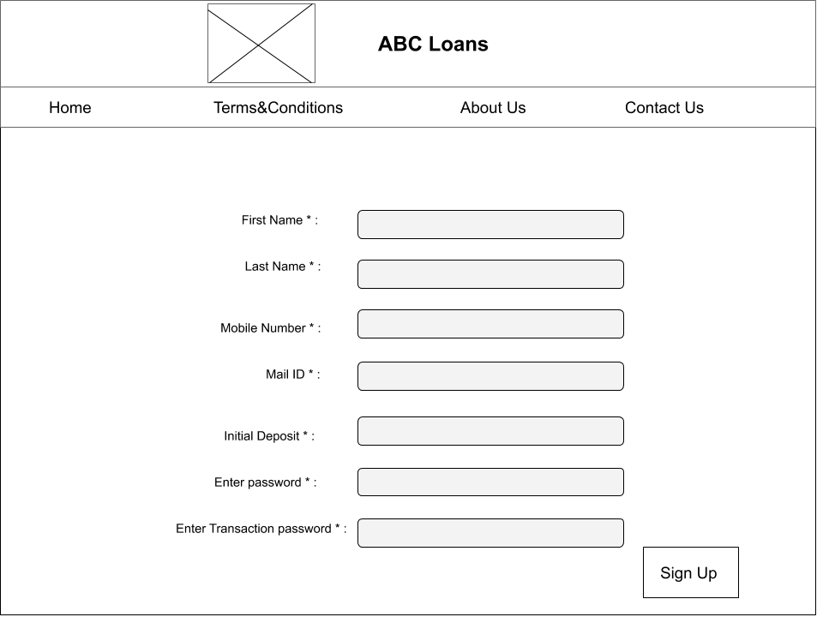

**Apply Loan:**

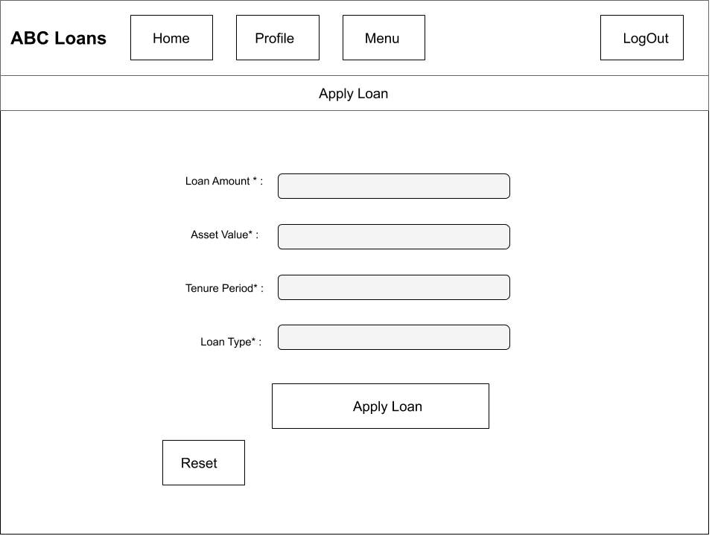

**Loan Details :**

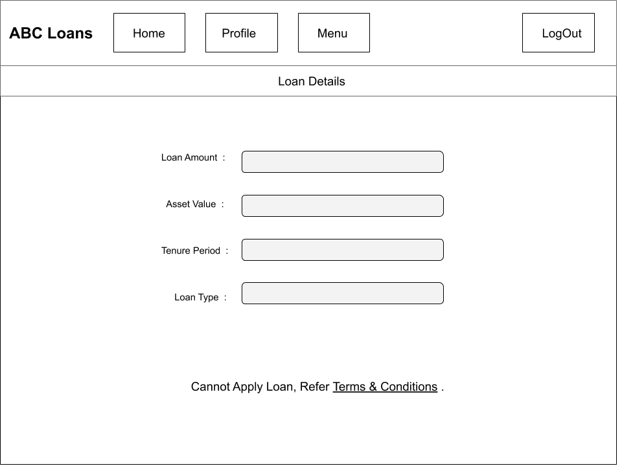

**Check Balance :**

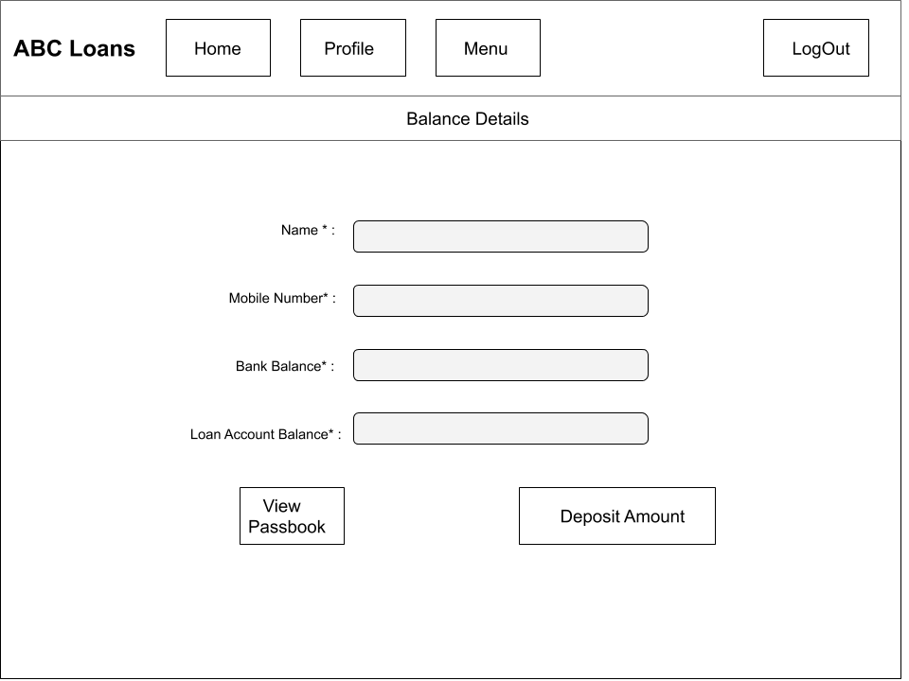

**Deposit :**

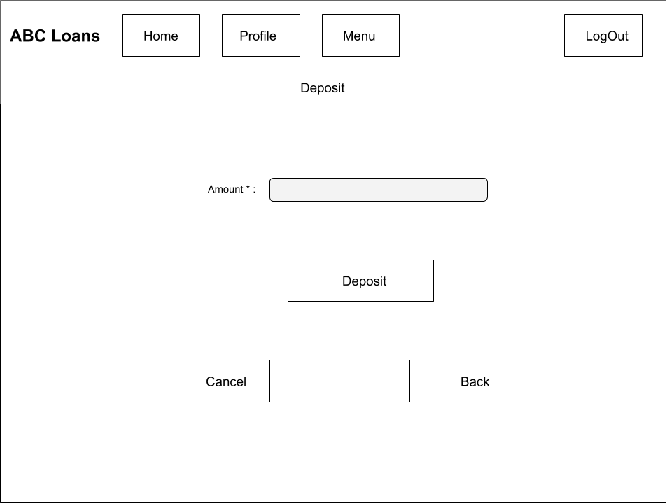

**Calculate EMI :**

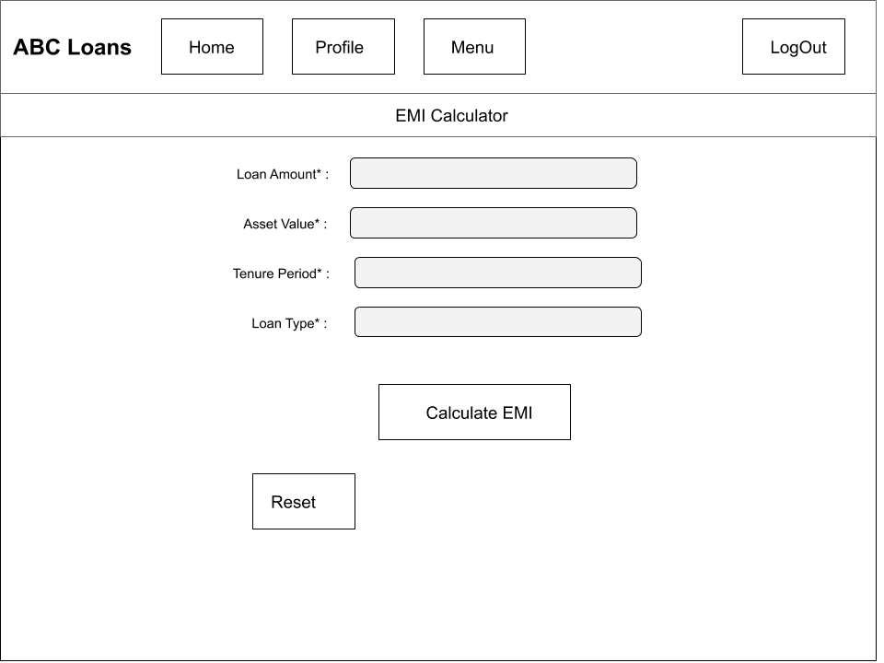

**Pay EMI :**

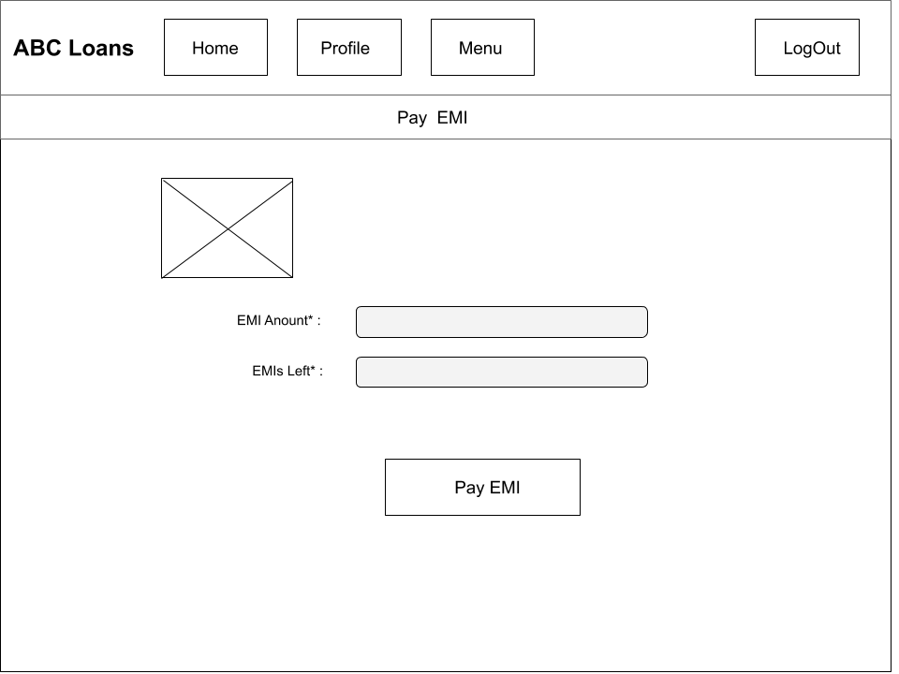

**Foreclose :**

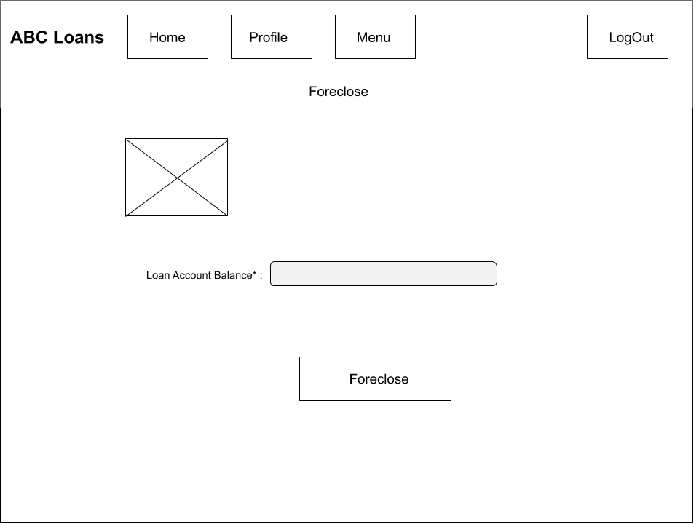

**Print Transactions :**

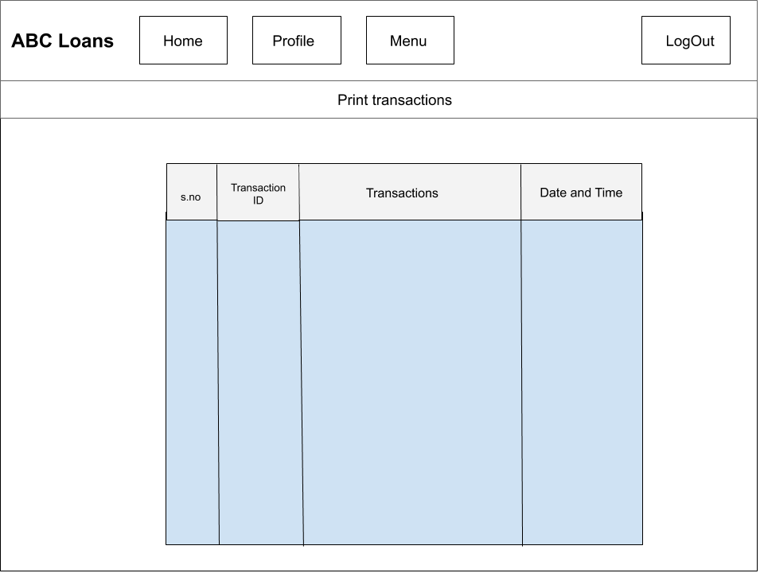

**Payment Interface :**

