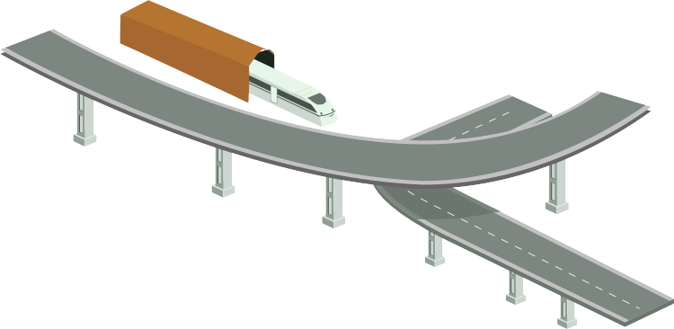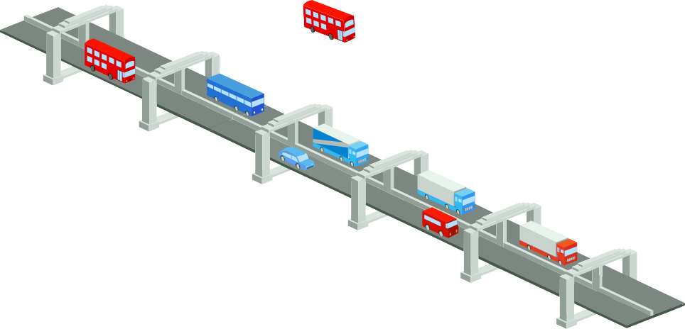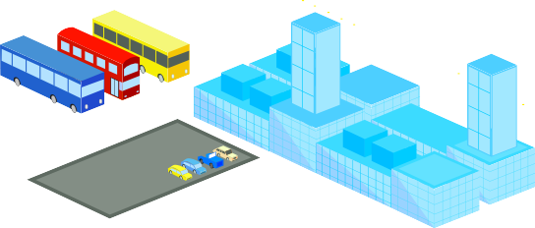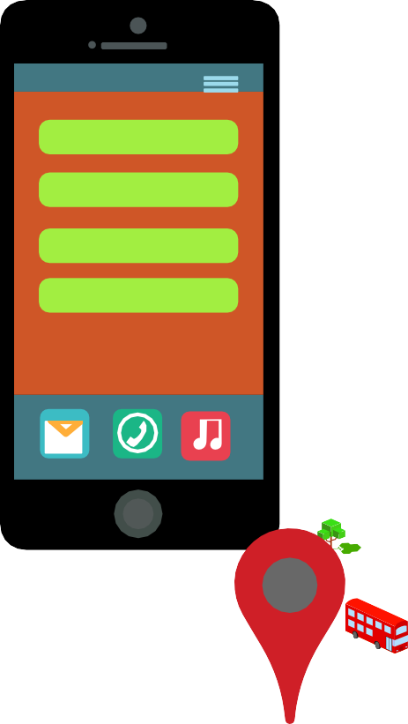

Enabling Intelligent Public Transportation Using IOT

**Seats vacant - 5**

**Speed - 60 kmph**

**Destination- x town**

**Reach next stop in 5 minutes**

Contents

Introduction. 3

Need and Benefit Analysis. 3

Broad Overview of Intelligent Transport System. 4

ITS – Real Life Use Cases Snapshot 4

ITS Scenario – Detailed Analysis. 5

Sensors required. 7

Payment methodology 7

Bus Maintenance System. 8

Profiling of the customers using CRM. 8

Tracing and tracking of special passengers like kids and woman for the safety purpose. 8

Current Practice Analysis. 9

# Introduction

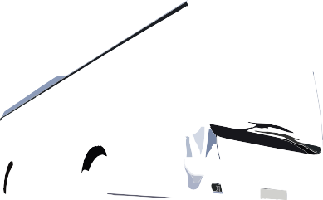

Transportation is the respiratory system of our economy as every day the world relies on a complex network of transportation system responsible for facilitating full range of human activities sustaining the civilization. According to a recent study US road traffic congestion in 2007 wasted 2.8 billion gallons of fuel and 4.2 billion hours, costing a whopping $ 87.2 Billion. In India around 5 lakhs road accidents happens, causing a loss of around $20 billion, getting 6 lakhs people injured and 1.5 lakhs getting killed. Every year, nearly 36,000 vehicles are stolen. Traffic congestion costs the European Union over 1% of GDP i.e. 100 Billion Euros per year.

These concerns, seeds the need of transformative change for World’s Transportation System by enhancing road Safety to commuters and driver, providing convenience and safety to use public transport, integrating Paratransit and Mass Transit modes, optimizing the emergency services by reducing time to respond, regulate driving behavior reducing accidents , manage city traffic by optimizing route reducing commutation time, automate toll collection reducing waiting time, control pollution caused by vehicles etc.

This is one of the most interesting times in Intelligent Transportation System as the developing countries have an advantage over the developed countries, where they can optimize their existing model by leveraging the forces of Social, Mobile, Analytics and Cloud.

Need and benefits analysis

This would give a "bird's-eye view" on unleashing the [IoT](http://www.happiestminds.com/Insights/internet-of-things/) potential and exploring new vistas for the developing nations, encompassing the major challenges and lessons learnt from the real life use cases implemented in developed nations like (Japan, South Korea, US, UK, Australia). It provides a holistic point of view for developing nations to implement ITS and the benefit they have over the developed nations on the following

* Enhancing efficiency and convenience to use public transport, connecting paratransit and mass transit modes.
* Optimize Emergency services saving lives and reducing road congestion contributing back to GDP.
* Provide Road Safety to commuters and drivers by regulating driving behavior and managing optimized routes
* Enable Parking assistance and Automated Road Tolling
* Create Vehicle to Vehicle and Vehicle to Infrastructure ecosystem and leveraging the Smart Phone Ecosystem
* Fleet Management, Vehicle Management and Track & trace Management

# Broad Overview of Intelligent Transport System

Remote Traveller Support

Traffic Management

Emergency

Management

Toll Administration

Commercial Vehicle Administrtaion

Maintenance & Construction Management

Personal Information Access

Information Service Provider

Emissions

Management

Transit Management

Fleet and Freight

Management

Achieved Data Management

Wide Area Wireless (Mobile)

Communications

Dedicated Short Range

Communications

Wireline (Fixed-Point to Fixed -Point) Communications

Vehicle

Vehicle to Vehicle Cmmunication

Emergency Vehicle

Commercial

Vehicle

Transit

Vehicle

Maintenance &

Roadway

Toll Collection

Parking Management

Commercial

Vehicle Check

Construction

Vehicle

Vehicles

Roadside

**Intelligent transport system – Real Life Use Case Scenarios**

Fleet Management

**Commuters**

**Traffic Planners**

**Transport Infra**

**Vehicle OEMs**

**Urban Development**

Utility Vehicle Management

Emergency Response

Public Safety

Waste Collection Management

Automated Pollution Control Check

Advanced Traffic Mngmt. System

Over Speeding Monitoring

Real-Time Passenger Information system

Automatic Passenger Counting

CCTV Junction Surveillance

E-Calling

Intelligent Transit Trip Planner

Personal car: Theft Prevention & Safety

Non-intruding Infotainment systems and Phones

Emergency Response

Employee Commutation

Management Inventory Tracking

Radio Taxi Management

School Bus Management System

Vehicle Diagnostic

Performance Report

Product Performance

Smart parking

Road Toll Collection

Smart Signals Smart Roads

Zebra Crossing Automation

Digital Signage

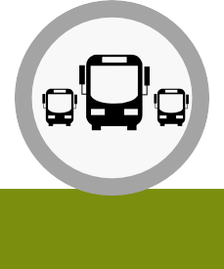

Intelligent Road Transport System Scenario - A Detailed Analysis

Public transportation is reducing energy consumption and harmful carbon dioxide (CO2) greenhouse gas emissions that damages the environment. Traveling by public transportation uses less energy and produces less pollution as compared to travel in private vehicles.

To make progress in reducing our dependence on foreign oil and impacting climate change, public transportation must be part of our [M2M](http://www.happiestminds.com/m2m/)

solution.

State Transport system in India is inefficient and slack. Lots of buses are involved in the public transport; they run on the scheduled time every day. The system has many problems that could be resolved by implementing [M2M solutions](http://www.happiestminds.com/m2m/). We have discovered some the problems that could be considered for Indian scenario.

|  |
| --- |
| **Note:**  The Use Case is prepared by considering the Indian scenario rather than referring other countries’ systems. Some of the recommendations would be for green field and some of them could be adopted by the existing system. |
| **Objectives:**   * To develop a Smart system that could benefit RTC (Road Transport Corporation) as well as the passengers * To develop a business model where operator can act as an Enterprise Service Provider * To encourage the passenger to use public transport for commuting there by reducing traffic congestion, air pollution etc. |
| **Problems:**   * Overloaded buses * Less frequency of buses * Breakdown of buses (e.g. proper maintenance & BCP) * Planning and priority on the basis of availability and urgency of the service provision (e.g. traffic system and priority management system integration) * Accidents by public transport vehicles due to rash driving |
| **Requirements:**   * GPS devices * Wheel speed sensors * Torque sensors * Sensors measuring the health of the vehicle |
| **Basic Infrastructure Requirement:**   * Wi-Fi at each bust stop and each bust depot |
| **Planning and managing the buses:**  The basic requirements for the use case is that all the Bus depot are connected to each other and all the small bus stands will be connected to the respective depots of the town. The source depot will update the departure time of the bus to all the bus stands and the destination depot. GPS tracking and tracing systems will provide the information about how far the bus is from the destination and the estimated time  of arrival. The number of the passengers waiting at the respective bus stand will be updated frequently. |

###### Bus Stand

A

###### Bus depot of the town B x

###### Bus depot of

E the town F

###### y

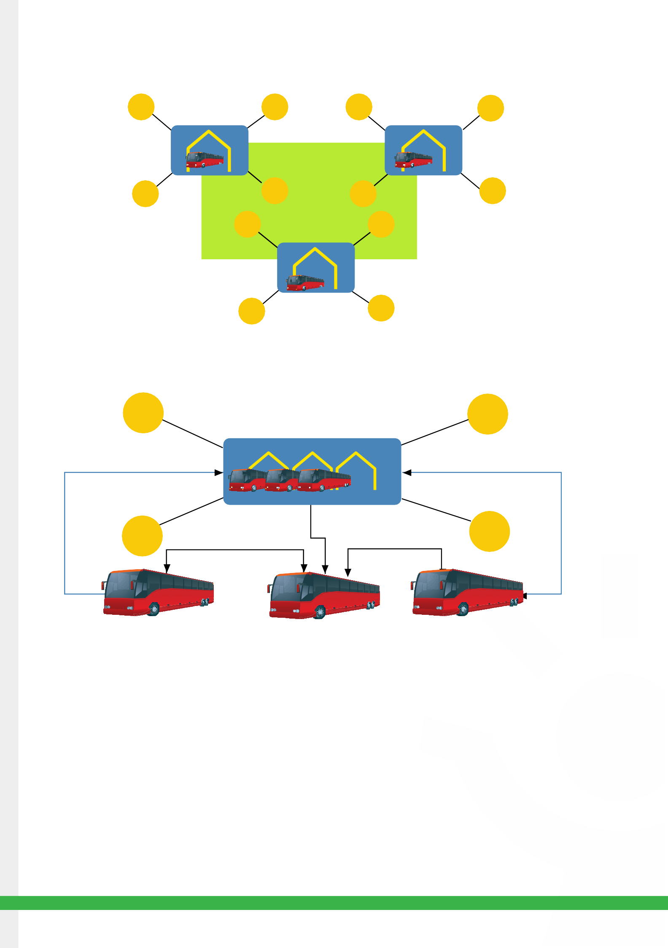

D C H G

I J

###### L Bus depot of K

###### the town

###### Figure 1 Communication in between all the bus depots and all the Bus stands

A B

###### Bus depot of the town

D C

##### Communication between various spots when buses are travelling from source to destination

(Assumption: Bus depot will have the buses in the buffer; passengers will travel from X to Y town)

Here, one scenario is discussed where at different times buses will depart from the depot X for the destination depot Y. The route will cover all the bus stops in between and bus timings are already predefined.

* Bus will depart from X depot with 50 vacant seats.
* It will pick up 30 passengers from 1st bus stop then the dashboard at the bus stop will display the information as shown in the

below diagram.

* After filling up the seats at the 2nd bus stop the bus will communicate with the bus depot X and also with all the bus stop regarding no

vacant seats.

•. Bus depot will make the arrangement of another bus and it will send the notification to all the bus stop about the departure and arrival time of the bus.

* At the same time bus will be notified about the passengers waiting at the 3rd and 4th bus stop.

Scenario when the bus travels from source to destination

Scenario when the bus travels from source to destination

**Information 1**: The bus will update the source bus depot regarding the no space in the bus and the depot will get the information about the number of passengers waiting at all the bus stand

**Information 2**: Depot will notify the bus stand 3 & 4 about the arrival timing of the bus.

Information 1& Information 2

A B E F

Bus stop

D C

Bus stop

Bus stop

Bus stop H G

Bus will leave with 1

50 empty seats

2 3 4

Dashboard at the bus stop Bus number

Destination of the bus Arival time of the bus Vacant seats

Updated details will be

Showed at the cashboard

There are more passengers waiting at the stand no 3&4

Now the dashboard will show the arrival time

Fuel monitoring and efficiency measurement system, control of air pollution & tracking of the driver’s driving behavior: The fuel prices are rising day by day. It’s been necessary to monitor the vehicle’s fuel consumption/usage and the efficiency, so that the frauds can be avoided and the efficiency of the vehicle could be maintained



# Sensors required

* Fuel level measurement sensors
* Fuel flow meters (measures the flow of the meter with the travelled distance)
* Torque Sensors
* Speed measurement sensors
* Air monitoring sensors

Whenever the fuel is filled or the level of the fuel changes the information regarding the same will be sent to the bus depot. The efficiency is measured by the fuel flow meters as it will send the information about the distance travelled and the fuel consumption in the meantime.

Now, the driving behavior can be analyzed through the sensors (speed measurement and torque sensors) which would be fitted in the bus’ tires. The sensors will measure the torque of the tires and the data regarding the same will be sent to the hub where the data will be analyzed

and the driver should be punished for the same.The air monitoring sensor will guide the hub about the content of the air pollution made by the bus.

# Payment methodology

* NFC: The passenger details would be recorded and the amount will be deducted from his account.
* Smart Card: Passenger need to recharge that card and payment will be made by swiping it.
* M-wallet, Google Wallet will be the other modes of payments

Figure 4 Bus Maintenance System

# Bus Maintenance System

Here, the scenario of ‘The Bus Breakdown’ is discussed just to get the idea how the NOC can take care of the buses. The bus breakdown occurs while in the route from X to Y. Please consider the below events & actions in chronological order:

## Pre-assumption:

### The transport corporation will be having collaboration with various garage parties

Bus depot

A of the town B

Bus stop

Bus depot

E of the town F

D C H G

Broken bus on the way from Xto Y

The bus breakdown information

will be sent to

the bus depot of both towns and all the bus stops in the route

Health report of the bus will be sent to the nearby garage or the mechanic

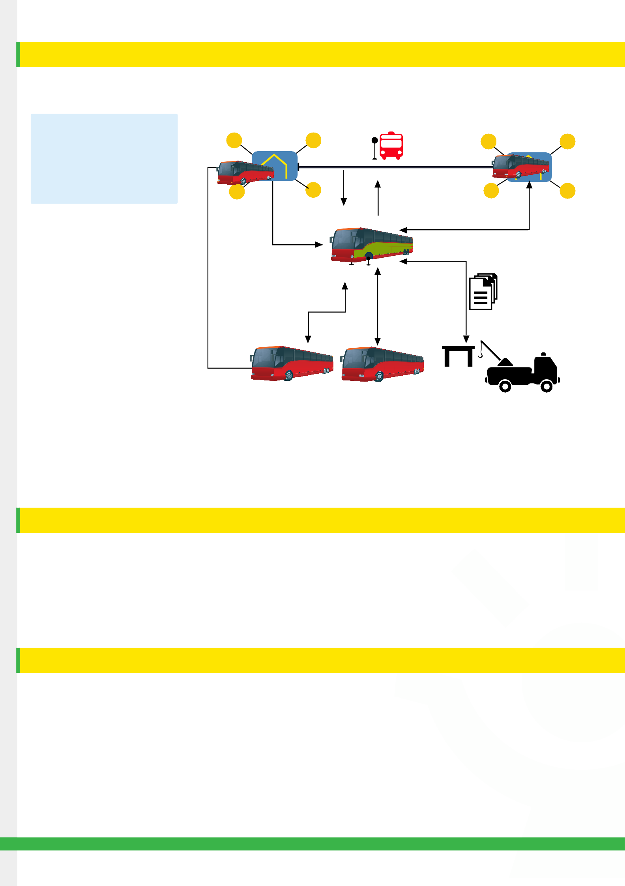

Garage

The broken bus will communicate with buses on the same route passengerswill be picked up by the nearby buses as priority

## Figure 4 Bus Maintenance System

# Profiling of the customers using CRM

State Road Transport System already has some limited Customer data that is taken during issue of a monthly pass. This customer data if could be extended to all other customers in more detailed fashion could be of great use for the implementation of [CRM](http://www.happiestminds.com/technology-focus/customer-relationship-management/). Assuming that Telecom operator will act as a leader in the system, its customer data might be useful for the profiling of the customers. Once all the customer data is captured the mapping of users could be done using parent ID’s and Child ID’s. This mapping is useful to have authentication for parents to track their child safety.

Usage patterns of the passengers could be analyzed and accordingly loyalty points could be added in the smart card provided to customer. Also CRM helps in getting proper timely feedback about the services offered to passengers.

# Tracing and tracking of special passengers like kids and woman for the safety purpose

Once we have captured the customer details and mapping of profiles is done. Only people who have the authority predefined can track and trace (using RFID tags or NFC) their kids and also for better women safety.

##### Infotainment:

A personalized smart screen is provided to each passenger in green field buses. As these are value added services offered, Telecom operators can charge passengers according to their usage. Different infotainment facilities such as streaming videos, preloaded content, real

time gaming and information services could be provided. These screens can also be used for advertising based on Location of the bus; content could be loaded through wifi at bus stops. And there by affordable infotainment services could be provided to passengers.

# Current practice analysis

## Jawaharlal Nehru National Urban Renewal Mission (JnNURM) Basic Block Diagram with Key Features

**Bus Depot (control Center)**

**Bus Driver (control Center)**

**GPRS**

**Wi-Fi**

**GSM**

**Single Control Unit**

**Speakers**

**RS 485**

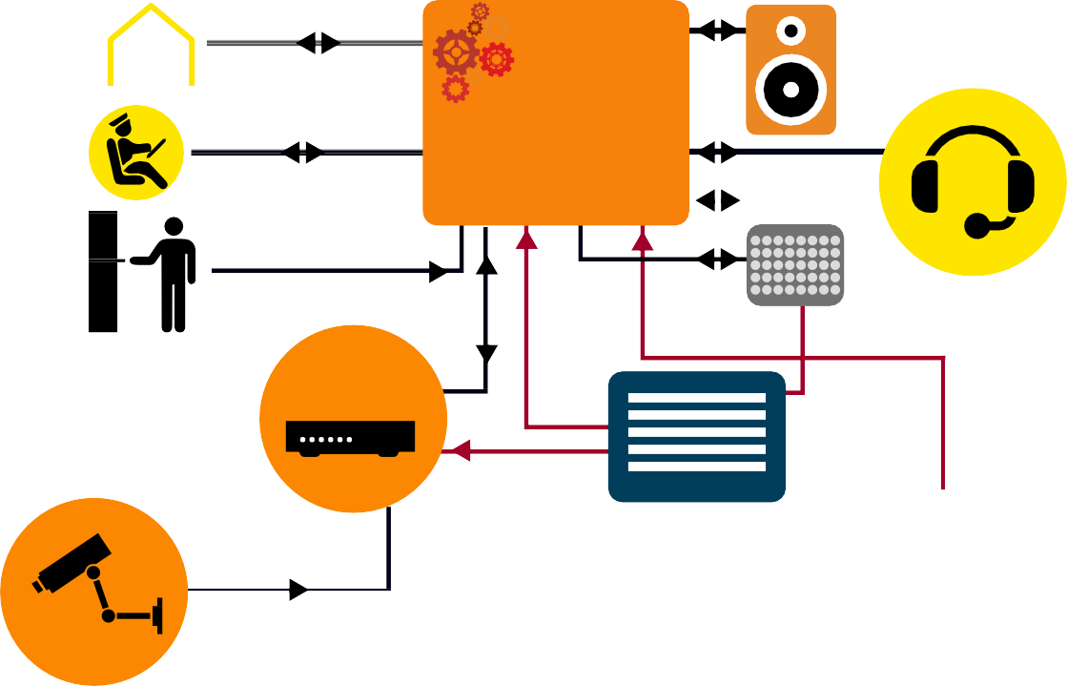

**MIC and Head set for Audio call**

**Ticketing machine**

**Ether net**

**Digital vdeo recorder**

LED

Display Boards

**Camera**

**Power supply**

**for recording**

**Power supply**

**Bus Multiplexing System**

**Combi Antenna**

**Ether net**

#### Depot

#### Centrl Control Centre (CCC) Route/

#### Management

**ETM**

#### C.C.T.V

GPS | GSM| WIFI

**Side Display Panel**

**CCTV**

**Speaker**

**Side Display Panel**

**Smart Card**

**r**

**Reade**

**Side Display Panel**

**Speaker**

**Smart Card Reader**

**CCTV**

**Rear Display Pannel**



**SCU**

* + Automatic vehicle Location (AVL)
  + Passenger Information System (PIS)
  + Synchronization with Bus Depot
  + Continuous/ Schedule based Security
  + Camera Recording on activation of predefined features
  + Emergency Two way Voice Call
  + Rear View Camera Display On BDC on Enabling Reverse Gear
  + GPS Based Navigation and 3G wireless Communication
  + Supports Communication protocols like CAN 2.0, RS 232, Ethernet and USB
  + Vehicle Heath Monitoring and Diagnostics (VHMD)
  + Vehicle Tracking System/ Navigation System
  + ETC RFID Tag
  + Speed Limiters
  + Immobilizers
  + Collision warning
  + Adaptive cruise control

Happiest Minds Internet of Things Approach

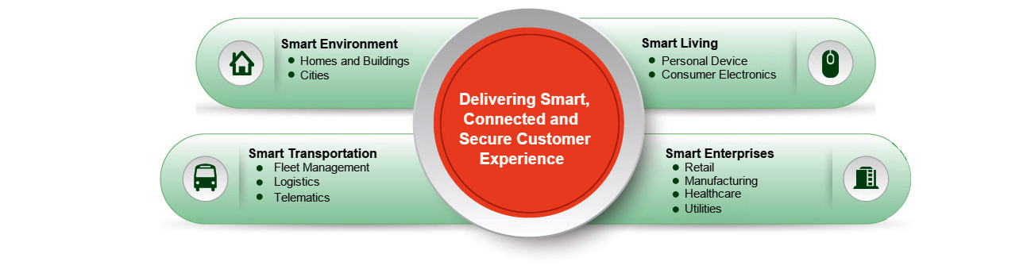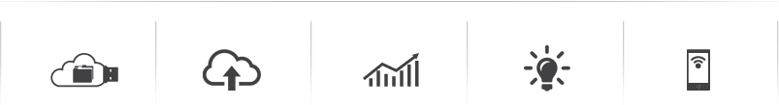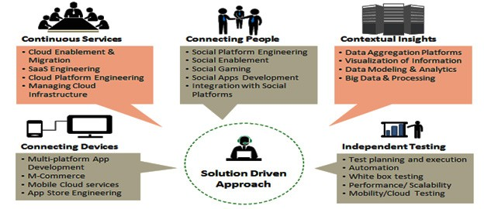

Our brand commitment is to deliver a [customer experience](http://www.happiestminds.com/services/it-services/connected-customer-experience/) which is smart, connected and secure. With the advanced benefits of [IoT](http://www.happiestminds.com/Insights/internet-of-things/) [technology](http://www.happiestminds.com/Insights/internet-of-things/), we focus on delivering services that would make enterprises, our environment and life smarter than in the future.

Our [Internet of Things](http://www.happiestminds.com/Insights/internet-of-things/) services range from designing hardware devices, cloud enablement, mobility enablement, engineering and real- time analytics, and consulting to create end-to-end solutions. Our [IoT services](http://www.happiestminds.com/Insights/internet-of-things/) encompass managed services via SOC/NOC that ensures smooth functioning of the M2M infrastructure for the business

|  |  |  |  |  |
| --- | --- | --- | --- | --- |
| **Embedded Design Services** | **Cloud Enablement** | **Real-time Analytics** | **Vertical Solutions** | **Mobility Enablement** |

# Conclusion

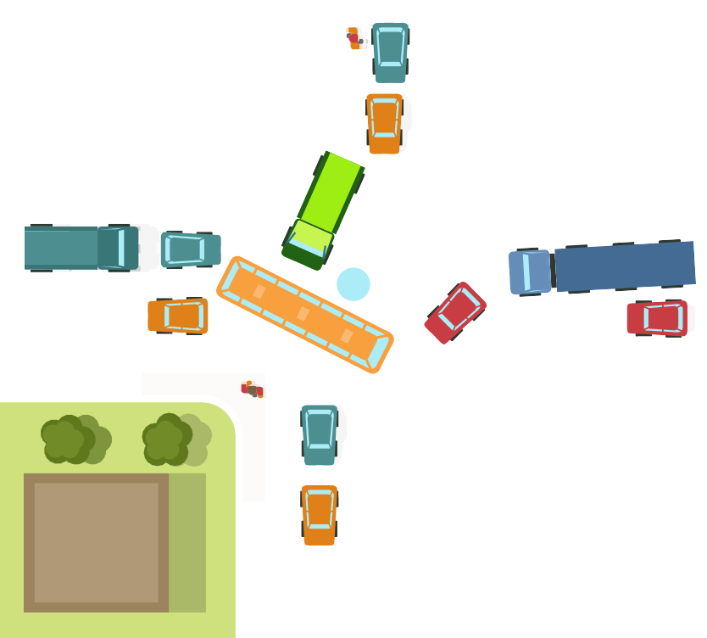

## The major enablers or drivers for Intelligent Transport system in India would be

* Exponential rise in the number of vehicles leading to traffic congestion, deterioration in air quality and increase in noise levels in metropolitan city.
* €60bn of transport-related investment expected over the next five years and a massive €390bn anticipated over the next two decades. (News Report, ITS International)
* Freight and logistics is a disorganized sector in india and demands huge potential for growth, development and investment. Leveraging IoT for ITS implementation for proper vehicle tracking, vehicle emissions and fuel costs, can help reduce carbon footprint 1and introduce1several degree of efficiency.

The ITS ecosystem in India is still in its nascent stage and there are some major challenges in implementing state-of-art technologies in India. Some of the prominent ones are:-

* Integration of the ITS applications and introduction of standards or the framework for an international ITS architecture.
* Implementation and development of a nation-wide ITS data archive
* Due to basic socio – geographical differences, India’s ITS cannot replicate existing successful models implemented in developed nations.
* High cost of implementation doesn’t allow high penetration.

|  |  |  |
| --- | --- | --- |
| |  | | --- | | **SAMPLE OUTPUT:**  Creating a public transportation program in Python that considers seat vacancy, speed, next stop distance, and destination can be quite complex and may involve real-time data and interactions. Below is a simplified example of a program that simulates a single bus journey:  **PROGRAM:** | |  |

import time

class Bus:

    def __init__(self, capacity, speed):

        self.capacity = capacity

        self.speed = speed

        self.passengers = 0

    def embark(self, passengers):

        if self.passengers + passengers <= self.capacity:

            self.passengers += passengers

            return True

        else:

            return False

    def disembark(self, passengers):

        if self.passengers >= passengers:

            self.passengers -= passengers

            return True

        else:

            return False

class BusStop:

    def __init__(self, name, distance_to_next, destination):

[self.name](http://self.name/) = name

        self.distance_to_next = distance_to_next

        self.destination = destination

    def __str__(self):

        return f"Bus Stop: {[self.name](http://self.name/)}, Next Stop Distance: {self.distance_to_next}, Destination: {self.destination}"

bus = Bus(capacity=50, speed=50)

bus_stops = [

    BusStop(name="Stop A", distance_to_next=10, destination="City Center"),

    BusStop(name="Stop B", distance_to_next=15, destination="Mall"),

    BusStop(name="Stop C", distance_to_next=12, destination="Park"),

    BusStop(name="Stop D", distance_to_next=8, destination="Final Destination")

]

current_stop_index = 0

while current_stop_index < len(bus_stops):

    current_stop = bus_stops[current_stop_index]

    print(current_stop)

    passengers_waiting = 5

    if current_stop.destination != bus_stops[-1].destination:

        can_embark = bus.embark(passengers_waiting)

    else:

        can_embark = False

    if can_embark:

        print(f"{passengers_waiting} passengers board the bus.")

    else:

        print(f"The bus is full. {passengers_waiting} passengers wait for the next bus.")

    time_to_next_stop = current_stop.distance_to_next / bus.speed * 60

    time.sleep(time_to_next_stop)

    print(f"Bus arrives at the next stop in {time_to_next_stop:.2f} minutes.")

    passengers_to_disembark = 3

    can_disembark = bus.disembark(passengers_to_disembark)

    if can_disembark:

        print(f"{passengers_to_disembark} passengers disembark the bus.")

    else:

        print("Not enough passengers to disembark.")

    current_stop_index += 1

print("Bus has reached the final destination.")

**OUTPUT:**

|  |  |
| --- | --- |
|  |  |

Bus Stop: Stop A, Next Stop Distance: 10, Destination: City Center

5 passengers board the bus.

Bus arrives at the next stop in 12.00 minutes.

3 passengers disembark the bus.

Bus Stop: Stop B, Next Stop Distance: 15, Destination: Mall

5 passengers board the bus.

Bus arrives at the next stop in 15.00 minutes.

3 passengers disembark the bus.

Bus Stop: Stop C, Next Stop Distance: 12, Destination: Park

5 passengers board the bus.

Bus arrives at the next stop in 14.40 minutes.

3 passengers disembark the bus.

Bus Stop: Stop D, Next Stop Distance: 8, Destination: Final Destination

5 passengers wait for the next bus.

Bus arrives at the next stop in 9.60 minutes.

Bus has reached the final destination.

This program simulates a bus journey with stops, passenger embarkation and disembarkation, and timing based on distance and speed. You can modify and expand this code for more complex scenarios. In a real-world application, you'd need to consider real-time data and user interactions.This output shows the bus stopping at each bus stop, passengers boarding and disembarking, and the time it takes to reach the next stop based on the bus's speed. The program continues until the final destination is reached