**CAPACITIVE ANALYSIS**

**PROJECT REPORT**

**Group Name: Aventers**

**Done by: Kishan Beesa**

**G Sai Vivek**

**CONTENTS**

Sr.No. Particulars

1. Introduction
2. Goal/Aim of the project
3. Used Material
4. Used Method
5. Result
6. Appendix
7. References

**INTRODUCTION:**

Queuing Theory is a branch of Operations Research because the results are often used when making business decisions about the resources needed to provide a service. Queuing theory can also be defined as the mathematical study of the congestion and delays of waiting in line. Real-life applications of queuing theory cover a wide range of applications, such as how to provide [customer service](https://www.investopedia.com/terms/c/customer-service.asp), improve traffic flow, efficiently ship orders from a warehouse, and design of telecommunications systems, from data networks to call centers.

In our project we have designed a model which can give appropriate results for a car wash company on how many cars are washed in a given a time. Usually the working hours of a company is 8 to 10 hours, so as to know the maximum no of servers required to design a minimum loss system.

**AIM:**

To find the total number of cars if the maximum queue length is 28 cars which a carwash company can accommodate for washing. Also finding the waiting time in queue and waiting time in system.

**Material:**

1. Matlab version R2019b
2. Queuing Theory
3. Partial code is taken from Q5 of problemset-6

**METHOD:**

To solve we have designed a model with 2 servers so as to know the number of cars being washed, average time of cars spending in system, average queue length. Here we are using two servers and checking if the number is capable of rescuing a company from running into huge losses.

**Theoretically:**

A M/M/s:finite queuing system consists of various equations which are solved for average queue length, average waiting time, length of queue.

State diagram is best way to explain the functioning of queue with multiple servers.

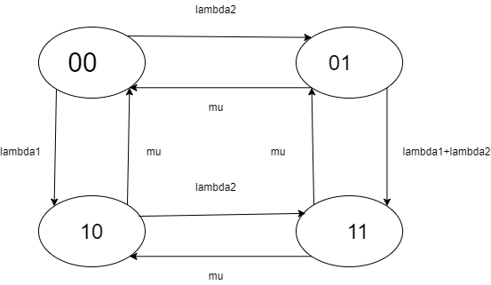

This is state diagram for 2server queueing model. Lambda 1 is arrival rate at server 1 and lambda 2 is arrival rate at server 2. Mu is the service rate.

Equations are as follows:

For Finite capacity

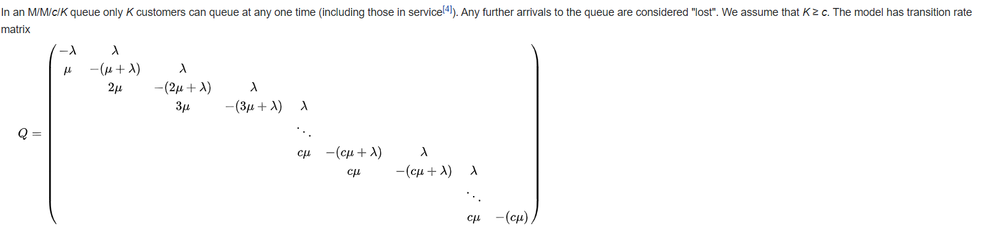

Equation

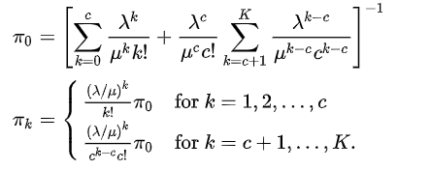

Where pi0 can also be referred as P0, it is the ideal state of a system(no queue in system).

Average numbers of customers in system.

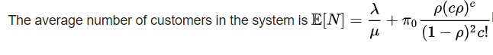

Average response time of a customer

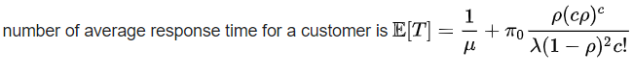

**Results:**

1. For arrival rate = lambda= 15, 22, 28 cars per hour
2. For service rate = mu = 60/8, 60/10, 60/11 time in hrs

For 8hrs and the above mentioned values

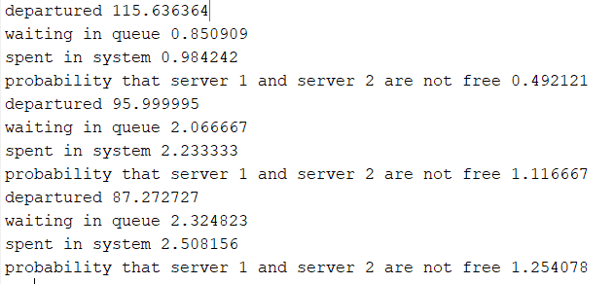

For 8hrs and constant service rate

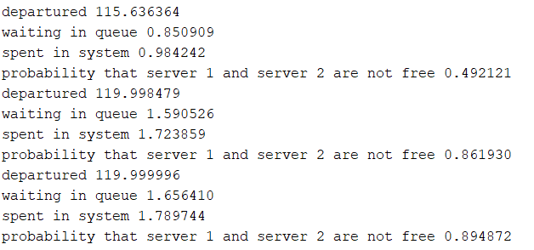

Total service time is 10hrs

1. For arrival rate = lambda= 15, 22, 28 cars per hour
2. For service rate = mu = 60/8, 60/10, 60/11 time in hrs

Total service time is 10hrs

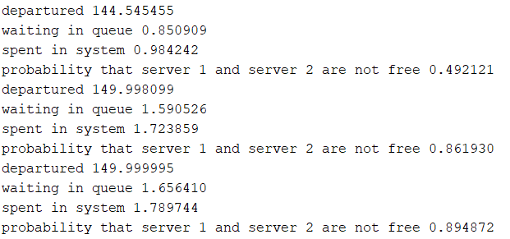

**CONCLUSIONS:**

* From the results we can conclude that with 2 carwashers a carwash company can obtain max customers if the service rate of carwasher is 8minutes per car.
* If the duration of working of carwash company is increase then it reduces the losses incurred on the company.
* The service rate for a carwasher must be less 8minutes per car so as to control the number of cars leaving the carwash without entering.

**APPENDIX:**

clc

clear all

lambda=[15,22,28];

mu=[60/8,60/8,60/8];%60 because is the number of minutes in one hour

for i=1:3

M=zeros(28);

M(1,1)=-lambda(i);

M(1,2)=mu(i);

M(2,1)=lambda(i);

M(2,2)=-(lambda(i)+mu(i));

M(2,3)=2*mu(i);

for j=3:27

M(j,j-1)=lambda(i);

M(j,j)=-(lambda(i)+2*mu(i));

M(j,j+1)=2*mu(i);

end

M(28,27)=lambda(i);

M(28,28)=-2*mu(i);

M(28,:)=ones(1,28);

B=[zeros(27,1);1];

S=linsolve(M,B);

cis=[0;cumsum(ones(27,1))];

lq=[0;0;cumsum(ones(26,1))];

wq=1/2/mu(i)*sum(lq.*S);

w=wq+1/mu(i);

sr=sum([0;mu(i);2*mu(i)*ones(26,1)].*S)*10;

fprintf('departured %f\n',sr)

fprintf('waiting in queue %f\n',wq)

fprintf('spent in system %f\n',w)

fprintf('probability that server 1 and server 2 are not free %f\n',w/2)

end

%%%%%%%%%%%%