|  |
| --- |
| [root@ip-172-31-60-126 solution]# docker pull infracloudio/csvserver:latest  latest: Pulling from infracloudio/csvserver  ae43b40a9945: Pull complete  7bb33bb2db38: Pull complete  c82d72e1bb76: Pull complete  Digest: sha256:20bc5a93fac217270fe5c88d639d82c6ecb18fc908283e046d9a3917a840ec1f  Status: Downloaded newer image for infracloudio/csvserver:latest  docker.io/infracloudio/csvserver:latest  [root@ip-172-31-60-126 solution]# docker images  REPOSITORY TAG IMAGE ID CREATED SIZE  infracloudio/csvserver latest 8cb989ef80b5 8 weeks ago 237MB  [root@ip-172-31-60-126 solution]# docker run -itd infracloudio/csvserver:latest  4fdfe04205cf9860485d7d9c533f0a7f1df4f7290c0ad77e33a440d52e7a1902  [root@ip-172-31-60-126 solution]# docker ps -a  CONTAINER ID IMAGE COMMAND CREATED STATUS PORTS NAMES  4fdfe04205cf infracloudio/csvserver:latest "/csvserver/csvserver" 5 seconds ago Exited (1) 5 seconds ago stoic_driscoll  [root@ip-172-31-60-126 solution]# docker logs -f 4fdfe04205cf  2021/05/07 02:56:54 error while reading the file "/csvserver/inputdata": open /csvserver/inputdata: no such file or directory  [root@ip-172-31-60-126 solution]# |

|  |
| --- |
| [root@ip-172-31-60-126 solution]# vi gencsv.sh  [root@ip-172-31-60-126 solution]# chmod +x gencsv.sh  [root@ip-172-31-60-126 solution]# ./gencsv.sh  [root@ip-172-31-60-126 solution]# ls -ltr  total 8  -rwxr-xr-x. 1 root root 86 May 7 02:59 gencsv.sh  -rw-r--r--. 1 root root 87 May 7 03:01 inputFile  [root@ip-172-31-60-126 solution]# cat inputFile  1, 29307  2, 27851  3, 15989  4, 6282  5, 5635  6, 14868  7, 2621  8, 24131  9, 2503  10, 28721  [root@ip-172-31-60-126 solution]# |

|  |
| --- |
| [root@ip-172-31-60-126 solution]# docker run -itd -v $(pwd)/inputFile:/csvserver/inputdata infracloudio/csvserver:latest  c48b1b36422c629c83670f4228896a7834f1c6b51dbe97c6d9bd30ca7d6c9b9b  [root@ip-172-31-60-126 solution]# docker ps  CONTAINER ID IMAGE COMMAND CREATED STATUS PORTS NAMES  c48b1b36422c infracloudio/csvserver:latest "/csvserver/csvserver" 19 seconds ago Up 17 seconds 9300/tcp crazy_sanderson  [root@ip-172-31-60-126 solution]# docker logs -f c48b1b36422c  2021/05/07 03:17:29 listening on ****  ^C  [root@ip-172-31-60-126 solution]# docker exec -it c48b1b36422c /bin/bash  [root@c48b1b36422c csvserver]# ls -ltr  total 8100  -rwxrwxr-x. 1 root root 8290304 Mar 10 14:35 csvserver  -rw-r--r--. 1 root root 87 May 7 03:01 inputdata  [root@c48b1b36422c csvserver]# netstat -tulpn  Active Internet connections (only servers)  Proto Recv-Q Send-Q Local Address Foreign Address State PID/Program name  tcp6 0 0 :::9300 :::* LISTEN 1/csvserver  [root@c48b1b36422c csvserver]# |

|  |
| --- |
| [root@ip-172-31-60-126 solution]# docker run -itd -v $(pwd)/inputFile:/csvserver/inputdata -p 9393:9300 infracloudio/csvserver:latest  ce07de86b54c75a07a4964cb3e2cd382fc908285ba9bade76c89056864aec9b9 |

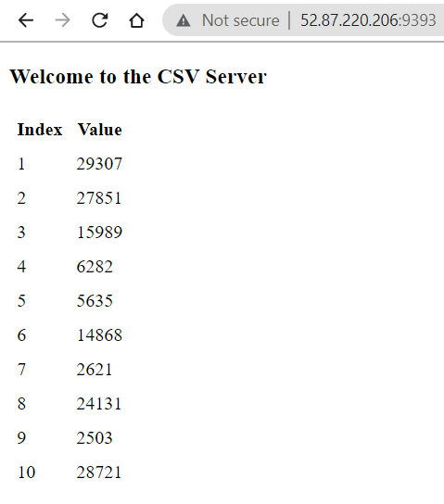

|  |
| --- |
| [root@ip-172-31-60-126 solution]# docker run -itd -v $(pwd)/inputFile:/csvserver/inputdata -p 9393:9300 -e CSVSERVER_BORDER='orange' infracloudio/csvserver:latest  45896825659a9fd1867163f7ec61dc0e3e7086c9fb585c0c6cc08ec3219aff29  [root@ip-172-31-60-126 solution]# |

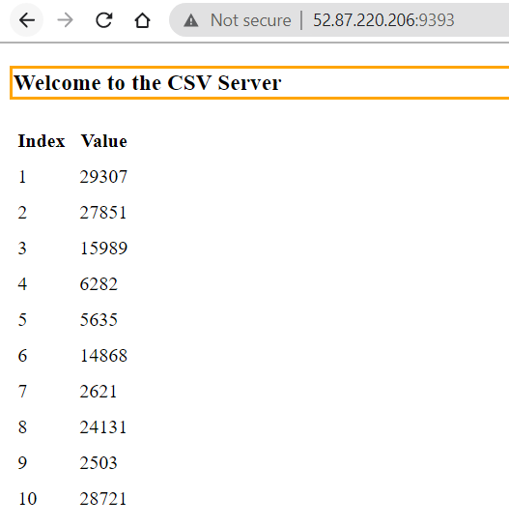

Prometheus

