Lab 13 – Add Prometheus Metrics & Grafana Dashboards to customer-order-service

🎯 Goal
Enable your customer-order-service Flask microservice to expose runtime metrics, have them scraped by Prometheus, visualized in Grafana dashboards, and linked inside Backstage for developer observability.

🔍 Why This Lab Matters in Platform Engineering
As part of an Internal Developer Platform (IDP):
- Self-service Observability
Developers should not need to manually set up monitoring for every new service. The Golden Path should include instrumentation by default.
- Faster Troubleshooting
Exposing metrics via Prometheus allows:
  - Real-time visibility into service health.
  - Quick detection of anomalies without SSH-ing into servers.
- Backstage Integration
Linking Grafana dashboards directly inside Backstage means:
  - One-click access to metrics per service.
  - A single pane of glass for developers and SREs.
- SLO / SLA Tracking
Metrics collected here can power Service Level Objectives (SLOs) and error budgets.

📦 Lab Outcomes
By end of this lab, you will:
- ✅ Have /metrics endpoint in your microservice.
- ✅ See metrics scraped by Prometheus.
- ✅ Build a Grafana dashboard.
- ✅ Link the dashboard in Backstage catalog-info.yaml.

🧩 Steps

Step 1 – Add Prometheus Client to Flask
- Install client library:

sudo apt update
sudo apt install python3-pip -y

apt install python3.12-venv
python3 -m venv venv

# 2. Activate it
source venv/bin/activate

# 3. Install dependencies inside the venv
pip install -r requirements.txt
Add to requirements.txt:
flask
prometheus_client

- Instrument your Flask app (app.py):
from flask import Flask, Response
from prometheus_client import Counter, Histogram, generate_latest, CONTENT_TYPE_LATEST
import time

app = Flask(__name__)

# Metrics
REQUEST_COUNT = Counter("request_count", "Total number of requests")
REQUEST_LATENCY = Histogram("request_latency_seconds", "Request latency in seconds")

@app.route("/")
def home():
REQUEST_COUNT.inc()
with REQUEST_LATENCY.time():
time.sleep(0.1) # Simulate processing
return "Hello from Raman Micro!"

# Expose metrics
@app.route("/metrics")
def metrics():
return Response(generate_latest(), mimetype=CONTENT_TYPE_LATEST)

if __name__ == "__main__":
app.run(host="0.0.0.0", port=5000)

Step 2 – Run and Test Metrics Endpoint
Python3 app.py
Check in browser or terminal:
curl http://pubIP:5000/metrics
You should see output like:
# HELP request_count Total number of requests
# TYPE request_count counter
request_count 2.0

Step 3 – Create Prometheus Config
Create prometheus.yml:
global:
scrape_interval: 10s

scrape_configs:
- job_name: 'raman-micro'
static_configs:
- targets: ['host.docker.internal:5000']
This scrapes metrics from your Flask app every 10 seconds.

Step 4 – Run Prometheus & Grafana in Docker
Create a shared network:
docker network create observability-net

Run Prometheus:
docker run -d \
--name prometheus \
--network observability-net \
--add-host=host.docker.internal:host-gateway \
-v "$(pwd)/prometheus.yml":/etc/prometheus/prometheus.yml \
-p 9090:9090 \
prom/Prometheus

Run Grafana:
docker run -d \
--name grafana \
--network observability-net \
-p 3001:3000 \
grafana/grafana

Step 5 – Check Prometheus Target
Go to:
http://<your-server-ip>:9090/targets
You should see:
raman-micro – UP

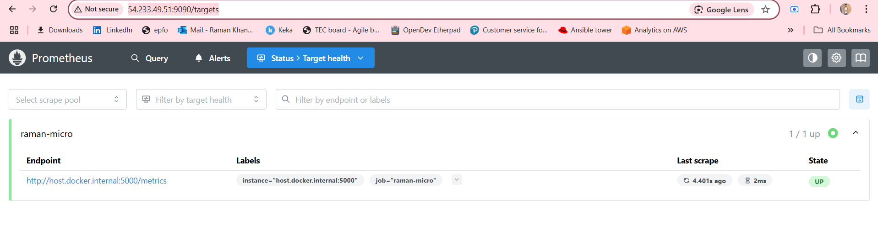

Step 6 – Configure Grafana
- Open Grafana:
http://<your-server-ip>:3001
(Default login: admin/admin)
- Go to:
⚙️ → Data Sources → Add Data Source → Prometheus
Set URL:
http://prometheus:9090
Click Save & Test → Should say “Data source is working”.

Step 7 – Create Grafana Dashboard
- Go to:
Dashboards → New → New Dashboard

Panel 1 – Total Requests:
- Query:
request_count_total
- Title: Total Requests
- Visualization: Time series

Panel 2 – Average Latency:
- Query:
rate(request_latency_seconds_sum[1m]) / rate(request_latency_seconds_count[1m])
- Title: Average Latency
- Visualization: Time series

Save as:
raman-micro-dashboard

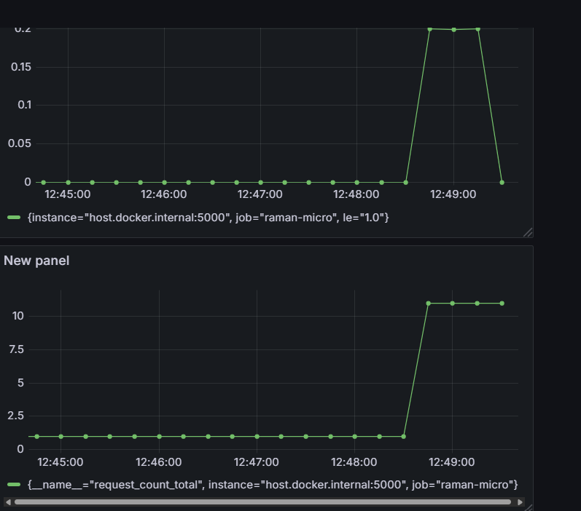

Step 8 – Link Dashboard in Backstage
Edit catalog-info.yaml of your service:
apiVersion: backstage.io/v1alpha1
kind: Component
metadata:
name: raman-micro
description: Flask microservice with metrics
annotations:
github.com/project-slug: ramannkhanna2/raman-micro
grafana/dashboard-url: http://<your-server-ip>:3001/d/abc123/raman-micro-dashboard
spec:
type: service
owner: user:raman
lifecycle: production
Now, inside Backstage service page, you can show a Grafana link to view metrics.

📌 Key Platform Engineering Takeaways
- Golden Path for Observability → Any new microservice should have metrics from day 1.
- Self-service Monitoring → Devs can see service health without raising infra tickets.
- One-Stop Developer Portal → Backstage becomes the central hub for code, builds, and monitoring.
- Promotes SRE Practices → Enables tracking of error budgets, latency SLIs, and uptime SLOs.

🟣 LAB 14 — Add TechDocs (Backstage-Native Documentation) to customer-orders-service
Day 4 → Completing Developer Experience: Documentation as Code

🎯 Lab Objective
In the previous labs, we built a complete workflow:
- We created a microservice using a Golden Path Template.
- We secured it with CI/CD scans (Lab 11).
- We integrated GitHub Actions (Lab 12).
- We added observability using Prometheus + Grafana (Lab 13).
Now comes the missing piece of a real Internal Developer Platform:
Documentation should live with the code and automatically render in Backstage.
By the end of this lab, we will:
✔ Write Markdown documentation for our Flask microservice
✔ Configure MkDocs (the static site generator)
✔ Add the TechDocs annotation to Backstage
✔ Render the docs inside Backstage with one click
✔ Understand why “docs-as-code” is a cornerstone of platform engineering
This lab completes the “Discover → Build → Secure → Observe → Document” lifecycle.

🧠 Why This Lab Matters (Platform Engineering Perspective)
Traditional documentation lives in scattered places:
- Confluence
- Google Docs
- OneNote
- random PDF files
- tribal knowledge in someone’s brain
TechDocs solves this by turning every service repository into a documentation website.
TechDocs brings:

1. Documentation where developers already are
Backstage integrates docs directly into the service page.

2. Docs as Code, inside Git
- version-controlled
- reviewed in PRs
- updated with code changes

3. A consistent format
Markdown + MkDocs everywhere → no confusion.

4. Self-service onboarding
New developers see everything (API info, endpoints, examples, deployment steps) in one portal.
This is the final ingredient of a modern IDP experience.

🛠 STEP-BY-STEP IMPLEMENTATION

STEP 1 — Ensure Documentation Folder Structure
We work inside the repository generated earlier (e.g., customer-orders-service).
Your directory must have:
customer-orders-service/
├── app.py
├── Dockerfile
├── requirements.txt
├── mkdocs.yml ← we will create this
├── docs/ ← we will create this
│ └── index.md
└── catalog-info.yaml
If docs/ does not exist, create it.

STEP 2 — Create mkdocs.yml (Documentation Blueprint)
Inside the microservice root folder, create a file named:
mkdocs.yml
Paste this:
site_name: customer-orders-service
nav:
- Home: index.md
plugins:
- techdocs-core

🔍 What this file means:
- site_name: The title of your documentation website
- nav: Controls sidebar navigation
- plugins: Mandatory — tells Backstage to use TechDocs builder
MkDocs is the engine; TechDocs is the Backstage wrapper around it.

STEP 3 — Create docs/index.md (Documentation Homepage)
Inside the docs/ folder, create:
index.md
Paste this:
# Customer Orders Service

Welcome to the documentation for the **customer-orders-service**.

## 🚀 Overview
This microservice was generated using our Golden Path Flask Template in Backstage.
It includes:

- Flask-powered API
- Prometheus `/metrics` endpoint
- Secure CI/CD pipeline (SAST, DAST, SBOM, Trivy)
- Docker image build and push to DockerHub
- Grafana dashboard for observability

## ⚙️ Architecture
- Python Flask application
- Dockerized runtime
- GitHub Actions for CI/CD
- Prometheus + Grafana for monitoring

## 📦 Deployment
This service is deployed via GitHub Actions workflows and can be extended to ECS/EKS in future labs.

## 🧪 Observability
- Metrics scraped by Prometheus
- Live dashboards available in Grafana

## 👤 Ownership
**Team:** Platform Engineering
**Service Owner:** Raman
This becomes the landing page in Backstage.

STEP 4 — Add TechDocs Annotation to catalog-info.yaml
Open catalog-info.yaml inside your service repo.
Add the annotation under metadata.annotations:
metadata:
annotations:
backstage.io/techdocs-ref: dir:.
This tells Backstage:
“Docs are inside this repository. Build them locally.”
If you used Grafana earlier, your annotations section may look like:
metadata:
annotations:
github.com/project-slug: ramannkhanna2/customer-orders-service
grafana/dashboard-url: http://<IP>:3001/d/abc123/customer-orders-dashboard
backstage.io/techdocs-ref: dir:.
Perfectly fine — annotations can coexist.

STEP 5 — Commit and Push Documentation
Run:
git add mkdocs.yml docs/
git commit -m "Add TechDocs documentation"
git push
Wait a few seconds for GitHub to update the branch.

STEP 6 — Ensure TechDocs Is Configured in Backstage
Open app-config.yaml (Backstage root config) and confirm:
techdocs:
builder: local
generator:
runIn: docker
publisher:
type: local

Why these settings?
- builder: local → Build docs on the Backstage server
- generator.runIn: docker → Ensures MkDocs environment is isolated
- publisher: local → Perfect for workshops and local VM setups
This is exactly what Spotify recommends for development environments.

STEP 7 — Restart Backstage
From your Backstage directory:
yarn start
Wait for:
TechDocsBuilder: Local builder ready

STEP 8 — View TechDocs in Backstage
- Open Backstage
- Go to: Catalog → customer-orders-service
- Look for a button: "View TechDocs"
- Click it
You should now see:
- A left sidebar from nav:
- Beautifully rendered Markdown
- Fully navigable documentation site
This means TechDocs worked ✔

🎉 LAB 14 — Verification Checklist
Check | Meaning
TechDocs button appears | Backstage annotation works
Docs load inside Backstage | mkdocs.yml + docs folder correct
Sidebar appears | nav config correct
Markdown renders correctly | MkDocs plugin working
Service page shows link | TechDocs integrated with catalog
If all these work → success 🎉

📚 What This Lab Adds to Your Platform
You now have:
- Self-service service creation (Golden Path)
- Automated CI/CD & security
- Observability dashboards
- Documentation integrated directly into Backstage
Your IDP is now:
Discover → Create → Build → Secure → Deploy → Observe → Document → Improve
This is the full Developer Experience loop.

