Lab 12 – GitHub Actions Deploy Integration (Click-to-Deploy in Backstage)

🎯 Objective
In this lab, you will:
- Integrate GitHub Actions into your Backstage developer portal.
- View CI/CD run history for each service inside Backstage.
- Trigger deployments manually via Click-to-Deploy from Backstage.
- Allow developers to inspect, retry, and audit pipelines without leaving Backstage.

🧠 Why This Matters in Platform Engineering
- Developer Experience (DevEx): Developers no longer need to switch to GitHub UI to see CI/CD runs.
- Self-Service Pipelines: Any onboarded service in Backstage can trigger its own build/deploy pipeline.
- Audit & Compliance: Centralized visibility for pipeline status, logs, and approvals.
- Consistency: Standardized CI/CD integration across all microservices using the Golden Path approach from Lab 6.

📋 Prerequisites
- Backstage instance running from Lab 6 setup.
- GitHub OAuth already configured (Lab 8).
- Your service (e.g., customer-orders-service) is already in the Backstage catalog with a working CI pipeline (Lab 10).
- GitHub Personal Access Token (PAT) or OAuth credentials.

🛠 Step-By-Step Implementation

Part 1 – Install GitHub Actions Plugin
1.1 – Install in Frontend
cd ~/backstage-app/raman-idp-portal
yarn --cwd packages/app add @backstage-community/plugin-github-actions
1.2 – Install GitHub Auth in Backend
(Skip if already done)
yarn --cwd packages/backend add @backstage/plugin-auth-backend-module-github-provider

Part 2 – Backend Auth Provider Setup ( skip if dne)
2.1 – Enable the GitHub Auth Backend Module
Edit:
vi packages/backend/src/index.ts
Add:
backend.add(import('@backstage/plugin-auth-backend-module-github-provider'));
2.2 – Add Credentials to app-config.yaml
auth:
providers:
github:
development:
clientId: ${AUTH_GITHUB_CLIENT_ID}
clientSecret: ${AUTH_GITHUB_CLIENT_SECRET}
Export in terminal (or .env file):
export AUTH_GITHUB_CLIENT_ID=your-client-id
export AUTH_GITHUB_CLIENT_SECRET=your-client-secret

Part 3 – GitHub Integration
Edit app-config.yaml:
integrations:
github:
- host: github.com
apiBaseUrl: https://api.github.com

Part 4 – Annotate Service for GitHub Actions
Edit catalog-info.yaml in your service repo (customer-orders-service):
apiVersion: backstage.io/v1alpha1
kind: Component
metadata:
name: customer-orders-service
description: Flask microservice
annotations:
github.com/project-slug: ramannkhanna2/customer-orders-service
spec:
type: service
lifecycle: production
owner: user:raman
Note:
github.com/project-slug is mandatory for Backstage to fetch the correct Actions runs.
Push changes to GitHub:
git add catalog-info.yaml
git commit -m "Add GitHub Actions annotation"
git push origin main

Part 5 – Enable GitHub Actions Tab in Backstage
Edit:
vi packages/app/src/components/catalog/EntityPage.tsx

Add at top:
import {
EntityGithubActionsContent,
isGithubActionsAvailable,
} from '@backstage-community/plugin-github-actions';
Inside your service page definition:
const serviceEntityPage = (
<EntityLayout>
{/* Existing tabs */}
<EntityLayout.Route
path="/github-actions"
title="GitHub Actions"
if={isGithubActionsAvailable}
>
<EntityGithubActionsContent view="cards" />
</EntityLayout.Route>
</EntityLayout>
);

Part 6 – Test the Integration
- Restart Backstage:
- Yarn start

- Go to your service in Backstage (customer-orders-service).
- You should see a "GitHub Actions" tab.
- Click it — you should see:
  - Run history
  - Statuses (✔️ Passed / ❌ Failed)
  - Click-to-Deploy button (if workflow supports workflow_dispatch trigger).

📌 Extra – Enable Click-to-Deploy
To allow manual deployments from Backstage:
- In your GitHub Actions workflow (.github/workflows/deploy.yml):
on:
workflow_dispatch: # Enables manual trigger
- Commit & push.
- In Backstage, open the GitHub Actions tab → click Run Workflow.

✅ Lab Verification
- GitHub Actions tab visible in Backstage service page.
- Workflow history loads without error.
- Clicking a run opens GitHub logs in a new tab.
- Manual deploy button works (workflow_dispatch).

🚀 Outcome
You’ve now:
- Integrated GitHub Actions into your Backstage portal.
- Enabled pipeline history + click-to-deploy for any onboarded service.
- Taken another step towards self-service platform engineering.

Lab 13 – Add Prometheus Metrics & Grafana Dashboards to customer-order-service

🎯 Goal
Enable your customer-order-service Flask microservice to expose runtime metrics, have them scraped by Prometheus, visualized in Grafana dashboards, and linked inside Backstage for developer observability.

🔍 Why This Lab Matters in Platform Engineering
As part of an Internal Developer Platform (IDP):
- Self-service Observability
Developers should not need to manually set up monitoring for every new service. The Golden Path should include instrumentation by default.
- Faster Troubleshooting
Exposing metrics via Prometheus allows:
  - Real-time visibility into service health.
  - Quick detection of anomalies without SSH-ing into servers.
- Backstage Integration
Linking Grafana dashboards directly inside Backstage means:
  - One-click access to metrics per service.
  - A single pane of glass for developers and SREs.
- SLO / SLA Tracking
Metrics collected here can power Service Level Objectives (SLOs) and error budgets.

📦 Lab Outcomes
By end of this lab, you will:
- ✅ Have /metrics endpoint in your microservice.
- ✅ See metrics scraped by Prometheus.
- ✅ Build a Grafana dashboard.
- ✅ Link the dashboard in Backstage catalog-info.yaml.

🧩 Steps

Step 1 – Add Prometheus Client to Flask
- Install client library:

sudo apt update
sudo apt install python3-pip -y

apt install python3.12-venv
python3 -m venv venv

# 2. Activate it
source venv/bin/activate

# 3. Install dependencies inside the venv
pip install -r requirements.txt
Add to requirements.txt:
flask
prometheus_client

- Instrument your Flask app (app.py):
from flask import Flask, Response
from prometheus_client import Counter, Histogram, generate_latest, CONTENT_TYPE_LATEST
import time

app = Flask(__name__)

# Metrics
REQUEST_COUNT = Counter("request_count", "Total number of requests")
REQUEST_LATENCY = Histogram("request_latency_seconds", "Request latency in seconds")

@app.route("/")
def home():
REQUEST_COUNT.inc()
with REQUEST_LATENCY.time():
time.sleep(0.1) # Simulate processing
return "Hello from Raman Micro!"

# Expose metrics
@app.route("/metrics")
def metrics():
return Response(generate_latest(), mimetype=CONTENT_TYPE_LATEST)

if __name__ == "__main__":
app.run(host="0.0.0.0", port=5000)

Step 2 – Run and Test Metrics Endpoint
Python3 app.py
Check in browser or terminal:
curl http://pubIP:5000/metrics
You should see output like:
# HELP request_count Total number of requests
# TYPE request_count counter
request_count 2.0

Step 3 – Create Prometheus Config
Create prometheus.yml:
global:
scrape_interval: 10s

scrape_configs:
- job_name: 'raman-micro'
static_configs:
- targets: ['host.docker.internal:5000']
This scrapes metrics from your Flask app every 10 seconds.

Step 4 – Run Prometheus & Grafana in Docker
Create a shared network:
docker network create observability-net

Run Prometheus:
docker run -d \
--name prometheus \
--network observability-net \
--add-host=host.docker.internal:host-gateway \
-v "$(pwd)/prometheus.yml":/etc/prometheus/prometheus.yml \
-p 9090:9090 \
prom/Prometheus

Run Grafana:
docker run -d \
--name grafana \
--network observability-net \
-p 3001:3000 \
grafana/grafana

Step 5 – Check Prometheus Target
Go to:
http://<your-server-ip>:9090/targets
You should see:
raman-micro – UP

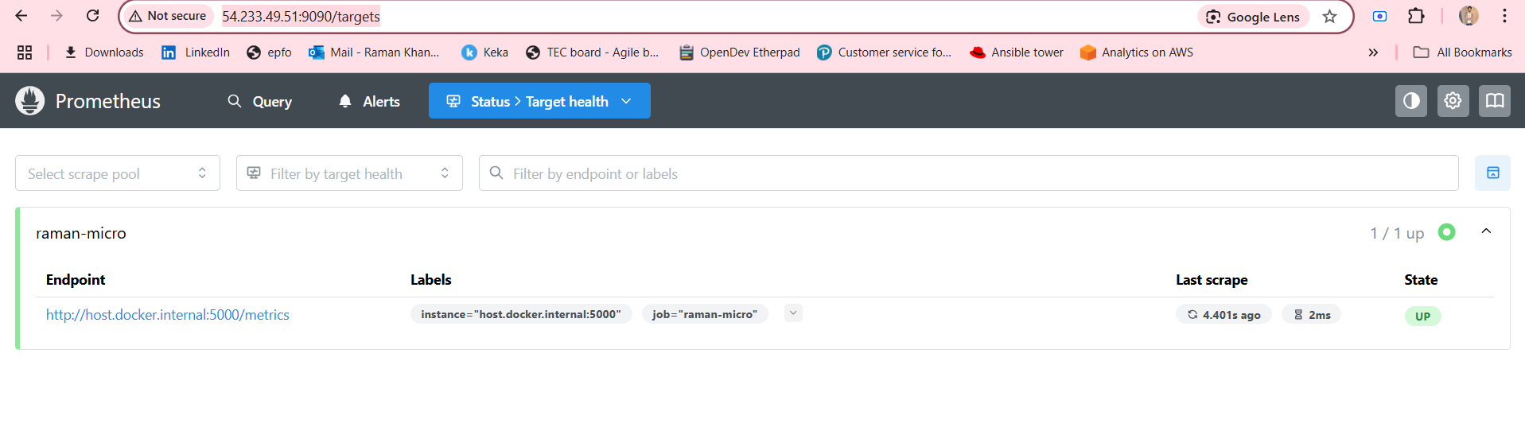

Step 6 – Configure Grafana
- Open Grafana:
http://<your-server-ip>:3001
(Default login: admin/admin)
- Go to:
⚙️ → Data Sources → Add Data Source → Prometheus
Set URL:
http://prometheus:9090
Click Save & Test → Should say “Data source is working”.

Step 7 – Create Grafana Dashboard
- Go to:
Dashboards → New → New Dashboard

Panel 1 – Total Requests:
- Query:
request_count_total
- Title: Total Requests
- Visualization: Time series

Panel 2 – Average Latency:
- Query:
rate(request_latency_seconds_sum[1m]) / rate(request_latency_seconds_count[1m])
- Title: Average Latency
- Visualization: Time series

Save as:
raman-micro-dashboard

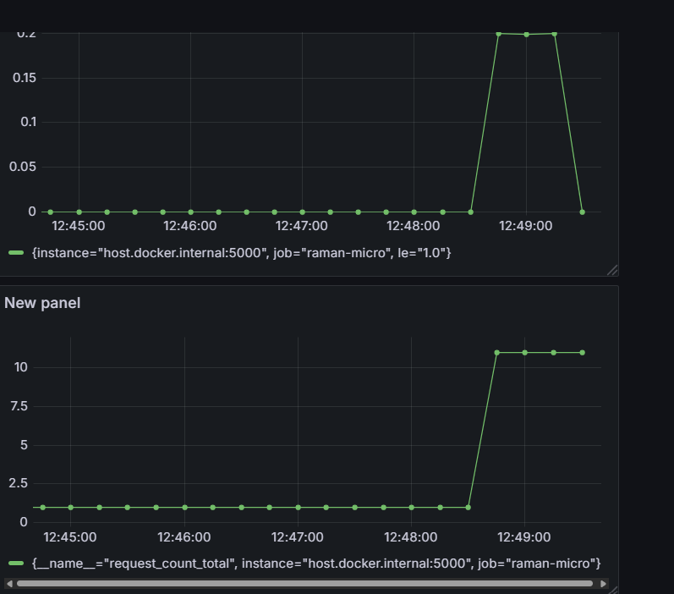

Step 8 – Link Dashboard in Backstage
Edit catalog-info.yaml of your service:
apiVersion: backstage.io/v1alpha1
kind: Component
metadata:
name: raman-micro
description: Flask microservice with metrics
annotations:
github.com/project-slug: ramannkhanna2/raman-micro
grafana/dashboard-url: http://<your-server-ip>:3001/d/abc123/raman-micro-dashboard
spec:
type: service
owner: user:raman
lifecycle: production
Now, inside Backstage service page, you can show a Grafana link to view metrics.

📌 Key Platform Engineering Takeaways
- Golden Path for Observability → Any new microservice should have metrics from day 1.
- Self-service Monitoring → Devs can see service health without raising infra tickets.
- One-Stop Developer Portal → Backstage becomes the central hub for code, builds, and monitoring.
- Promotes SRE Practices → Enables tracking of error budgets, latency SLIs, and uptime SLOs.

