1. Installed Anaconda and created multiple environments (Snowflakes and Snakes)

Also installed packages (beautifulsoup4, ipykernel, jupyter etc) under environment snakes

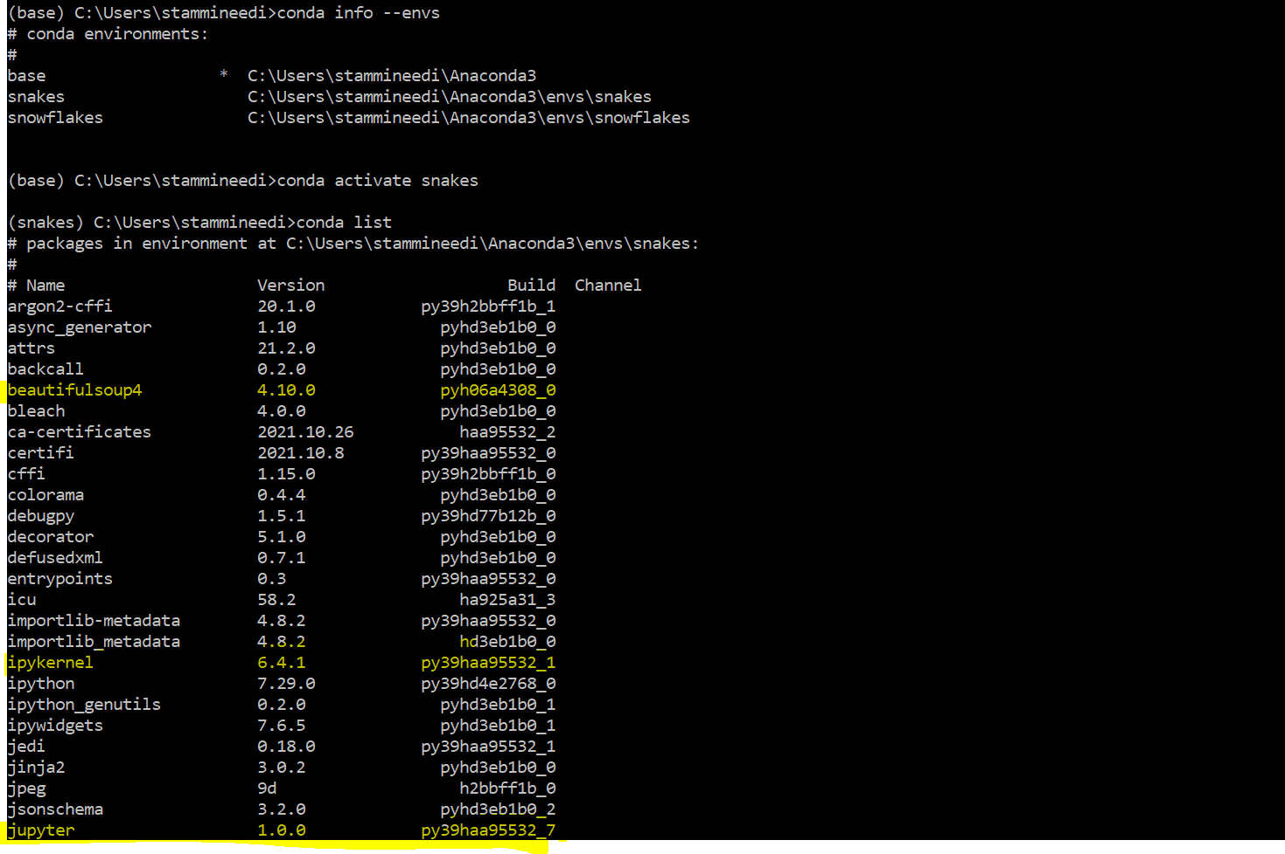

1. Also verified these Environments by launching Anaconda navigator (highlighted installed packages below)

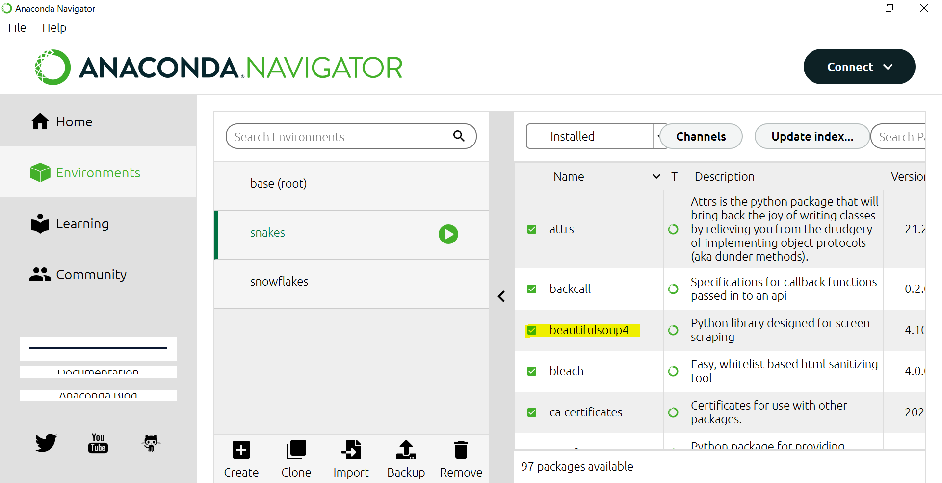

Updated Python to 3.9.7

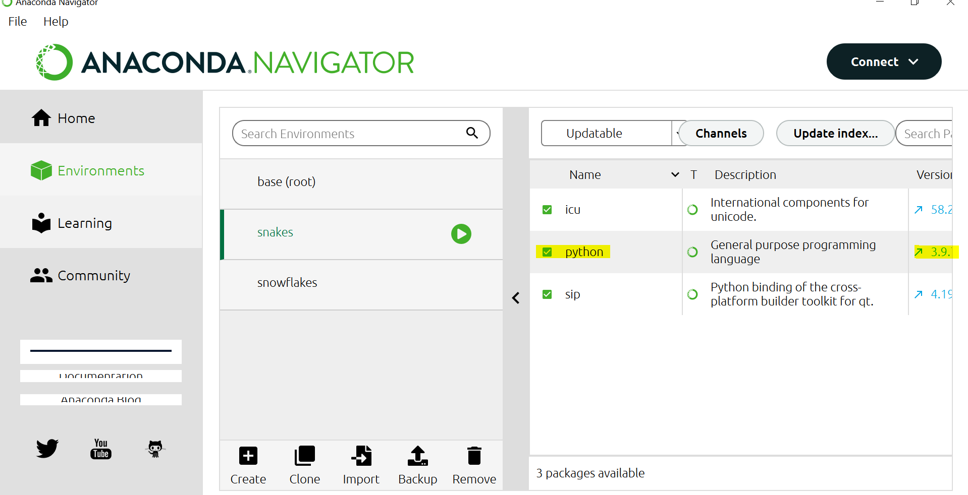

1. Launched Jupyter Notebook ( from Snakes Environment) through navigator

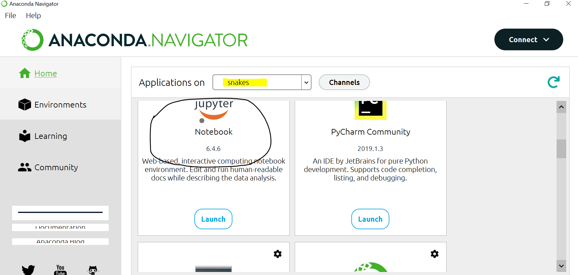

1. Executed Simple python and Markdown program

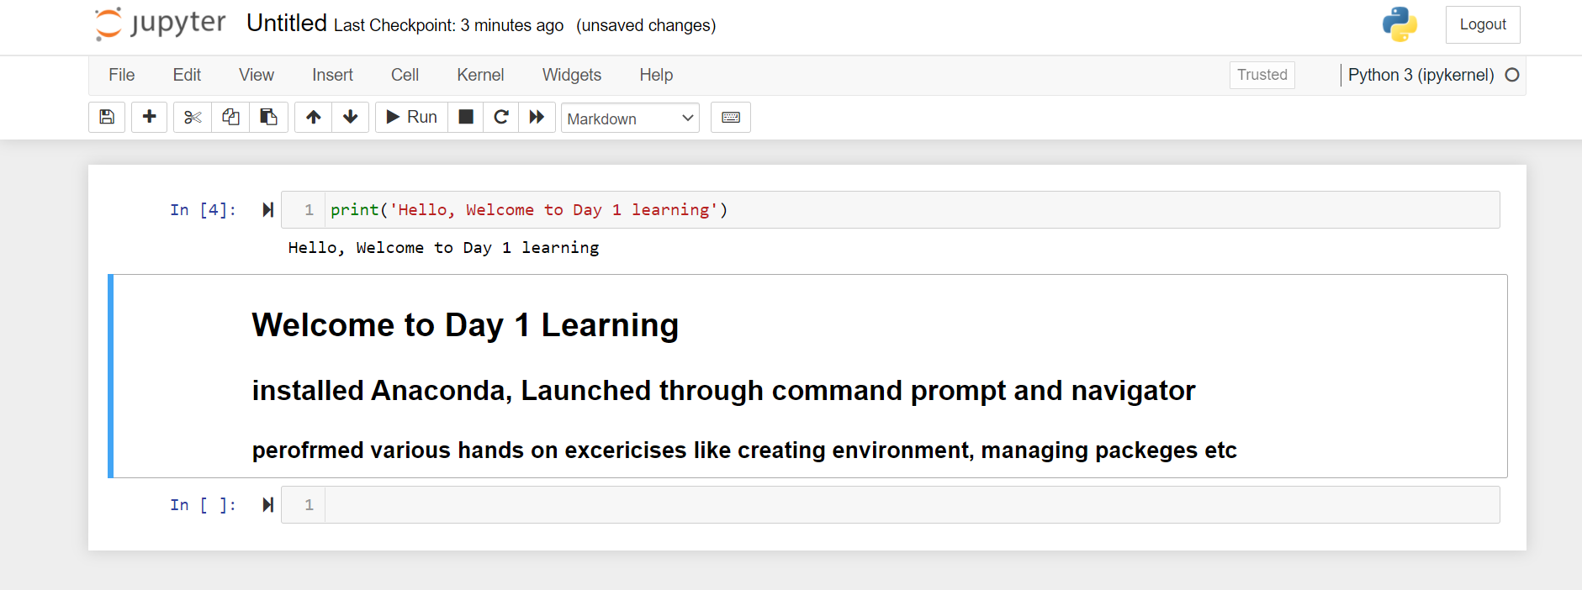

And downloaded this as HTML

