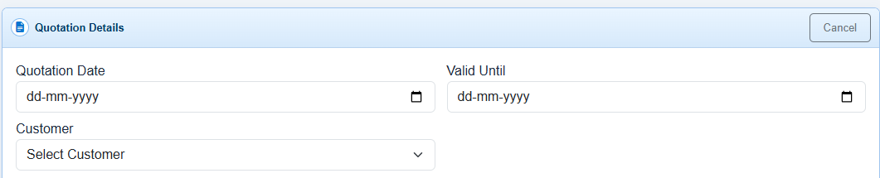
Item Details
Add Items
S.No | Item Name | Qty | Price | Amount
1 | Item1 | 1 | 1200 | 1200

