IoT Based Smart Water Management System

A Project report submitted in partial fulfilment of the requirements for the degree of B.E in Electronics and Communication Engineering

By

D.Gnanasekar(513221106309)

Under the supervision of

Professor & Mentor

Department of Electronics and

Communication Engineering

Smart water management system

PHASE-1 : PROBLEM DEFFINITION AND DESIGN THINKING

* Problem Definition
* Design Thinking

Problem Statement

* Smart water management gives a greater understanding of the water system, including flaw detection, preservation, and water management.
* A comprehensive database of regions with water losses or unlawful connections can be built with the introduction of smart water system technology by public service corporations.
* Smart water grids can save costs by conserving water and energy while improving the quality of service to consumers. Wireless data transfer allows consumers to assess their water use to reduce water costs in other circumstances.
* Thermal Characterstics have significantly impacted the environmental forrtprint and life cycle evalution of buildings. It is proposed in this study that the opacity of a façade element could be adjusted year-round in response to seasonal variations using the smart water filled glass controltechnology described in this research.
* Acc to a new study, the internet of things could moniter renters’and landlords can see the data gathered through an android application.

Ppon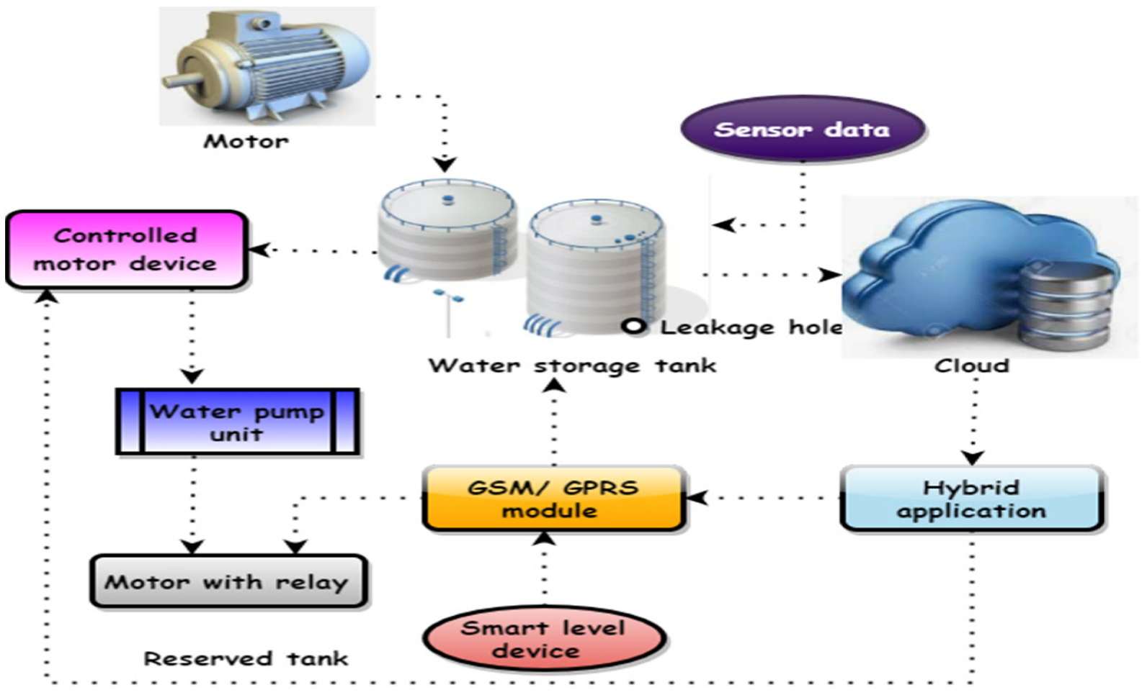’

* **Design Thinking**

1. Project Objectives:

* Real-time Water Consumption monitering:

1. Respond and avoid emergencies efficiently.
2. Recapture revenue
3. Lower energy costs
4. Reduce emergency repair scenarios
5. Detect and manage water loss
6. Predict potential pipe failures
7. Manage water pressure
8. Better allocate maintenance and repair costs

* Public awareness:
* [Creating a Ripple Effect The Power of Public Awareness in Water Conservation](https://energy5.com/the-importance-of-public-awareness-campaigns-on-water-conservation#anchor-0)
* [From Drops to Ocean The Significance of Public Awareness in Protecting Water Resources](https://energy5.com/the-importance-of-public-awareness-campaigns-on-water-conservation#anchor-1)
* [Joining Forces The Key Role of Public Awareness Campaigns in Water Conservation Efforts](https://energy5.com/the-importance-of-public-awareness-campaigns-on-water-conservation#anchor-2)
* Water Conservation:
* With less than 1% of the worlds water being freshwater,[]](https://en.wikipedia.org/wiki/Water_conservation#cite_note-6) one aim is ensuring the availability of water for [future generations](https://en.wikipedia.org/wiki/Future_generations) where the withdrawal of [freshwater](https://en.wikipedia.org/wiki/Freshwater) from an [ecosystem](https://en.wikipedia.org/wiki/Ecosystem) does not exceed its natural replacement rate.
* [Energy conservation](https://en.wikipedia.org/wiki/Energy_conservation) as water pumping, delivery, and [wastewater treatment](https://en.wikipedia.org/wiki/Wastewater_treatment) facilities consume a significant amount of energy. In some regions of the world, over 15% of the total [electricity consumption](https://en.wikipedia.org/wiki/Electricity_consumption) is devoted to [water management](https://en.wikipedia.org/wiki/Water_management). 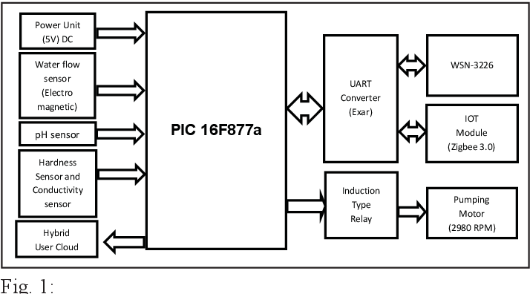

* [Habitat conservation](https://en.wikipedia.org/wiki/Habitat_conservation) where minimizing human water usage helps to preserve [freshwater habitats](https://en.wikipedia.org/wiki/Freshwater_habitat) for local wildlife and migrating [waterfowl](https://en.wikipedia.org/wiki/Waterfowl),
* Sustainable Water Resources Management (SWAM):
* geopolitical and socio-economic aspects of water-resource management.
* water development and human activity impacts on ecologic systems and human health.
* water use and reuse including managed aquifer recharge and storage. sustainability of water resources and water availability. geothermal energy development and subsurface energy storage.

