1. t_customers table creation

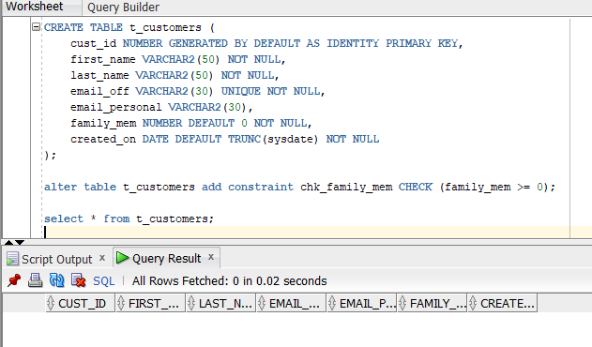

1. t_products table creation

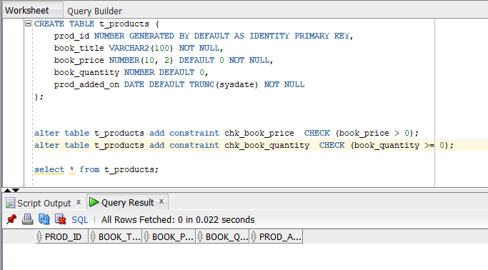

1. t_cust_prod table creation with cascade constraint( to maintain the data integrity and avoid integrity constraint error)

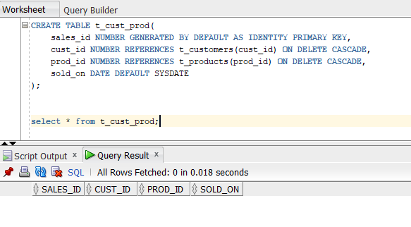

1. Index creation on t_customers and t_products tables

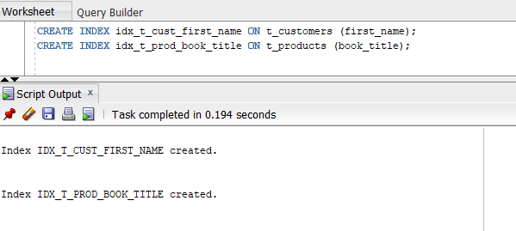

1. Creating package to demonstrate insert into 3 tables using separate procedures.
2. Also create a transactional procedure to demonstrate the transaction management

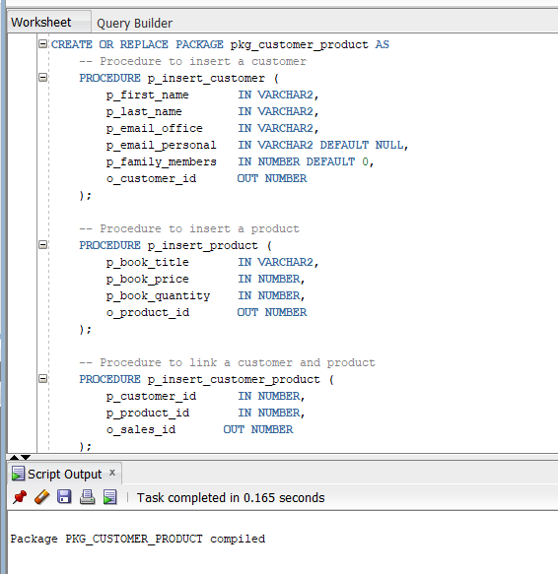

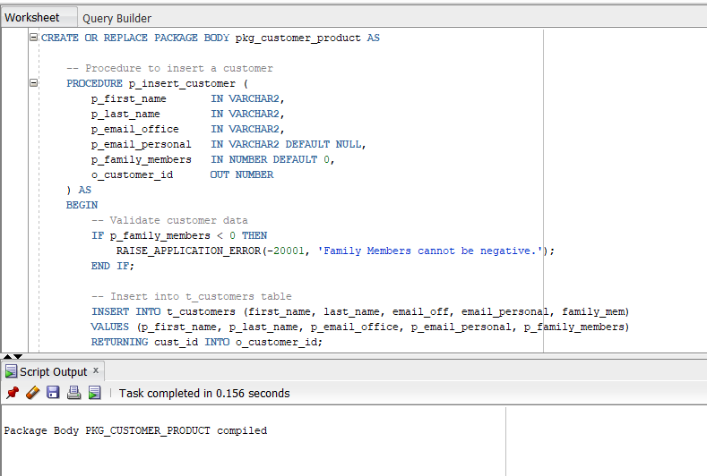

1. Inserting a transaction by creating a customer, product and a sales transaction by calling p_manage_customer_product_trans procedure.

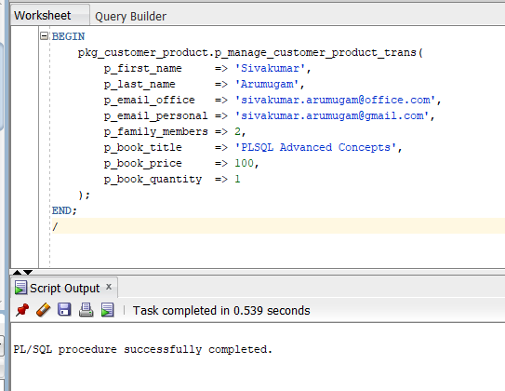

Results successful

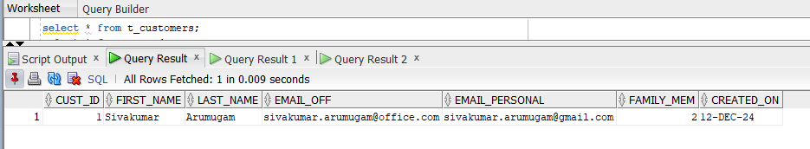

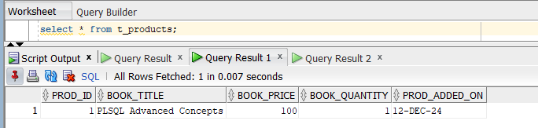

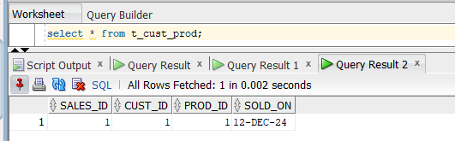

1. safeguarding sensitive data and preventing SQL Injection.

* When string concatenation is used in SQL with parameter RISK of SQL injection attack is possible like below. The table have 2 records in total and all are brought by passing some attack string like **''' OR ''1''=''1'**

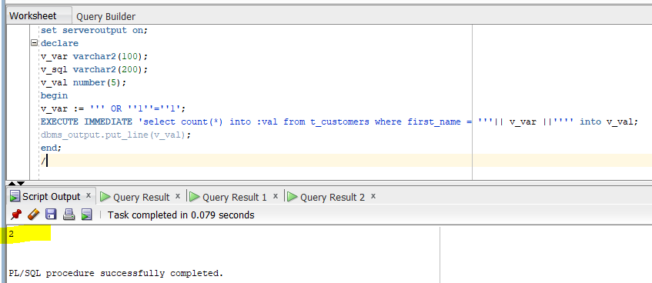

* Can be avoided by using bind variable or DBMS_ASSERT.ENQUOTE_LITERAL

Bind variable

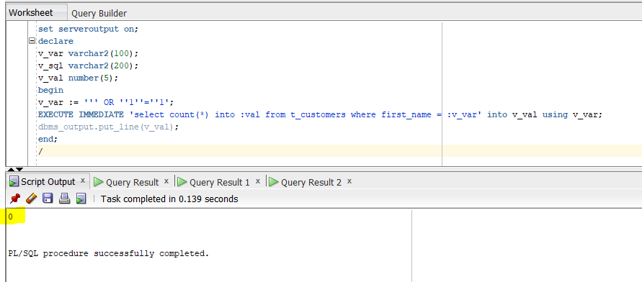

DBMS_ASSERT.ENQUOTE_LITERAL gives numeric or value error which can be handled in exception block.

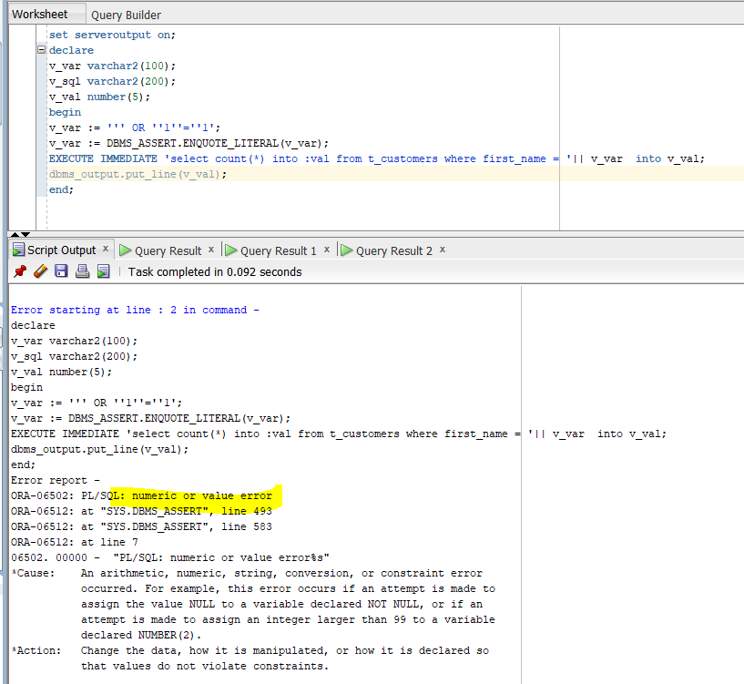

Correct output when proper first_name is passed

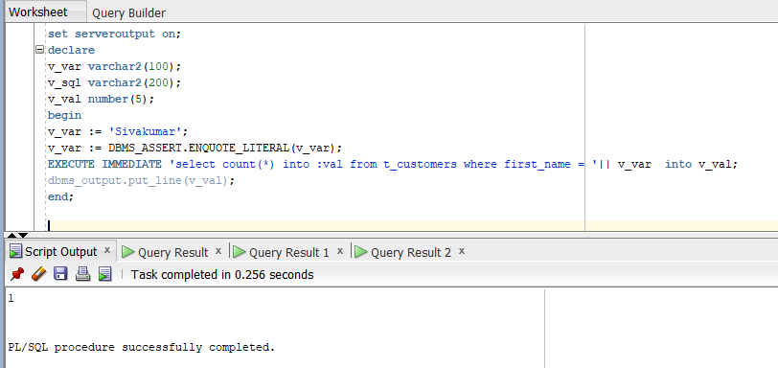

1. Demo for scheduling job.

Grant privilege to user for creating job

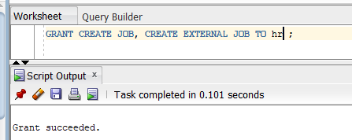

Create job

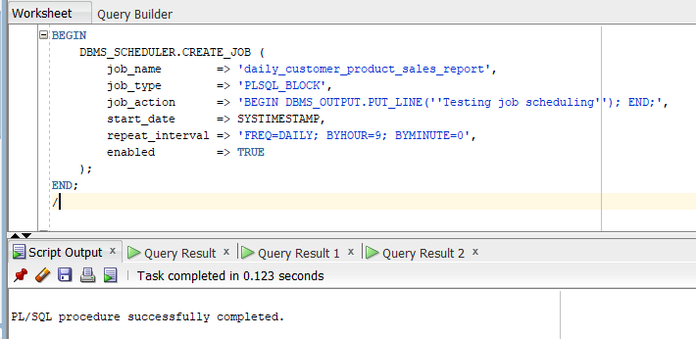

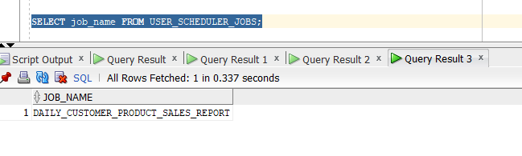

Drop job

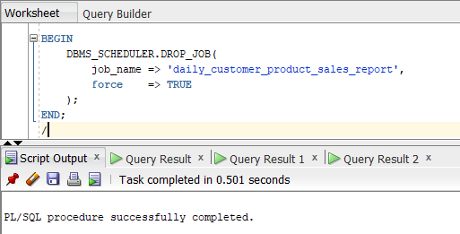

1. Caching and Bulk Processing demo:

Increasing the book_price for all the product in t_product table by 10%. It will be helpful when millions of rows are present in real time scenario.

Before update

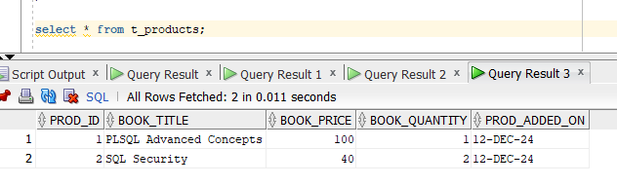

Bulk collect processing to increase price by 10%

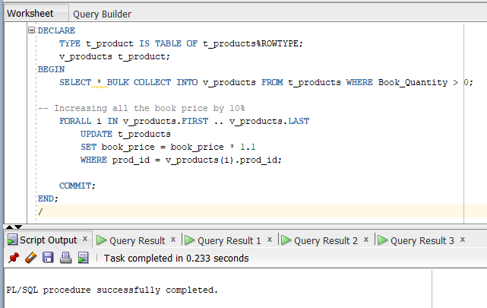

After processing

