**Kubernatees Microservices**

[**https://www.youtube.com/watch?v=lXqqhyCPWC0**](https://www.youtube.com/watch?v=lXqqhyCPWC0)

[**https://github.com/shabbirdwd53/Springboot-Microservice/tree/kubernetes**](https://github.com/shabbirdwd53/Springboot-Microservice/tree/kubernetes)

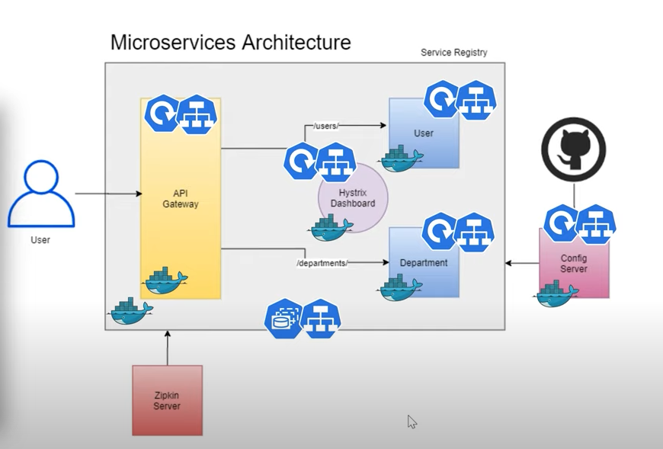

**User Service and Department Service is with cluster IP (service) ,Deployment Service**

**API Gateway -- load balancer ,Ingress controller.**

**Hystrix Dashboard -- Node Port**

**Service registry – Statefull set. We have to maintain the host name .It should be with Headless Service.**

**Accessing Statefull set.**



**Plugin Docker**

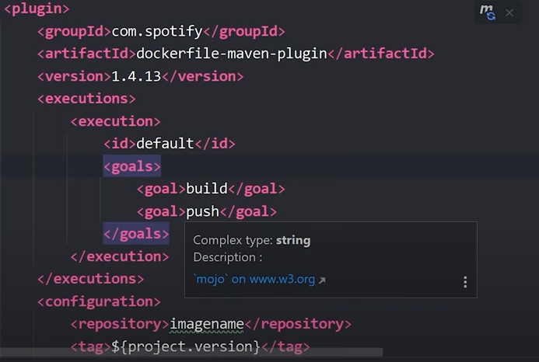

**Setting.xml for accessing github**

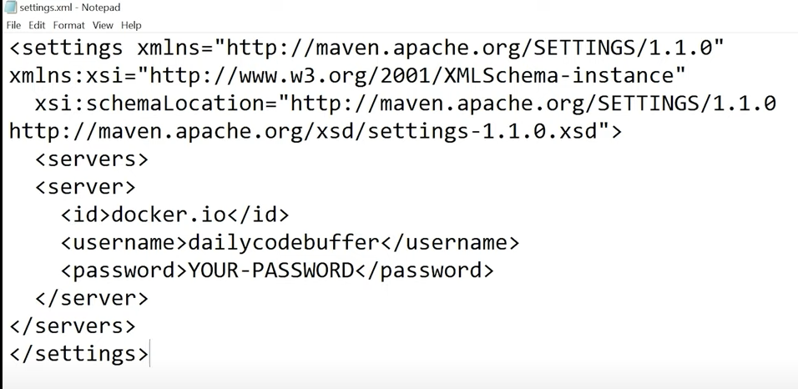

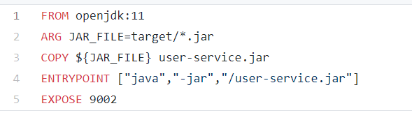

**Eureka server:**

