1. **FIZZ Buss ( number Divide by 5, & 3)**

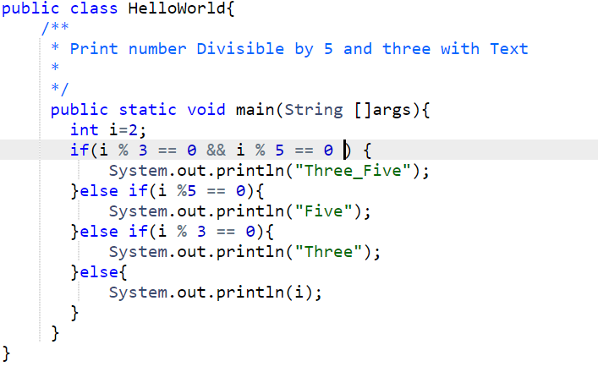

1. **Palindrome number :**

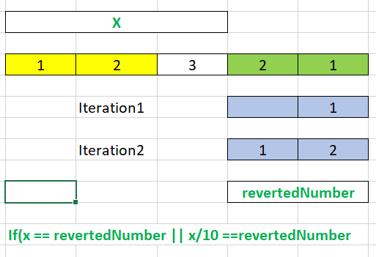

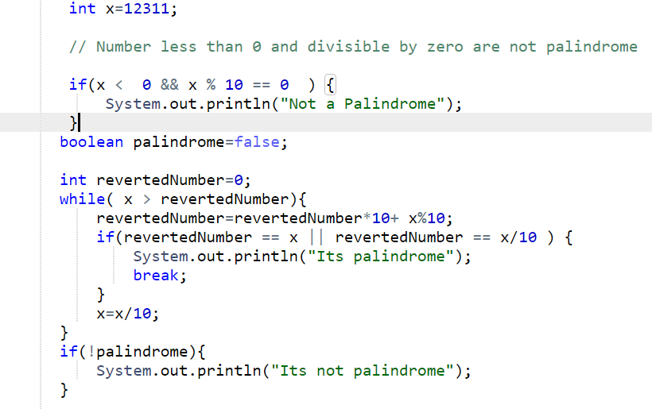

**3)pow (x,n)**

**223 = (222)1= ((Ans=1 *2 )* *2)22**

**28= (2*2)4= (4*4)2=(8*8)1=64**

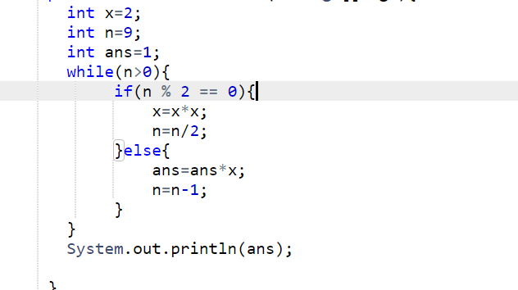

**If n<0 make it multiply by -1 and finaly 1/answer**

1. **Reverse a string (pointer start to end swap)**

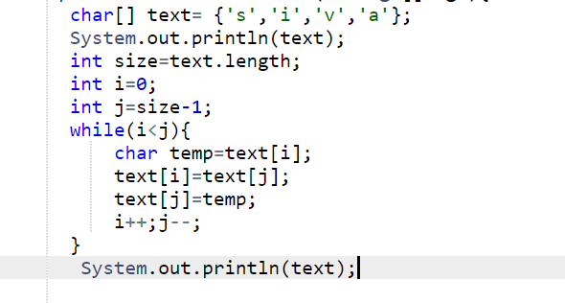

1. **Revers word in a string**

