Urban Pulse NYC
Findings, interpretation and limitations

Analysis of NYC 311 service requests, October 2025 to September 2026 (about 3% sample, 118,866 requests)

By Mahalakshmi Sivakumar – AIML | B19 | WE – Mini Project 1

1. The short version
New York's 311 line is mostly used for everyday problems: parking, noise and heating. Just ten complaint types make up more than half of all requests, and two agencies, the police and housing, receive two out of every three. Requests arrive steadily through the year and peak on weekday mornings.
The most interesting result is how long requests take. Most are marked closed within a day (the typical request takes under eight hours), but about one in six takes more than a week and a few take months. Those long cases pull the average up to almost seven days, so the average and the typical request tell very different stories. That is why this analysis relies on the median instead of the mean.
Almost every request (96.5%) has a closed date, but that only tells us the record was closed, not that the problem was solved or the person was satisfied. And everything here describes what people reported, taken from a 3% sample, so it shows patterns in reporting, not how bad conditions are or how well any agency performs.

2. About the data
- Source: NYC Open Data, 311 Service Requests from 2020 to Present, extracted on 30 October 2026.
- Sample: 118,866 requests created between 1 October 2025 and 30 September 2026. It is a systematic sample of about 3% (request IDs ending in 07, 37 or 67), with the same fraction taken from every month.
- Resolution times: 114,660 requests have a valid resolution time (a closed date that comes after the created date).
- Agency abbreviations: NYPD police; HPD housing; DSNY sanitation; DOT transportation; DEP environmental protection; DPR parks; DOB buildings; DOHMH health; DCWP consumer and worker protection; TLC taxi and limousine; OOS office of the sheriff; DHS homeless services; EDC economic development.

3. Findings and Interpretation
Each section gives Data, then Interpretation in simple terms.

What people ask about, and who handles it (Tasks 2 to 4)
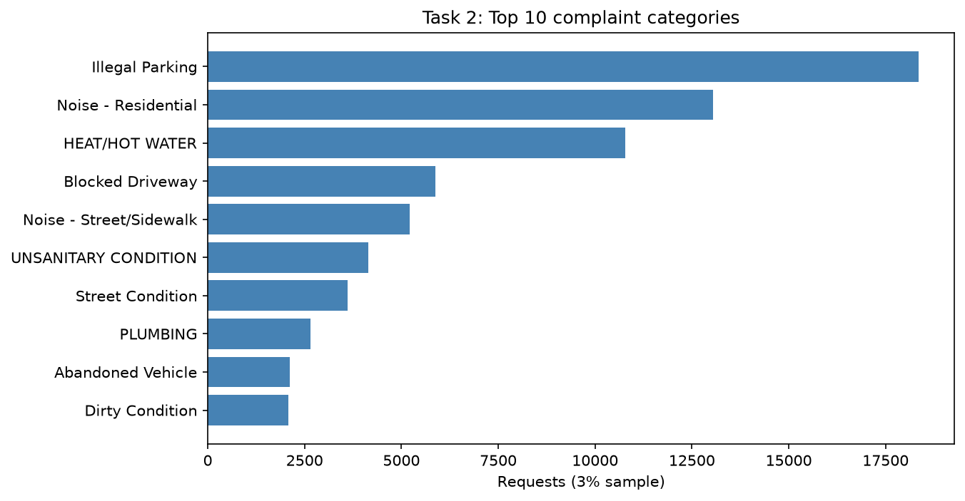
Data:

- Ten complaint types make up 57.1% of all requests. Illegal Parking leads with 15.45%, followed by Noise - Residential (10.97%) and Heat/Hot Water (9.07%).
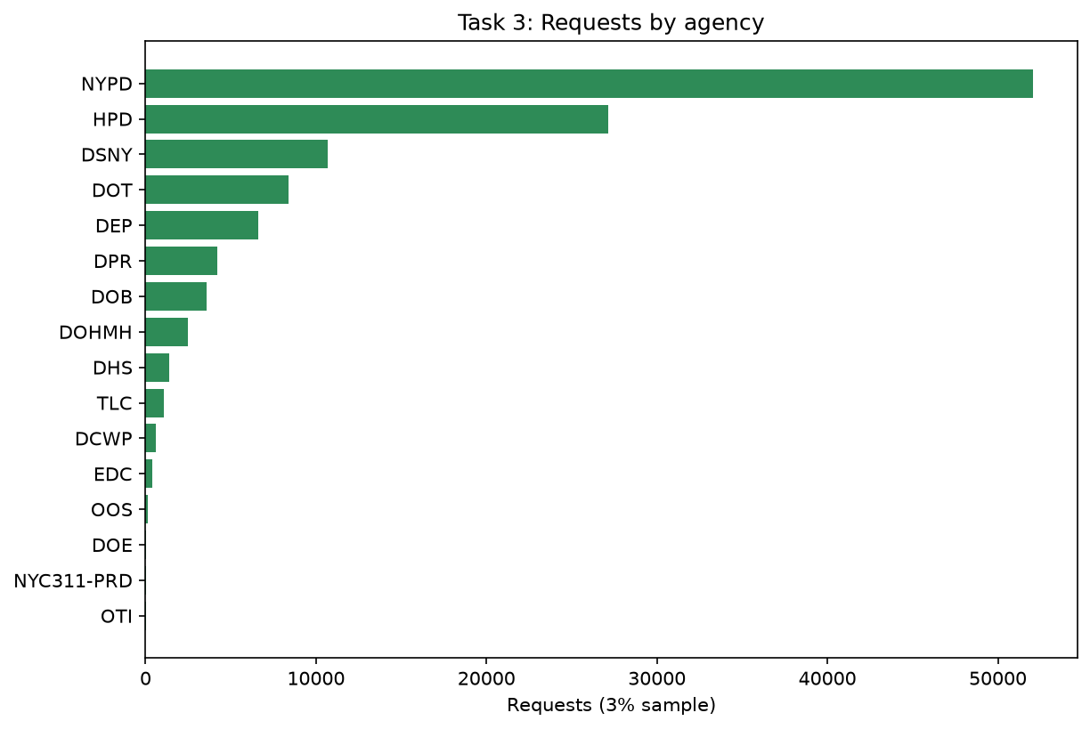
- Two agencies carry most of the load: the police department (NYPD) handles 43.8% of requests and housing (HPD) another 22.8%, together 66.6%.
- By borough, Brooklyn has the most requests (30.8%), then Queens (24.2%), the Bronx (21.5%), Manhattan (19.3%) and Staten Island (4.1%).
Interpretation:
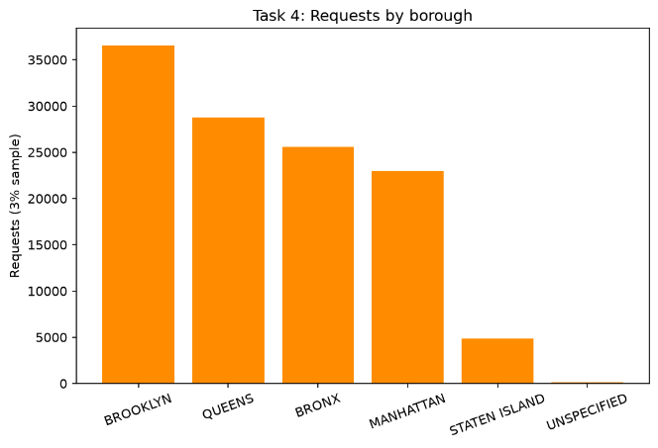
- 311 is mostly an everyday-problems line: parking, noise and heating. The agency split follows from that, since those are the problems the police and housing deal with. The borough numbers are raw counts, so they say nothing about which borough has more problems per resident. A bigger borough having more requests is not surprising.

When requests arrive (Tasks 5 and 6)
Data:
Monthly volume stays between 9,085 and 10,444 requests, with no steady rise or fall. Tuesday is the busiest weekday (18,245 requests) and Saturday the quietest (15,267). The five busiest hours, 9 am to 1 pm, hold 29.1% of all requests.
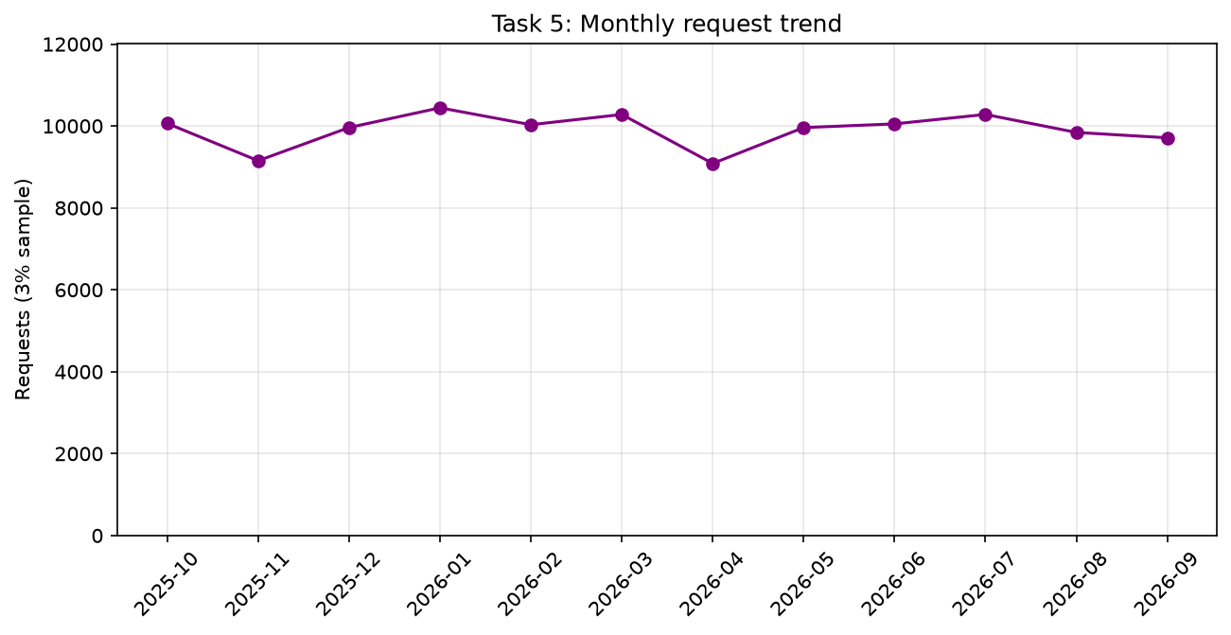
Interpretation:
Demand is steady through the year and follows the working day: people report problems on weekday mornings. Because only have twelve months, cannot separate a true seasonal pattern from one-off events, so the small ups and downs between months should not be over-read.
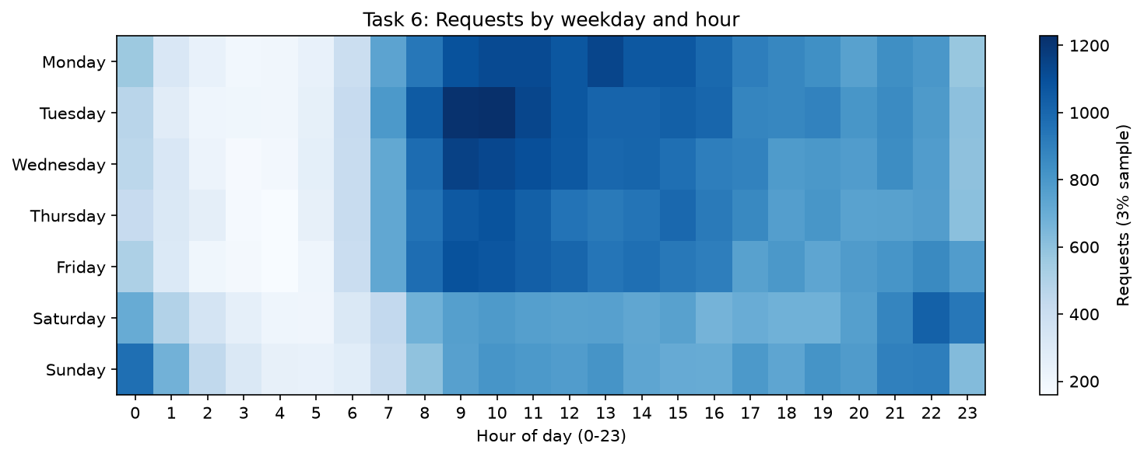

Status and recorded closure (Tasks 7 and 14)
Data:
- 96.48% of requests have a closed date.
- Closure is similar across the five main boroughs (95.8% to 97.8%), but very different across agencies: from 100% at several agencies down to 67.4% at Parks (DPR), 44.0% at the Taxi and Limousine Commission (TLC) and 3.5% at the Economic Development Corporation (EDC).
- By creation month it slips from 98.0% for October 2025 to 92.7% for September 2026. Also, 482 requests have a closed date although their status is not 'Closed'.
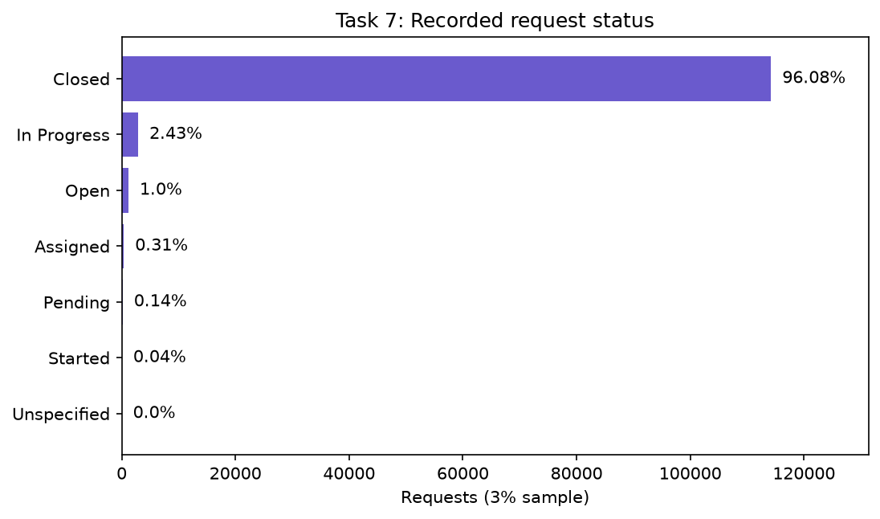
Interpretation:
- 'Closed' here only means the record has a closure date. It does not mean the problem was fixed or the person was satisfied.
- The slide in recent months is what would be expected if newer requests simply have had less time to close, so it is not evidence that service got worse.
- The very low rates at a few agencies may come from how those agencies record closure, not from unresolved problems.
- The 482 mismatches show that status and closed date do not always follow the same rules.
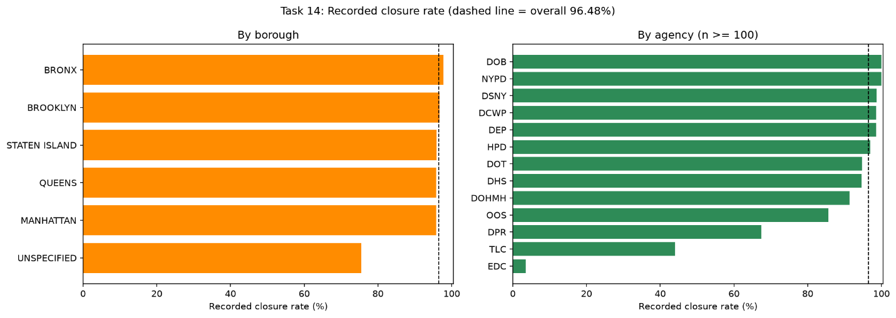

How long requests take (Tasks 8 and 12)
Data:
- The median resolution time is 7.66 hours, but the mean is 166.85 hours, about 22 times larger.
- About 60% of requests reach a recorded closure within a day (22.6% in under an hour, 37.6% between one and 24 hours), while 16.9% take more than a week and 26.2% take more than 72 hours.
- The slowest 1% take about 112 days or more, and the longest case is 9,261 hours (about 386 days).
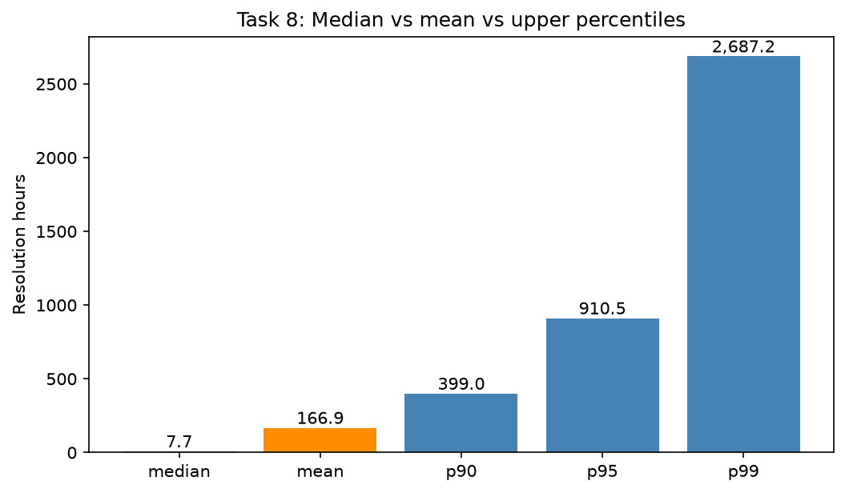
Interpretation:
- There are really two groups: a large group that closes quickly and a smaller group that takes a very long time.
- The long cases drag the average up to almost seven days, so the average describes almost nobody.
- If someone asks 'how long does a 311 request take?', the honest answer is 'usually a matter of hours, but about one in six takes more than a week'. This is why the median is the right number to quote.
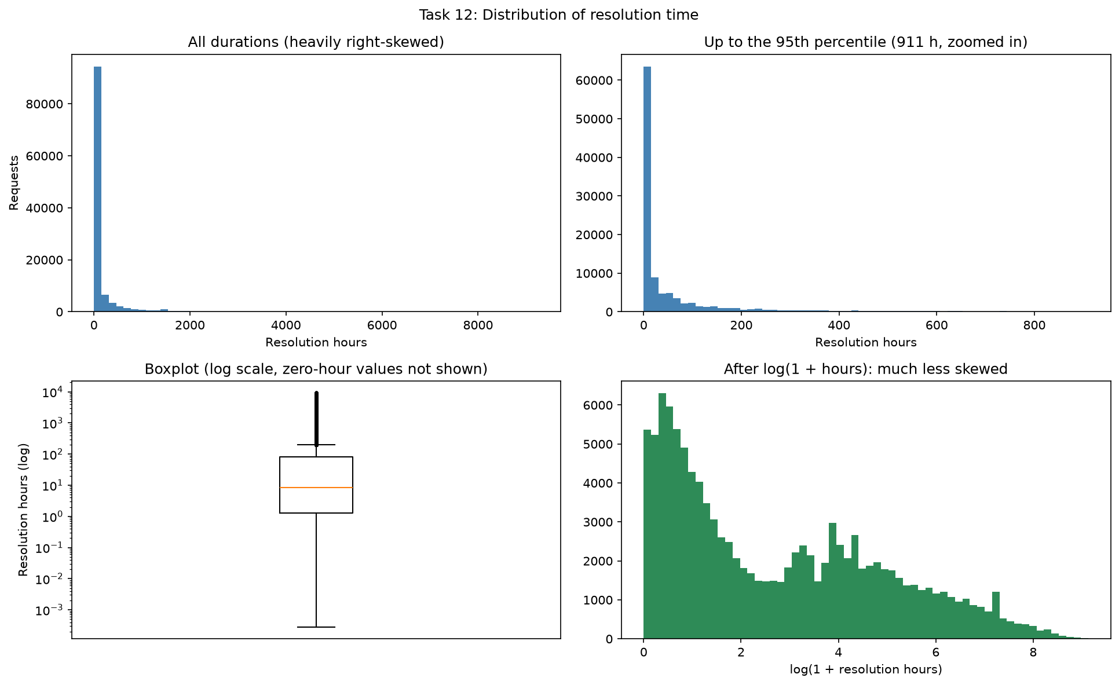

Which agencies and complaint types are quicker or slower (Tasks 9 and 10)
Data:
- Among agencies with at least 100 valid durations, the median runs from 1.34 hours for NYPD to about 1,072 hours for the Office of the Sheriff (OOS), with housing (HPD) at 97 hours, transportation (DOT) at 50 hours and sanitation (DSNY) at 39 hours.
- By complaint type, the longest medians are for Hire Vehicle Complaint (about 2,374 hours), Food Establishment (1,440) and Smoking or Vaping (1,431), while Vendor Enforcement (0.33 hours), Traffic and Illegal Fireworks close in under an hour. NYPD supplies about 45% of all valid durations.
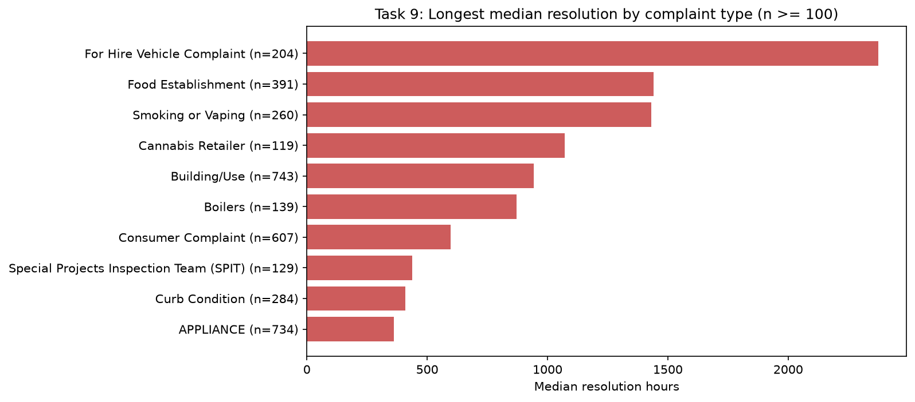
Interpretation:
- The pattern follows the type of work. A noise or parking complaint can be closed once officers respond, while an inspection, licensing or building case takes weeks.
- These are differences in the work, not a ranking of who performs well. Two overlaps are worth knowing: all of OOS's cases are one complaint type (Cannabis Retailer), and all of the Department of Consumer and Worker Protection's cases are Consumer Complaints.
- So agency and category results are the same evidence seen twice. NYPD's large share also pulls the overall median down, which hides how different the agencies really are.
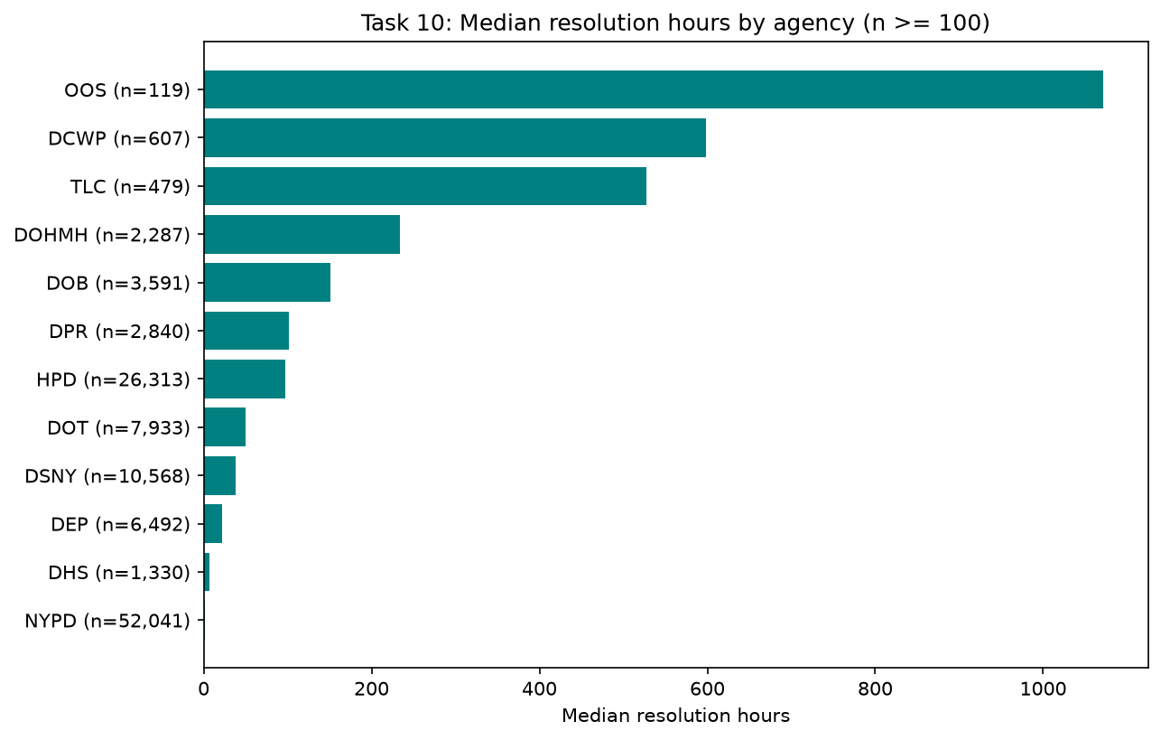

Unusually long cases (Task 11)
Data:
- Using the standard IQR rule, any resolution time above 192 hours (8 days) is flagged: 17,869 requests, or 15.6% of valid durations.
- HPD holds more than half of them (9,426). In several housing-related categories, more than half of the requests are flagged, for example Unsanitary Condition (62.2%), Door/Window (64.5%) and Building/Use (76.9%).
- Among agencies, the highest outlier rates are in small specialised ones such as OOS, TLC, DCWP and DOHMH.
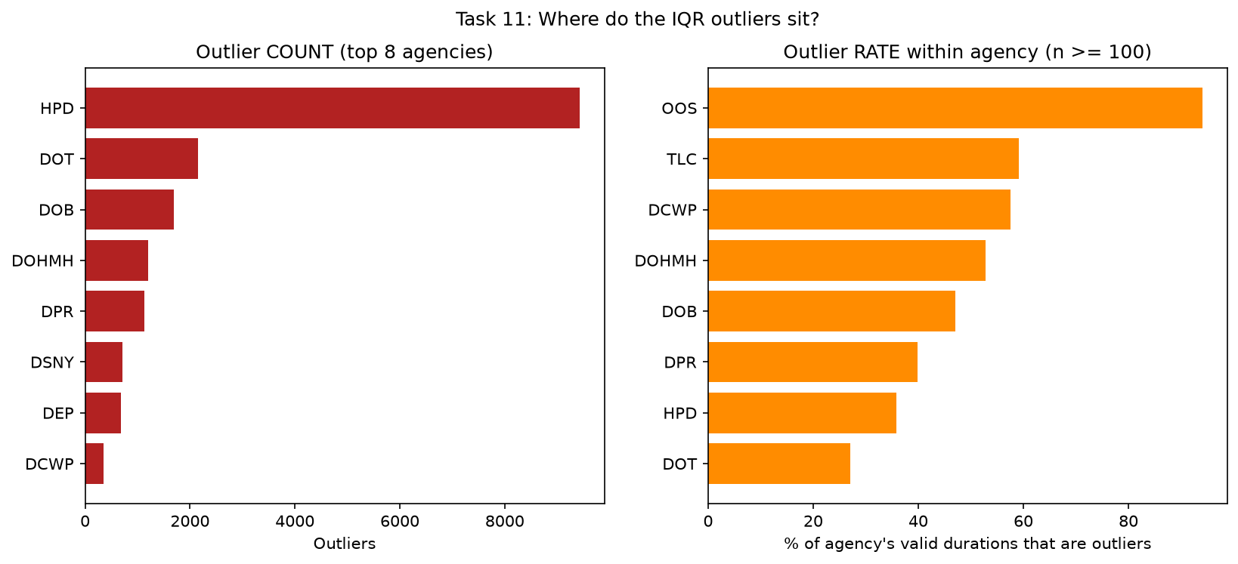
Interpretation:
- When more than half of a category is labelled an 'outlier', long resolution is simply normal for that kind of request, and the rule is telling us more about itself than about the cases.
- The rule uses one cut-off for everything, which works poorly across such different types of work. Have kept every flagged case, because they may be legitimate and the flags are only prompts for a closer look.

Where requests come from (Task 13)
Data:
- 97.96% of requests have usable coordinates (2,429 have none). Eight of the ten busiest ZIP codes are in the Bronx range, led by 10466 (2.52% of requests).
- Each borough has its own top complaints: illegal parking dominates Brooklyn and Queens (about 20% each), noise and heating lead in the Bronx, heating and hot water leads in Manhattan, and Staten Island's list includes snow or ice.
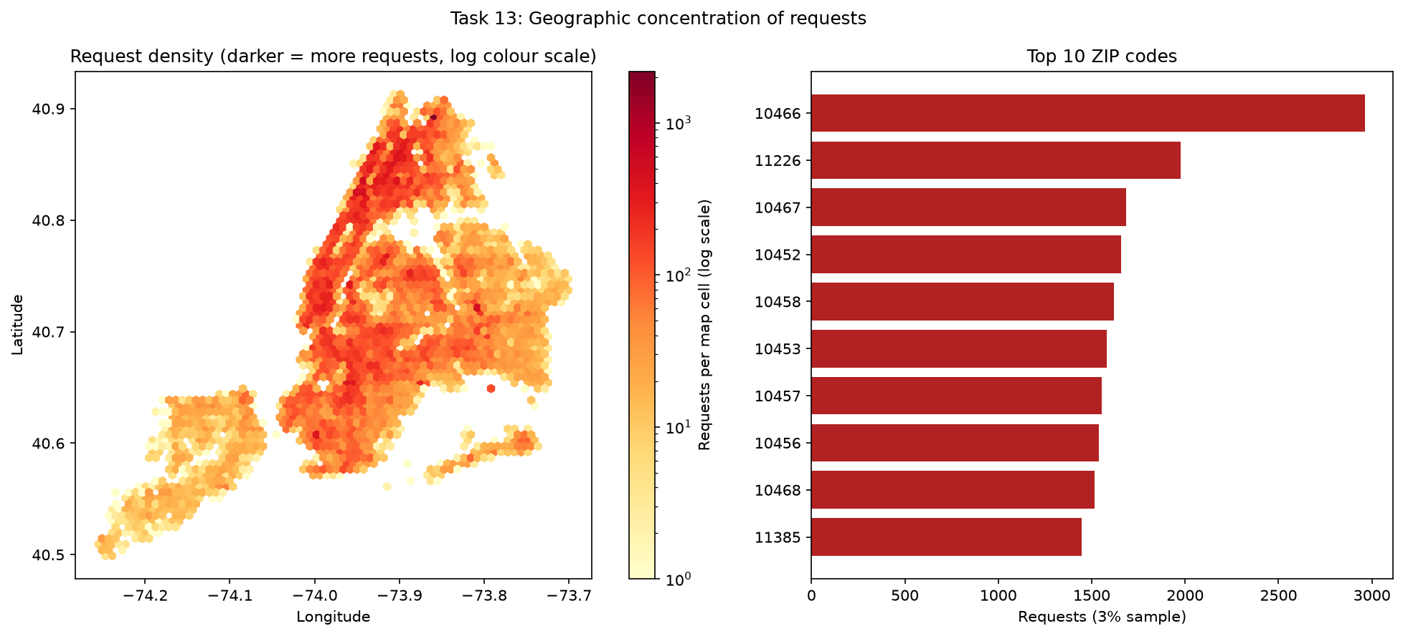
Interpretation:
- The map shows requests are spread across the city and densest in the Bronx, upper Manhattan, Brooklyn and Queens.
- It is interesting that Brooklyn has the most requests overall but the Bronx owns most of the busiest ZIP codes. That suggests Bronx requests are more concentrated in fewer areas, but did not test this. All of it is raw counts, not per resident or per square mile.

High volume and slow: where to look first (Task 15)
Data:
- Three complaint types combine many requests with long median resolution times: Unsanitary Condition (4,137 requests, median 288 hours), Door/Window (1,602 requests, 319 hours) and Water Leak (1,425 requests, 289 hours).
- Together they are 6.0% of all requests, and their medians are about 12 to 13 days.
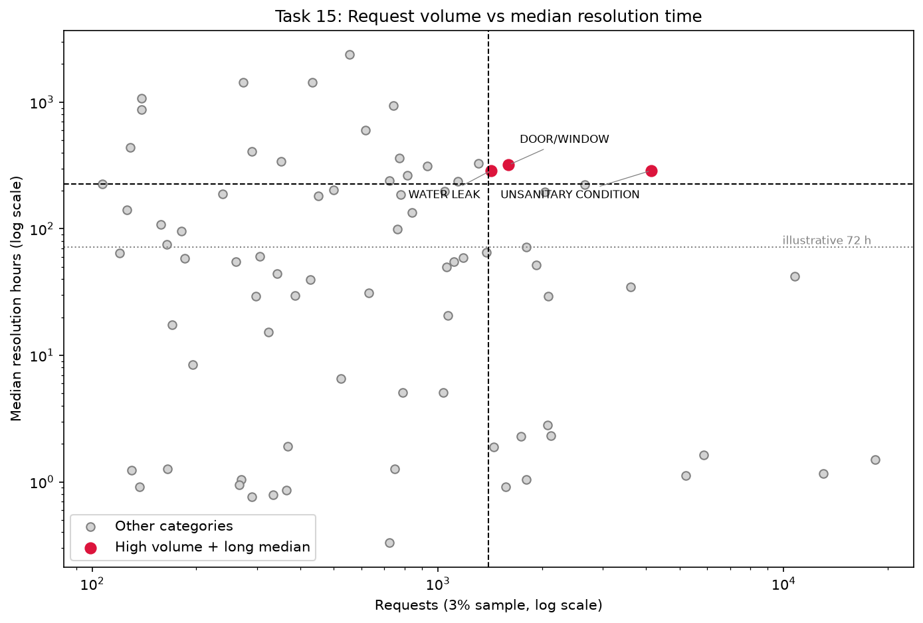
Interpretation:
- All three are housing-maintenance problems, so they are the natural place to look first: a small improvement here would help many people who currently wait a long time.
- The cut-offs used to pick them (top quarter for volume and for median time) are our own analytical choice, and the median shows time to recorded closure, not the quality of the repair.

4. Putting it together
A helpful way to picture 311 is as two systems under one phone number. One is fast response: noise, parking and enforcement requests that are closed within hours. The other is slow process: housing repairs, inspections and licensing that take weeks or months. The overall figures blend the two, which is why the average is so far from the median, why agency medians range from about one hour to over a thousand, and why a single outlier rule flags so many housing cases.
Two cautions run through everything. First, recorded closure is a date in a database, not a measure of satisfaction or of a problem being fixed, and recent months look worse mainly because they have had less time to close. Second, differences between agencies and complaint types reflect the kind of work, so they should not be read as good or bad performance.
What the data can fairly support is a map of where demand is, when it arrives, and where the long waits sit. It cannot show why those patterns exist.

5. Further Investigations
These are questions the patterns raise, not conclusions about causes.
- Housing maintenance: Review the process for Unsanitary Condition, Door/Window and Water Leak, which combine high volume with medians of 12 to 13 days. Case complexity should be taken into account.
- Recording of closure: Ask the data owners how closure is recorded, since 482 requests have a closed date but a status other than 'Closed', and a few agencies show unusually low closure.
- Staffing: Plan around weekday-morning demand, and check whether the weekend late-night load comes from particular complaint types.
- Outlier rule: Replace the single outlier cut-off with one calculated within each complaint type, so 'long' means long for that kind of request.

6. Limitations
- Reported, not actual: 311 records are requests that people chose to make. They do not measure how common a problem really is, and easy-to-report problems look bigger.
- A sample: Counts are about 3% of the true totals, so trends and proportions are meaningful but absolute volumes are not. The sample takes IDs ending in 07, 37 and 67, and was assumed these are unrelated to the type of request; was not tested.
- One window: The data covers one 12-month window as of 30 October 2026. The dataset changes over time, so a different extraction date would give slightly different results, and twelve months cannot show year-to-year trends.
- Closure is not resolution: Closure means a recorded closed date. Newer requests have had less time to close, and status and closed date sometimes disagree.
- Missing and odd values: 2,429 requests have no coordinates, 27 were closed before they were created and 4,206 have no valid resolution time. These were flagged and kept, not deleted, and some analyses leave them out.
- Agencies and categories are not like for like: Medians reflect case mix and how each agency defines and records its work. Some agencies and categories overlap completely (for example OOS and Cannabis Retailer), and small groups under 100 valid cases were not compared.
- Not per resident: Borough and ZIP code counts are raw volumes. They are not adjusted for population or area.
- Project-defined cut-offs: The 72-hour threshold, the 100-case minimum, the top-quarter cut-offs in Task 15 and the single IQR outlier rule are choices made for this project, not official standards.
- Descriptive only: The analysis is descriptive. Here did not run statistical tests, so differences between agencies or boroughs have not been tested for significance. The SQL ran on MariaDB (XAMPP) through a MySQL-compatible driver.

Key Data
Measure | Value | Task
Distinct requests | 118,866 | 1
Top 10 complaint types, share of requests | 57.1% | 2
NYPD and HPD, share of requests | 66.6% | 3
Busiest and quietest weekday | Tuesday, Saturday | 6
Recorded closure | 96.48% | 14
Median resolution time | 7.66 hours | 8
Mean resolution time | 166.85 hours | 8
Skewness of resolution time | 6.40 | 8
Valid durations over 72 hours | 26.23% | 12
IQR outliers (above 191.99 hours) | 17,869 (15.6%) | 11
Requests with usable coordinates | 116,437 (97.96%) | 13
High volume and long median | Unsanitary Condition, Door/Window, Water Leak | 15

