Implementation of linear model in order to approximate the given data.

Aim:

To implement linear model in order to approximate the given data using python for the dataset,

A3 B3

12 39

20 36

28 30

18 52

29 54

33 46

24 55

45 59

45 63

52 70

Coding with output:

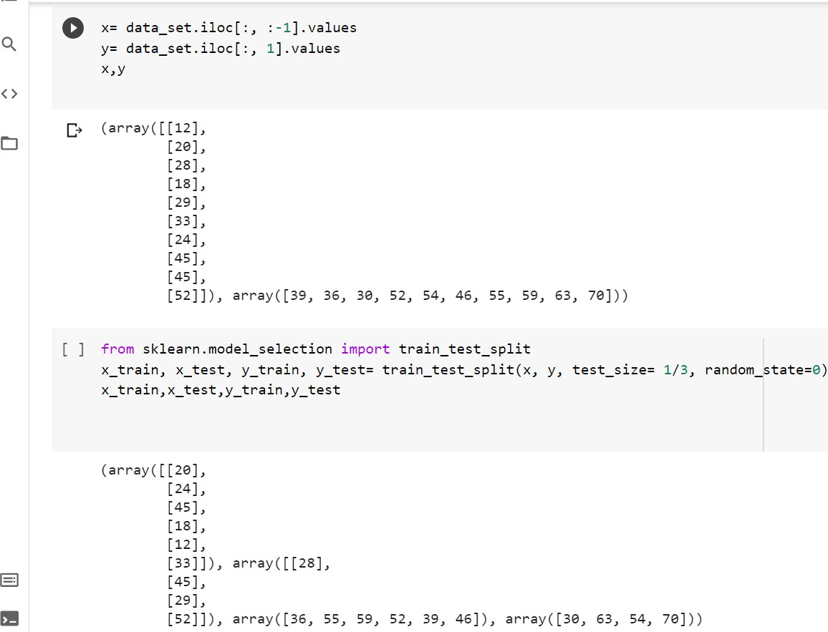

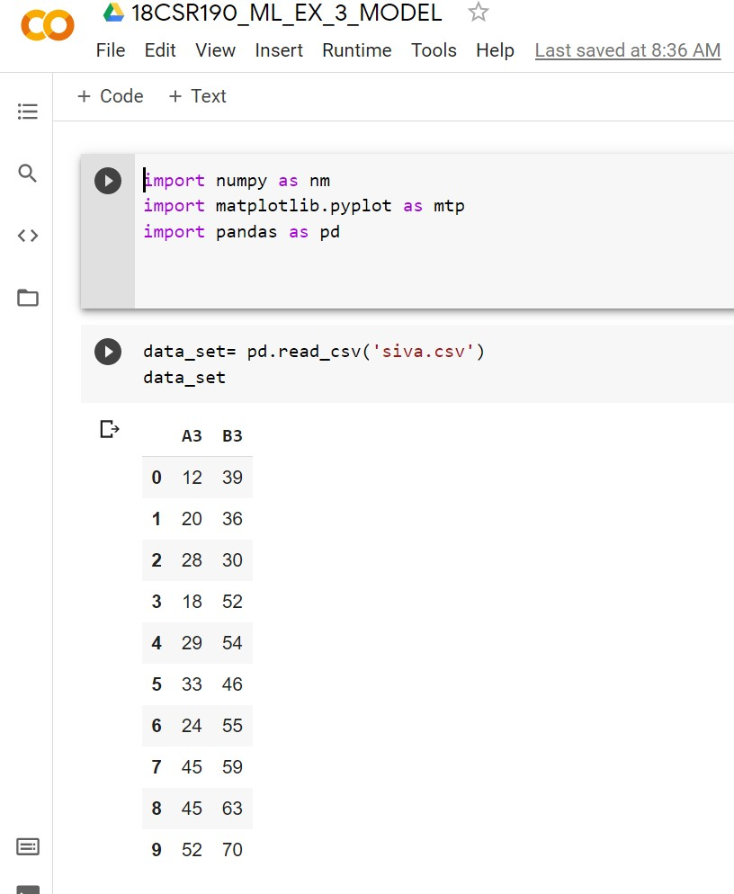

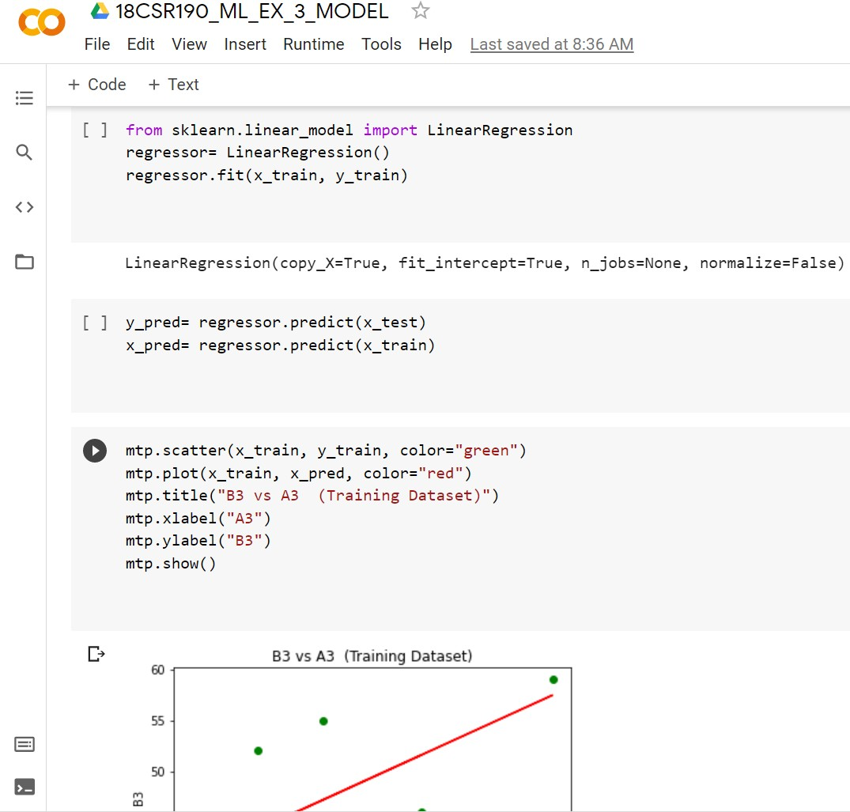

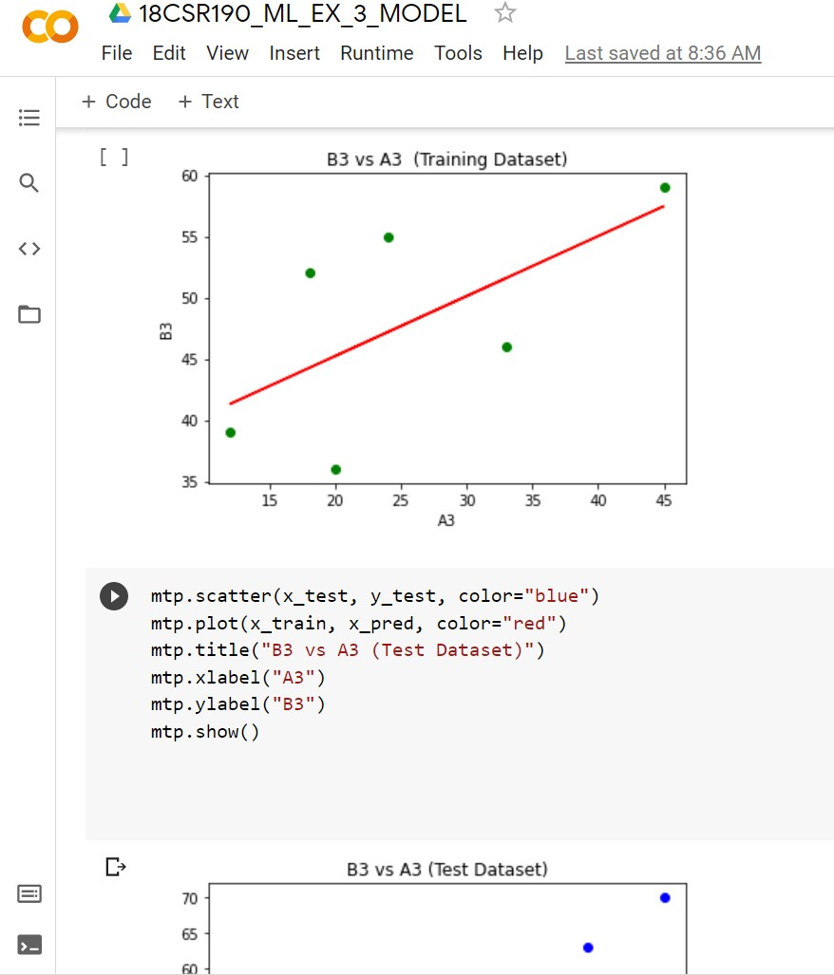

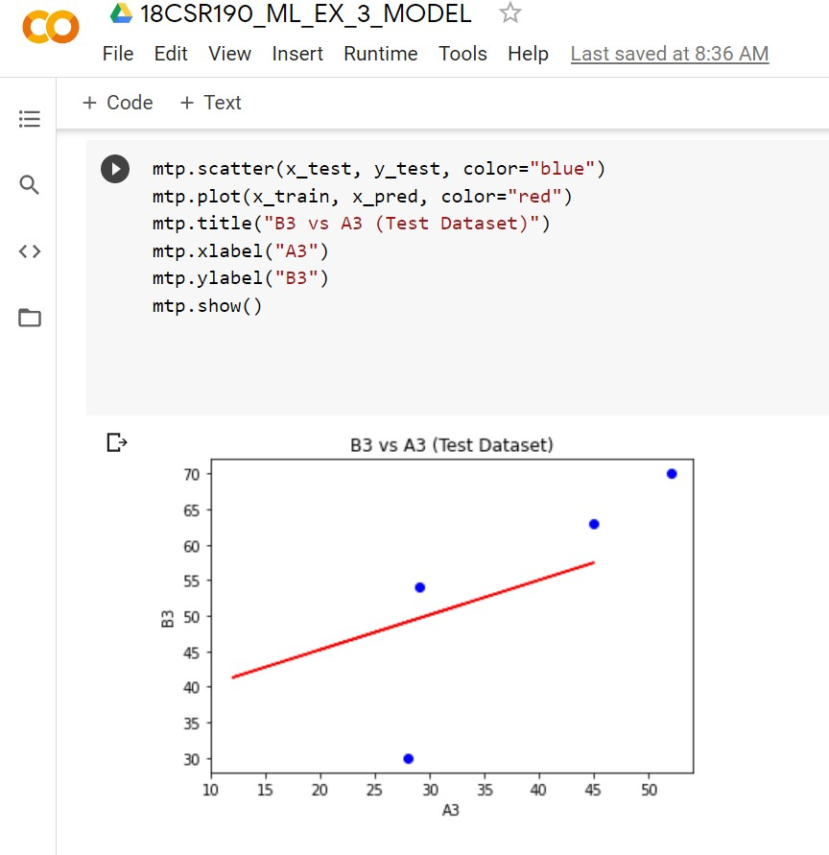

**Calculation:**

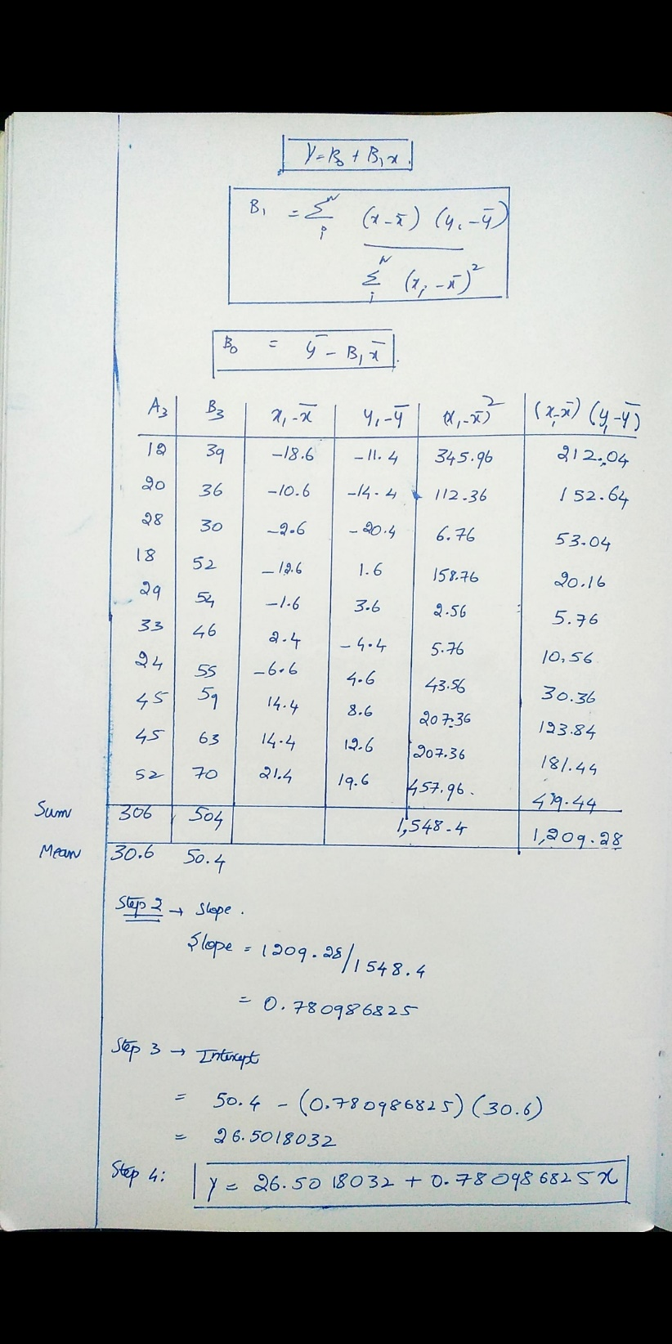

# Result:

Thus the implementation of linear model in order to approximate the given data using python was successfully completed and the output was verified.