**Report Screens**

**Screen 1:**

Report Menu

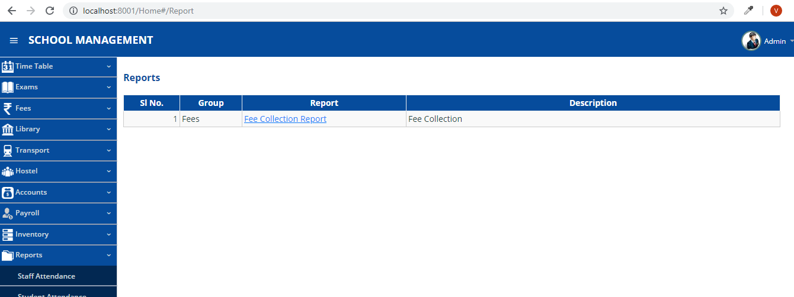

**Screen 2:**

On click of Fee Collection Report Link, redirect to Fee Collection Report Page

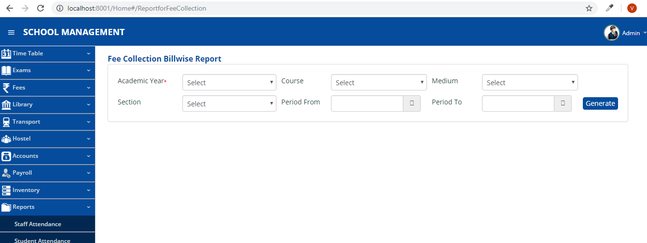

**Screen 3:**

Click on Generate Button, Report will be Generated

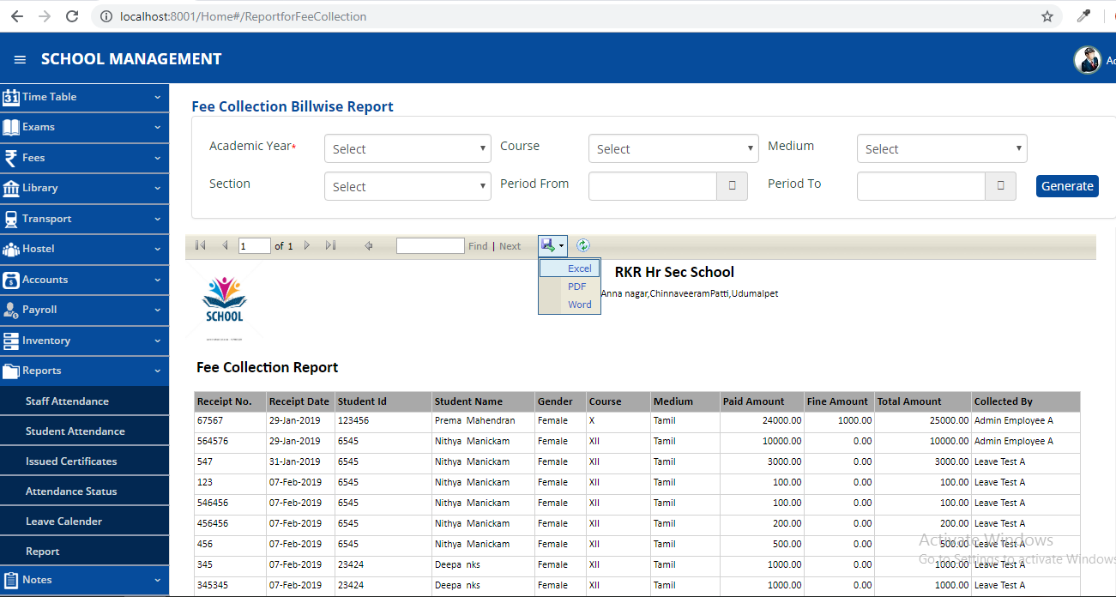

**Screen 4:**

Click on Excel, report exported to Excel Format

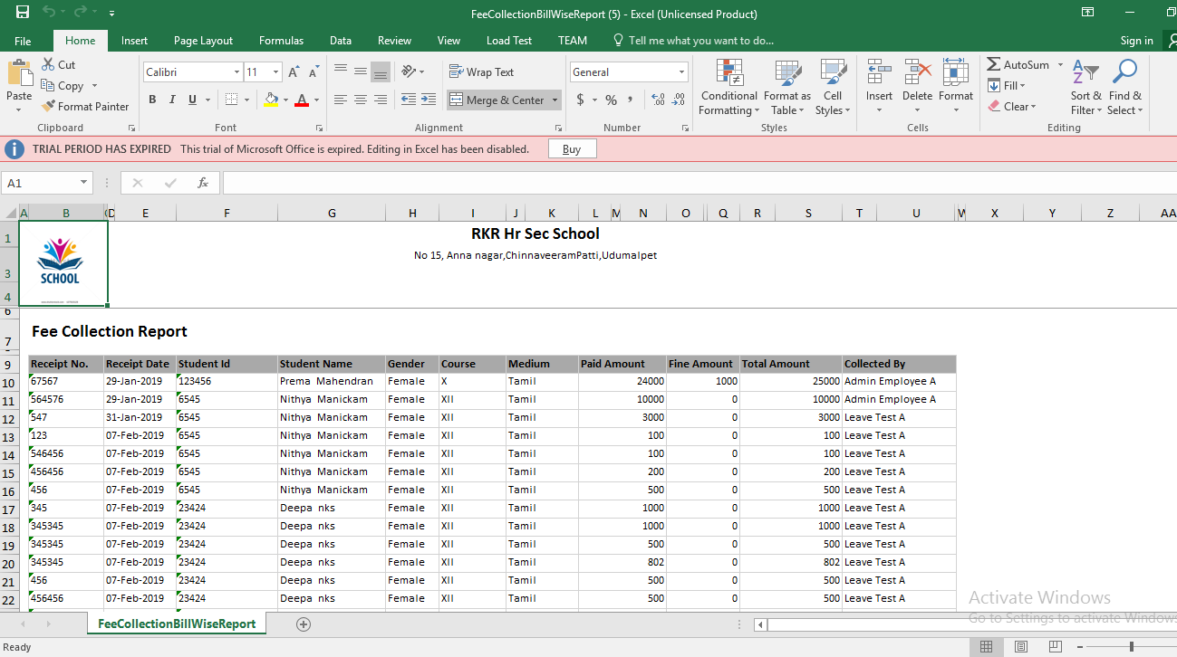

**Screen 5:**

Click on Word, report Exported to Word Format

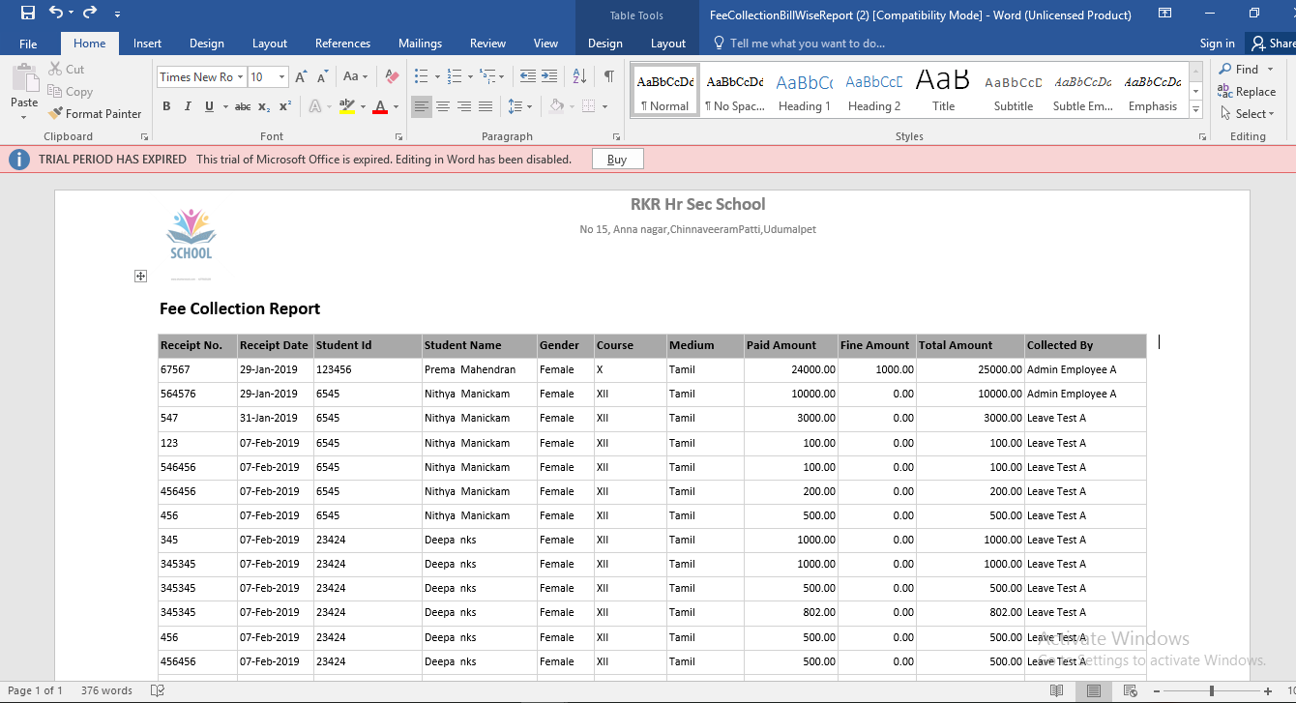

**Screen 6:**

Click on PDF, report exported to PDF format

