#mv sivaleela1.txt sivaleela1.yml

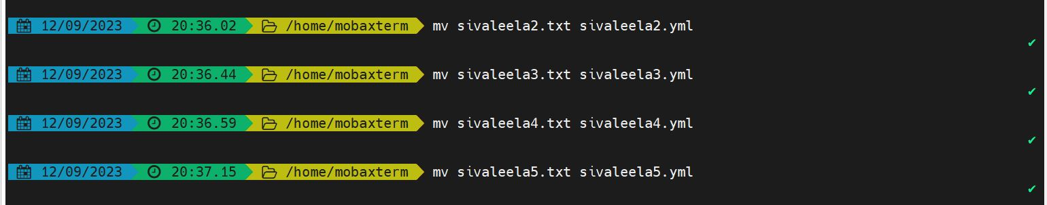

#ls -l

