1.esc :%s/system/technology/g will replace occurrence of word “system” with “technology”

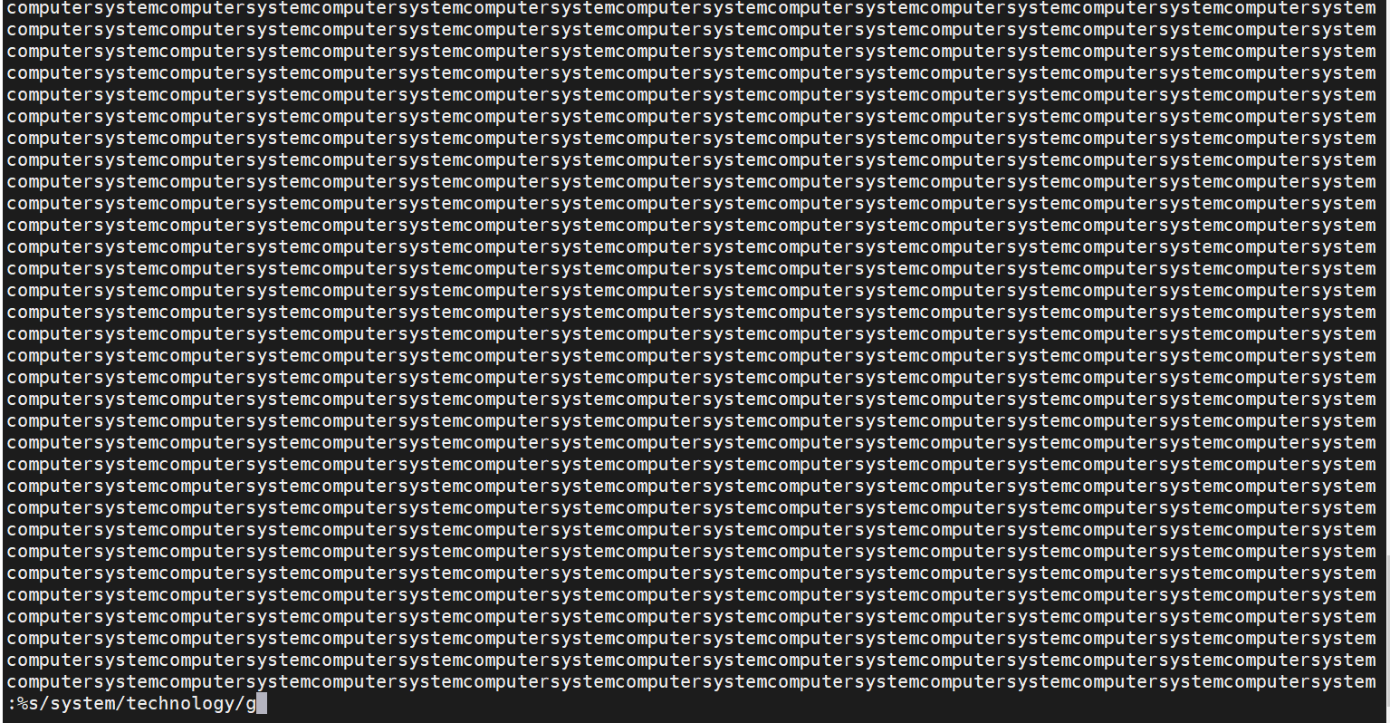

2. esc: %s/[aeiou]//g ----it will remove letters “a,e,i ,o,u” from the file

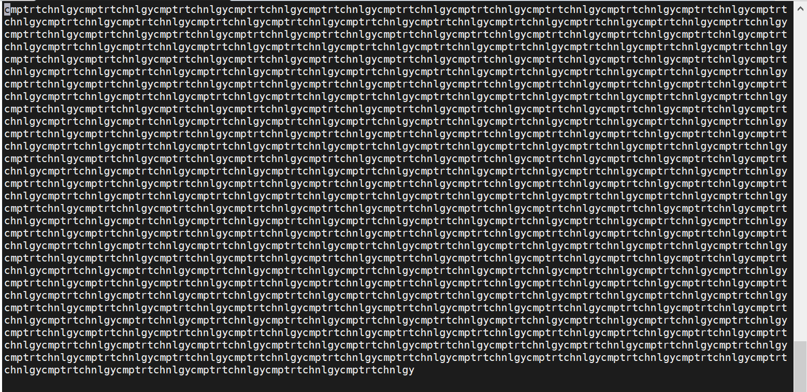

File permissions   
first output file is test1.txt

Second output file is test2.txt

