Microservices Architecture

Use Case Architecture
----------------------------------------------------------------------------------------------------------

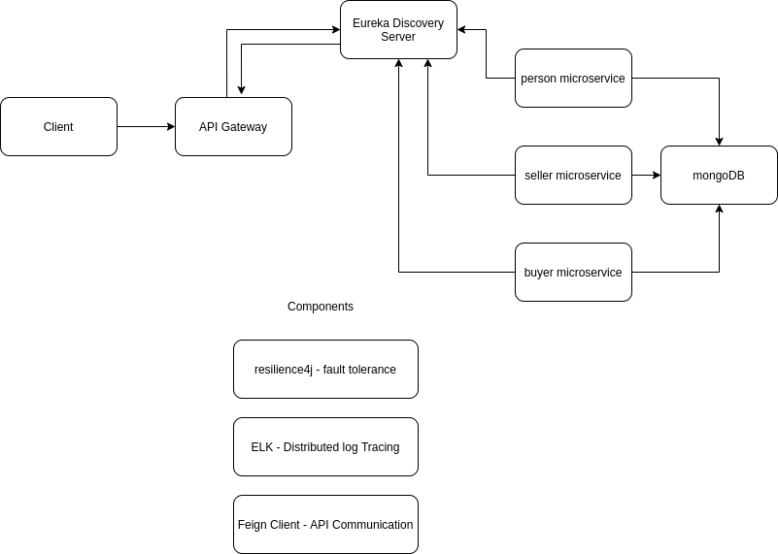

Please find below the details of design patterns used to implement the use case

Microservices Design Pattern
----------------------------------------------------------------------------------------------------------

Decomposition pattern - Decompose by Business Capability

This pattern has the following benefits:

- Stable architecture since the business capabilities are relatively stable
- Development teams are cross-functional, autonomous, and organized around delivering business value rather than technical features
- Services are cohesive and loosely coupled

Database Design
----------------------------------------------------------------------------------------------------------

Database Deployment pattern – Shared database

The benefits of this pattern are:

- A developer uses familiar and straightforward ACID transactions to enforce data consistency
- A single database is simpler to operate

Data Related Pattern
----------------------------------------------------------------------------------------------------------

Pattern – CQRS (Command Query Responsibility Segregation)

Benefits of CQRS:

- Clear boundaries between the system behaviour
- Closer to business logic
- Loose coupling
- Easier scaling, optimisations and architectural changes
- Predictability

Creational Design Pattern
----------------------------------------------------------------------------------------------------------

Pattern – Builder design pattern

Advantages of Builder Design Pattern:

- The parameters to the constructor are reduced and are provided in highly readable method calls.
- Builder design pattern also helps in minimizing the number of parameters in the constructor and thus there is no need to pass in null for optional parameters to the constructor.
- Object is always instantiated in a complete state
- Immutable objects can be built without much complex logic in the object building process.

