Project Agenda :- Swag Labs Automation using page object model and testNG with Selenium.
Application URL : https://www.saucedemo.com/v1/index.html
- Create new Maven Project
  - Group id = com.simplilearn
  - Artificat id = SwagLabs_TestNg
- Add the dependencies
- Create the Base class, Test classes and Page classes
- LoginTest.java
  - TC01_LoginSuccessTest
  - TC02_LoginFailureTest
  - TC03_LockedUserTest
- HomePageTest.java
  - TC01_AddToCartTest
- Add page classes
- Add the testng.xml file
- Run the test using testng.xml file
- Push the project to gitHUB

Code :-
- Package – Pages
Login Page.java
package pages;

import org.openqa.selenium.WebDriver;
import org.openqa.selenium.WebElement;
import org.openqa.selenium.support.FindBy;
import org.openqa.selenium.support.PageFactory;
import org.testng.Assert;

import tests.baseclass;

public class loginpage {
WebDriver driver = baseclass.driver;
@FindBy(css ="input[type='text']")
WebElement usrnm;

@FindBy(name = "password")
WebElement pwd;

@FindBy(css = "input.btn_action")
WebElement btn;

@FindBy(xpath = "//h3[@data-test='error']")
WebElement failerror;

public loginpage() {
PageFactory.initElements(driver, this);
}

public void loginsucess(String Usrnm, String Pwd) {
usrnm.sendKeys(Usrnm);
pwd.sendKeys(Pwd);
btn.click();
}

public void LoginFailure(String Expmsg) {
String Actualmsg = failerror.getText();
Assert.assertEquals(Expmsg, Actualmsg);
System.out.println("The expected msg is :- "+ Expmsg);
System.out.println("The actual msg is :- "+ Actualmsg);
}
public void LockedUser(String lockerror) {
String actuallockmsg = failerror.getText();
Assert.assertEquals(lockerror,actuallockmsg);
System.out.println("The expected msg is :- "+ lockerror);
System.out.println("The actual msg is :- "+ actuallockmsg);
}

}

HomePage.java
package pages;

import org.openqa.selenium.WebDriver;
import org.openqa.selenium.WebElement;
import org.openqa.selenium.support.FindBy;
import org.openqa.selenium.support.PageFactory;

import tests.baseclass;

public class homepage {
WebDriver driver = baseclass.driver;

@FindBy(xpath = "//div[@class='inventory_container']/div/div[1]/div[3]/button")
WebElement cartbutton;

public homepage() {
PageFactory.initElements(driver, this);
}

public void carttest() {
cartbutton.click();
}

}
Package – Test
BaseClass.java
package tests;

import java.time.Duration;

import org.openqa.selenium.WebDriver;
import org.openqa.selenium.chrome.ChromeDriver;
import org.testng.annotations.AfterMethod;
import org.testng.annotations.BeforeMethod;

public class baseclass {

public static WebDriver driver;

@BeforeMethod()
public void BeforeTest() {
driver = new ChromeDriver();
driver.get("https://www.saucedemo.com/v1/index.html");
driver.manage().window().maximize();
driver.manage().timeouts().implicitlyWait(Duration.ofSeconds(5000));
}

@AfterMethod()
public void AfterTest() {
driver.close();
}}
LoginTest.java
package tests;

import org.testng.annotations.Listeners;
import org.testng.annotations.Test;

import pages.loginpage;
@Listeners(Listener.class)
public class logintest extends baseclass{

@Test
public void TC01_LoginSuccessTest() {
loginpage lp = new loginpage();
lp.loginsucess("standard_user","secret_sauce");
}
@Test
public void TC02_LoginFailureTest() {
loginpage lg = new loginpage();
lg.loginsucess("standard_user", "asd@123");
String msg = "Epic sadface: Username and password do not match any user in this service";
lg.LoginFailure(msg);
}
@Test
public void TC03_LockedUserTest() {
loginpage lg = new loginpage();
lg.loginsucess("locked_out_user","secret_sauce");
String lock ="Epic sadface: Sorry, this user has been locked out.";
lg.LockedUser(lock);}
}
HomeTest.java
package tests;

import org.testng.annotations.Listeners;
import org.testng.annotations.Test;

import pages.homepage;
import pages.loginpage;
@Listeners(Listener.class)
public class hometest extends baseclass {
@Test
public void Addtocart(){
loginpage lg = new loginpage();
homepage hp= new homepage();
lg.loginsucess("standard_user", "secret_sauce");
hp.carttest();
}
}

Listener.java
package tests;

import java.io.File;
import java.io.IOException;

import org.apache.commons.io.FileUtils;
import org.openqa.selenium.OutputType;
import org.openqa.selenium.TakesScreenshot;
import org.testng.ITestContext;
import org.testng.ITestListener;
import org.testng.ITestResult;

public class Listener implements ITestListener {

@Override
public void onTestStart(ITestResult result) {
// TODO Auto-generated method stub

}

@Override
public void onTestSuccess(ITestResult result) {
// TODO Auto-generated method stub
TakesScreenshot obj = (TakesScreenshot) baseclass.driver;
File source = obj.getScreenshotAs(OutputType.FILE);
File target = new File("Screenshot/" +result.getName() + ".png");
try {
FileUtils.copyFile(source,target);
} catch (IOException e) {
// TODO Auto-generated catch block
e.printStackTrace();
}

}

@Override
public void onTestFailure(ITestResult result) {
// TODO Auto-generated method stub

}

@Override
public void onTestSkipped(ITestResult result) {
// TODO Auto-generated method stub

}

@Override
public void onTestFailedButWithinSuccessPercentage(ITestResult result) {
// TODO Auto-generated method stub

}

@Override
public void onStart(ITestContext context) {
// TODO Auto-generated method stub

}

@Override
public void onFinish(ITestContext context) {
// TODO Auto-generated method stub

}
}
pom.xml
<project xmlns="http://maven.apache.org/POM/4.0.0" xmlns:xsi="http://www.w3.org/2001/XMLSchema-instance"
xsi:schemaLocation="http://maven.apache.org/POM/4.0.0 http://maven.apache.org/xsd/maven-4.0.0.xsd">
<modelVersion>4.0.0</modelVersion>

<groupId>com.simplilearn</groupId>
<artifactId>SwagLabs_TestNg_P2</artifactId>
<version>0.0.1-SNAPSHOT</version>
<packaging>jar</packaging>

<name>SwagLabs_TestNg_P2</name>
<url>http://maven.apache.org</url>

<properties>
<project.build.sourceEncoding>UTF-8</project.build.sourceEncoding>
</properties>

<dependencies>
<dependency>
<groupId>junit</groupId>
<artifactId>junit</artifactId>
<version>3.8.1</version>
<scope>test</scope>
</dependency>
<dependency>
<groupId>org.seleniumhq.selenium</groupId>
<artifactId>selenium-java</artifactId>
<version>4.21.0</version>
</dependency>
<dependency>
<groupId>commons-io</groupId><!-- this is for screenshor -->
<artifactId>commons-io</artifactId>
<version>2.15.0</version>
</dependency>
<dependency>
<groupId>org.testng</groupId>
<artifactId>testng</artifactId>
<version>6.14.3</version>
<scope>test</scope>
</dependency>
<dependency>
<groupId>com.simplilearn</groupId>
<artifactId>SwagLabs_TestNg</artifactId>
<version>0.0.1-SNAPSHOT</version>
</dependency>
<dependency>
<groupId>com.simplilearn</groupId>
<artifactId>Cucumber_Project</artifactId>
<version>0.0.1-SNAPSHOT</version>
</dependency>
</dependencies>
</project>

testng.xml
<?xml version="1.0" encoding="UTF-8"?>

<suite name="Suite">
<test thread-count="5" name="Test">
<classes>
<class name="tests.hometest"/>
<class name="tests.logintest"/>
</classes>
</test> <!-- Test -->
</suite> <!-- Suite -->
Evidences: -
Login Test
TC01_LoginSuccessTest
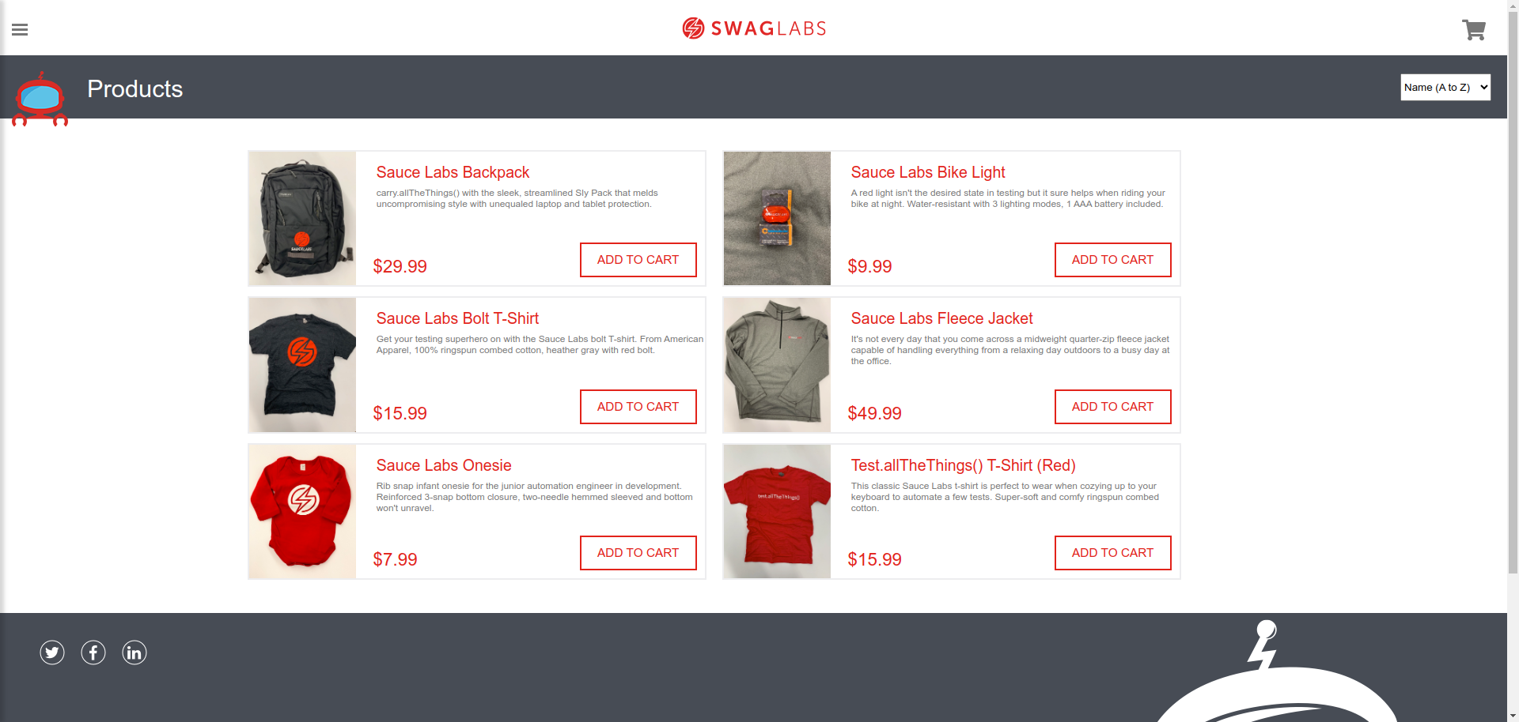
TC02_LoginFailureTest
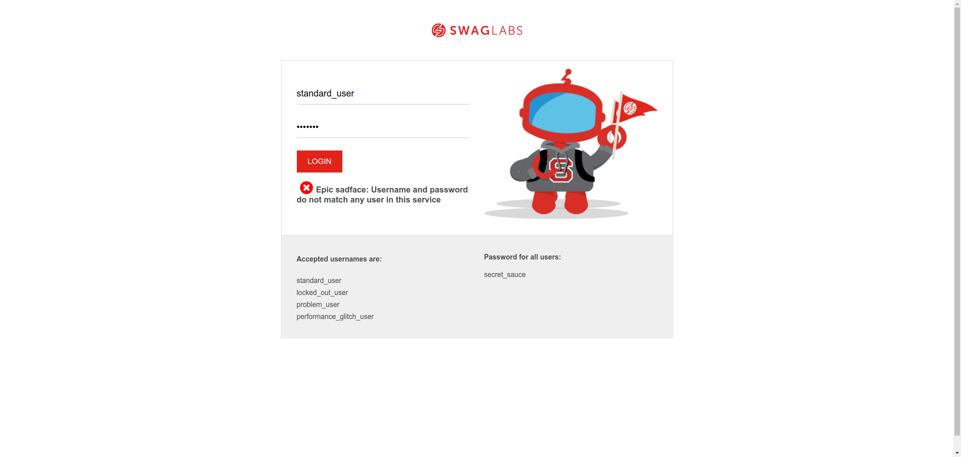

TC03_LockedUserTest
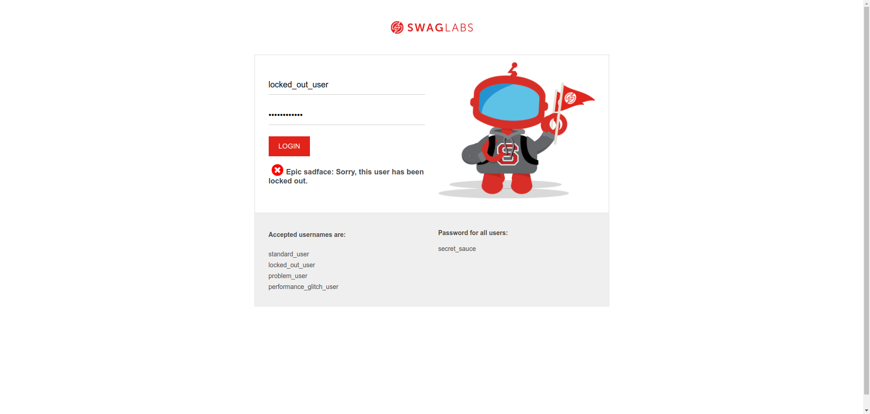
HomeTest
TC01_AddToCartTest
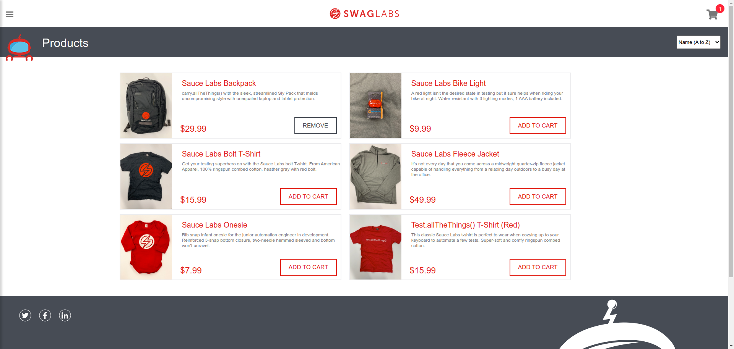
Git Hub - https://github.com/sivalingaa/E-Commerce_SwagLab_Automation_Selenium_TestNG

