HSBC Login Test Scenario
Project Agenda: To automate functionalities on the HSBC.co.in website using Cypress.io

Scenario:
You are working as a Test Engineer in XYZ Corp. Your company has decided to automate a few functionalities for one of the Banking companies.

You have been asked to design a functionality to automate testing using Cypress.io framework.
Tools Required:
- Node.js
- Java 1.8+
- Visual Studio Code
- Cypress [npm install Cypress]

Expected Deliverables:
- HSBC Login Test Scenario
Create a Cypress project in VS Code and automate the following test
scenarios:
- Open https://www.hsbc.co.in/
- Validate HSBC Bank Logo
- Validate Home Page Title = HSBC India - Credit Cards, NRI Services, Saving
and Deposit
- Click on Login button
- Validate Log On header in Login page
- Check Continue button is available
- Also validate initially Continue button is disabled.8. Type any random email in the username field
- Now check Continue button is Enabled
- Validate Remember me check box is not checked by default
- Validate there is a question mark tooltip present on the page
- Click on the tooltip
- Now validate the username header in the new pop-up screen
- Validate there is a Close button in the new pop-up screen
- Click on the close button present in the new pop-up screen
Follow these instructions while developing the code :
- Follow page object model
- For locators you can use any locators, but try to use Xpath
- Use before() to launch the application
- Test data should be derived from fixture/example.json file
- Try to avoid hard coded data
Source Code :-

beforeEach(() => {
cy.viewport(1500, 1000);
})
Cypress.on('uncaught:exception', (err, runnable) => {
return false;
});

describe('HSBC Bank Login Scenarios', () => {
it('Login Test cases', () => {
cy.visit('https://www.hsbc.co.in/');
cy.screenshot();
cy.wait(3000);
cy.get('h1>img').should('be.visible').screenshot();
cy.wait(3000);
cy.title().should('eq','HSBC India - Credit Cards, NRI Services, Saving and Deposit');
cy.screenshot();
cy.wait(3000);
cy.contains('Log On').click({force:true});
cy.screenshot();
cy.wait(3000);
cy.contains('Continue to log on with browser').click();
cy.screenshot();
cy.wait(3000);
cy.get('h2').contains('Log On');
cy.screenshot();
cy.wait(3000);
cy.get('button[name="continue"]').should('be.visible');
cy.screenshot();
cy.wait(3000);
cy.get('button[name="continue"]').should('be.disabled');
cy.screenshot();
cy.wait(3000);
cy.get('input#username').type("TestUser1");
cy.screenshot();
cy.wait(3000);
cy.get('button[name="continue"]').should('not.be.disabled');
cy.screenshot();
cy.wait(3000);
cy.get('input#rememberMe').should('not.be.checked');
cy.screenshot();
cy.wait(3000);
cy.get('a#username_help_link>span>span').should('be.visible');
cy.screenshot();
cy.wait(3000);
cy.get('a#username_help_link').click({force:true});
cy.screenshot();
cy.wait(3000);
cy.get('h3>span').should('be.visible');
cy.screenshot();
cy.wait(3000);
cy.get('a.close-btn>span>span').should('be.visible');
cy.screenshot();
cy.wait(3000);
cy.get('a.close-btn').click({force: true});
cy.screenshot();
})

})

Evidence Screenshots :-
- Open https://www.hsbc.co.in/
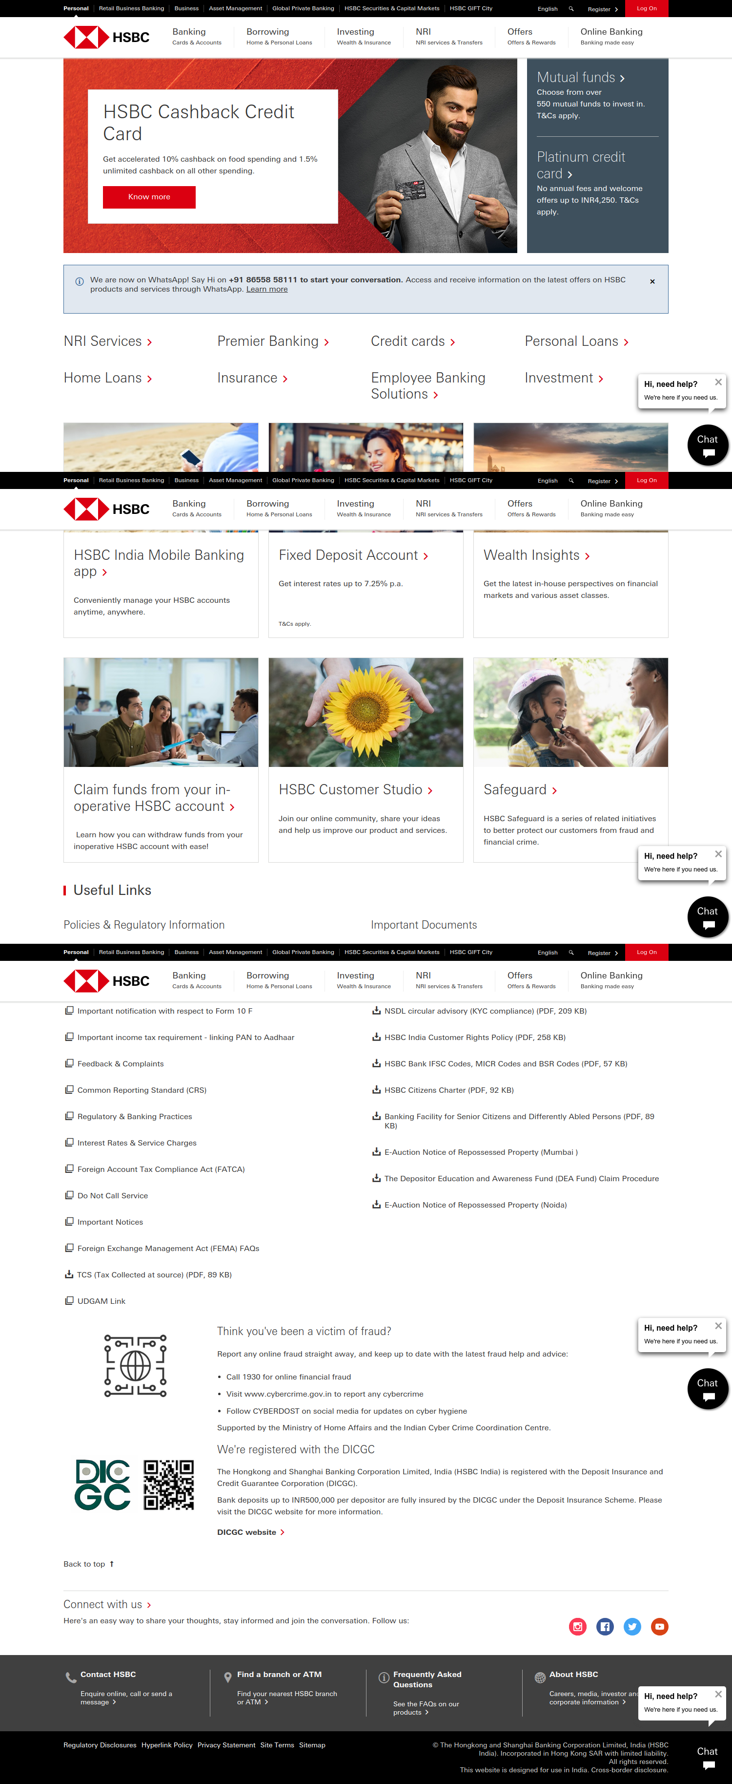

- Validate HSBC Bank Logo


- Validate Home Page Title = HSBC India - Credit Cards, NRI Services, Saving
and Deposit

- Click on Login button
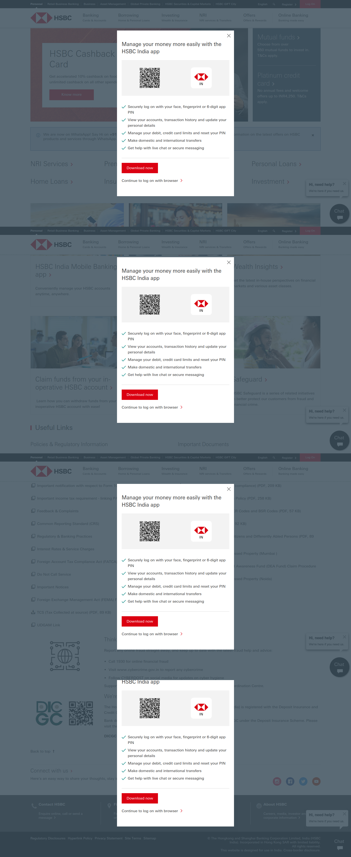

- Validate Log On header in Login page
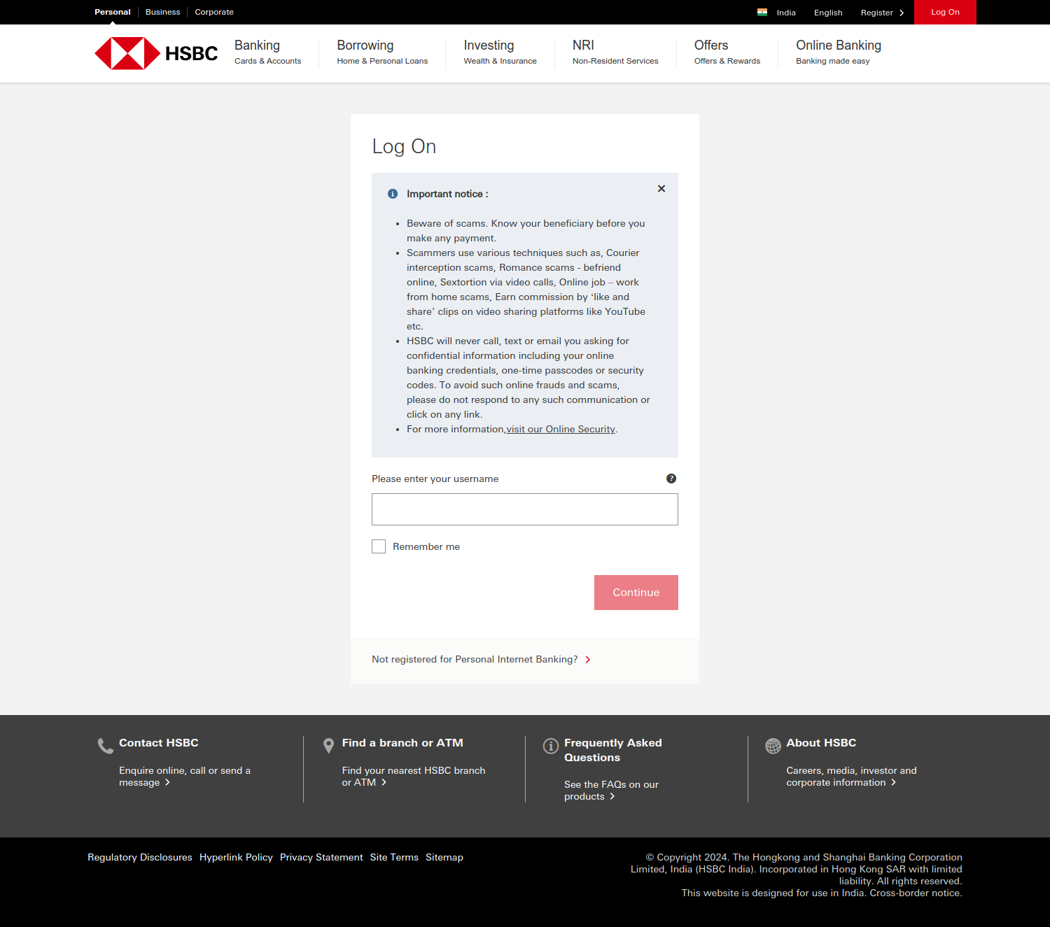

- Check Continue button is available

- Also validate initially Continue button is disabled.

- Type any random email in the username field
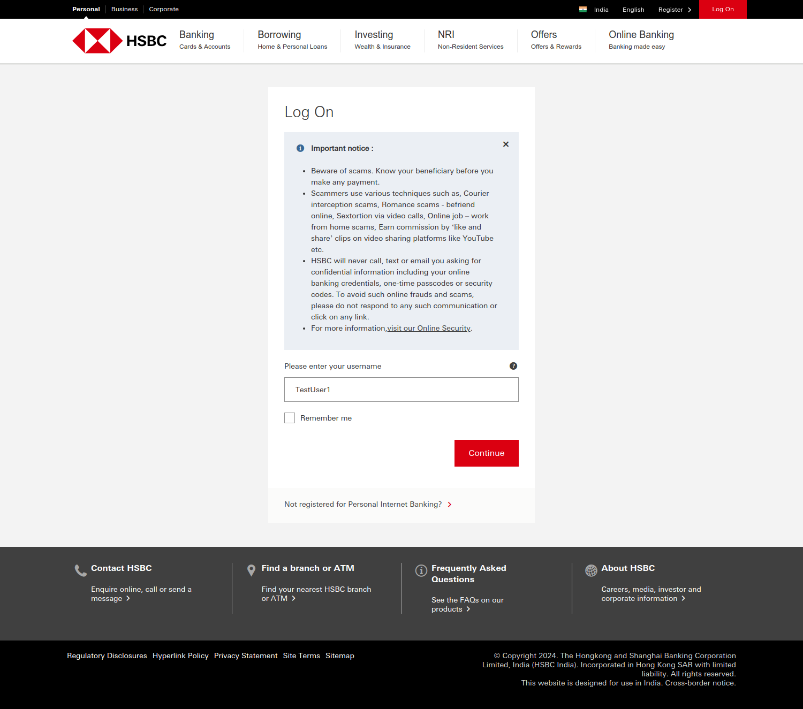

- Now check Continue button is Enabled

10. Validate Remember me check box is not checked by default
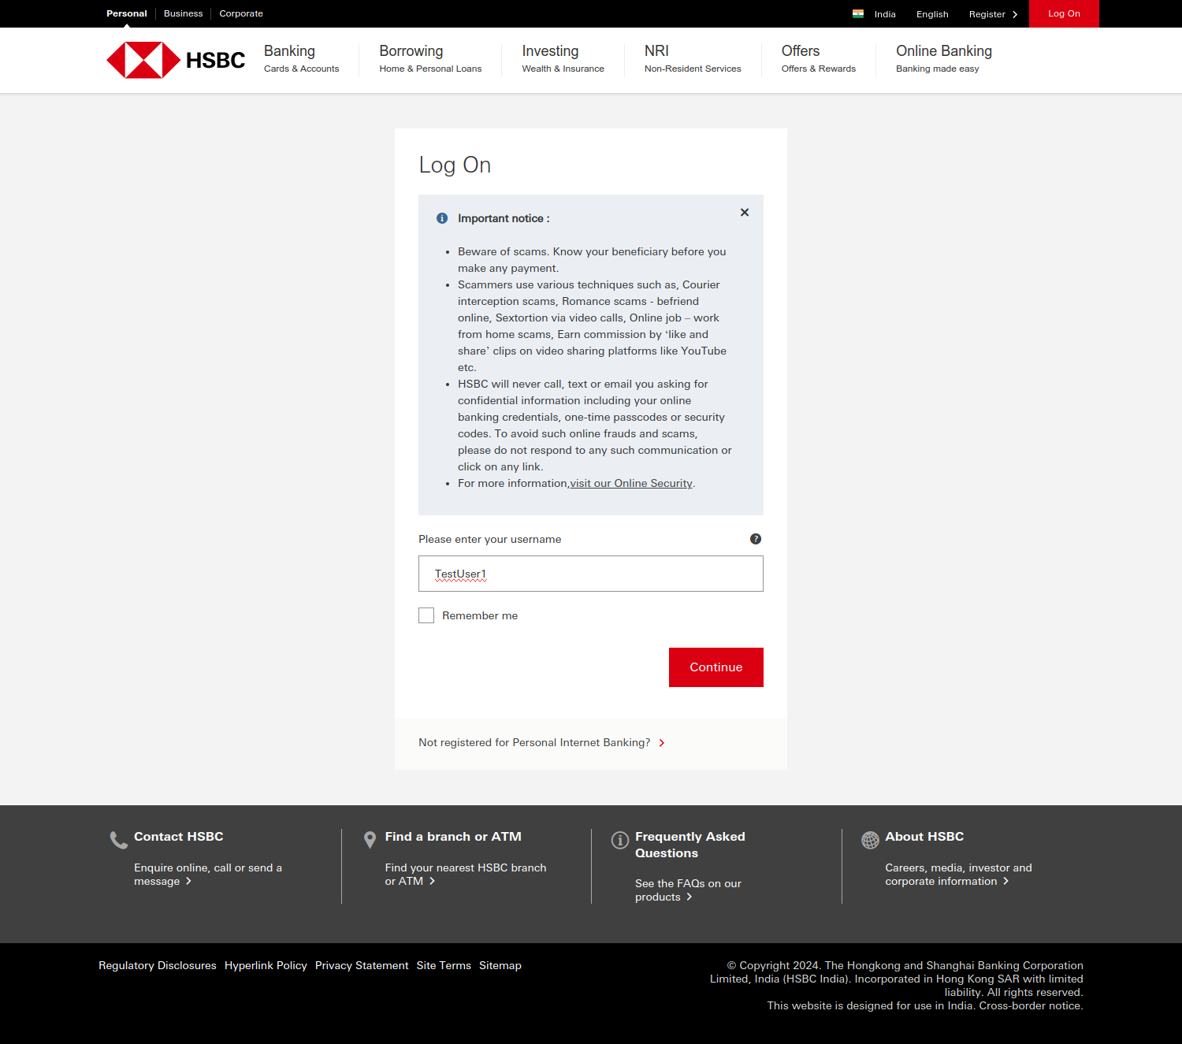

11. Validate there is a question mark tooltip present on the page

12. Click on the tooltip
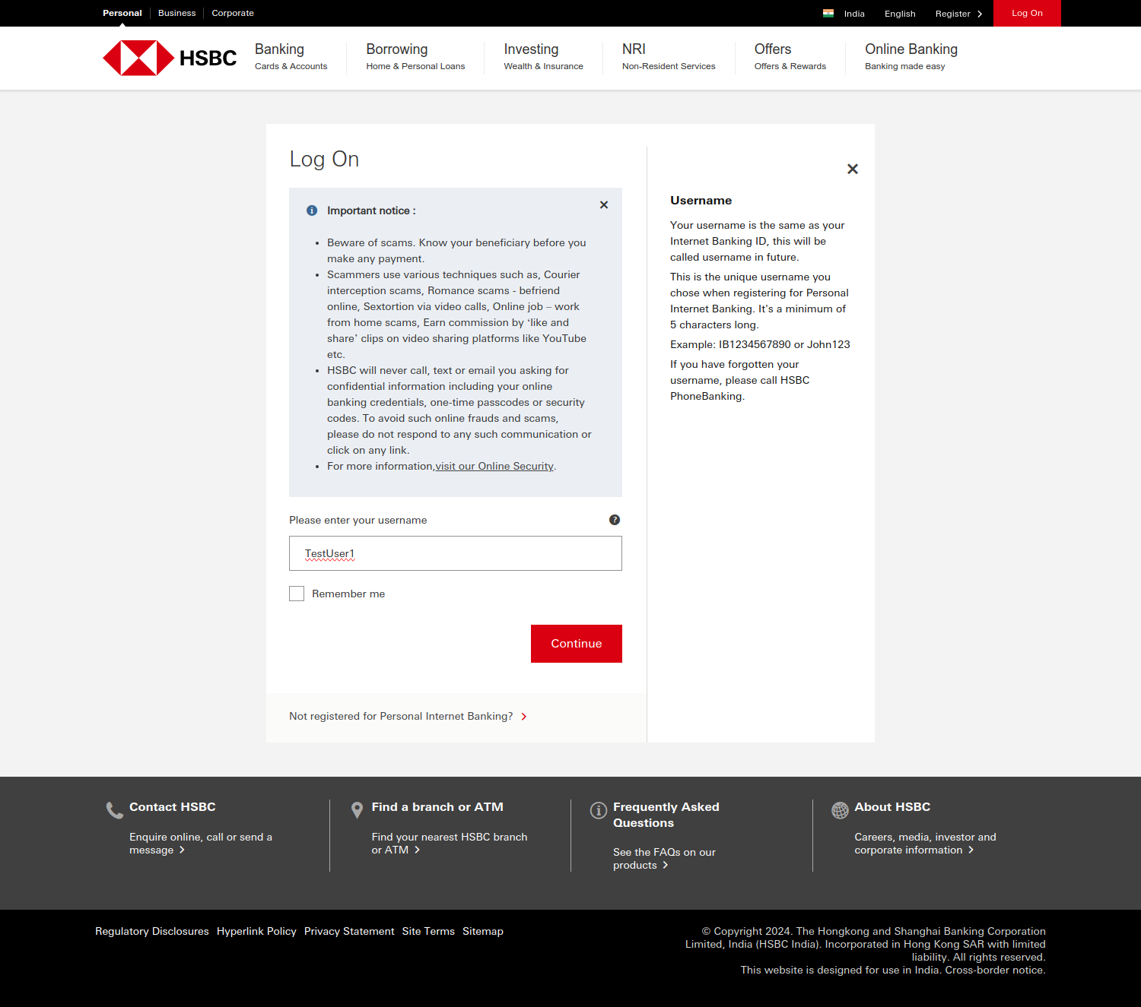

13. Now validate the username header in the new pop-up screen

14. Validate there is a Close button in the new pop-up screen

15. Click on the close button present in the new pop-up screen

HSBC ATM Search Test Scenario
1. Open https://www.hsbc.co.in/
2. Scroll down to the bottom of the page
3. Click on Find your nearest branch or ATM link in footer section
4. Validate in new page the URL has String = ‘/ways-to-bank/branches/’
5. Validate Header as Branches & ATM
6. Click on before Branch & ATM Locator button
7. Type country name as India
8. In drop-down option click option India
9. Validate ATM Header name is showing as Rajbhavan Road
10. Click on add Show more results button
11. Check second ATM branch name tooltip as 2 in red color is getting displayed
12. Check Instagram in social media option in footer section
13. Check Facebook in social media option in footer section
14. Check Twitter in social media option in footer section
15. Check Youtube in social media option in footer section
16. Click on HSBC Logo
17. Validate page is navigating to home page by its title
18. Scroll down to the bottom
19. Check and Click on Privacy link
20. Validate Privacy Statement as Header

Source Code :-

beforeEach( () => {
cy.viewport(1600, 1000)
cy.visit('https://www.hsbc.co.in/')
})

Cypress.on('uncaught:exception', (err,runnable) => {
return false;
})

describe('ATM search test', () => {
it('Testing ATM search test scenarios', () => {
cy.screenshot()
cy.wait(3000)
cy.contains('Find your nearest HSBC branch or ATM').click({force: true});
cy.screenshot()
cy.wait(3000)
cy.url().should('include','/ways-to-bank/branches/')
cy.screenshot()
cy.wait(3000)
cy.get('h1').contains('Branches & ATMs')
cy.screenshot()
cy.wait(3000)
// cy.get('a#content_main_button_1').click()
cy.contains('Branch & ATM Locator').click()
cy.screenshot()
cy.wait(3000)
cy.get('input#searchInput').type('india{enter}')
cy.screenshot()
cy.wait(3000)
//cy.get('input#searchInput').type('india')
//cy.get('ul#autocomplete-results>li').click({multiple: true})
cy.contains('Rajbhavan Road, Somajiguda , Hyderabad, India, 500082').should('be.visible')
cy.screenshot()
cy.wait(3000)
cy.contains('Show more results').click()
cy.screenshot()
cy.wait(3000)
//cy.xpath('//*[contains(text(),"580.1")]/span/span').should('be.visible')
cy.contains('Amar Avinash Corporate City, Bund Garden Road, Pune, India, 411001').should('be.visible');
cy.screenshot()
cy.wait(3000)
cy.get('a.social-icon-instagram').should('be.visible');
cy.get('a.social-icon-facebook').should('be.visible');
cy.get('a.social-icon-twitter').should('be.visible');
cy.get('a.social-icon-youtube').should('be.visible');
cy.screenshot()
cy.wait(3000)
cy.get('div.header-logo>a>img').click();
cy.screenshot()
cy.wait(3000)
cy.title().should('eq','HSBC India - Credit Cards, NRI Services, Saving and Deposit')
cy.screenshot()
cy.wait(3000)
cy.contains('Privacy Statement').click({force: true});
cy.screenshot()
cy.wait(3000)
cy.get('h1').contains('Privacy Statement');
cy.screenshot()
cy.wait(3000)

})
})

Evidence Screenshot :-
- Open https://www.hsbc.co.in/
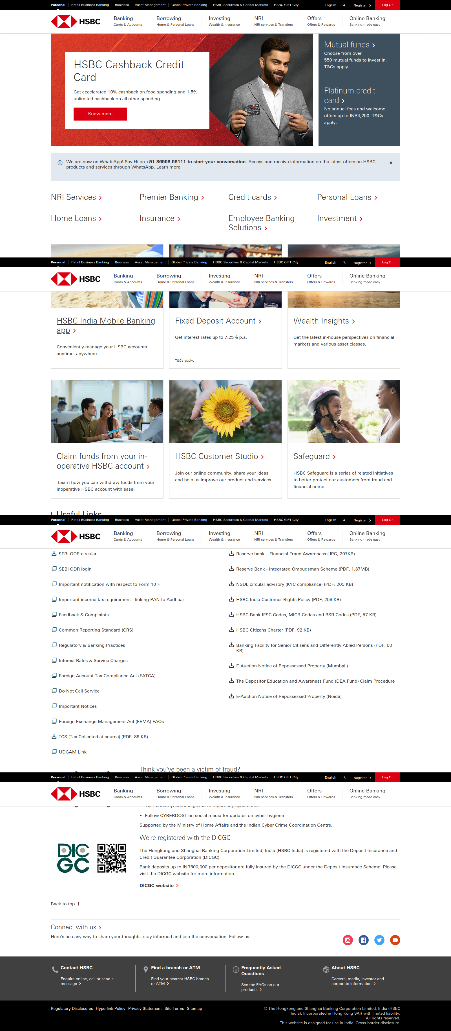

- Click on Find your nearest branch or ATM link in footer section
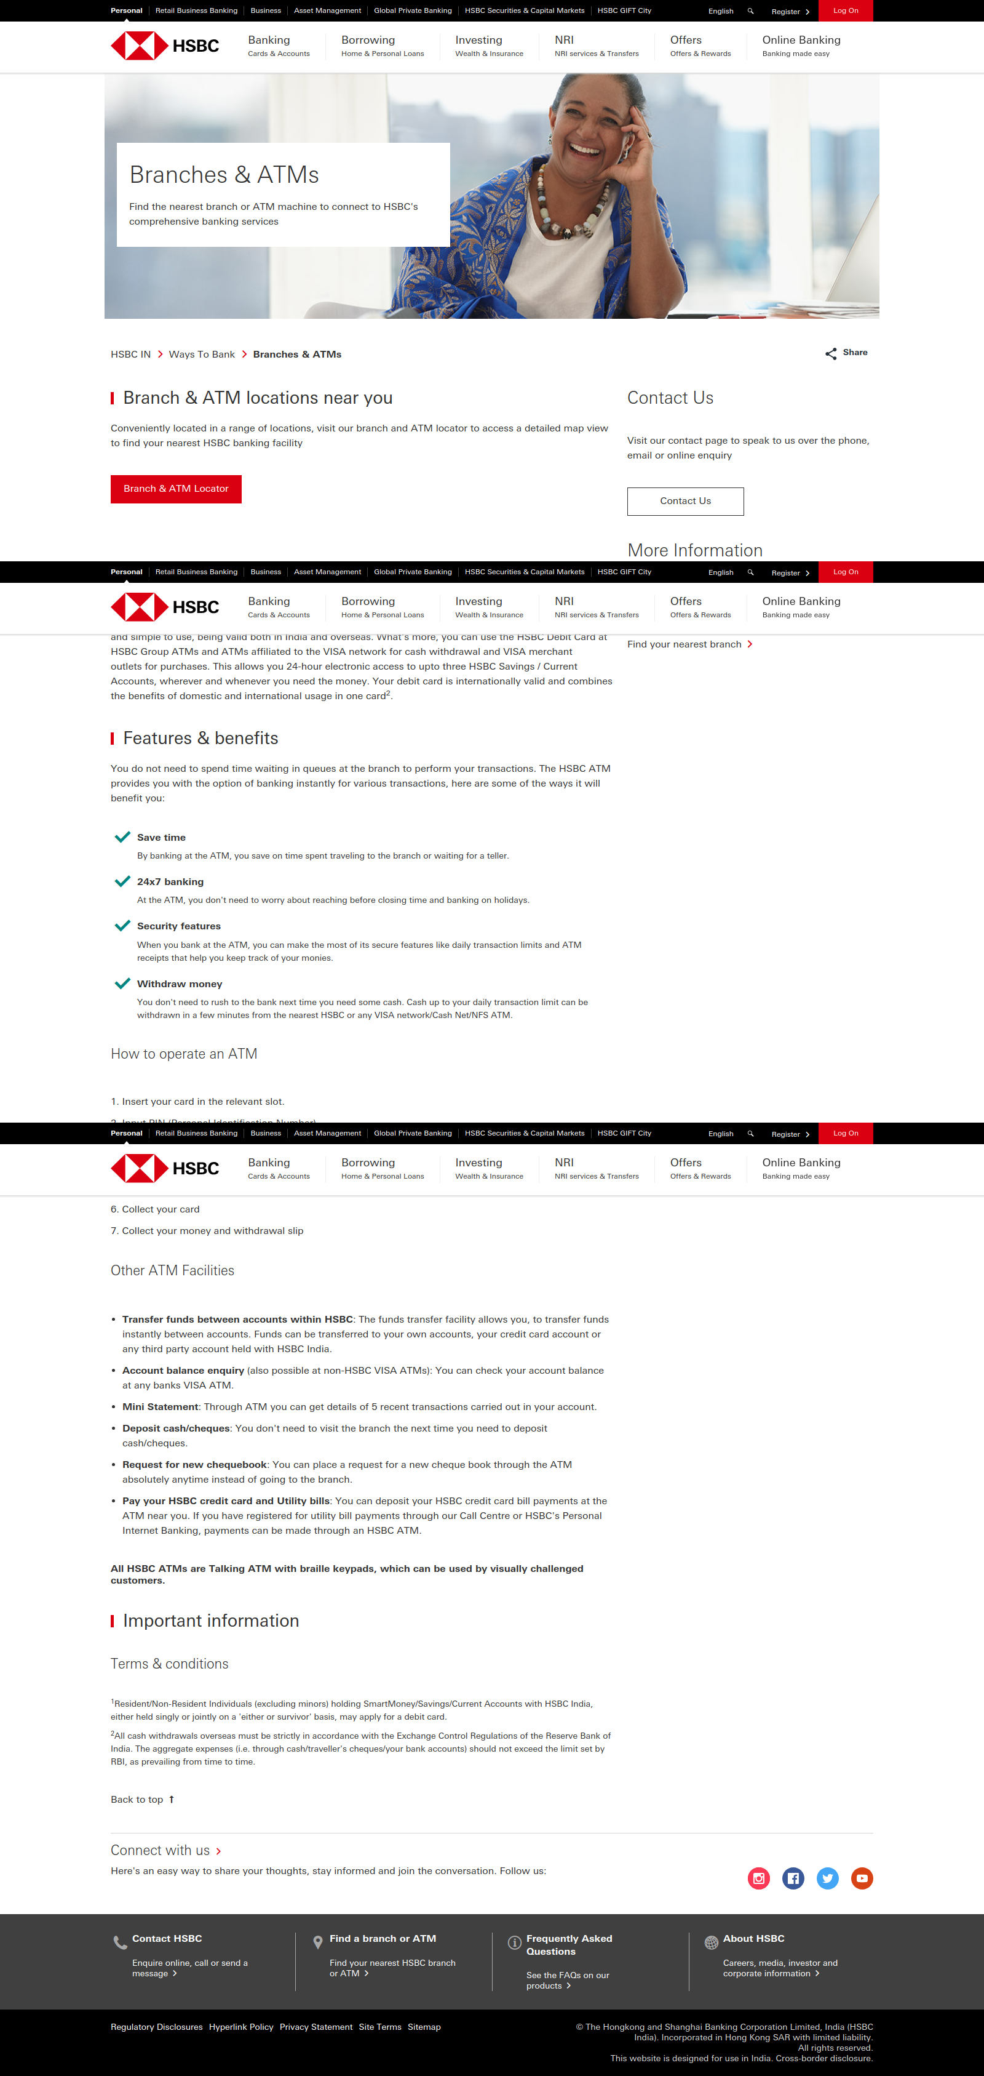

- Validate in new page the URL has String = ‘/ways-to-bank/branches/’
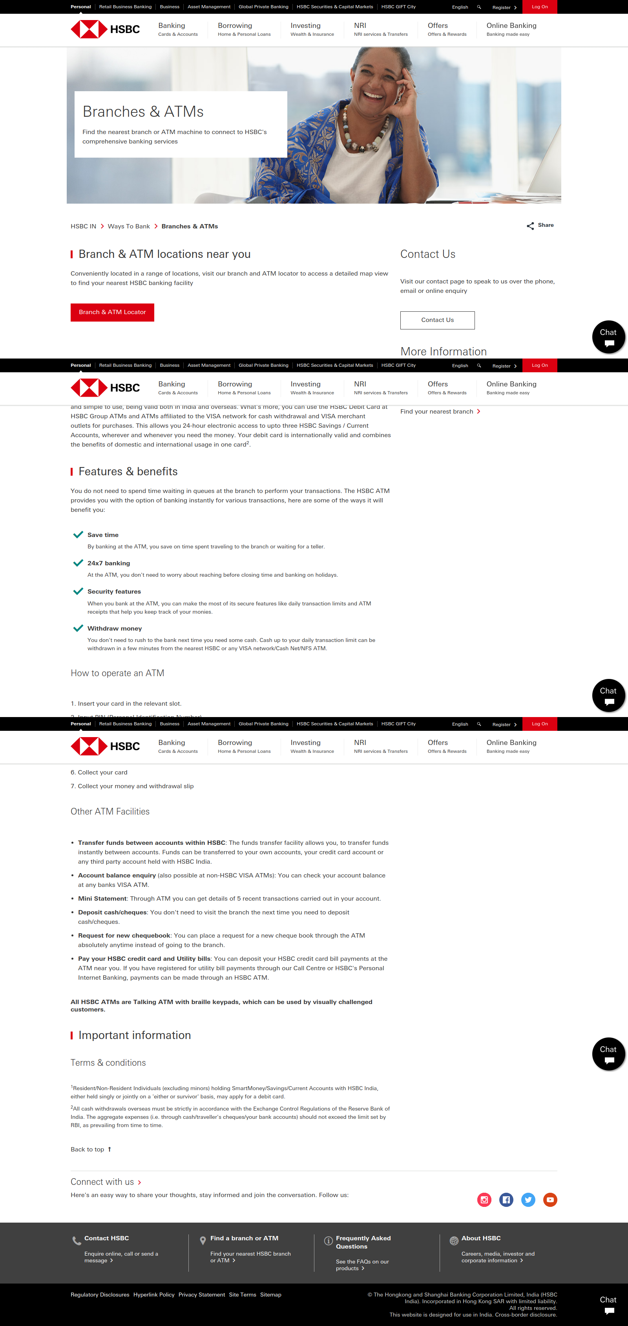

- Validate Header as Branches & ATM

- Click on before Branch & ATM Locator button

- Type country name as India
- In drop-down option click option India
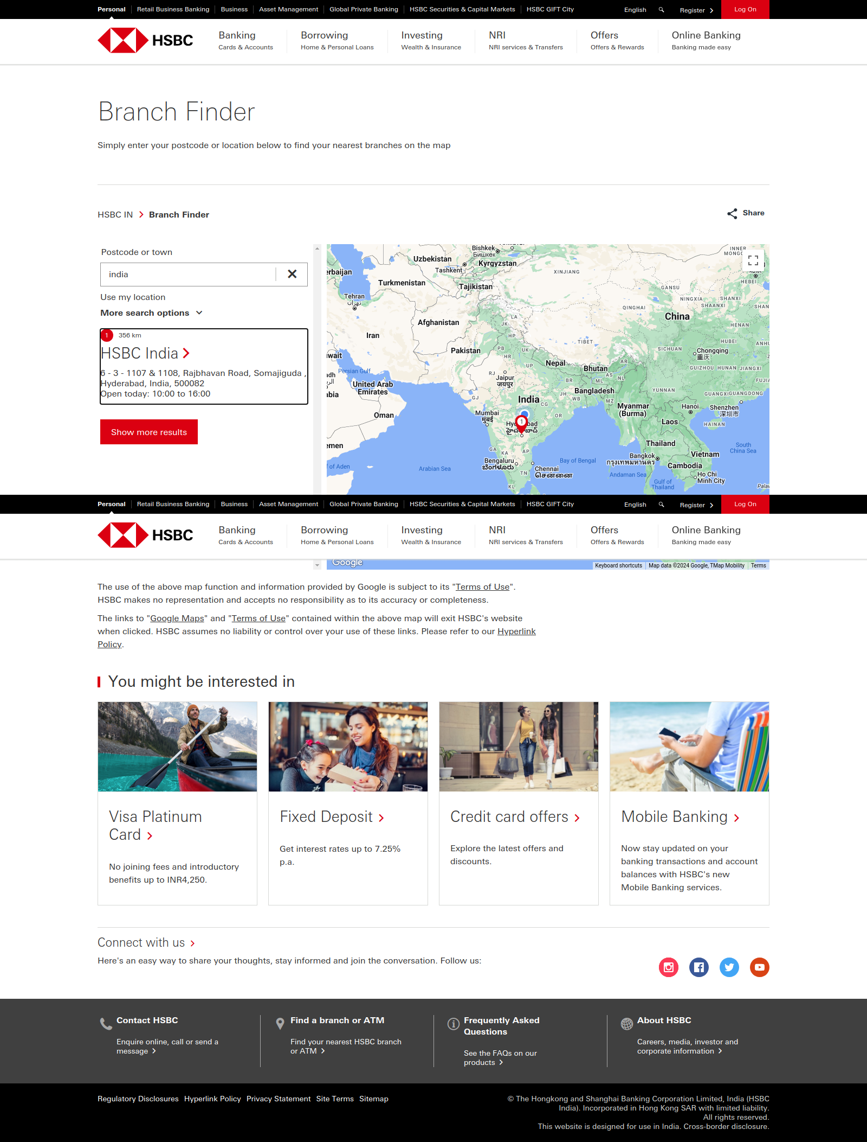

- Validate ATM Header name is showing as Rajbhavan Road

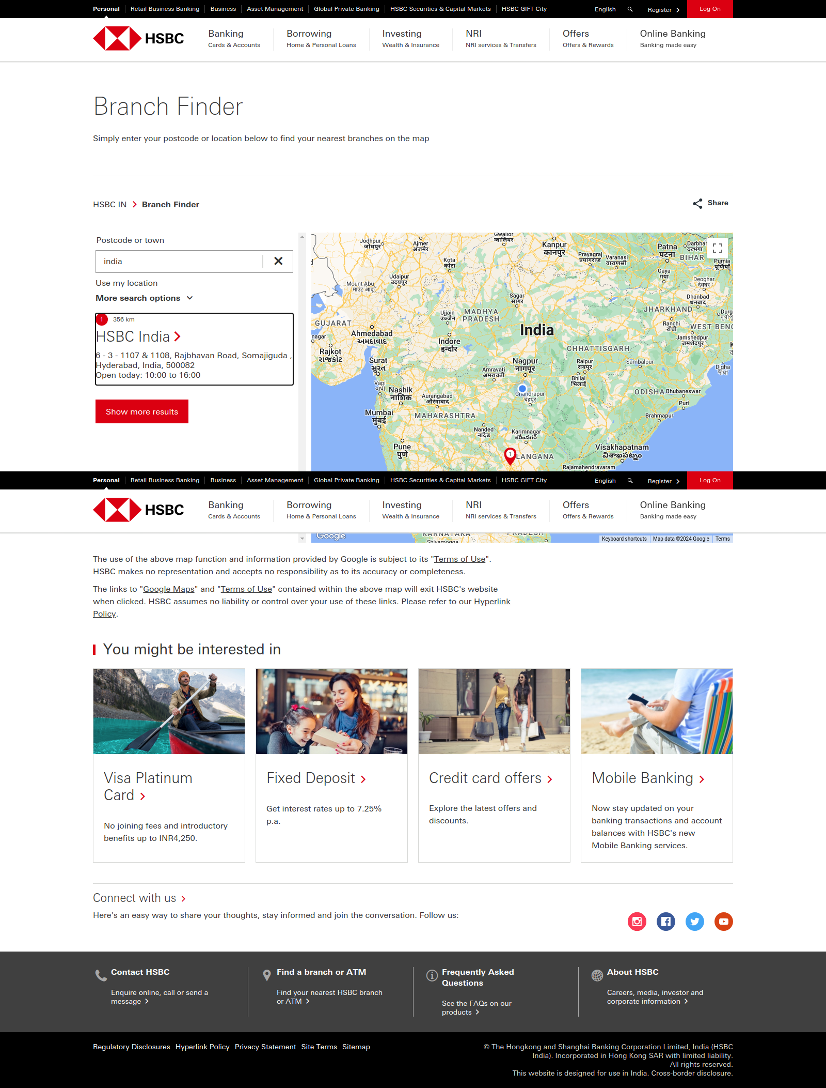

- Click on add Show more results button

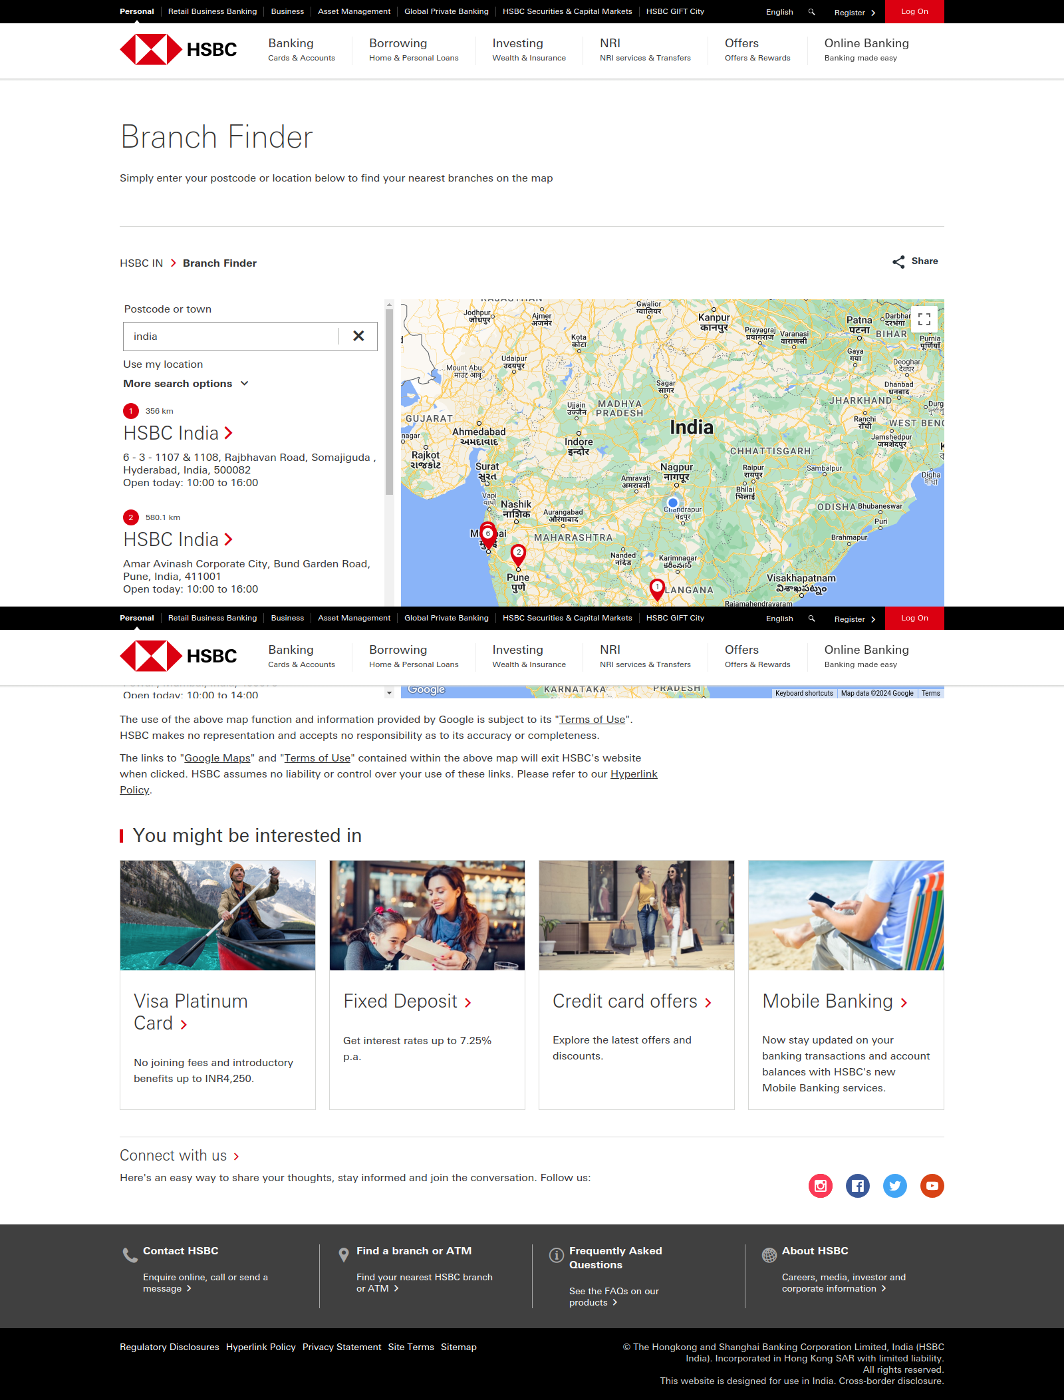

- Check second ATM branch name tooltip as 2 in red color is getting displayed

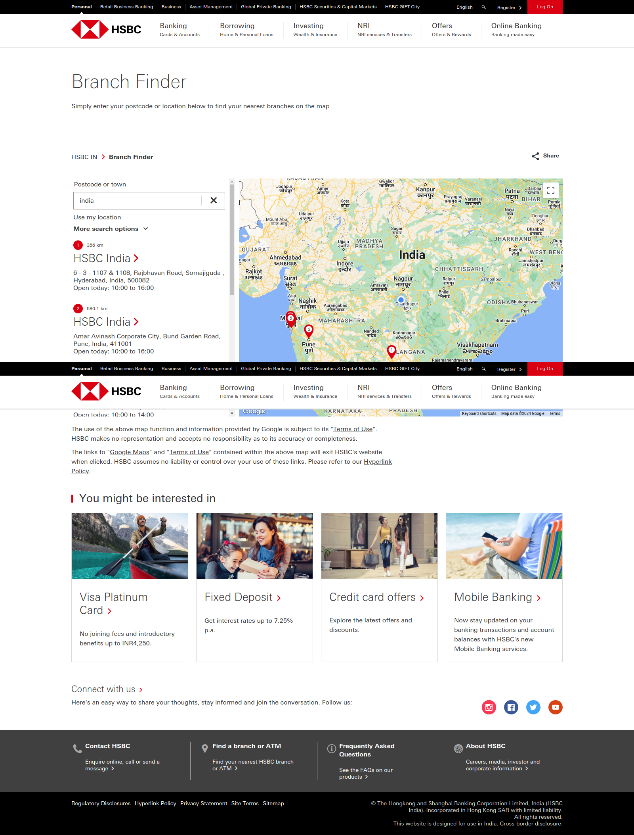

- Check Instagram in social media option in footer section
- Check Facebook in social media option in footer section
- Check Twitter in social media option in footer section
- Check Youtube in social media option in footer section

- Click on HSBC Logo
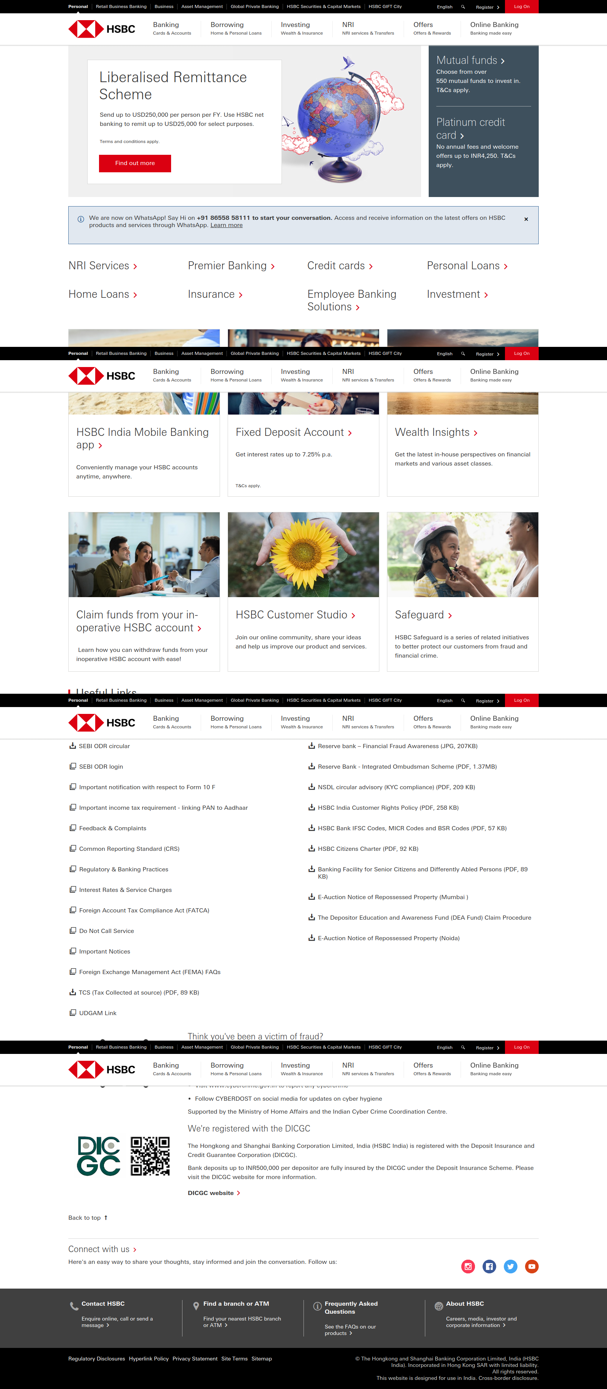

- Validate page is navigating to home page by its title

- Check and Click on Privacy link
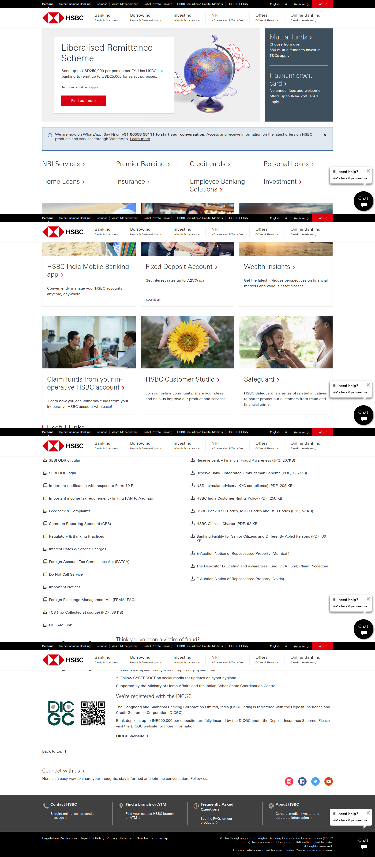

- Validate Privacy Statement as Header

HSBC Credit Card Flow
1. Open https://www.hsbc.co.in/
2. Hover cursor on Banking menu navigation
3. Click on Credit Cards link
4. Validate Credit Card as a header text
5. Validate second credit Card header text is HSBC Cashback Credit Card
6. Click on the HSBC cashback Credit card
7. Validate there is Apply now button
8. Validate the URL contains credit-cards/products/visa-cashback/
9. Validate the HSBC credit card image is displayed
10. Validate the joining fee mentioned as INR999
11. Validate the text mentioned as INR999 (waived if you spend more than INR200,000 per year)
12. Validate the Chat image is displayed in the bottom
13. Click on HSBC Logo
14. Validate page is navigating to home page by its title

Source Code :-

beforeEach( () => {
cy.viewport(1600, 1000)
cy.visit('https://www.hsbc.co.in/')
})

Cypress.on('uncaught:exception', (err,runnable) => {
return false;
})

describe('Credit card flow test', () => {
it('Credit card test scenarios', () => {
cy.screenshot()
cy.wait(3000)
//trigger('mouseover') -----//li[1]//span[text()='Banking'] ----//span[text()="Banking"] invoke('show')
cy.xpath('//li[1]//span[text()="Banking"]').eq(0).invoke('show').click()
cy.screenshot()
cy.wait(3000)
// this are things tried for nxt point
// cy.get('div.links-group>a[tabindex="-1"]').contains('h2','Credit Cards').click()
//cy.get('div.links-group>a[tabindex="-1"]').eq(0).click({force: true})
cy.xpath('//h2[text()="Credit Cards"]').eq(0).click({force: true})
cy.screenshot()
cy.wait(3000)
// cy.xpath('//h1[text()="Credit cards"]').should('be.visible')
cy.contains('h1','Credit cards').should('be.visible')
cy.screenshot()
cy.wait(3000)
cy.xpath('//span[text()="HSBC Cashback Credit Card"]').should('be.visible')
cy.screenshot()
cy.wait(3000)
cy.xpath('//span[text()="HSBC Cashback Credit Card"]').click()
cy.screenshot()
cy.wait(3000)
cy.xpath('//span[text()="Apply now"]').eq(0).should('be.visible')
cy.xpath('//span[text()="Apply now"]').eq(1).should('be.visible')
cy.screenshot()
cy.wait(3000)
cy.url().should('include','credit-cards/products/visa-cashback/')
cy.screenshot()
cy.wait(3000)
cy.get('img#pp_intro_image_3').should('be.visible')
cy.screenshot()
cy.wait(3000)
cy.xpath('//span[contains(text(),"INR999")]').eq(0).should('be.visible')
cy.screenshot()
cy.wait(3000)
cy.xpath('//span[contains(text(),"INR200,000")]').eq(0).should('be.visible')
cy.screenshot()
cy.wait(3000)
cy.get('img[alt="Chat"]').should('be.visible')
cy.screenshot()
cy.wait(3000)
cy.get('img[alt="HSBC India Bank"]').eq(0).click()
cy.screenshot()
cy.wait(3000)
cy.title().should('eq','HSBC India - Credit Cards, NRI Services, Saving and Deposit')
cy.screenshot()
cy.wait(3000)
})
})
Test Evidence :-
Open https://www.hsbc.co.in/
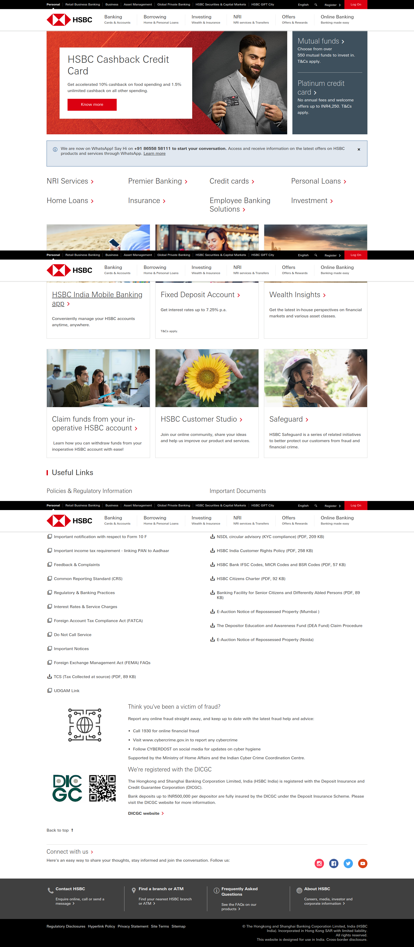

Hover cursor on Banking menu navigation
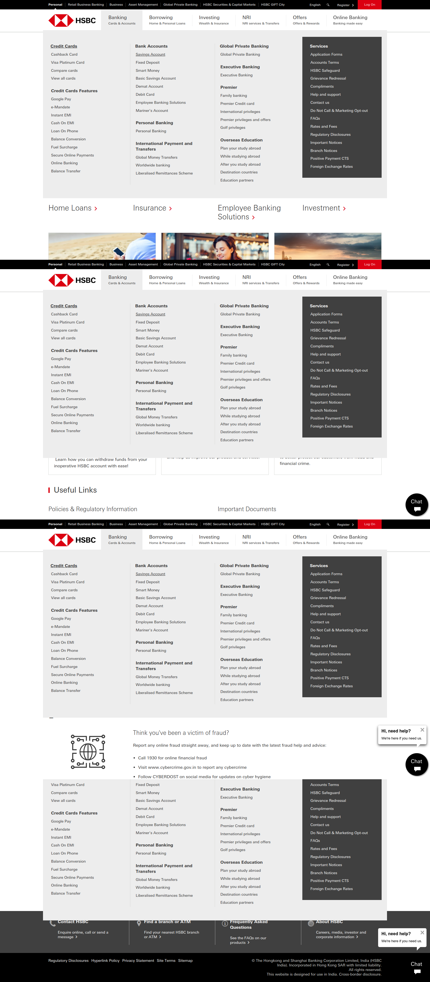

Click on Credit Cards link
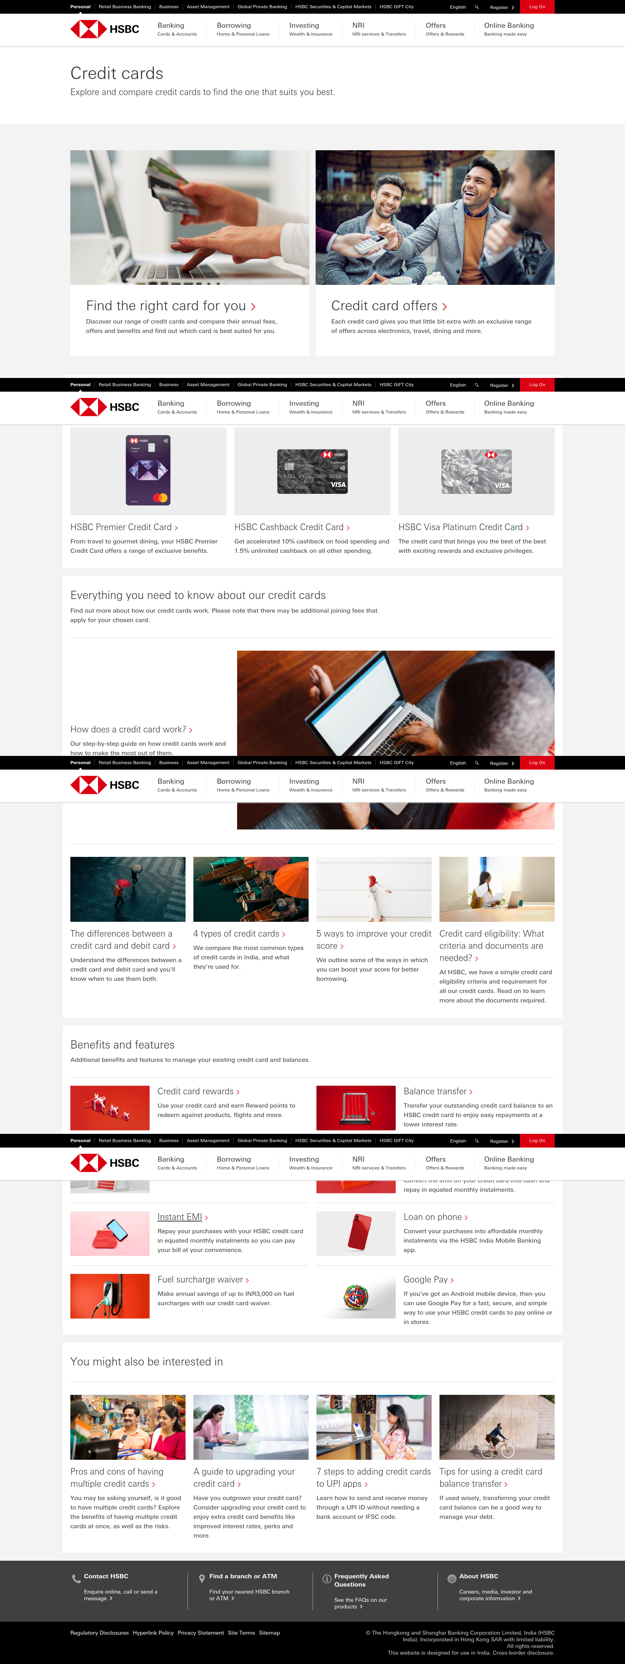

Validate Credit Card as a header text

Validate second credit Card header text is HSBC Cashback Credit Card

Click on the HSBC cashback Credit card
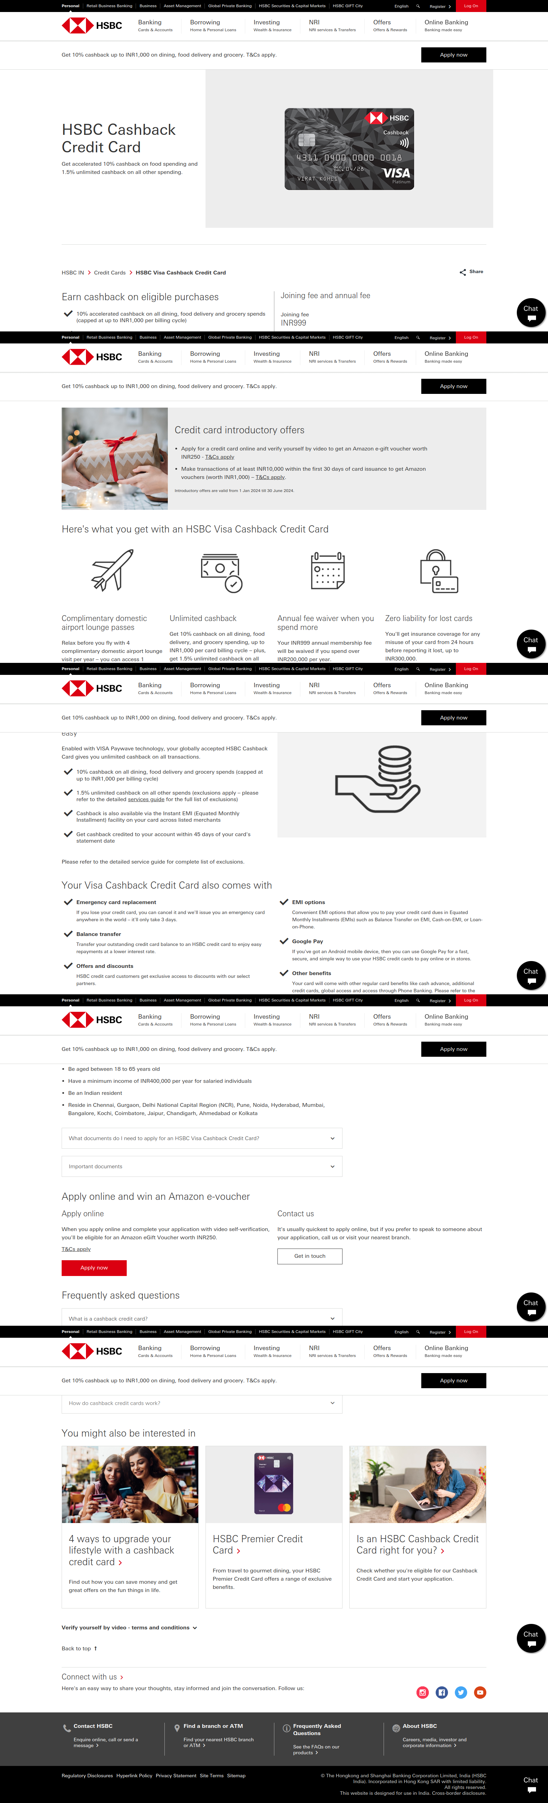

Validate there is Apply now button

Validate the URL contains credit-cards/products/visa-cashback/

Validate the HSBC credit card image is displayed

Validate the joining fee mentioned as INR999

Validate the text mentioned as INR999 (waived if you spend more than INR200,000 per year)

Validate the Chat image is displayed in the bottom

Click on HSBC Logo
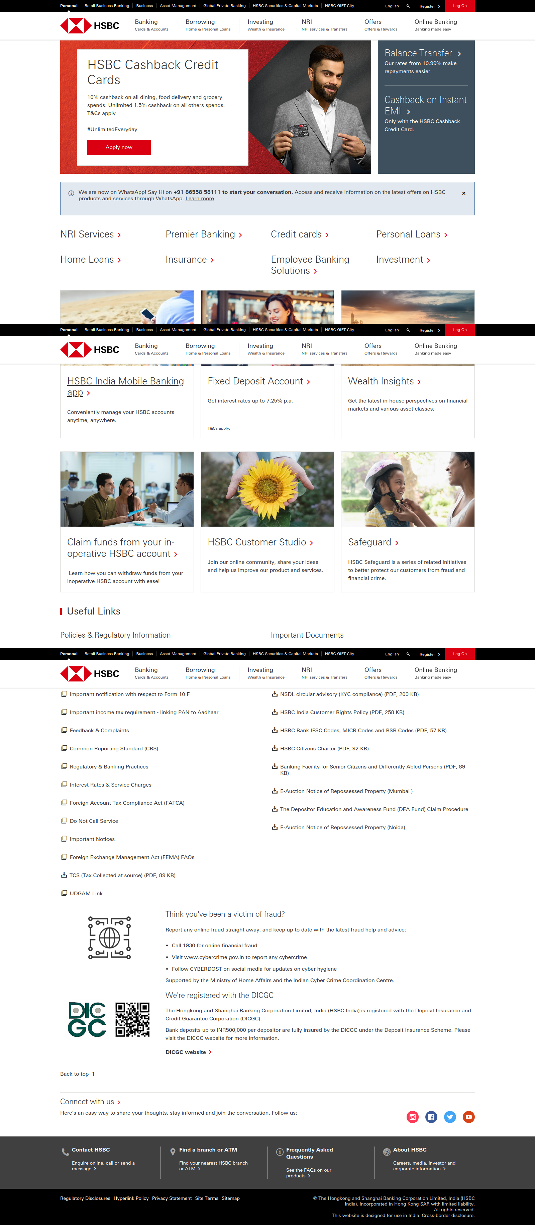

Validate page is navigating to home page by its title

