FLOWCHARTS AND ALGORITHMS
10 Python Programs
Practical Record

1. ATM Transaction Sequence Simulation
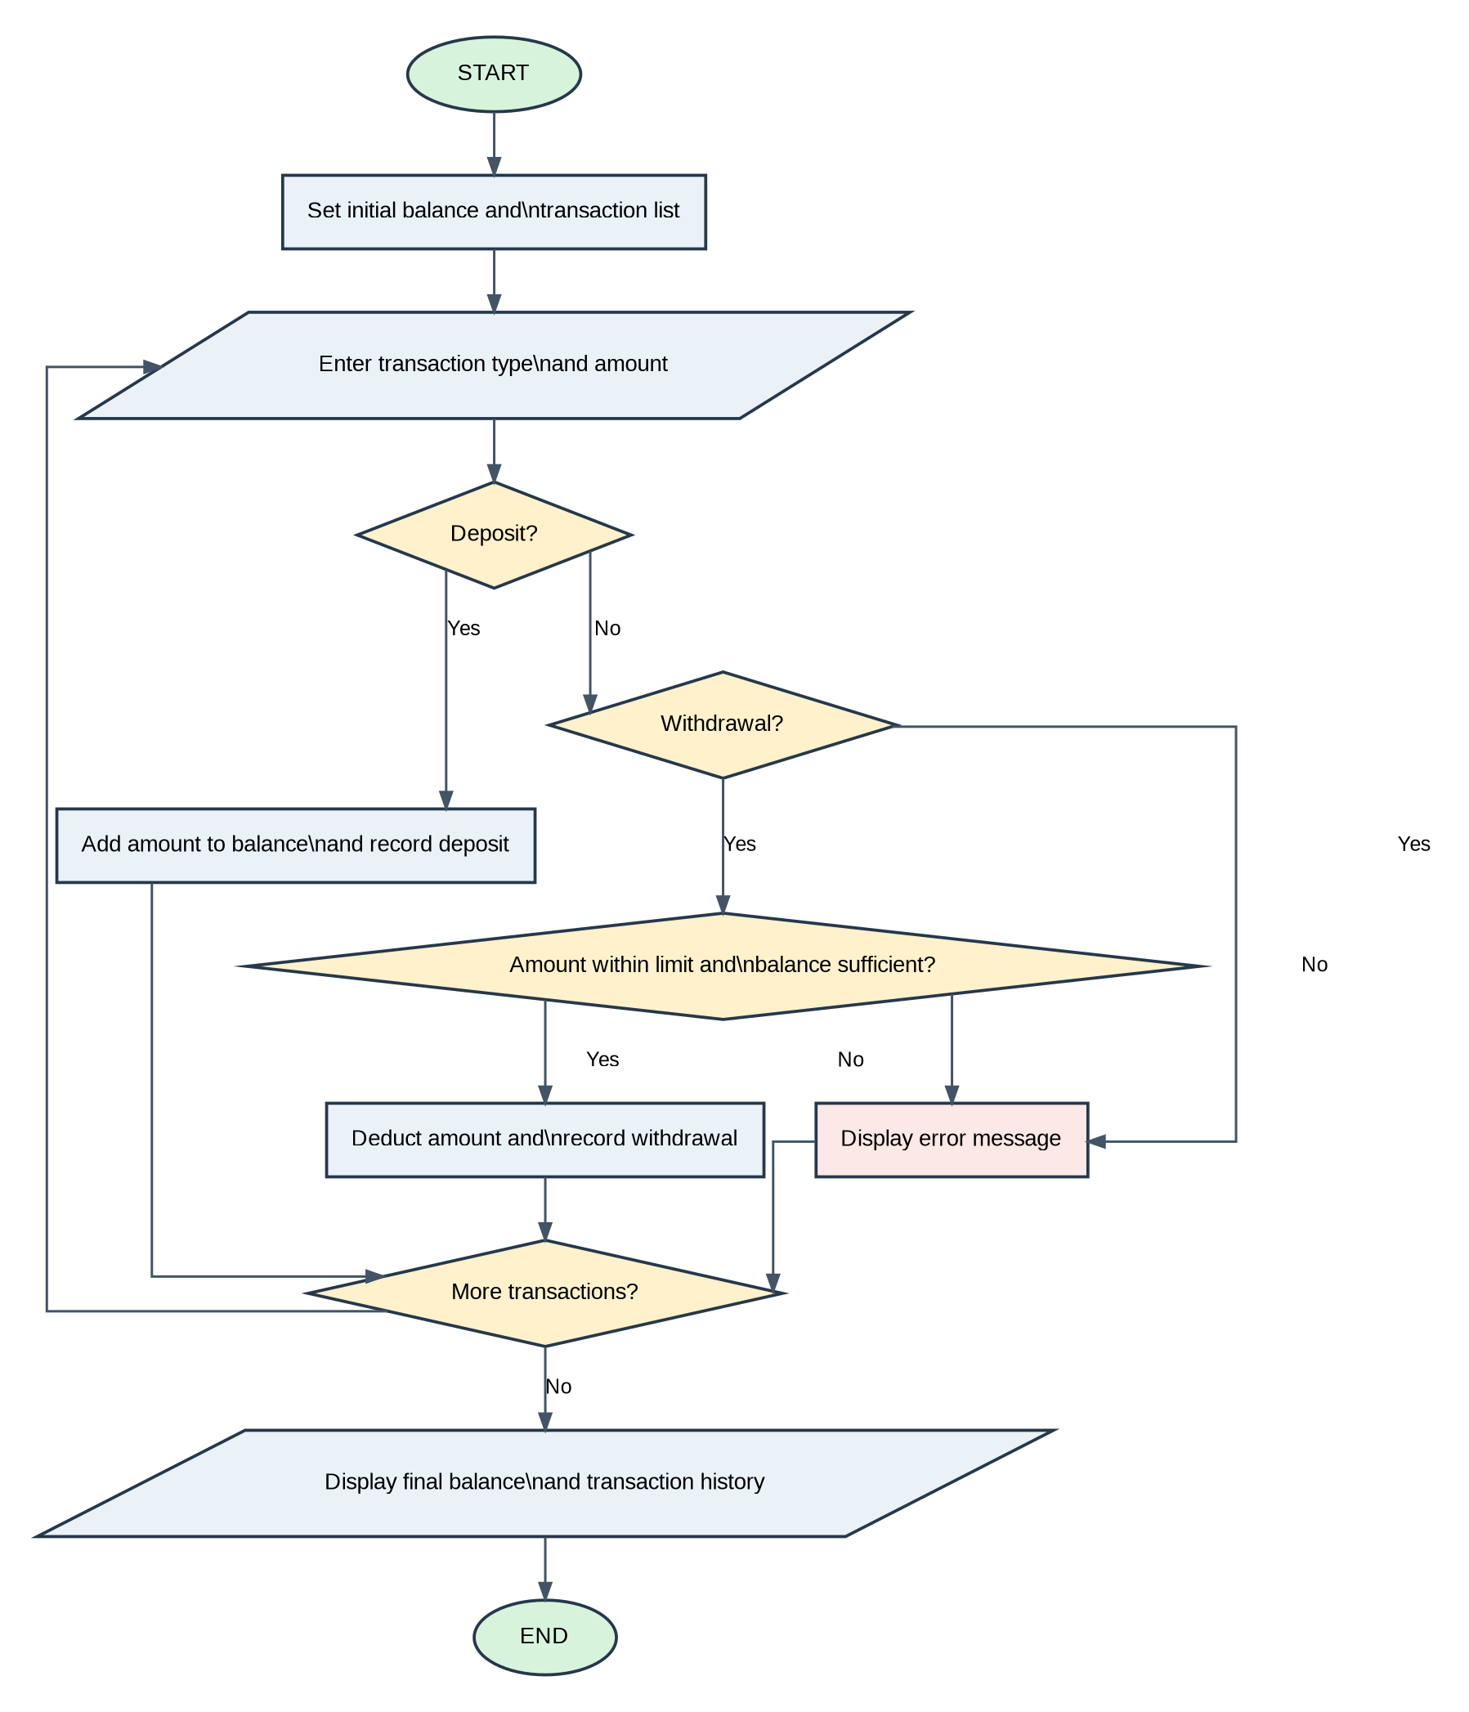
Flowchart

Algorithm
- Start.
- Initialize the account balance and transaction list.
- Enter the transaction type and amount.
- Check whether the transaction is a deposit.
- If yes, add the amount to the balance and record the deposit.
- Otherwise, check whether it is a withdrawal.
- If yes, check whether the amount is within the withdrawal limit and sufficient balance is available.
- If both conditions are satisfied, deduct the amount and record the withdrawal.
- Otherwise, display an error message.
- Ask whether the user wants more transactions. If yes, repeat the transaction process.
- Display the final balance and transaction history.
- Stop.

2. Laboratory Chemical Inventory Validation
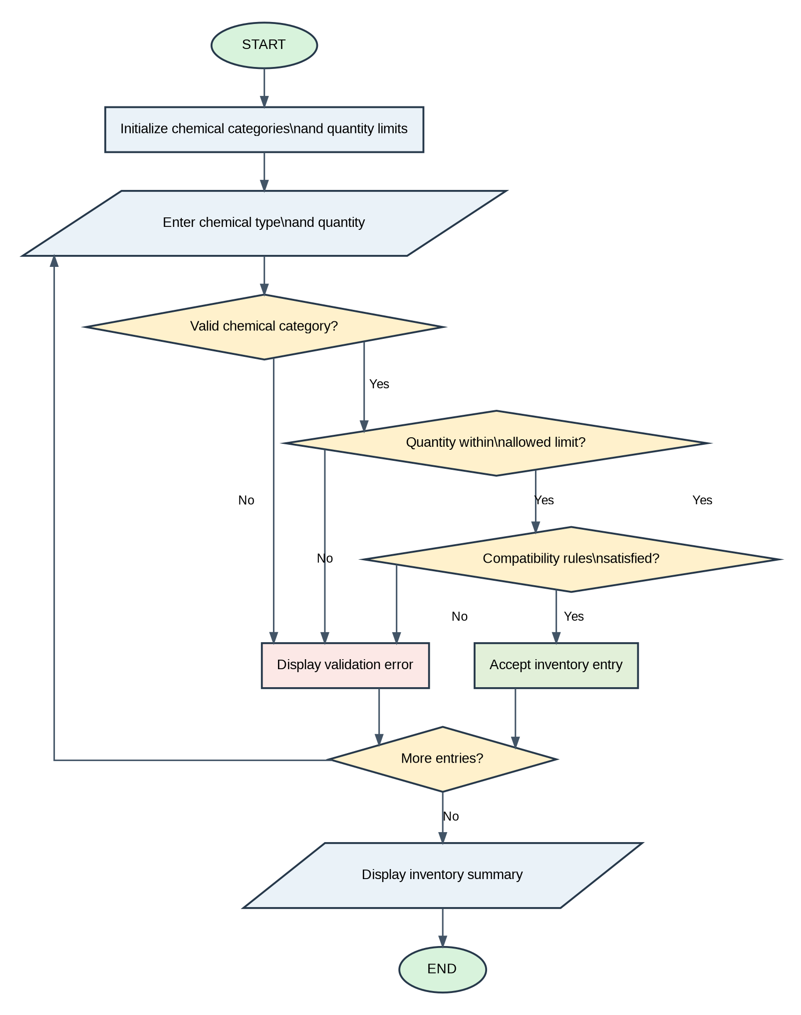
Flowchart

Algorithm
- Start.
- Initialize chemical categories and quantity limits.
- Enter the chemical type and quantity.
- Check whether the chemical category is valid. If not, display a validation error.
- If the category is valid, check whether the quantity is within the allowed limit.
- Check whether the compatibility rules are satisfied.
- If all conditions are satisfied, accept the inventory entry; otherwise, display a validation error.
- Ask whether more entries are required. If yes, repeat the process.
- Display the inventory summary.
- Stop.

3. Student Email and Identifier Validation
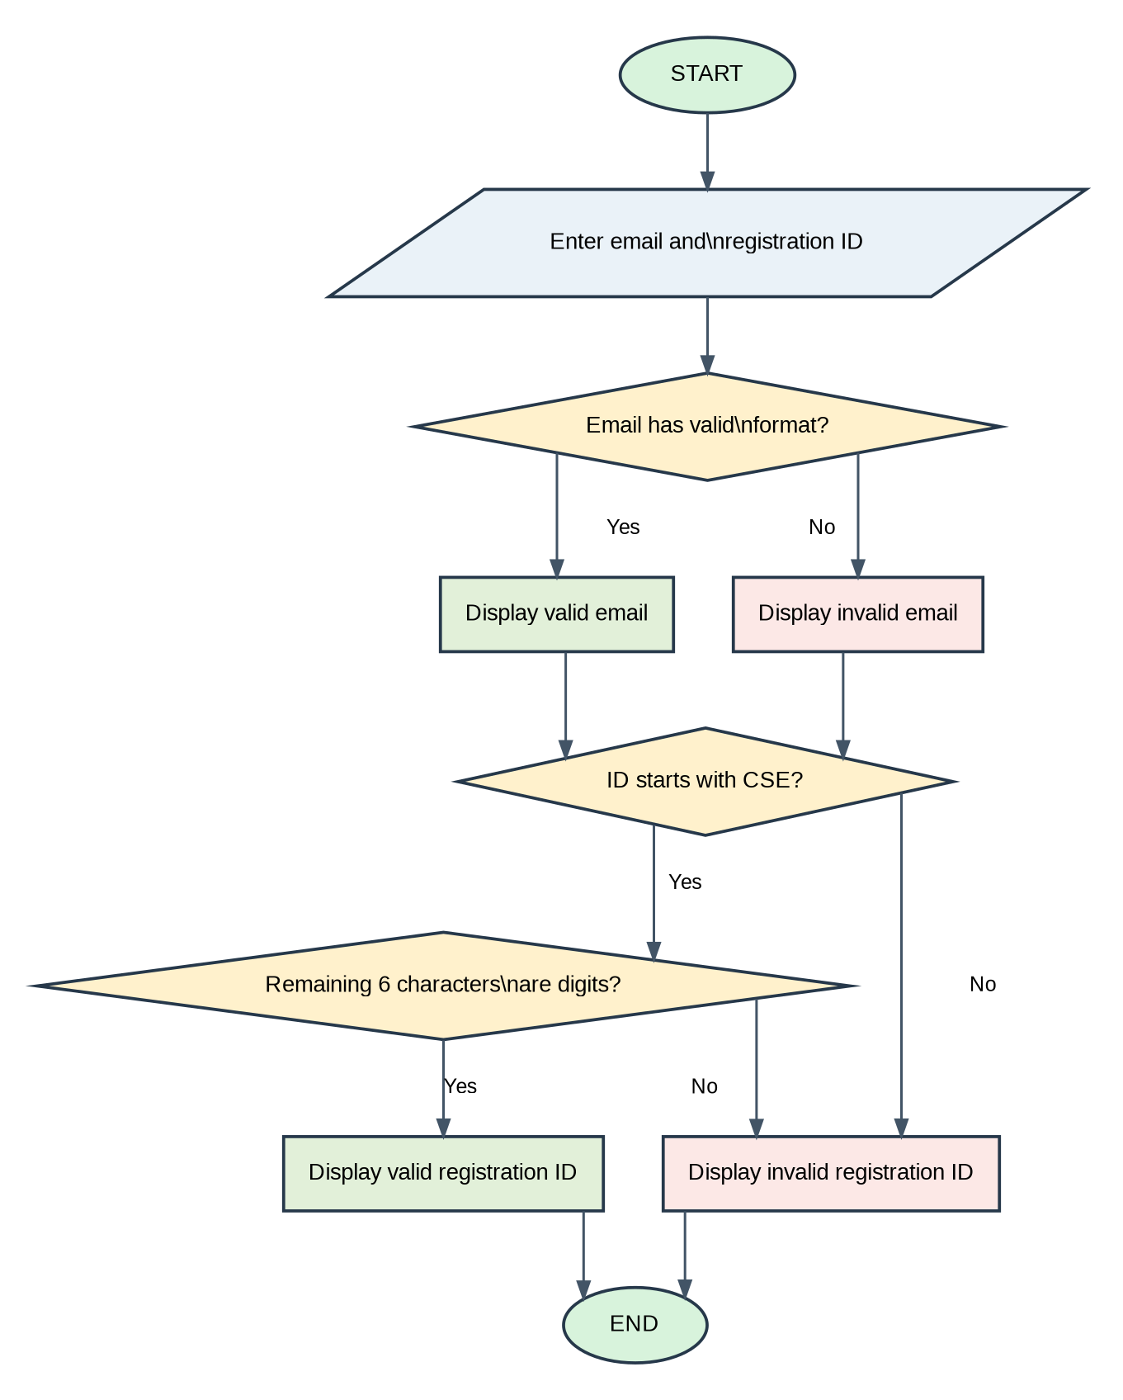
Flowchart

Algorithm
- Start.
- Enter the student email and registration ID.
- Check whether the email has a valid format.
- Display valid email if the format is correct; otherwise, display invalid email.
- Check whether the registration ID starts with CSE.
- If it starts with CSE, check whether the remaining six characters are digits.
- Display valid registration ID if the condition is satisfied; otherwise, display invalid registration ID.
- Stop.

4. Campus Registration Identifier Analyzer
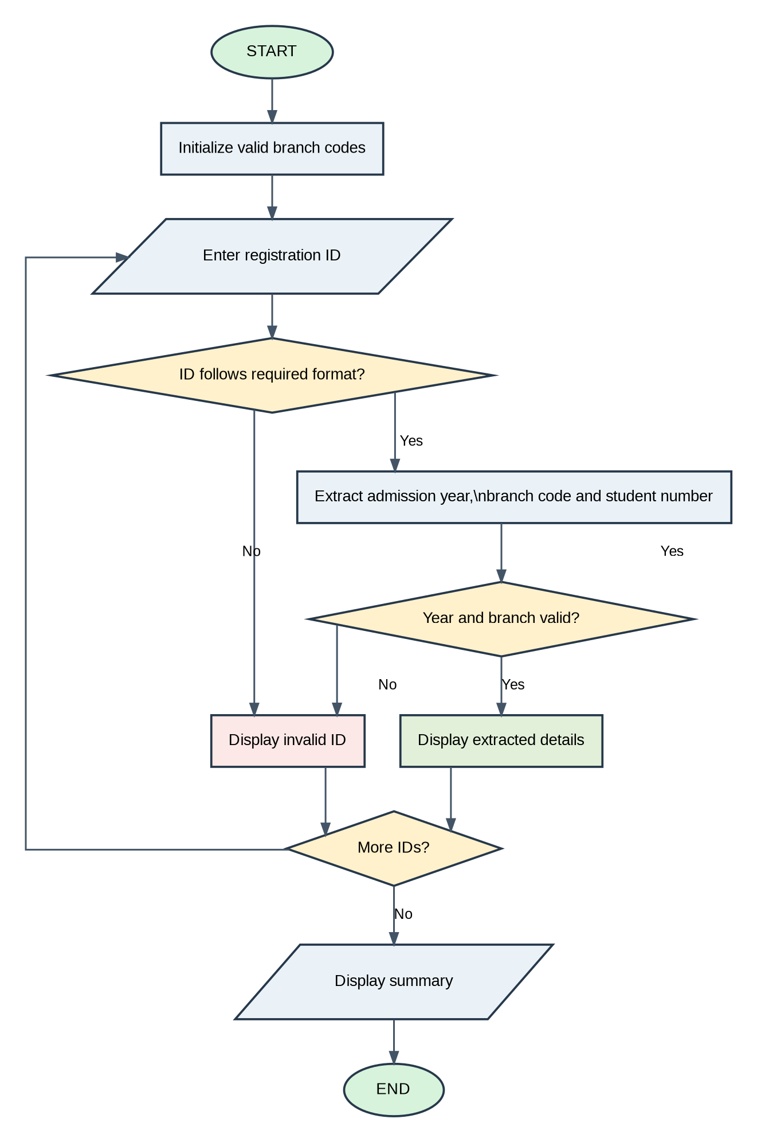
Flowchart

Algorithm
- Start.
- Initialize the valid branch codes.
- Enter the registration ID.
- Check whether the ID follows the required format.
- If the format is invalid, display an invalid ID message.
- Otherwise, extract the admission year, branch code and student number.
- Check whether the year and branch are valid.
- Display the extracted details if valid; otherwise, display invalid ID.
- Ask whether more IDs need to be checked. If yes, repeat the process.
- Display the summary.
- Stop.

5. ATM Menu-Driven Banking Simulation
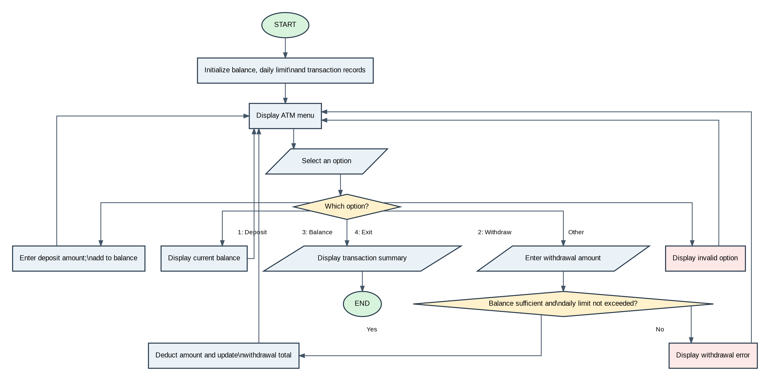
Flowchart

Algorithm
- Start.
- Initialize the account balance, daily withdrawal limit and transaction records.
- Display the ATM menu and enter the selected option.
- If option 1 is selected, enter the deposit amount and add it to the balance.
- If option 2 is selected, enter the withdrawal amount.
- For a withdrawal, check whether the balance is sufficient and the daily limit is not exceeded.
- If both conditions are satisfied, deduct the amount and update the withdrawal total; otherwise, display an error.
- If option 3 is selected, display the current balance.
- If option 4 is selected, display the transaction summary and exit.
- For any other option, display an invalid option message.
- Repeat the menu until the user selects Exit.
- Stop.

6. Food Waste Monitoring System
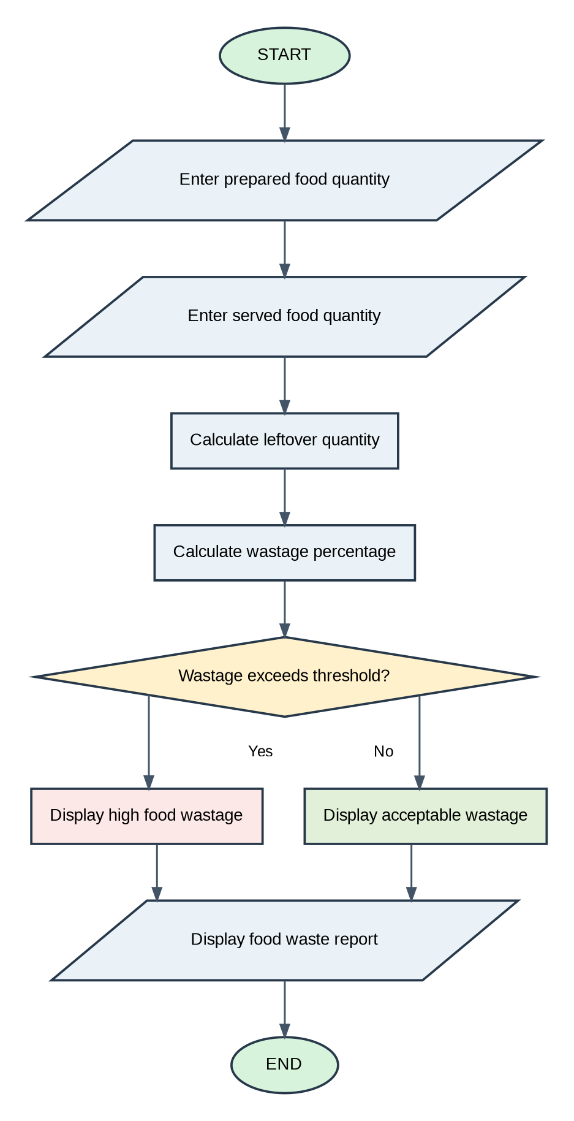
Flowchart

Algorithm
- Start.
- Enter the prepared food quantity.
- Enter the served food quantity.
- Calculate the leftover quantity.
- Calculate the wastage percentage.
- Check whether wastage exceeds the threshold.
- If yes, display high food wastage; otherwise, display acceptable wastage.
- Display the food waste report.
- Stop.

7. Library Borrowing and Fine Reconciliation
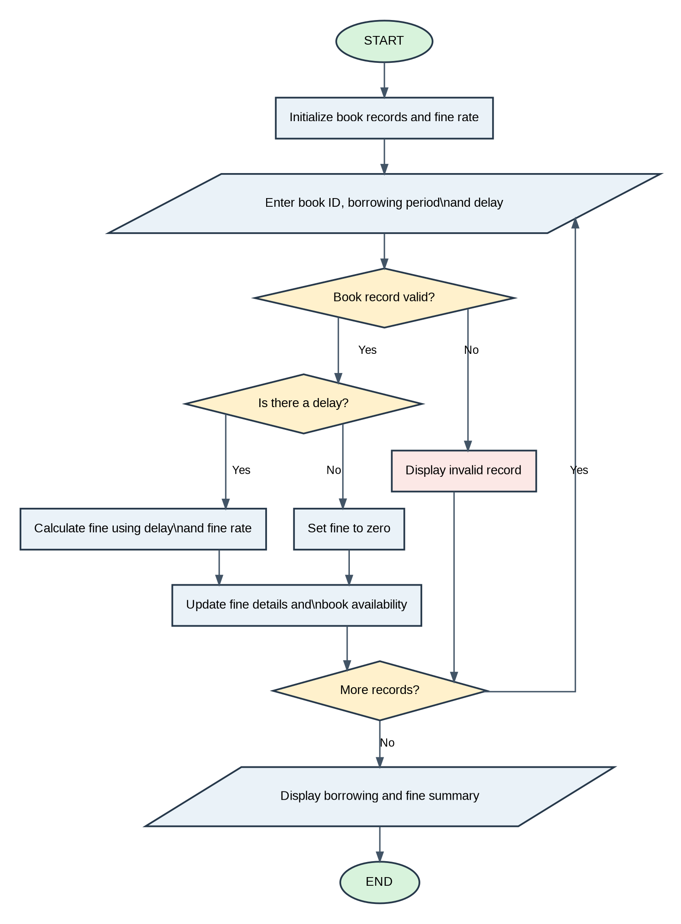
Flowchart

Algorithm
- Start.
- Initialize book records and the fine rate.
- Enter the book ID, borrowing period and delay.
- Check whether the book record is valid. If not, display an invalid record message.
- If the record is valid, check whether there is a delay.
- If there is a delay, calculate the fine using the delay and fine rate; otherwise, set the fine to zero.
- Update fine details and book availability.
- Ask whether more records are available. If yes, repeat the process.
- Display the borrowing and fine summary.
- Stop.

8. Smart Canteen Order and Stock Management
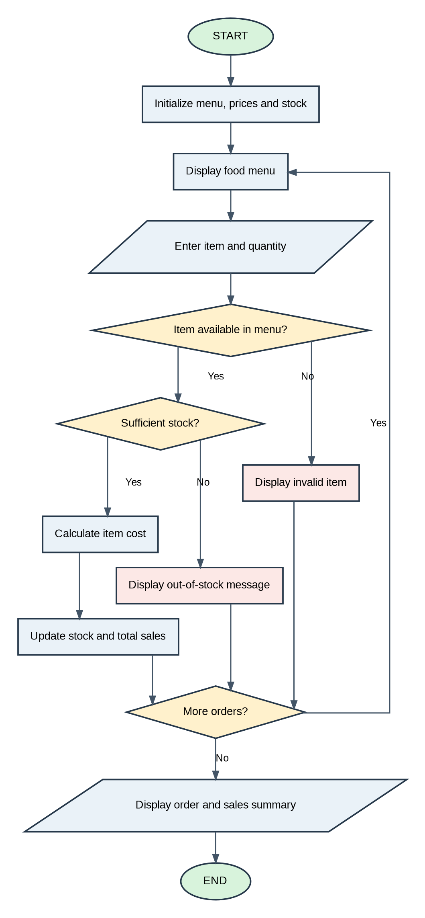
Flowchart

Algorithm
- Start.
- Initialize menu items, prices and stock.
- Display the food menu.
- Enter the item and quantity.
- Check whether the item is available in the menu. If not, display an invalid item message.
- If the item is available, check whether sufficient stock is available.
- If stock is insufficient, display an out-of-stock message.
- Otherwise, calculate the item cost, display it, and update stock and total sales.
- Ask whether more orders are required. If yes, repeat the process.
- Display the order and sales summary.
- Stop.

9. Retail Order Dispatch and Return Analysis
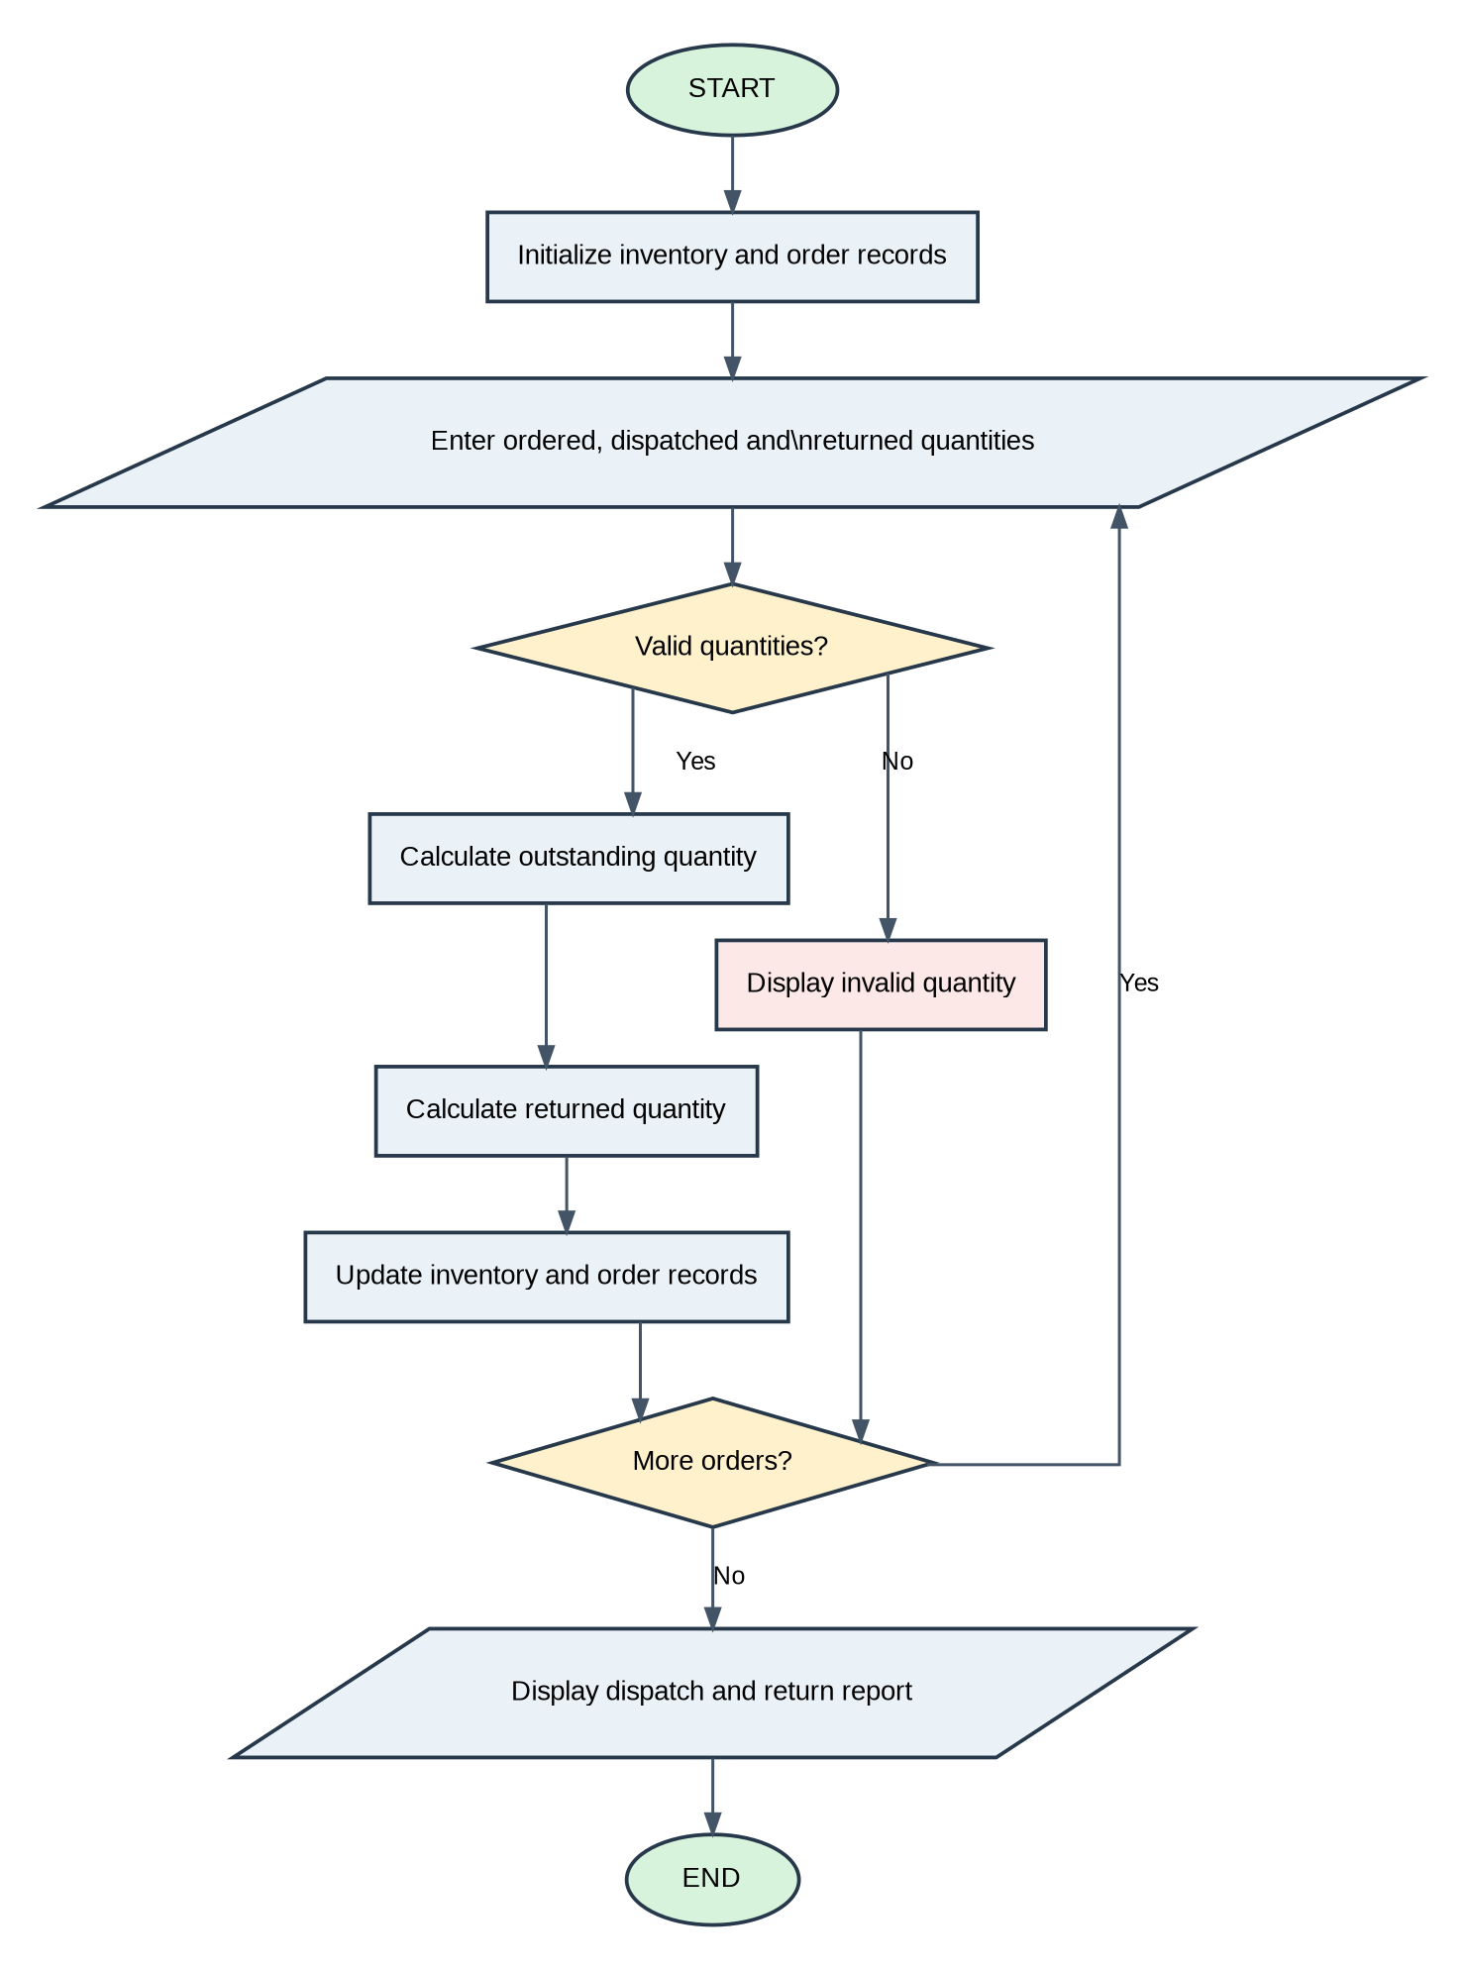
Flowchart

Algorithm
- Start.
- Initialize inventory and order records.
- Enter the ordered, dispatched and returned quantities.
- Check whether the quantities are valid. If not, display an invalid quantity message.
- If the quantities are valid, calculate the outstanding quantity.
- Calculate the returned quantity.
- Update inventory and order records.
- Ask whether more orders are available. If yes, repeat the process.
- Display the dispatch and return report.
- Stop.

10. Environmental Monitoring Data Analyzer
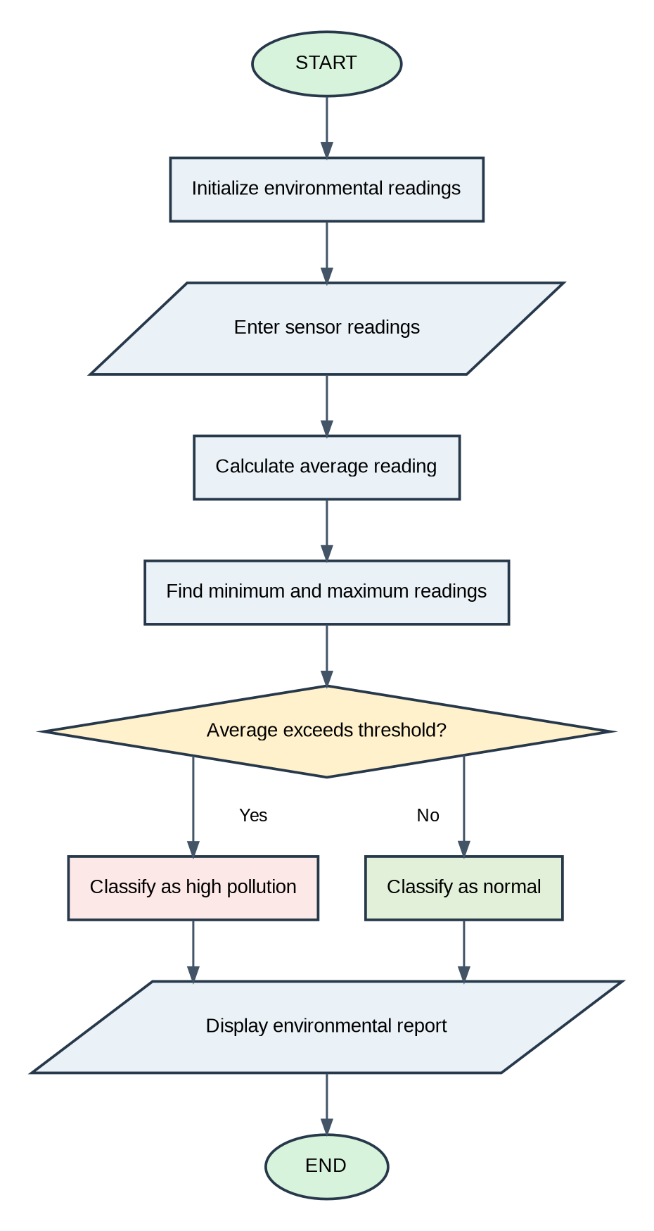
Flowchart

Algorithm
- Start.
- Initialize environmental readings.
- Enter the sensor readings.
- Calculate the average reading.
- Find the minimum and maximum readings.
- Check whether the average exceeds the threshold.
- If yes, classify it as high pollution; otherwise, classify it as normal.
- Display the environmental report.
- Stop.

