Kubernetes Retail App Deployment

Namespace Creation
- create a new namespace in Kubernetes.

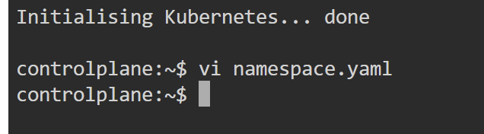

Create Namespace
- This shows the namespace YAML file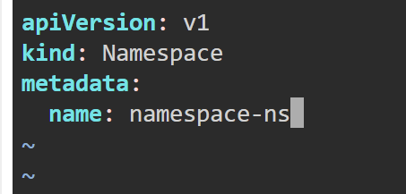
- Applied using kubectl apply
- It shows the successful creation of the namespace
- Getting verification using kubectl get ns.
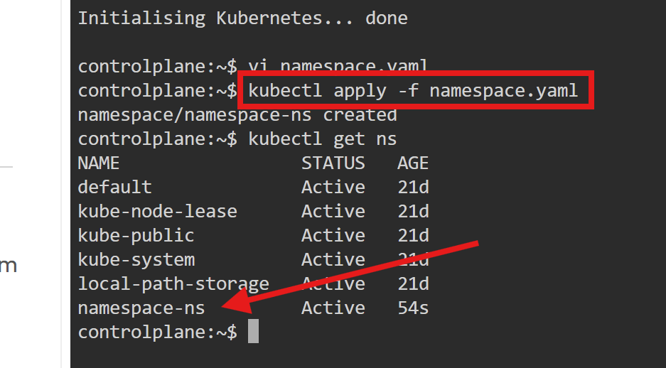

Create ConfigMap
- This shows the ConfigMap YAML file which stores non-sensitive configuration like APP_NAME and APP_VERSION, and the command used to apply it.
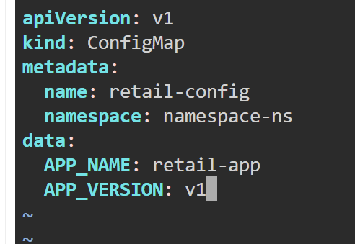
- Applied configmap.yaml
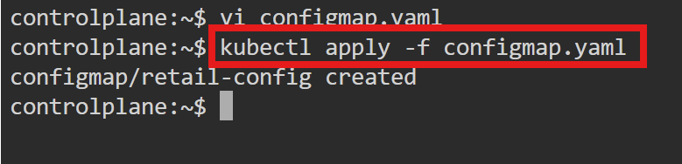

Create Secret
- It shows the Secret YAML file used to store sensitive data like
SESSION_SECRET,
EMAIL_USER, and
EMAIL_PASS securely in Kubernetes.
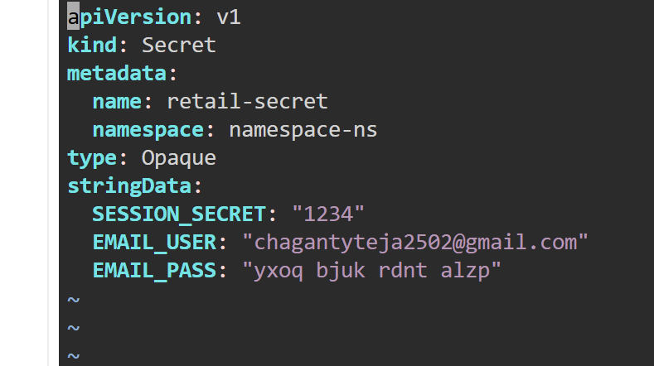
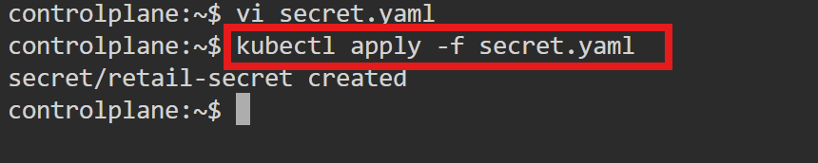

Deploy MongoDB
- This shows the MongoDB deployment YAML and is used to create the MongoDB pod inside the cluster.
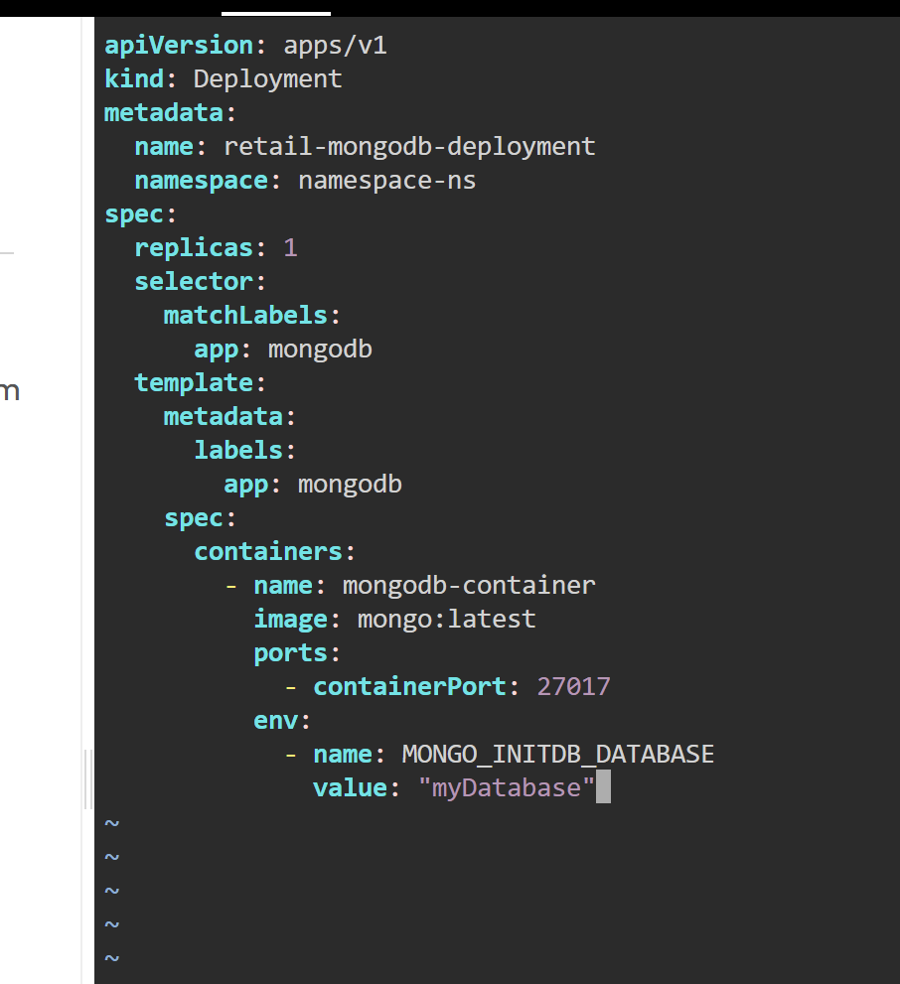
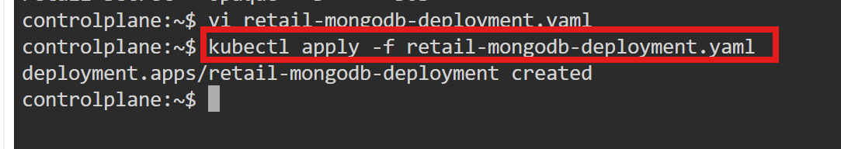

Create MongoDB Service
- This shows the MongoDB service YAML file which exposes MongoDB internally using ClusterIP.
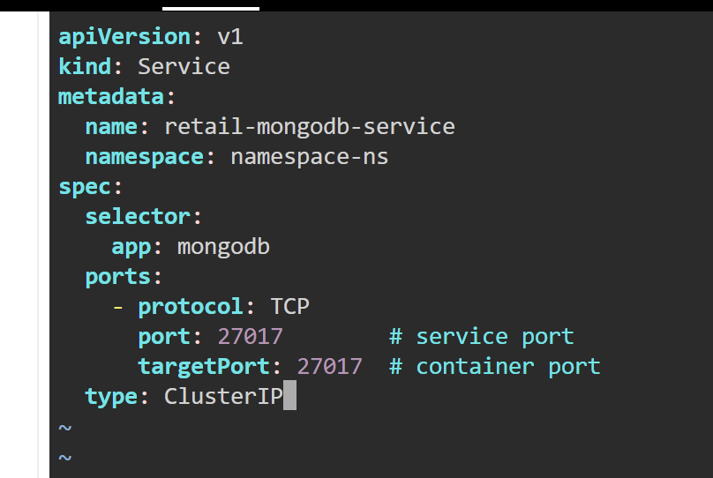
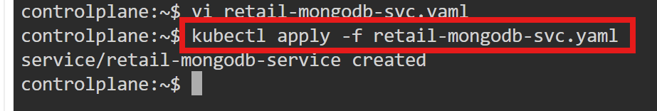

Check MongoDB Pod and Service
- It verifies that the MongoDB pod is running and the service is created successfully.
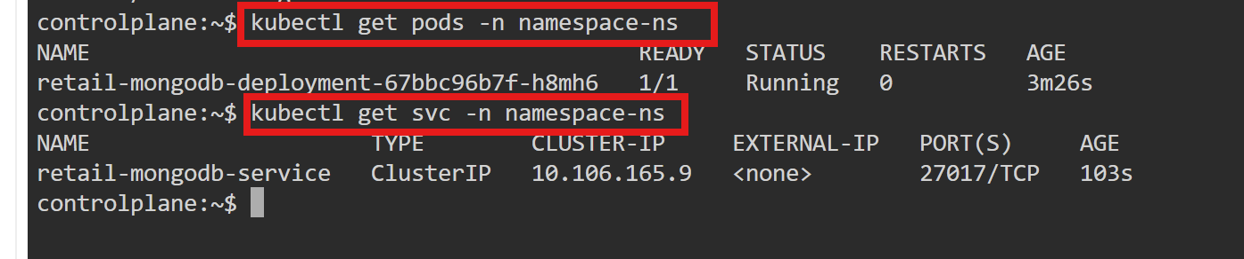

Deploy Retail Application
- It shows the retail application deployment YAML and we deploy the application pods.
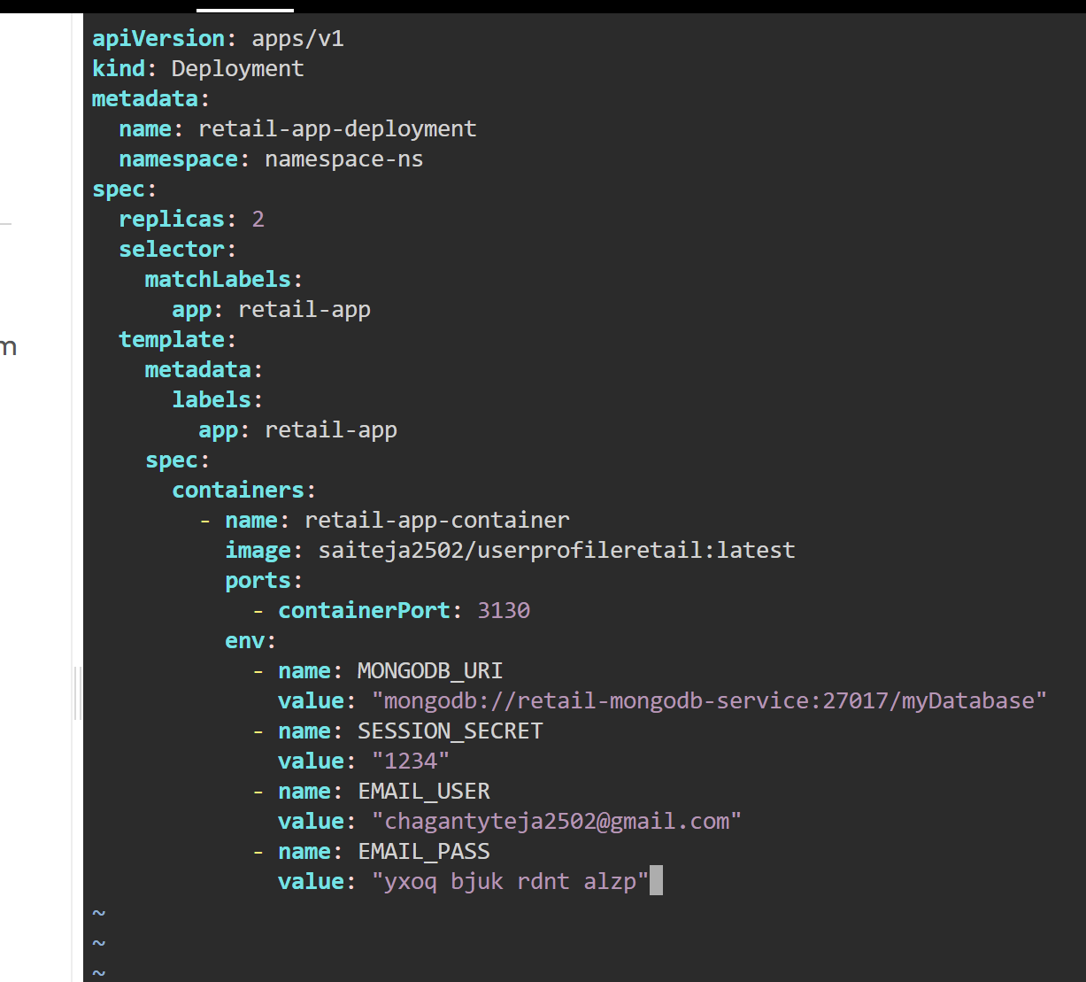
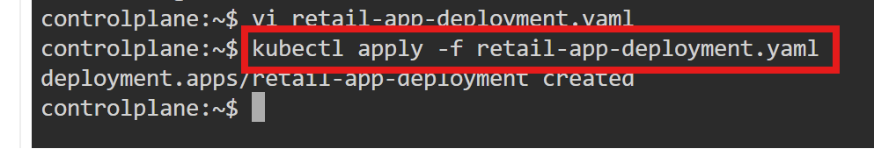

Create Retail App Service
- This shows the service YAML for the retail application which exposes the app inside the cluster.
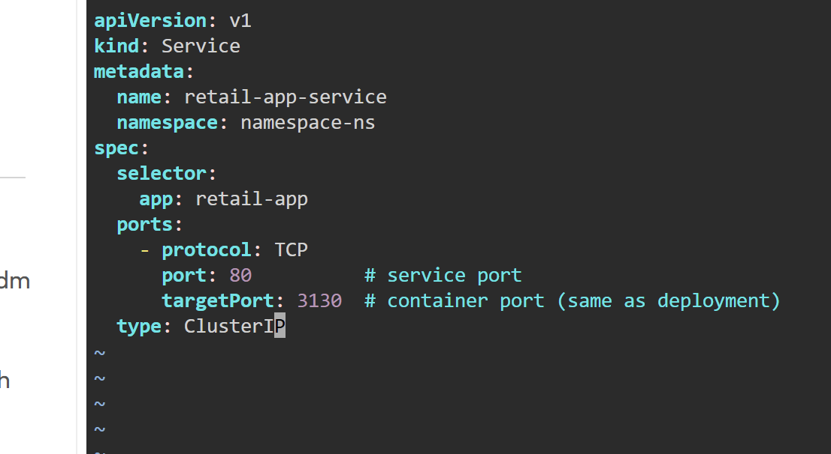
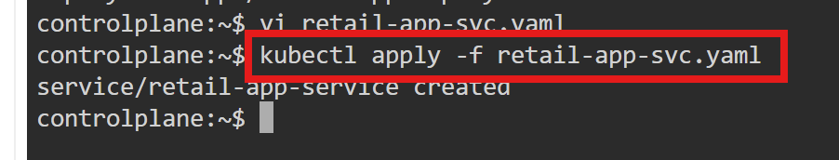

Check Pods and Services
- This verifies that both the retail app pods and MongoDB pod are running and services are created.
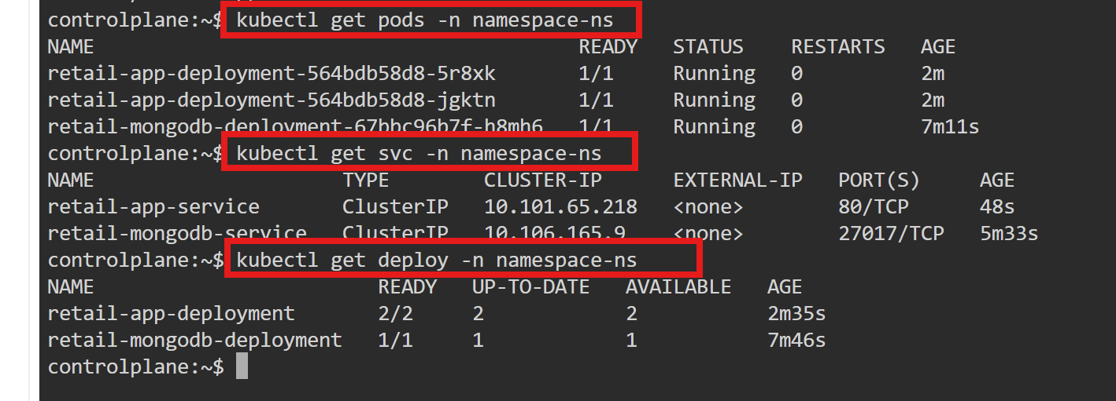

Check Deployments
- It shows that both deployments (retail app and MongoDB)are in READY state.
- This shows the output of kubectl get all -n namespace-ns confirming all resources are running.
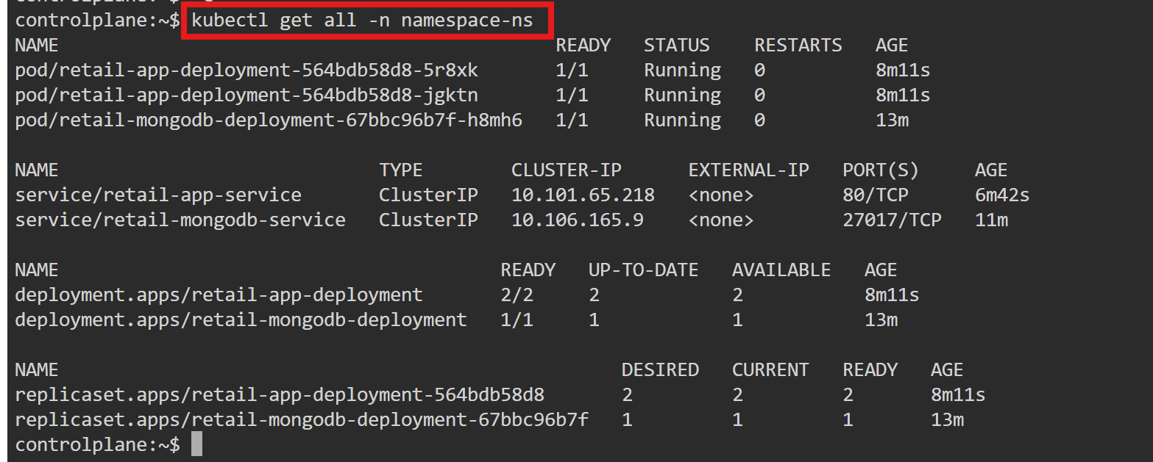

List All Files
- This shows all YAML files present in the project directory.

kubectl describe pod
- Kubernetes configured the env vars for the pod
- It shows kubectl describe pod output, confirming environment variables are injected into the container.
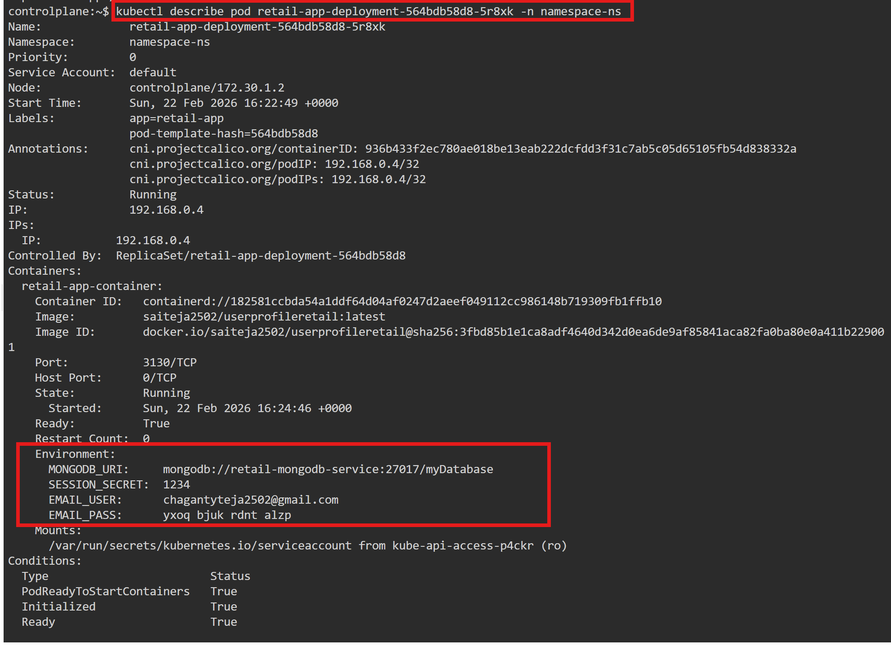

kubectl exec ... printenv
- The container actually has those env vars at runtime
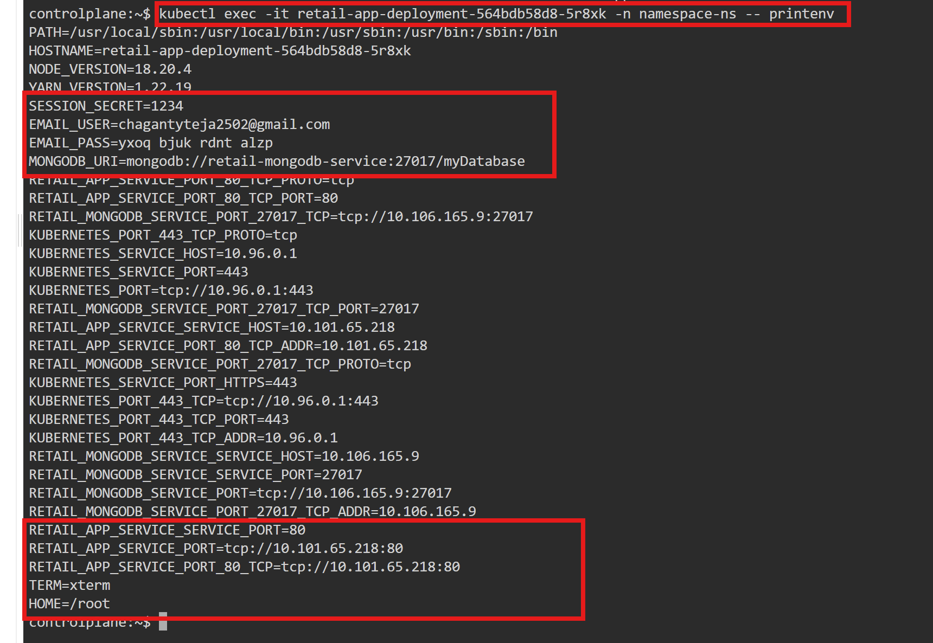

Final Result
- Namespace created successfully.
- MongoDB deployed internally.
- Retail application deployed with replicas.
- ConfigMap and Secret injected successfully.
- Application resources verified inside Kubernetes cluster.

