Jira Task & Team Management

This document explains how to use Jira to add people, create teams, and create tasks, using the screenshots you shared. It is written in a clear, beginner-friendly way and can be used for learning, training, or documentation.

Add People in Jira
- This section shows: Add People in Jira.
- Users are added to Jira
- They can be assigned tasks and added to teams
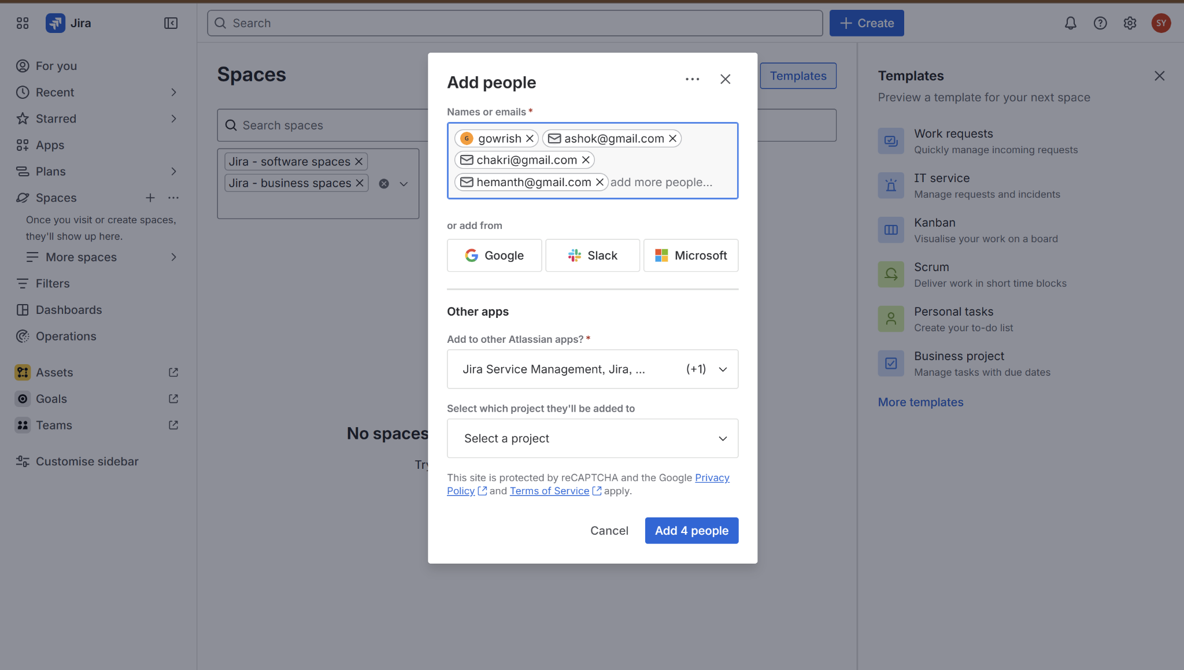

Create Team in Jira
- This section shows: Create Team in Jira.
- Team is created
- Members are visible under the team
- Team can be linked to tasks
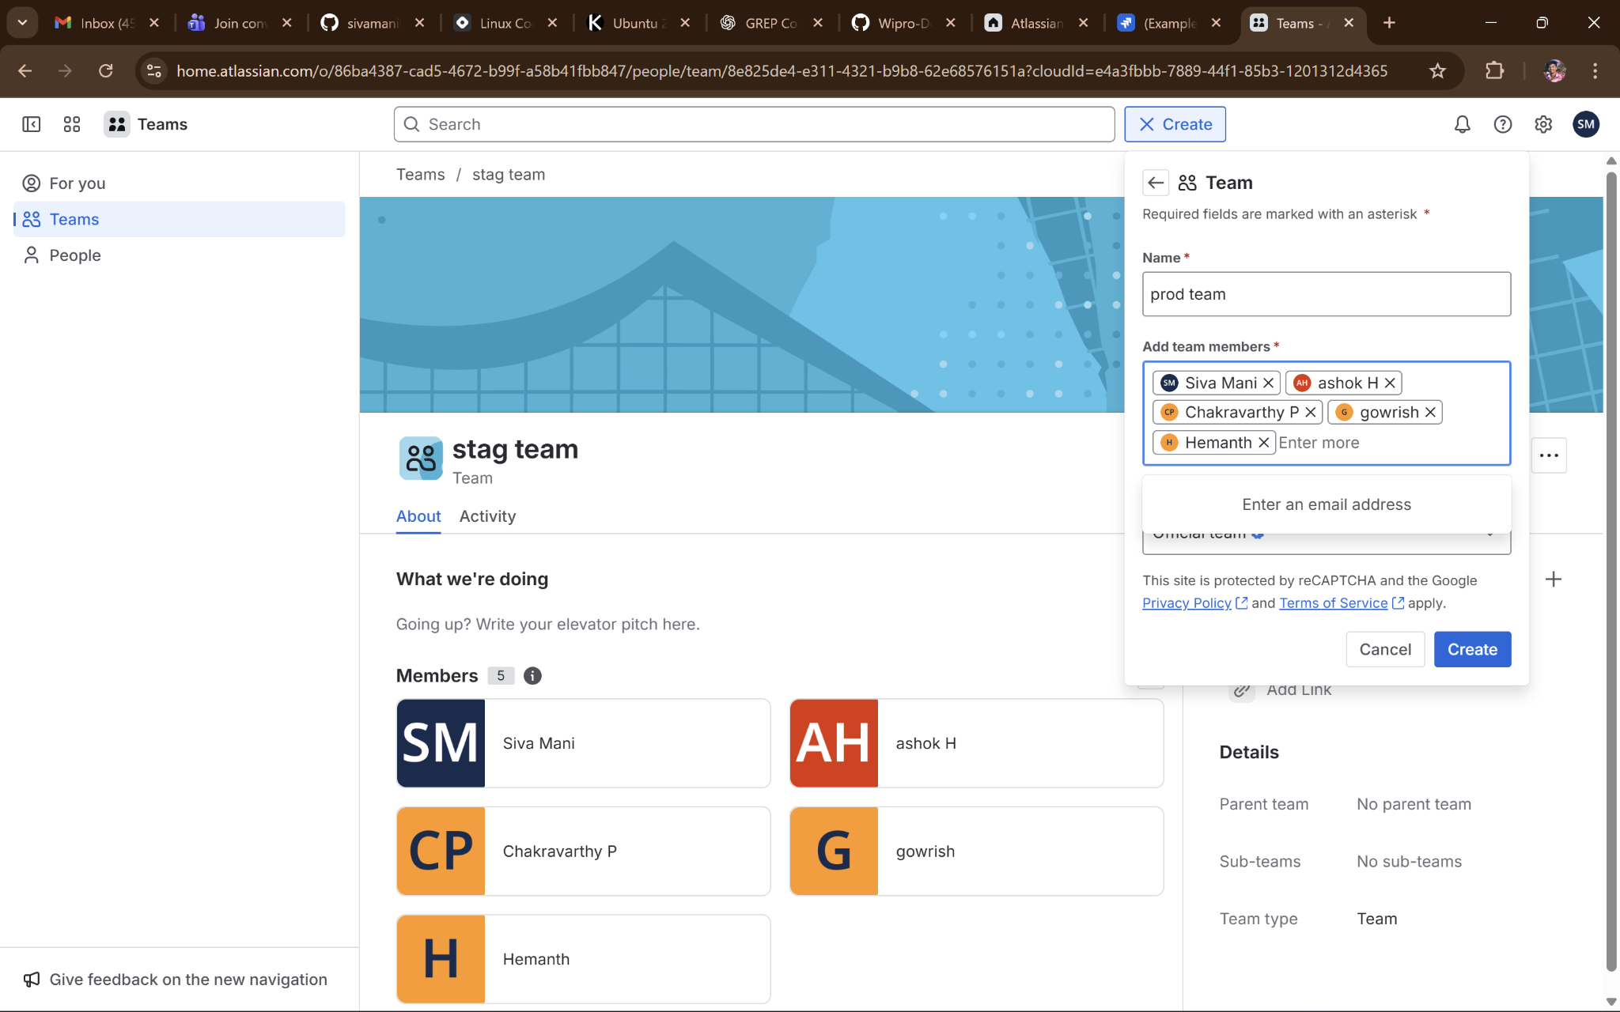

Create Task
Y
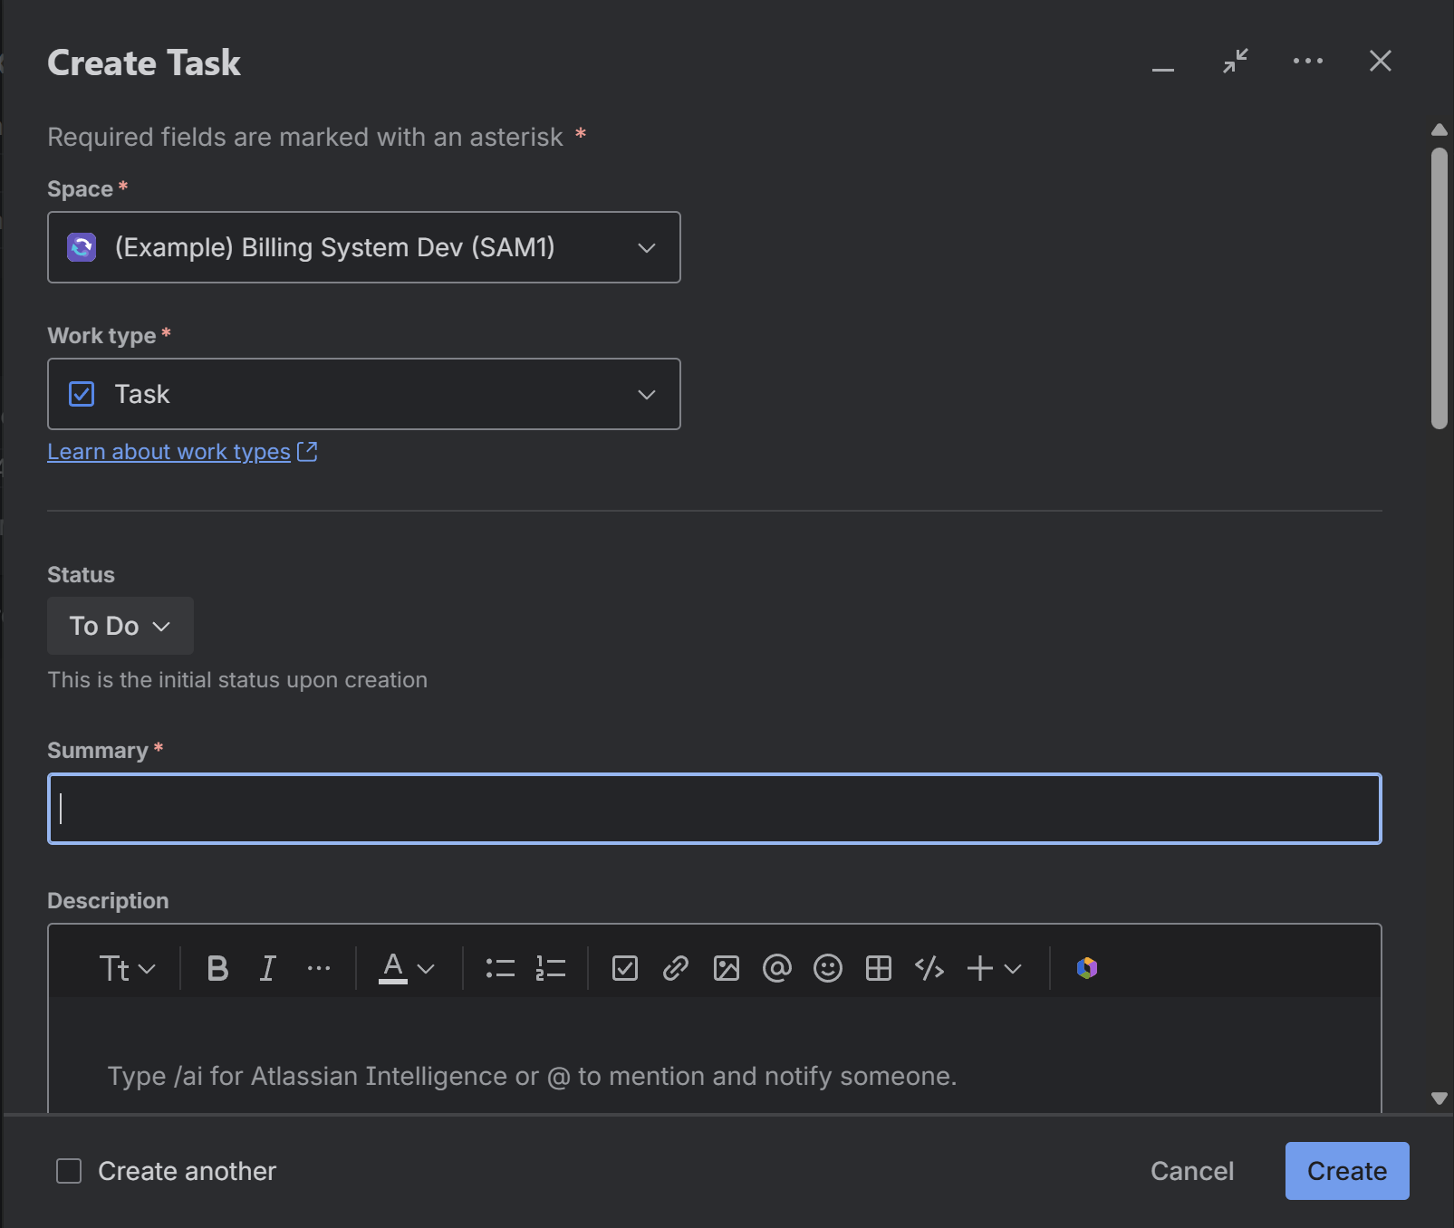

Create Task – Description & Assignee
This section shows: Create Task – Description & Assignee.
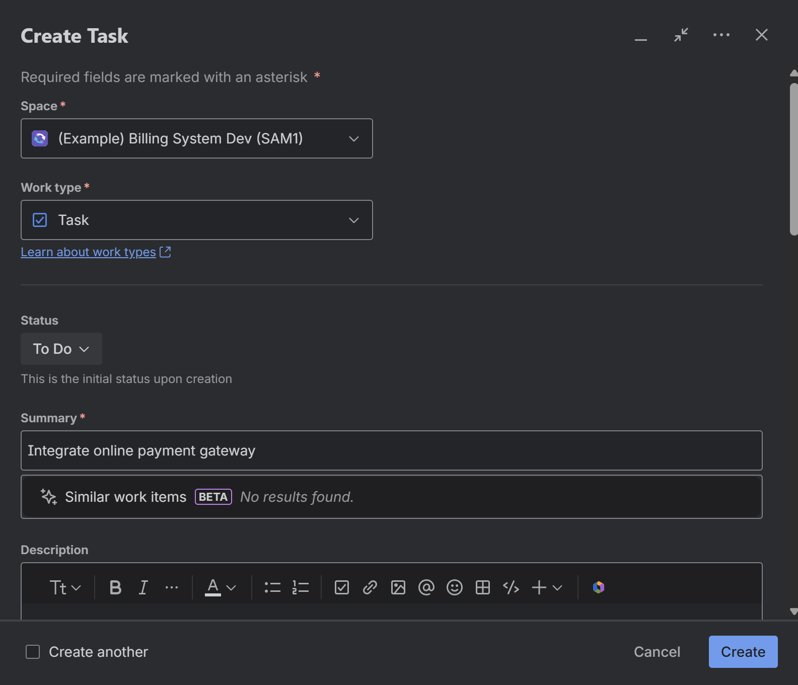

Create Task – Dates & Team
This section shows: Create Task – Dates & Team.
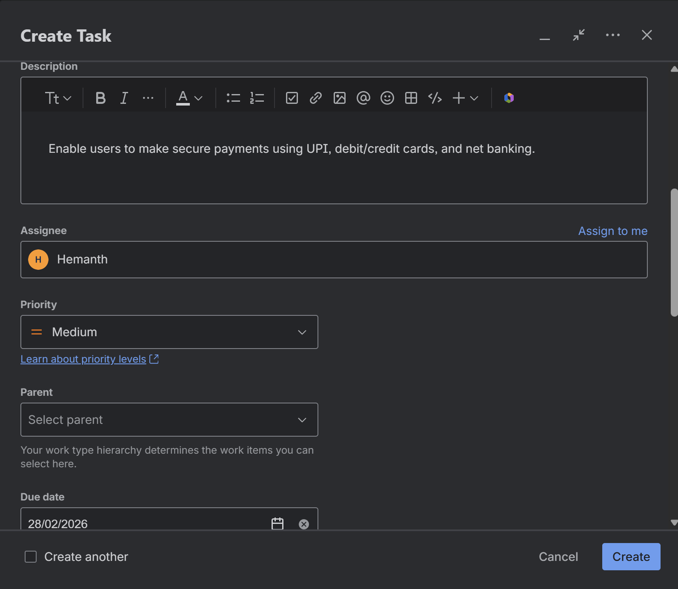

Jira Board View
- This section shows: Jira Board View.
- The board visually shows task progress.
- Columns
- To Do – Tasks not started
- In Progress – Tasks being worked on
- In Review – Tasks under review
- Done – Completed tasks
- Actions
- Drag tasks between columns
- Quickly see task owner and due date
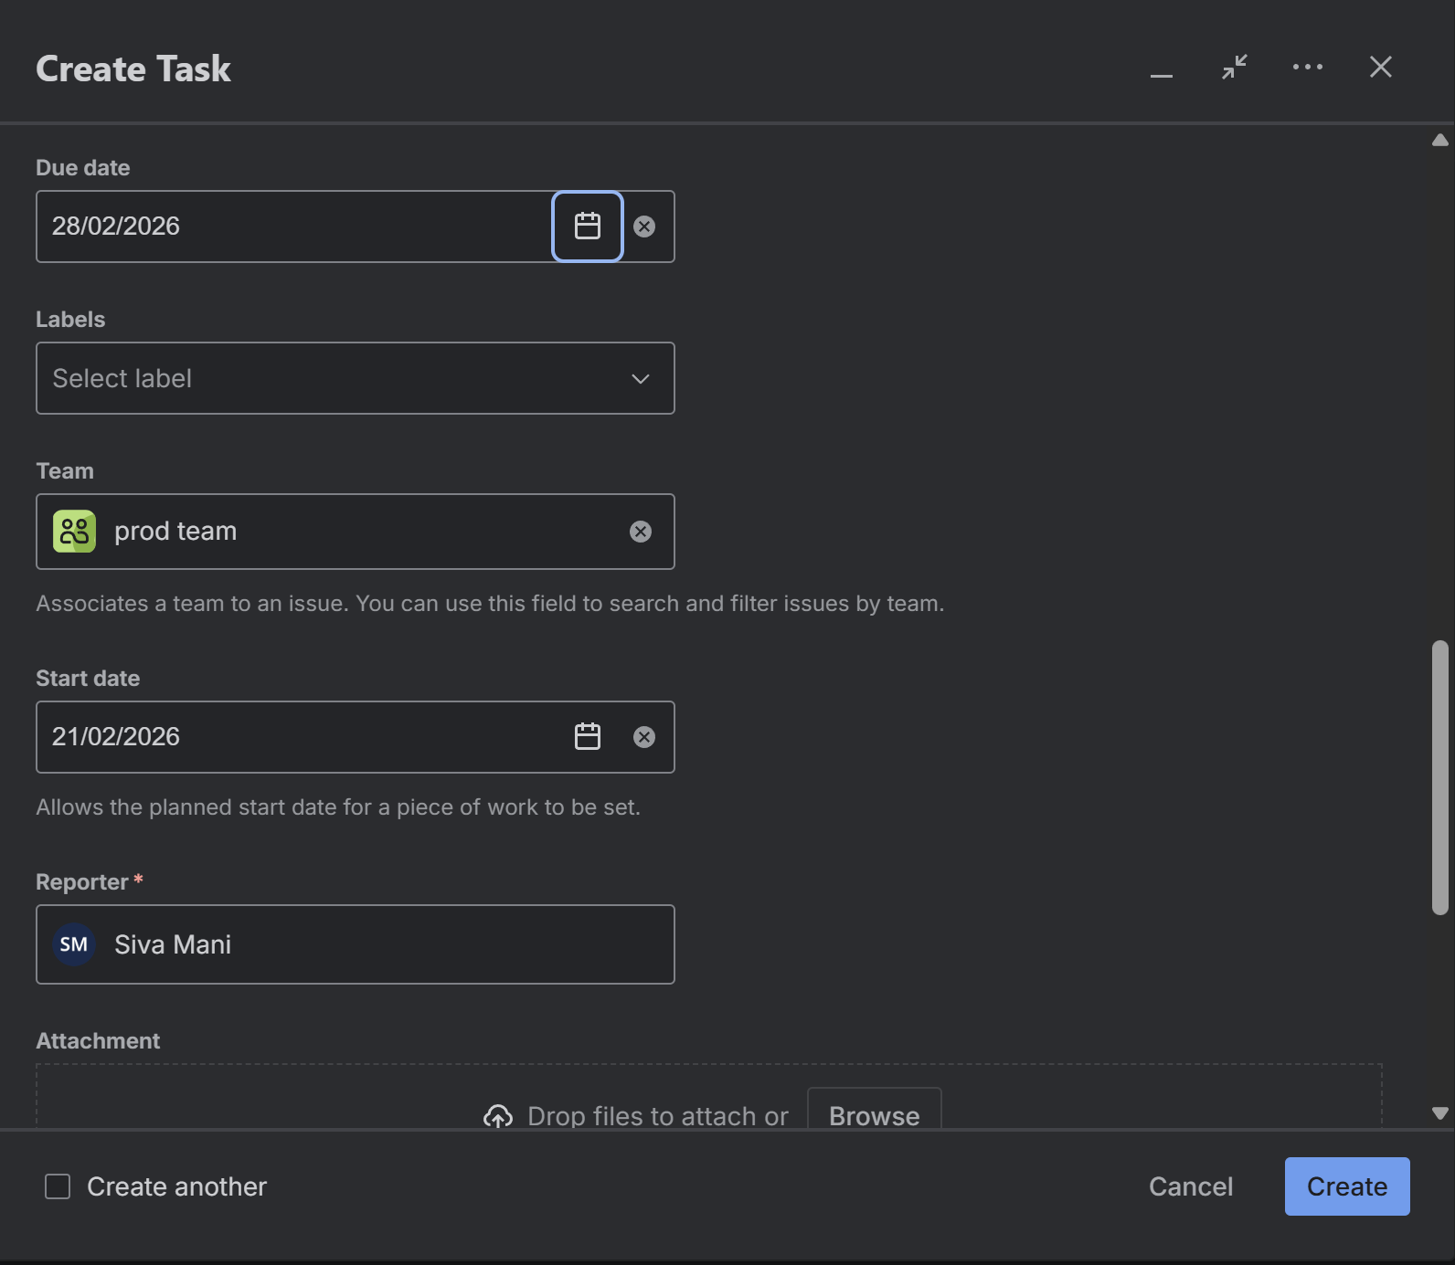

Teams Dashboard
- This section shows: Teams Dashboard.
- View all teams and members in one place.
- What you see
- Your profile
- Teams you belong to (Dev, QA, Prod)
- Member count per team
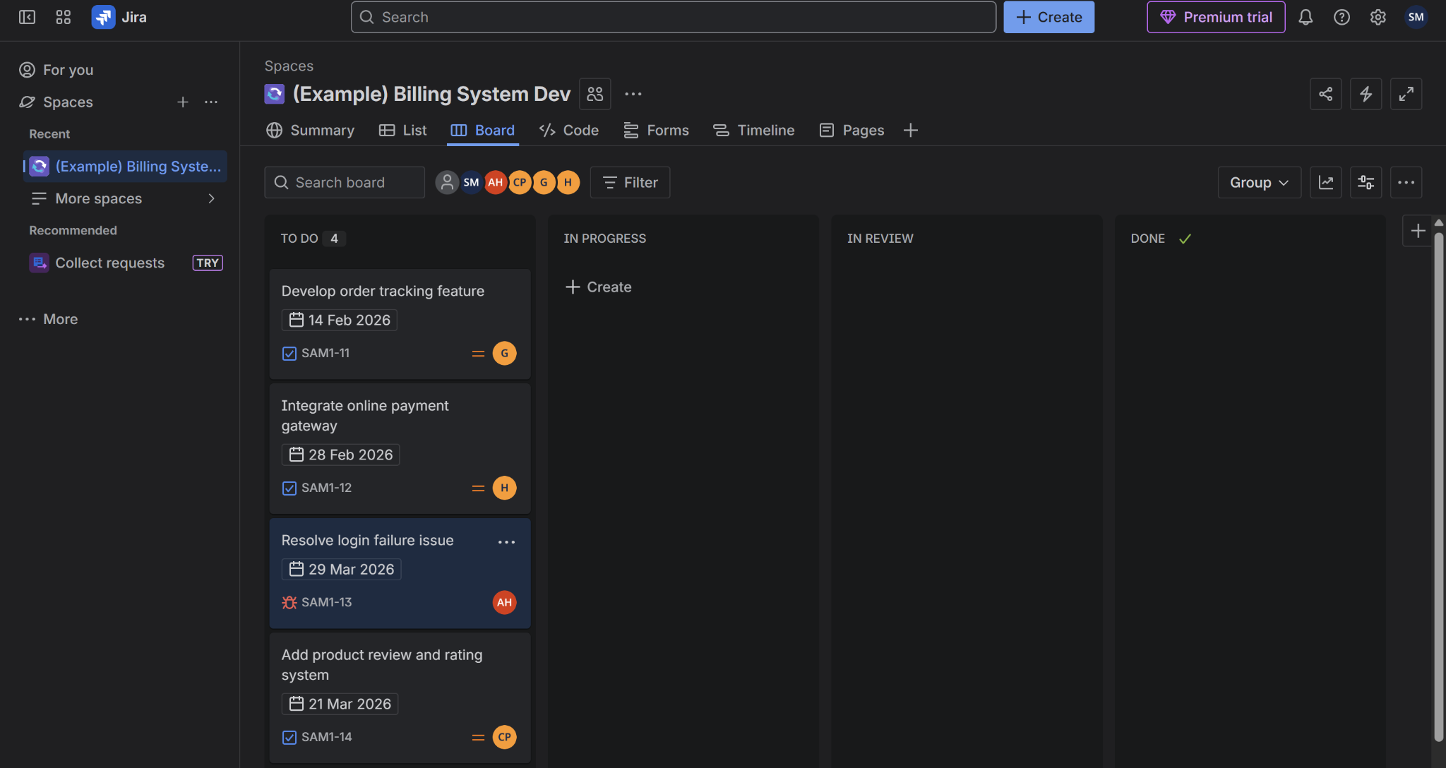

Teams Overview Page
This section shows: Teams Overview Page.
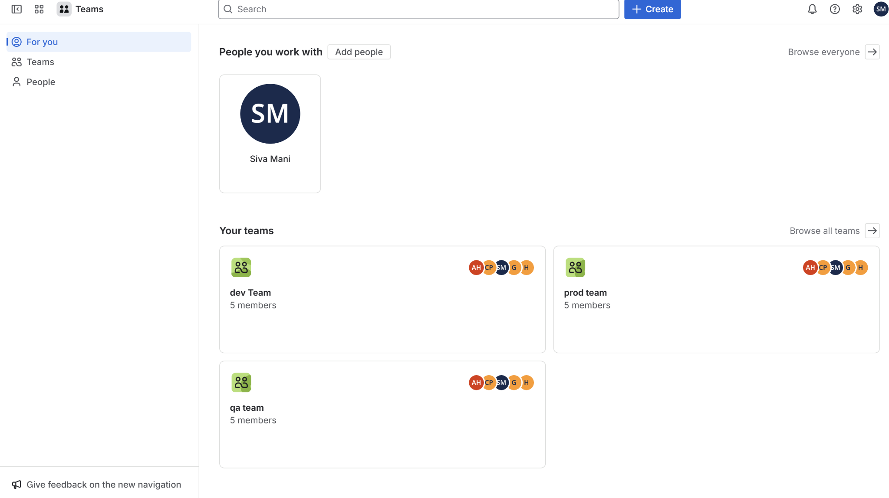

Task Details, Comments, and Collaboration

Viewing Task Details
This screen shows the detailed view of a Jira task. It includes the task title, description, assignee, priority, team, start date, due date, and reporter. This view helps team members clearly understand what needs to be done and by whom.
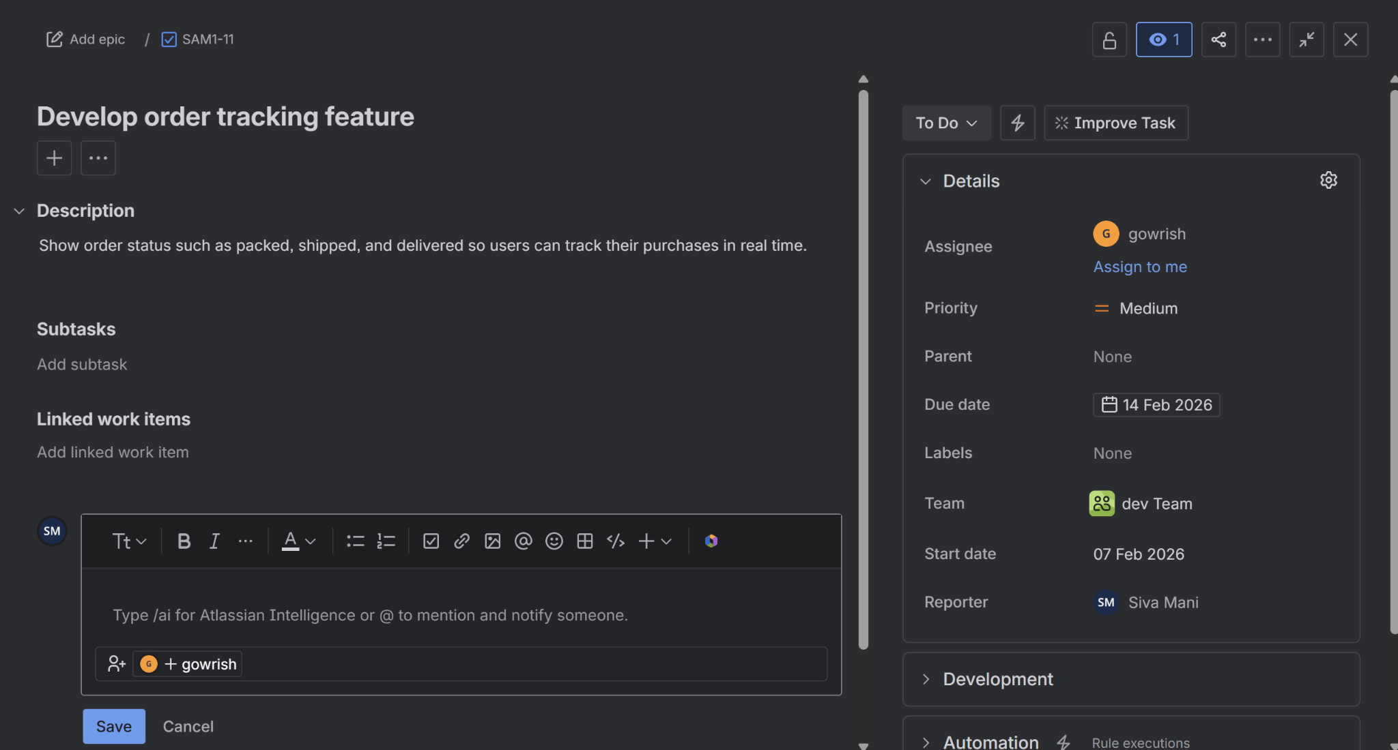

Adding Comments to a Task
This screen demonstrates how users can add comments to a task. Comments are used for communication, updates, and clarification between team members without leaving Jira.
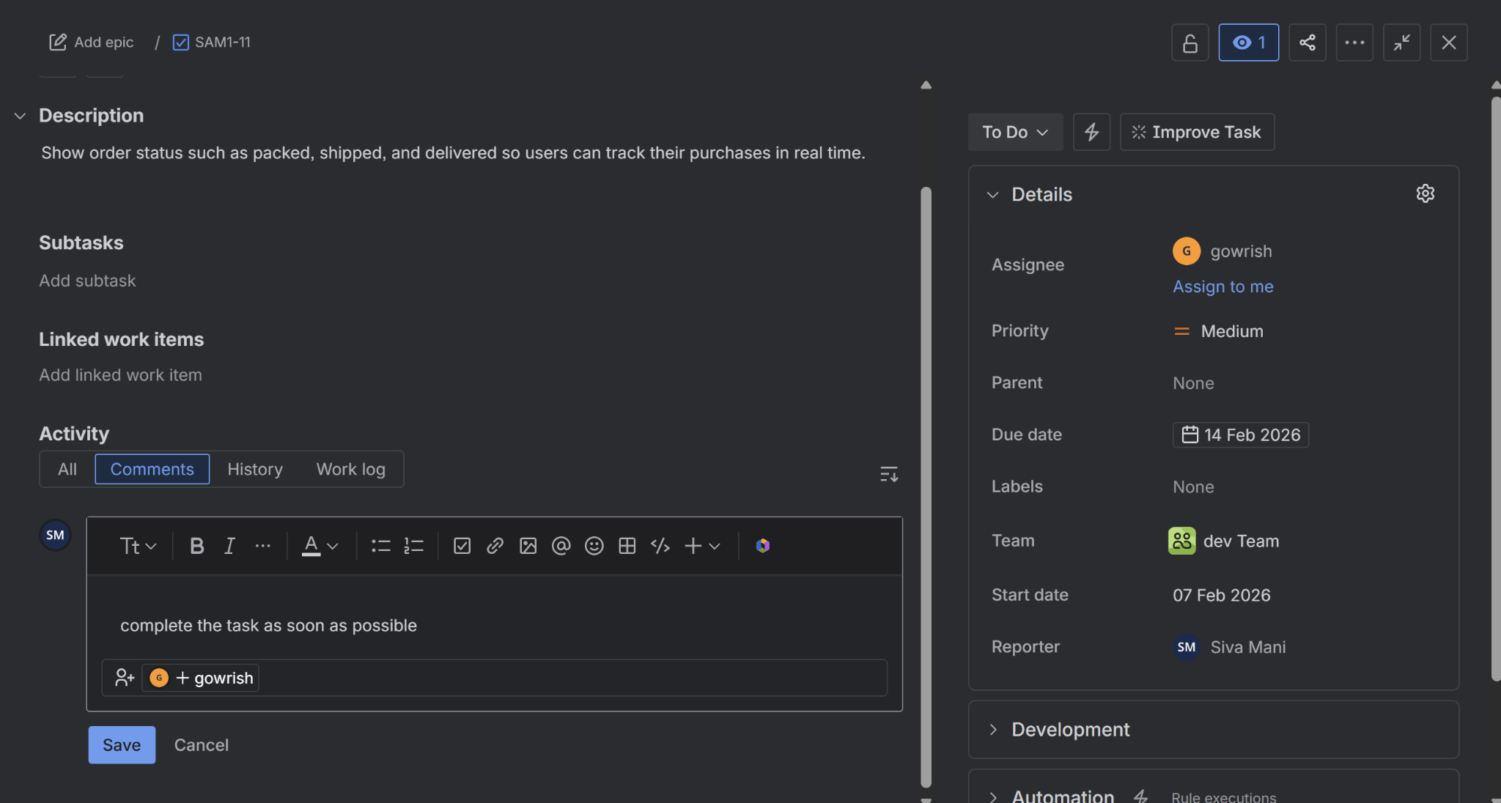

Replying and Collaboration
This screen shows replying to comments using @mentions. It helps notify specific users, ensuring effective collaboration and faster communication within the team.
