**1.** **Introduction**: To build a site which will be used to manage and maintain listing of Cloud Foundry user groups.

**1.1 Scope** : Initial scope of the user groups would be India.

**1.2 References :**  <http://www.gtugs.org/>

<http://www.meetup.com/>

<https://developers.google.com/>

**1.3 glossary**

**2. System Overview :** This system enables to create and manage events and chapters. This essentially maintains the user groups of cloud foundry.

**2.1 System Architecture:** MVC architecture

**3. Design Overview:** This system is built on MVC architecture.

This system is so generic such that it can adapted in any language. This is achieved by internationalisation. (I18 and localisation techniques).

To implement this, all the content is saved in the file. So for each language, we can maintain different files. The required language is specified during run time.

Since the same hierarchy of content is maintained, we can achieve this internationalisation.

This system maintains the historical data. Also the records are soft deleted and not hard deleted.

This system maintains the created user details, modified user details along with the time stamps.

**3.1 Use case diagram:**

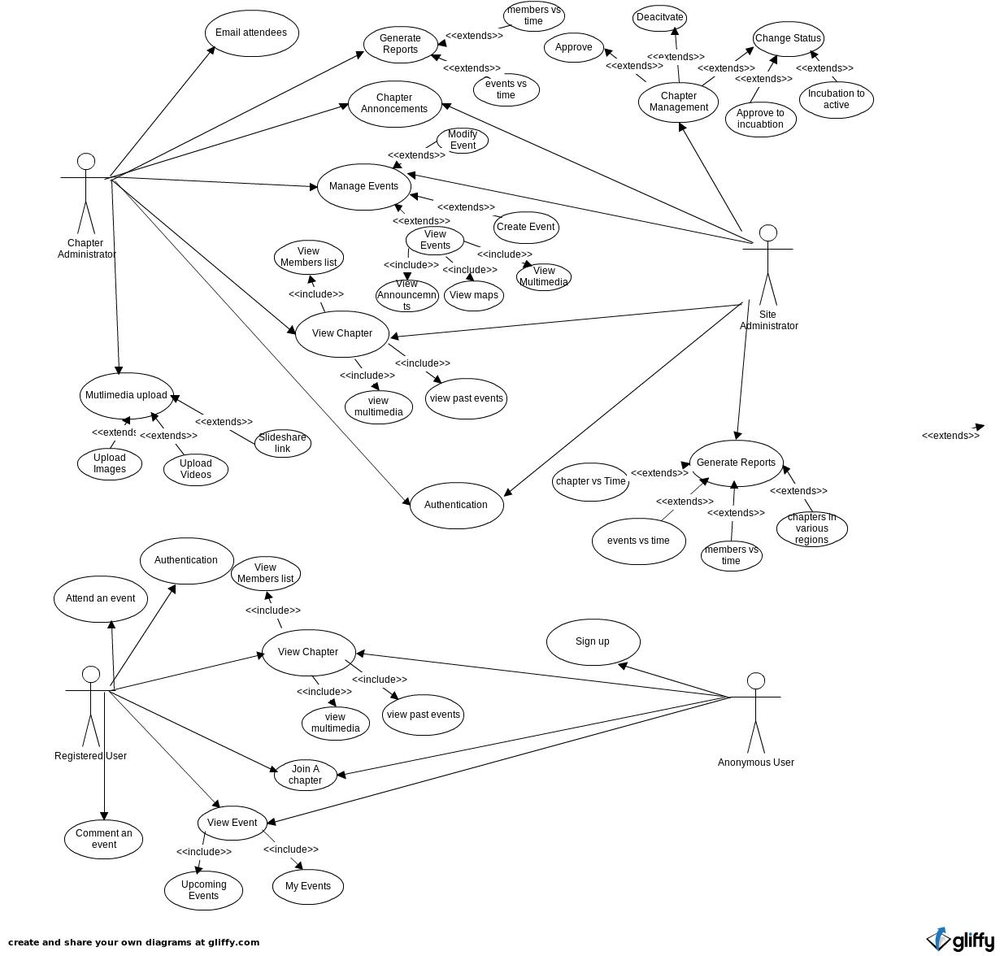

**3. 2 Use case descriptions:**

1)

|  |  |
| --- | --- |
| Use case Name: | Sign-in / Sign-up (Authentication) |
| Actors Involved: | Site Admin , Chapter Admin , Normal user / Member |
| Use case Description: | User need to authenticate to login into the system |
| Pre Conditions: | NA |
| Post Conditions: | User have to redirect/navigate to home page. |
| Basic Flow: | Authentication process can be done by the following options :  1) Gmail login  2) Yahoo login  3) By providing normal Email address |
| Alternate Flow: | Shows errors if mandatory fields are empty |

2)

|  |  |
| --- | --- |
| Use case Name: | Posting Announcements on the main page |
| Actors Involved: | Site Administrator |
| Use case Description: | CMS Capabilities where site administrator can post announcements . |
| Pre Conditions: | The Site Administrator should be logged in. |
| Post Conditions: | Created announcements are stored in database. |
| Basic Flow: | Administrator will create announcements from CMS page and posted them on the main page. |
| Alternate Flow: | Shows errors if mandatory fields are empty. |

3)

|  |  |
| --- | --- |
| Use case Name: | Approve Chapter |
| Actors Involved: | Site Administrator |
| Use case Description: | Site Administrator can view the list of the chapters to be approved .  This enables the site administrator to approve the chapters. |
| Pre Conditions: | The site administrator should be logged in. |
| Post Conditions: | Chapter should be in approved state |
| Basic Flow: | 1. User has to log in with appropriate credentials.  2. A list of non-approved chapters will be shown in the admin panel.  3. Site administrator will approve or deny a chapter.  4. If its approved, the status becomes approved.  5. If rejected, the status becomes rejected |
| Alternate Flow: | NA |

4)

|  |  |
| --- | --- |
| Use case Name: | Change Chapter status |
| Actors Involved: | Site Administrator |
| Use case Description: | This enables site administrator to move the chapters from one status to another. |
| Pre Conditions: | The site administrator should be logged in. |
| Post Conditions: | Chapter status changed from applied to incubating or incubating to active status. |
| Basic Flow: | Will show list of chapters which are approved and applied status.  Basic conditions flow  1. Site Administrator has to login with proper credentials.  2. He can view the list of chapters.  2.1) If it is applied status → Chapter admin can move to incubating status  2.2) if it is incubating status → chapter admin can move to active status. |
| Alternate Flow: | NA |

5)

|  |  |
| --- | --- |
| Use case Name: | De-activate a chapter |
| Actors Involved: | Site Administrator |
| Use case Description: | This enables site administrator to deactivate the active chapters . |
| Pre Conditions: | The user should be logged in. |
| Post Conditions: | Chapter status changed to De-active Status |
| Basic Flow: | 1. User has to login with proper credentials.  2. System will show a list of active Chapters .  3. Site administrator can deactivate the chapters. |
| Alternate Flow: | NA |

6)

|  |  |
| --- | --- |
| Use case Name: | Sending emails from the site |
| Actors Involved: | Site administrator |
| Use case Description: | This enables site administrator to send emails to users participating events or any kind of emails |
| Pre Conditions: | The user should be logged in. |
| Post Conditions: | Emails sent to the email addresses |
| Basic Flow: | Site administrator will fill up the “to” addresses, subject and body of the email and clicks on the send button. |
| Alternate Flow: | Shows errors if mandatory fields are empty. |

7)

|  |  |
| --- | --- |
| Use case Name: | Generate Reports |
| Actors Involved: | Site Administrator |
| Use case Description: | This enables site administrator to generate reports based on the conditions like :  1) Chapters vs time  2) Events vs time  3) Members vs time  4) Chapters in various regions |
| Pre Conditions: | The user should be logged in. |
| Post Conditions: | Reports will be displays based on the criteria |
| Basic Flow: | User can select the criteria to generate reports. The corresponding report will be generated and displayed |
| Alternate Flow: | NA |

8)

|  |  |
| --- | --- |
| Use case Name: | Announcements about a chapter |
| Actors Involved: | Chapter administrator |
| Use case Description: | This enables chapter administrator to post a announcements about a chapters. |
| Pre Conditions: | The chapter administrator should be logged in. |
| Post Conditions: | Announcements should be saved in the database and displays in the chapters page |
| Basic Flow: | Site administrator create the announcement about the chapter and post them into the chapters page. |
| Alternate Flow: | Shows errors if mandatory fields are empty. |

9)

|  |  |
| --- | --- |
| Use case Name: | Creating / Managing Events |
| Actors Involved: | Chapter administrator |
| Use case Description: | This enables chapter administrator to create and manage events. |
| Pre Conditions: | The chapter administrator should be logged in. |
| Post Conditions: | Events are either created or updated. |
| Basic Flow: | Chapter administrator can create and manage events in the chapter. By creating event , chapter administrator needs to provide list of values :  1) Name  2) Location  3) Registration link  4) Images  5) videos  6) slideshare links  7) List of emails attendees  2. He can also modify the existing chapter. |
| Alternate Flow: | Shows errors if mandatory fields are empty. |

10)

|  |  |
| --- | --- |
| Use case Name: | Fetching Email Attendees |
| Actors Involved: | Chapter administrator |
| Use case Description: | This enables chapter administrator to fetch the list email attendees for the event. |
| Pre Conditions: | The chapter administrator should be logged in. |
| Post Conditions: | Emails can be sent to the email attendees. |
| Basic Flow: | Chapter administrator can fetch the list of email attendees and can send emails to all in the list |
| Alternate Flow: | Shows errors if mandatory fields are empty. |

11)

|  |  |
| --- | --- |
| Use case Name: | Multimedia Upload |
| Actors Involved: | Chapter administrator |
| Use case Description: | This enables the chapter administrator to upload photos , slide share links and videos for a chapter or event |
| Pre Conditions: | The chapter administrator should be logged in. |
| Post Conditions: | Multimedia is updated. |
| Basic Flow: | 1. Chapter administrator has to log in.  2. He can select a chapter or event.  3. He can upload event photos slide share links and videos for a chapter or event. |
| Alternate Flow: | Show errors, if there is failure in multimedia uploaded. |

12)

|  |  |
| --- | --- |
| Use case Name: | Generating Reports |
| Actors Involved: | Chapter Administrator |
| Use case Description: | This enables chapter administrator to generate reports based on the conditions like :  1) Events vs time  2) Members vs time |
| Pre Conditions: | The chapter administrator should be logged in. |
| Post Conditions: | Reports will be displays based on the criteria |
| Basic Flow: | There is drop with the different criteria to generate reports, by selecting one of the options, the report will be generated and displayed. |
| Alternate Flow: | NA |

13)

|  |  |
| --- | --- |
| Use case Name: | Join a Chapter |
| Actors Involved: | Registered users |
| Use case Description: | Chapter membership – each member can be part of more than one chapter. |
| Pre Conditions: | The user should be logged in.( if Anonymous user , he needs to sign up to join a chapter) |
| Post Conditions: | User becomes member of the chapter |
| Basic Flow: | There will a list of chapters will be displayed with the “join” and “view” links / buttons , users can view the chapter or they can join the chapter by clicking the “join” link. Once the user clicks on the “join” link, he will becomes member of the chapter.  Basic Condition:  ============  1) “join” links will be shown only when the user is not a member of that chapter listed in the list. |
| Alternate Flow: | NA |

14)

|  |  |
| --- | --- |
| Use case Name: | Comment on an event |
| Actors Involved: | Chapter administrator, Site Administrator, Registered user |
| Use case Description: | This enables users to comment on an event. |
| Pre Conditions: | The user should be logged in. |
| Post Conditions: | Store the comment in the DB |
| Basic Flow: | By viewing the Event , users can comment on an event and post the comment |
| Alternate Flow: | Shows errors if compulsory fields are empty. |

15)

|  |  |
| --- | --- |
| Use case Name: | Attend an event |
| Actors Involved: | User / Member |
| Use case Description: | This enables users to attend an event or not attending or may be |
| Pre Conditions: | The user should be logged in. |
| Post Conditions: | 1. Updates the event attendees list.  2.If user is attending, it is updated in the my events list. |
| Basic Flow: | 1. User has to log in with proper credentials.  2. He can view the list of events of the chapter he subscribed for.  3. Each event will show three options like :  1) Attending  2) Not Attending  3) May be.  User can select any one of the options. |
| Alternate Flow: | Shows errors if compulsory fields are empty. |

16)

|  |  |
| --- | --- |
| Use case Name: | Internationalization support |
| Actors Involved: | Any one |
| Use case Description: | This enables users to view the site content any international languages. |
| Pre Conditions: | NA |
| Post Conditions: | Translate the content with the selected language. |
| Basic Flow: | There will be a drop down with the list international languages. Users can select any one of the language to view the content in the select language. |
| Alternate Flow: | NA |

17)

|  |  |
| --- | --- |
| Use case Name: | Create a Chapter |
| Actors Involved: | Chapter administrator |
| Use case Description: | This enables users to create his own chapters |
| Pre Conditions: | The user should be logged in. |
| Post Conditions: | The chapter request should go to Site administrator for approval. |
| Basic Flow: | 1. Users needs to log in to the system.  2. Users can create a chapter , while creating a chapter user needs to provide the following information :  2.1) Uploading Logo  2.2) Name  2.3) Type of Chapter - professional or student if user has selected “student” ,it has to be associated with institutions.  2.4) Chapter Coordinators list if any  2.5) Multimedia ( Images, Videos, Slide share link) |
| Alternate Flow: | Shows errors if mandatory fields are not filled. |

18)

|  |  |
| --- | --- |
| Use case Name: | Show Past Events |
| Actors Involved: | Chapter Administrator, Site administrator, Anonymous User, Registered user |
| Use case Description: | This enables to show a list of Past Events |
| Pre Conditions: | NA |
| Post Conditions: | NA |
| Basic Flow: | Displays a list of Past Events |
| Alternate Flow: | NA |

19)

|  |  |
| --- | --- |
| Use case Name: | Show Upcoming Events |
| Actors Involved: | Chapter Administrator, Site administrator, Anonymous User, Registered user |
| Pre Conditions: | NA |
| Post Conditions: | NA |
| Basic Flow: | Displays a list of Upcoming Events. |
| Alternate Flow: | NA |

20)

|  |  |
| --- | --- |
| Use case Name: | Show My Events |
| Actors Involved: | Chapter Administrator, Site administrator, User, Registered user |
| Use case Description: | This enables to show a list of the events the user attended. |
| Pre Conditions: | User has to login with proper credentials. |
| Post Conditions: | NA |
| Basic Flow: | 1. User has to log in with proper credentials.  2. He can view the events he has subscribed for. (past , present or future) |
| Alternate Flow: | NA |

4 Database Design

4.1 E-R diagram

