Spring Boot

==========

1)

To create a spring boot web Application go to the bellow link

<https://start.spring.io/>

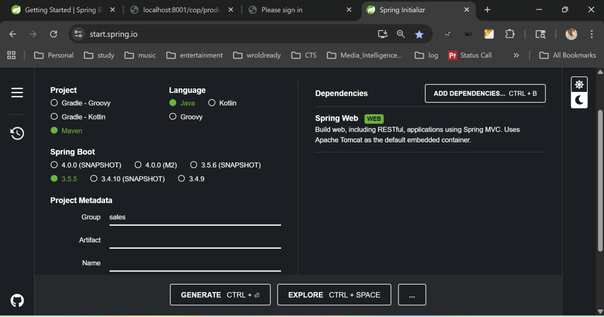

And create a spring project, download and extract it into your project folder.

2) Go to your Spring Tool Suite and File -> import -> Existing Maven Projects

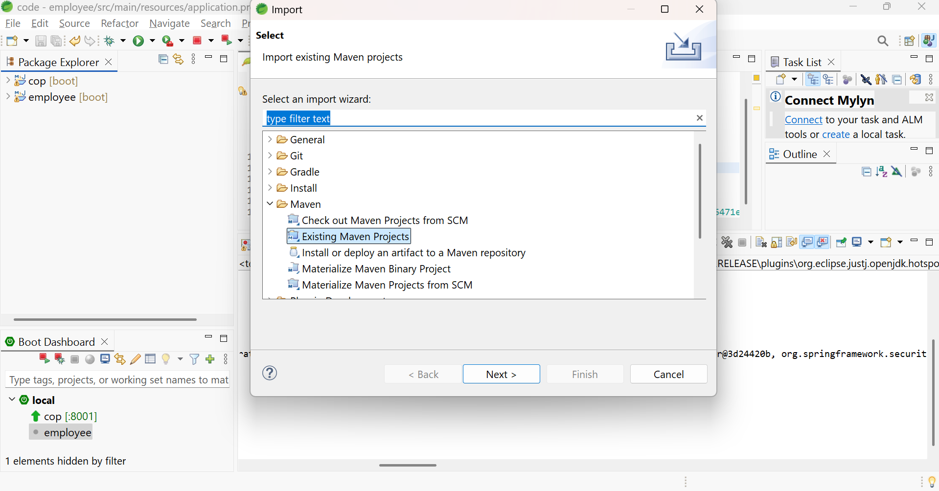

Import the project.

Add Controller into your java.src

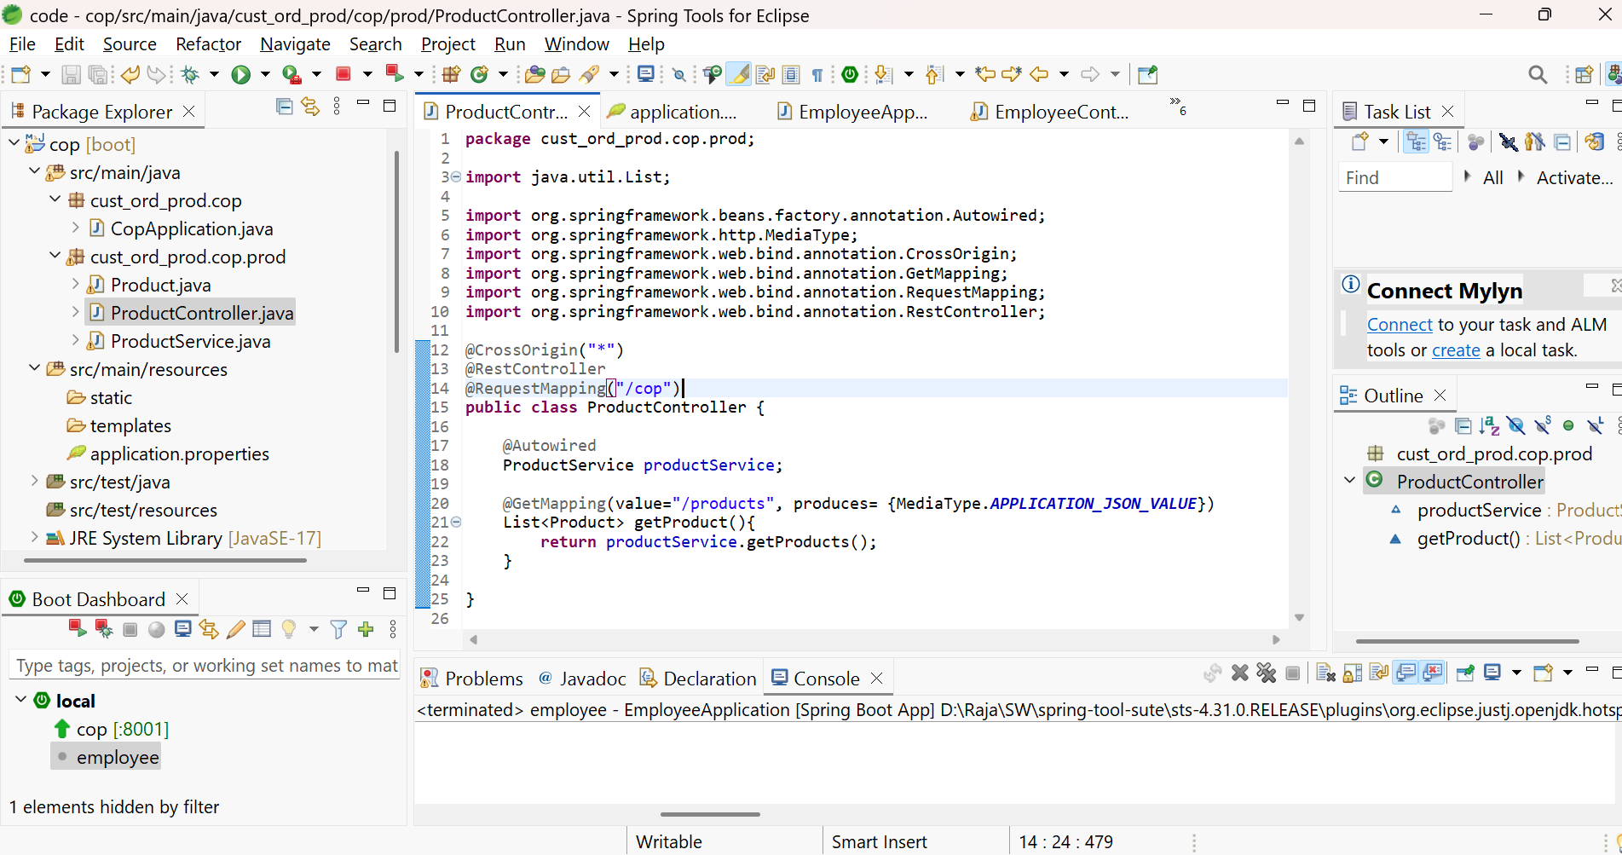

**ProductController.java**

**package** cust_ord_prod.cop.prod;

**import** java.util.List;

**import** org.springframework.beans.factory.annotation.Autowired;

**import** org.springframework.http.MediaType;

**import** org.springframework.web.bind.annotation.CrossOrigin;

**import** org.springframework.web.bind.annotation.GetMapping;

**import** org.springframework.web.bind.annotation.RequestMapping;

**import** org.springframework.web.bind.annotation.RestController;

@CrossOrigin("*")

@RestController

@RequestMapping("/cop")

**public** **class** ProductController {

@Autowired

ProductService productService;

@GetMapping(value="/products", produces= {MediaType.***APPLICATION_JSON_VALUE***})

List<Product> getProduct(){

**return** productService.getProducts();

}

}

**ProductService.java**

**package** cust_ord_prod.cop.prod;

**import** java.util.ArrayList;

**import** java.util.List;

**import** org.springframework.stereotype.Component;

@Component

**public** **class** ProductService {

List<Product> getProducts(){

List<Product> products = **new** ArrayList();

products.add(**new** Product("101","Tracfone"));

products.add(**new** Product("102","Totalwireless"));

products.add(**new** Product("103","SimpleMoble"));

products.add(**new** Product("104","Avaya"));

products.add(**new** Product("105","Verizon"));

**return** products;

}

}

**Product.java**

**package** cust_ord_prod.cop.prod;

**public** **class** Product {

**public** Product(String id, String name) {

**this**.id = id;

**this**.name = name;

}

String id;

**public** String getId() {

**return** id;

}

**public** **void** setId(String id) {

**this**.id = id;

}

**public** String getName() {

**return** name;

}

**public** **void** setName(String name) {

**this**.name = name;

}

String name;

}

Then in **CopApplication.java** file add @ComponentScan

**package** cust_ord_prod.cop;

**import** org.springframework.boot.SpringApplication;

**import** org.springframework.boot.autoconfigure.SpringBootApplication;

**import** org.springframework.context.annotation.ComponentScan;

@SpringBootApplication

@ComponentScan("cust_ord_prod.cop")

**public** **class** CopApplication {

**public** **static** **void** main(String[] args) {

SpringApplication.*run*(CopApplication.**class**, args);

}

}

Go to Run configuration and do maven clean install

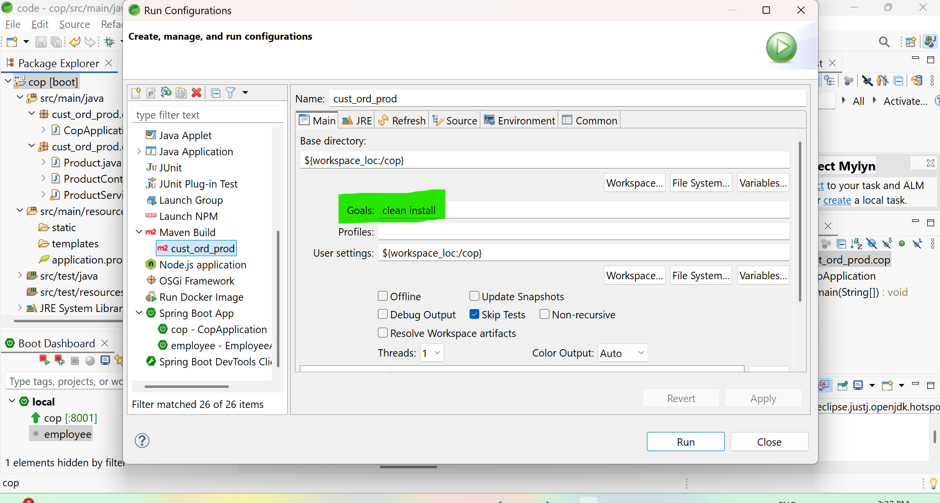

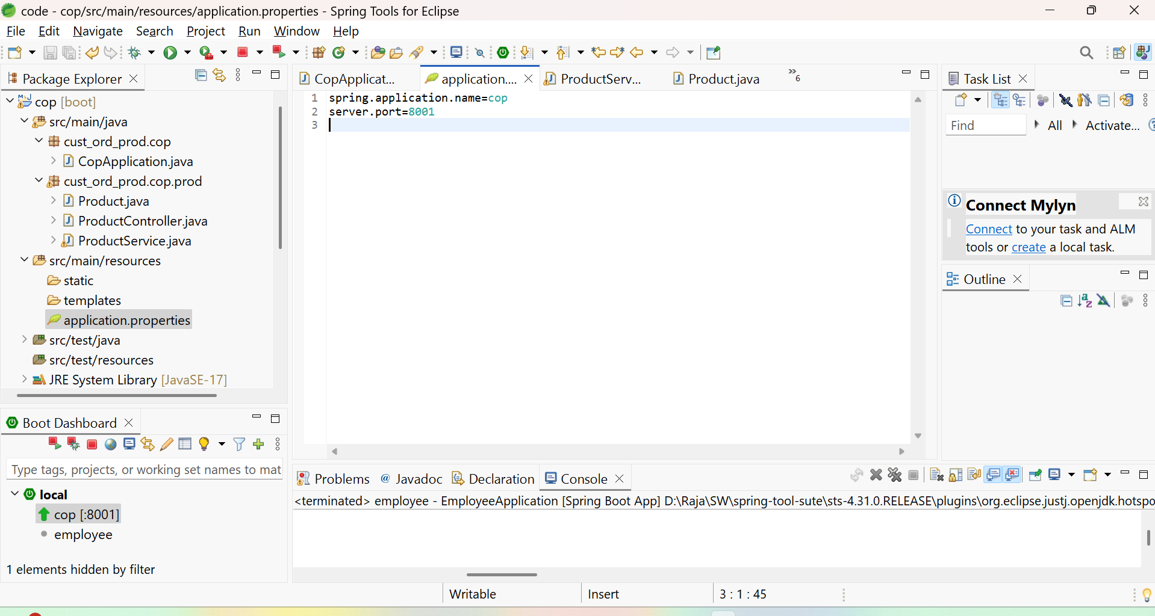

Start the server and go to browser.

To prepare the URL

Port number from application.properties file server.port number.

@RequestMapping("/cop") => cop

@GetMapping(value="/products", produces= {MediaType.***APPLICATION_JSON_VALUE***})

=> products

<http://localhost:8001/cop/products>

call this url from postman or browser.

You will get this bellow response.

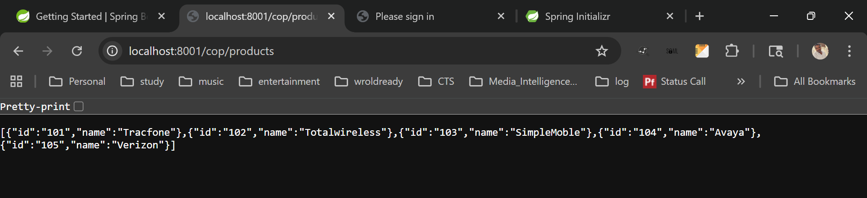

This is simple web application API development using spring boot.

Authentication using oauth2

=======================