Now let us look how to create simple ReactJS application and create components , making API call to get the data and show into the screen.

**Step 1: Install Node.js and NPM please refer web for latest version and install.**

**PS D:\Raja\code\UI\cop> node -v**

**v18.16.0**

**PS D:\Raja\code\UI\cop> npm -v**

**9.6.7**

**Step 2: Initialize the React App Using create-react-app**

**npx create-react-app cop**

cd cop

npm start will start the npm server.

The default files created by reacts is.

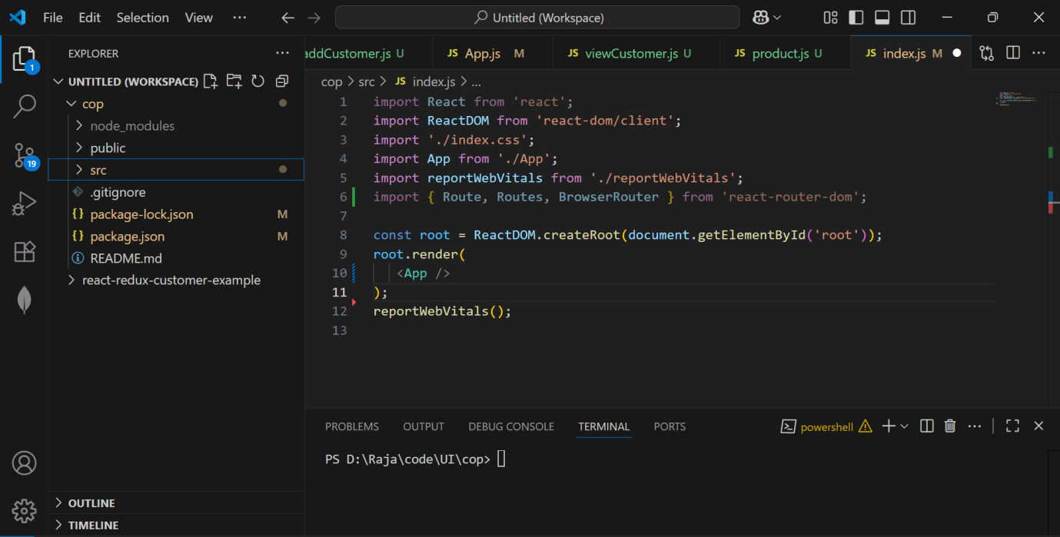

Inside src you will see index.js and App.js files and their .css files.

1.

**Index.js**

**import React from 'react';**

**import ReactDOM from 'react-dom/client';**

**import './index.css';**

**import App from './App';**

**import reportWebVitals from './reportWebVitals';**

**import { Route, Routes, BrowserRouter } from 'react-router-dom';**

**const root = ReactDOM.createRoot(document.getElementById('root'));**

**root.render(**

**<App />**

**);**

**reportWebVitals();**

**2)**

**App.js**

import logo from './logo.svg';

import './App.css';

import Customer from './cus/customer';

import Product from './prd/product';

import Sidebar from './components/sidebar';

import ViewCustomer from './cus/viewCustomer';

import AddCustomer from './cus/addCustomer';

import { Route, Routes, BrowserRouter as Router } from 'react-router-dom';

import { Provider } from 'react-redux';

function App() {

  return (

    <div className="App">

      <br/>Products Ordered by Customers

      <Router>

        <Routes>

          <Route path='customer' element={<Customer/>}/>

          <Route path='product' element={<Product/>}/>

        </Routes>

      </Router>

    </div>

  );

}

export default App;

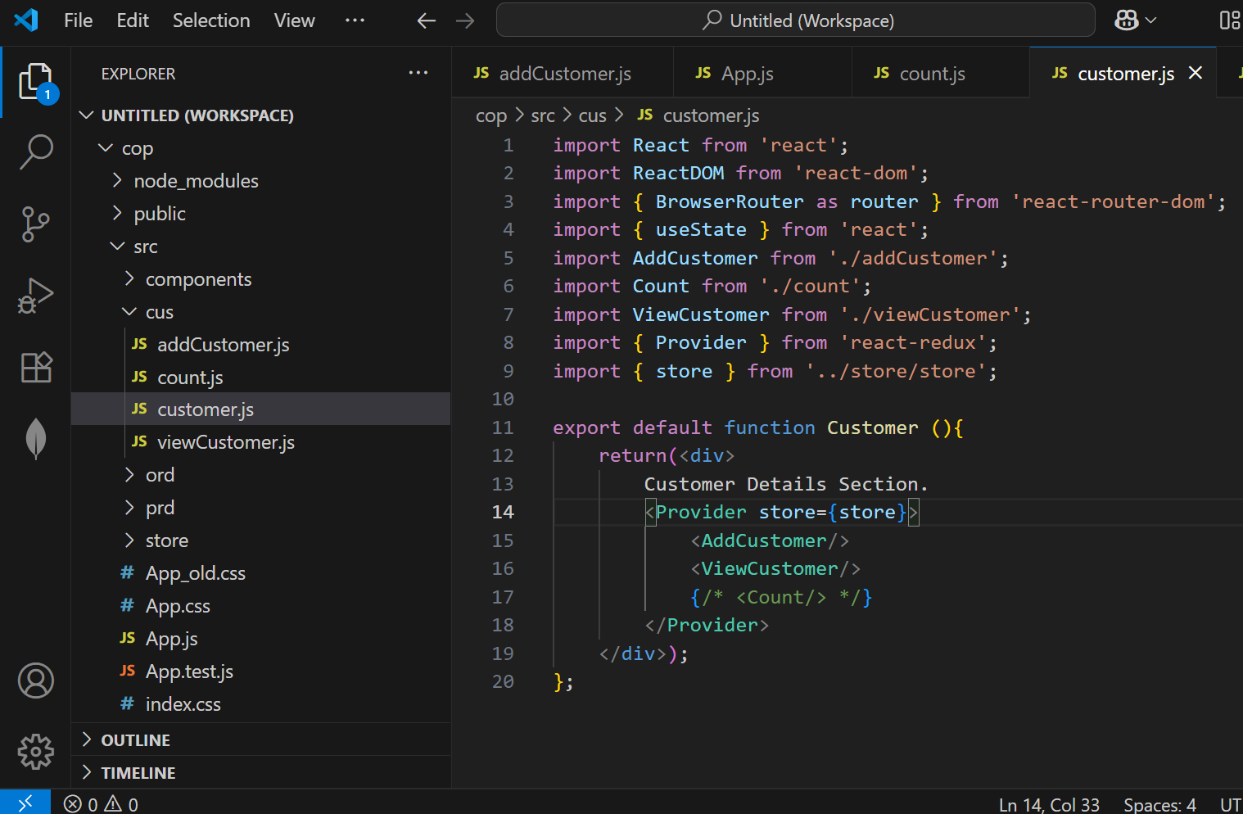

1. **Customer.js**

import React from 'react';

import ReactDOM from 'react-dom';

import { BrowserRouter as router } from 'react-router-dom';

import { useState } from 'react';

import AddCustomer from './addCustomer';

import Count from './count';

import ViewCustomer from './viewCustomer';

import { Provider } from 'react-redux';

import { store } from '../store/store';

export default function Customer (){

    return(<div>

        Customer Details Section.

        <Provider store={store}>

            <AddCustomer/>

            <ViewCustomer/>

            {/* <Count/> */}

        </Provider>

    </div>);

};

1. addCustomer.js

import React from "react";

import ViewCustomer from "./viewCustomer";

import { useState, useEffect } from "react";

import { addCustomer as addCustomerAction } from "../store/customerSlice";

import { useDispatch } from "react-redux";

export default function AddCustomer(){

    const dispatch = useDispatch();

    const [customer, setInput] = useState("");

    const [customers, setCustomers] = useState([]);

    const [custName, setCusName] = useState('Krishna');

        function addCustomer(){

            if(customer){

                dispatch(addCustomerAction(customer))

                setInput("");

            }

            else{

                return<div>Please enter Customer Name</div>

            }

        }

    return(

    <div>

        <div>

            <h2>Add new Customer</h2>

            <input type='text' value={customer} onChange={(e) => setInput(e.target.value)}/>

            <button onClick={addCustomer} >Add</button>

            {/* <button onChange={setCustomers()}>Add</button> */}

        </div>

    </div>

    );

}

1. viewCustomer.js

import React, { useState } from "react";

import { useSelector } from "react-redux";

export default function ViewCustomer(){

    const customers = useSelector((state) => state.customers)

    return(

    <div>

        Customers List

        <ul style={{listStyle:'none'}}>

           {customers.map((customer) => <li>{customer}</li> )}

        </ul>

    </div>)

}

1. Product.js => Making backend API call

import React, { useState } from 'react';

import ReactDOM from 'react-dom';

import { BrowserRouter as router, useFetcher } from 'react-router-dom';

import { useEffect } from 'react';

import axios from 'axios';

export default function Product (){

    const [data, setData] = useState([]);

    const [loading, setLoading] = useState(true);

    const [error, setError] = useState(null);

    useEffect(() => {

        axios.get(

            "http://localhost:8001/cop/products",

            {

                headers: {

                    'Access-Control-Allow-Origin':'*',

                    'Access-Control-Allow-Methods':'GET'

                }

            }

        ).then((response) => {

            setData(response.data);

            setLoading(false);

        }).catch((err) => {

            setError(err.message);

            setLoading(false);

        })

    }, []);

    return(

    <div>

        Product Details Section.

        { data.map((k) => (<li>{k.name +'    ' +k.id}</li>))}

    </div>);

};

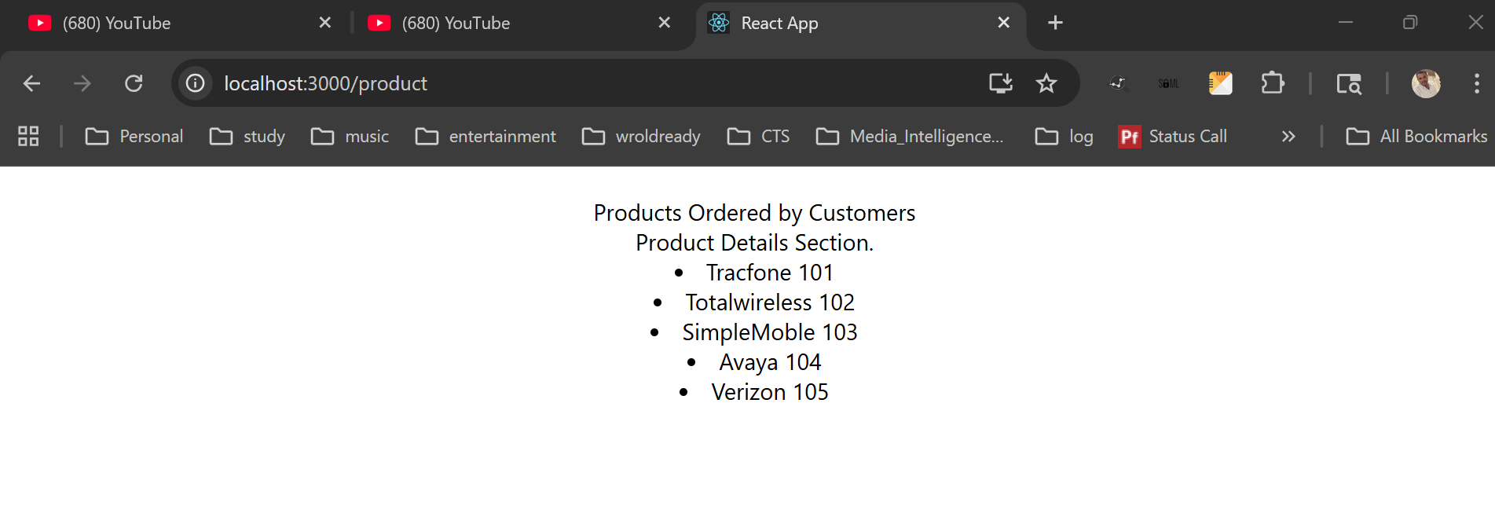

The data is pulled from backend API

