**Industrial Internship Report on**

**”** Prediction of Agriculture Crop Production In India**”**

**Prepared by**

[ SIVAGNANASEKAR G 1 , SHAMEEM MOHAMED A R 2 ]

[ [99210041286@klu.ac.in](mailto:99210041286@klu.ac.in) 1  , [sham2000md@gmail.com](mailto:sham2000md@gmail.com) 2  ]

|  |
| --- |
| *Executive Summary* |
| This report provides details of the Industrial Internship provided by upskill Campus and The IoT Academy in collaboration with Industrial Partner UniConverge Technologies Pvt Ltd (UCT).  This internship was focused on a project/problem statement provided by UCT. We had to finish the project including the report in 6 weeks’ time.  My project was (Tell about ur Project)  This internship gave me a very good opportunity to get exposure to Industrial problems and design/implement solution for that. It was an overall great experience to have this internship. |

**TABLE OF CONTENTS**

1 Preface 3

2 Introduction 4

2.1 About UniConverge Technologies Pvt Ltd 4

2.2 About upskill Campus 8

2.3 Objective 9

2.4 Reference  11

3 Problem Statement 12

4 Existing and Proposed solution 13

5 Proposed Design/ Model 13

5.1 High Level Diagram (if applicable) 15

5.2 Interfaces (if applicable) 16

6 Performance Test 18

7 My learnings 23

8 Future work scope 23

# Preface

Summary of the whole 6 weeks’ work.

About need of relevant Internship in career development.

Brief about Your project/problem statement.

Opportunity given by USC/UCT.

How Program was planned

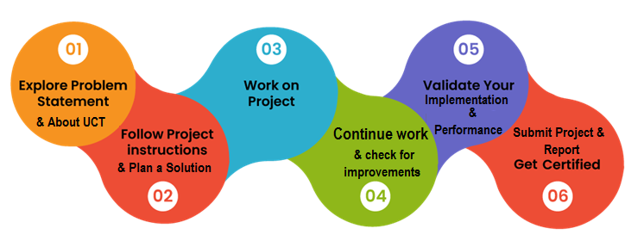

Your Learnings and overall experience.

Thank to all (with names), who have helped you directly or indirectly.

Your message to your juniors and peers.

# Introduction

## About UniConverge Technologies Pvt Ltd

A company established in 2013 and working in Digital Transformation domain and providing Industrial solutions with prime focus on sustainability and RoI.

For developing its products and solutions it is leveraging various**Cutting Edge Technologies e.g. Internet of Things (IoT), Cyber Security, Cloud computing (AWS, Azure), Machine Learning, Communication Technologies (4G/5G/LoRaWAN), Java Full Stack, Python, Front end**etc.



1. UCT IoT Platform**(****)**

**UCT Insight** is an IOT platform designed for quick deployment of IOT applications on the same time providing valuable “insight” for your process/business. It has been built in Java for backend and ReactJS for Front end. It has support for MySQL and various NoSql Databases.

* It enables device connectivity via industry standard IoT protocols - MQTT, CoAP, HTTP, Modbus TCP, OPC UA
* It supports both cloud and on-premises deployments.

It has features to  
• Build Your own dashboard  
• Analytics and Reporting  
• Alert and Notification  
• Integration with third party application(Power BI, SAP, ERP)  
• Rule Engine



1. **Smart Factory Platform (****)**

Factory watch is a platform for smart factory needs.

It provides Users/ Factory

* with a scalable solution for their Production and asset monitoring
* OEE and predictive maintenance solution scaling up to digital twin for your assets.
* to unleased the true potential of the data that their machines are generating and helps to identify the KPIs and also improve them.
* A modular architecture that allows users to choose the service that they what to start and then can scale to more complex solutions as per their demands.

Its unique SaaS model helps users to save time, cost and money.

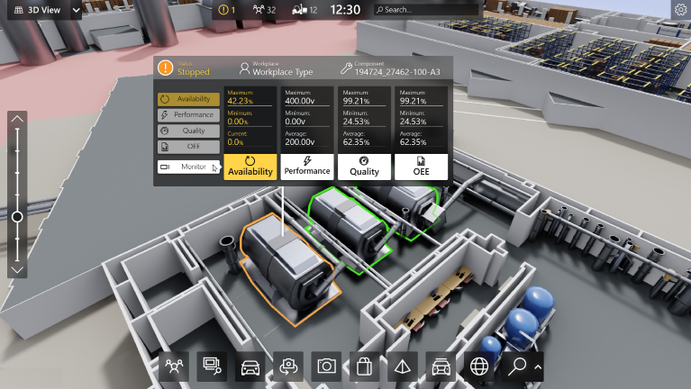

1. based Solution

UCT is one of the early adopters of LoRAWAN teschnology and providing solution in Agritech, Smart cities, Industrial Monitoring, Smart Street Light, Smart Water/ Gas/ Electricity metering solutions etc.

1. Predictive Maintenance

UCT isproviding Industrial Machine health monitoring and Predictive maintenance solution leveraging Embedded system, Industrial IoT and Machine Learning Technologies by finding Remaining useful life time of various Machines used in production process.



## About upskill Campus (USC)

upskill Campus along with The IoT Academy and in association with Uniconverge technologies has facilitated the smooth execution of the complete internship process.

USC is a career development platform that delivers **personalized executive coaching** in a more affordable, scalable and measurable way.



Seeing need of upskilling in self paced manner along-with additional support services e.g. Internship, projects, interaction with Industry experts, Career growth Services

<https://www.upskillcampus.com/>

upSkill Campus aiming to upskill 1 million learners in next 5 year

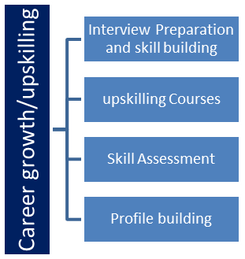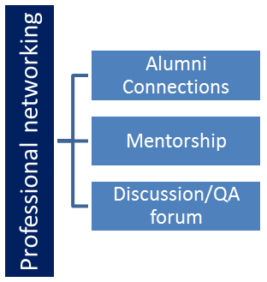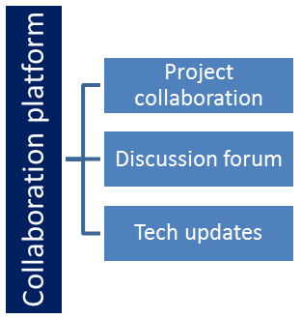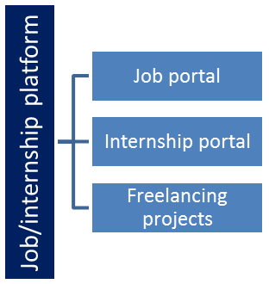

## The IoT Academy

The IoT academy is EdTech Division of UCT that is running long executive certification programs in collaboration with EICT Academy, IITK, IITR and IITG in multiple domains.

## Objectives of this Internship program

The objective for this internship program was to

 ☛ get practical experience of working in the industry.

 ☛ to solve real world problems.

 ☛ to have improved job prospects.

 ☛to have Improved understanding of our field and its applications.

 ☛to have Personal growth like better communication and problem solving.

## Reference

[1] Crop Price Prediction Using Machine Learning Techniques: A Comparative Study"

Author: John Smith

[2] "Long Short-Term Memory Networks for Crop Price Forecasting: A Deep Learning Approach"

Author: Emily Johnson

[3] "Economic Factors and Crop Price Volatility: An Analysis and Prediction Framework"

Author: David Rodriguez

# Problem Statement

In the assigned problem statement

Prediction of Agriculture Crop Production In India

In our problem statement they given the crop price prediction based on the previous data on various crops and various state and cost of cultivation and production and they given crop yield of that particular crop based on that we need to build our model and need to predict the future model and predictions.

Data set details:

In that data set we select the data set 1 for our model deployment and predictions.

In that data set they given crop yield of that particular crop based on that we need to build our model and need to predict the future model and predictions.

# Existing and Proposed solution

In previous method they used linear regression method to predict the future prediction it is quite simple but the accuracy level of the linear regression model is low with compared with our model so we moved to the random forest method to predict the prediction.

## Code submission (Github link)

https://github.com/sivamusk/CROP_PREDICTION.git

## Report submission (Github link) : first make placeholder, copy the link.

## https://github.com/sivamusk/CROP_PREDICTION.git

# Proposed Design/ Model

Random Forests: To increase prediction accuracy, random forests is an ensemble learning technique that blends different decision trees. For addressing intricate interactions between input variables and crop yield, random forests are effective. In comparison to individual decision trees, they can handle big datasets, provide feature importance rankings, and lessen overfitting.

Random Forest :

Popular machine learning technique Random Forest is utilised for both classification and regression tasks. It is a method of ensemble learning that mixes different decision trees to generate predictions. Here are some crucial details regarding the Random Forest approach:

Random Forest is an illustration of ensemble learning, in which various models are integrated to enhance overall performance. Decision trees serve as the individual models in Random Forest.

Multiple decision trees are constructed by Random Forest based on various subsets of the training data. A random subset of the characteristics and samples from the original dataset is used to train each tree individually.

Random Forest introduces randomization in two different ways. At each node of the decision tree, a subset of features is first chosen at random. The training data is then randomly sampled with replacement using bootstrapping. These methods of randomization aid in reducing overfitting and strengthening the model.

Bagging: Random Forest builds a variety of decision trees using a method known as bagging (bootstrap aggregating). By randomly choosing samples with replacement, bagging entails extracting numerous bootstrap samples from the original dataset. One of these bootstrap samples is used to train each tree.

After all the decision trees have been trained, the forecasts are combined by Random Forest to get the final prediction. It employs majority voting for classification problems, selecting the class that has received the most votes from the individual trees. It uses the average of the projected values from each individual tree for regression tasks.

Random Forest is able to quantify the significance of a feature. It determines the typical impurity reduction brought on by a characteristic across all of the decision trees, such as the Gini impurity or entropy. This data can be helpful for feature selection and determining the relative weights of various dataset features.

Overfitting-resistant: Random Forest is renowned for being overfitting-resistant. Combining different decision trees using randomization methods reduces variation and enhances generalisation performance. In comparison to individual decision trees, it is less susceptible to noisy data and outliers.

Scalability: Random Forest is capable of processing big datasets with multidimensional attributes. Individual decision trees can be trained in parallel, making it possible to implement them quickly on multicore processors and distributed computing frameworks.

The number of trees in the forest, the maximum depth of each tree, the number of features taken into account at each split, and other hyperparameters can all be tweaked to improve performance in Random Forest. To prevent either underfitting or overfitting, careful hyperparameter optimisation is essential.

Interpretability: Although Random Forest offers metrics of feature relevance, the total model is more difficult to understand than a single decision tree. Because the predictions are based on the collective judgements of several trees, it might be difficult to pinpoint the precise logic behind a given forecast.

Due to its accuracy, resilience, and adaptability, Random Forest is a strong and popular machine learning technique. It can be used in many different fields, including as finance, healthcare, image analysis, and natural language processing.

## High Level Diagram (if applicable)

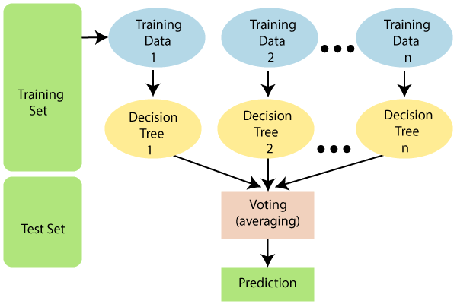

Figure 1: HIGH LEVEL DIAGRAM OF THE SYSTEM

## 

## Interfaces (if applicable)

GUI (tkinter)

The common Python package Tkinter is used to build GUIs, or graphical user interfaces. It offers a collection of widgets and features that enable programmers to create interactive applications with a unified look and feel. The following are some significant Tkinter points:

Integration: The Tcl programming language gave rise to the Tk GUI toolkit, which is the foundation of Tkinter. Since it is part of Python, using Tkinter does not require the installation of any other packages or dependencies.

Cross-platform: Tkinter is a Python GUI development tool that runs on a variety of operating platforms, including Windows, macOS, and Linux.

User interfaces can be made using a variety of built-in widgets that Tkinter offers. These comprise buttons, labels, text boxes, check boxes, radio buttons, entry fields, and more. The use of frames, grids, or pack layouts can be used to order and organise widgets.

Event-driven programming: Tkinter uses this approach to programming. It enables programmers to associate particular user actions, such as button presses or keyboard input, with particular functions or processes. This makes it possible to develop applications that are interactive and responsive.

Geometry management: Tkinter provides three separate techniques—pack, grid, and place—for controlling the positioning and organisation of widgets within a window or frame. Widgets are automatically arranged horizontally or vertically via the pack approach. Widgets can be arranged using the grid approach in a grid-like structure with rows and columns. Widget size and position can be precisely controlled with the put technique.

Customization: Tkinter offers tools for altering the way widgets look. When creating an application, developers can change variables like size, colour, font, and style to achieve the desired appearance and feel. Widgets can also show images, providing further customisation opportunities.

Event loop: To handle events and maintain the responsiveness of the GUI, Tkinter uses an event loop. The accompanying event handlers or callbacks are triggered by the event loop, which monitors user activity. It makes that the programme is always running and capable of responding to user input.

Support for dialogues and message boxes: Tkinter has built-in support for dialogues and message boxes that are often used, including file dialogues, colour pickers, alert boxes, and boxes that request user confirmation. These pre-made dialogues offer a practical way to communicate with users and get information.

Extensibility: Tkinter can be made more functional and integrated with other programmes and frameworks by integrating new Python libraries and modules. It can be used, for instance, in conjunction with Matplotlib to develop interactive data visualisation for Tkinter applications.

Resources and documentation: Tkinter comes with a wealth of information, including official Python documentation and several online tutorials, guidelines, and examples. Developers in need of assistance or motivation can find resources and support from the vibrant Tkinter community.

The popular and adaptable Tkinter package is used to build GUI programmes in Python. It offers a simple and approachable method for creating user interfaces, making it suited for both inexperienced and seasoned developers.

# Performance Test

We completed our accuracy test and mean square error and r^2 error . Here our random forest model score is 95.53 % so no need to improve our model it’s good one.

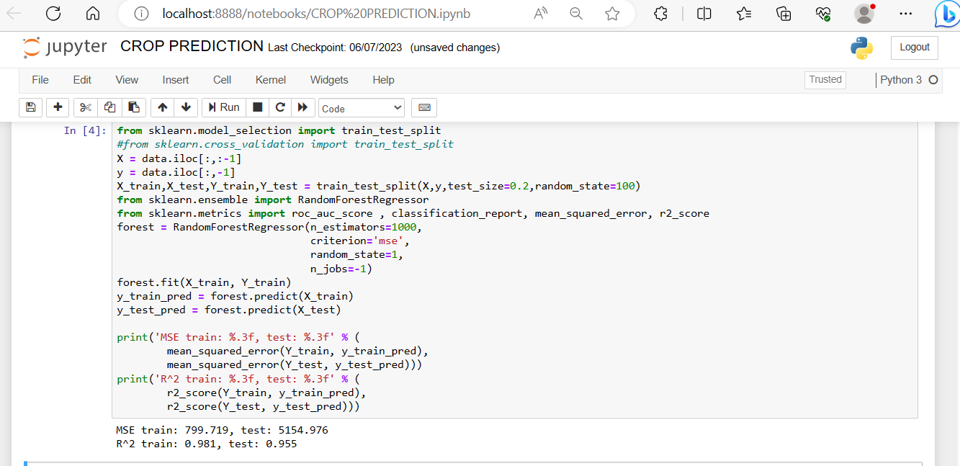



OUTPUTS

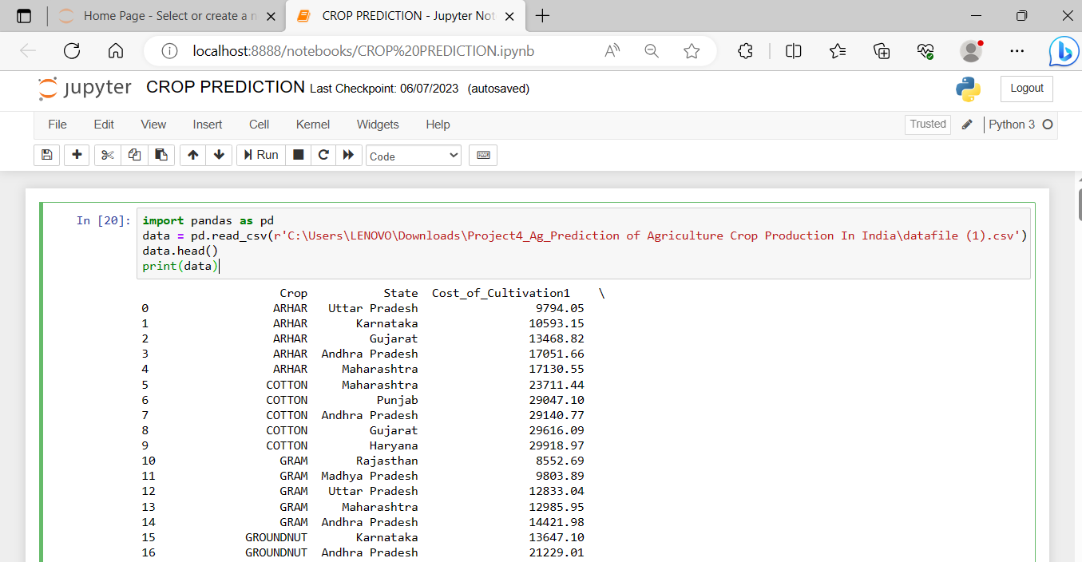

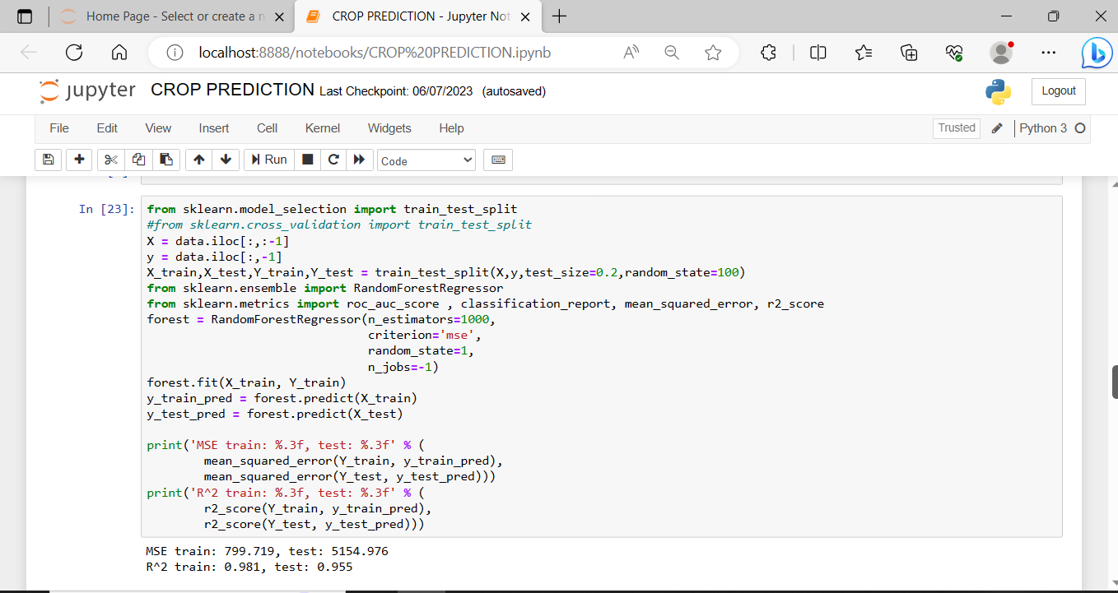

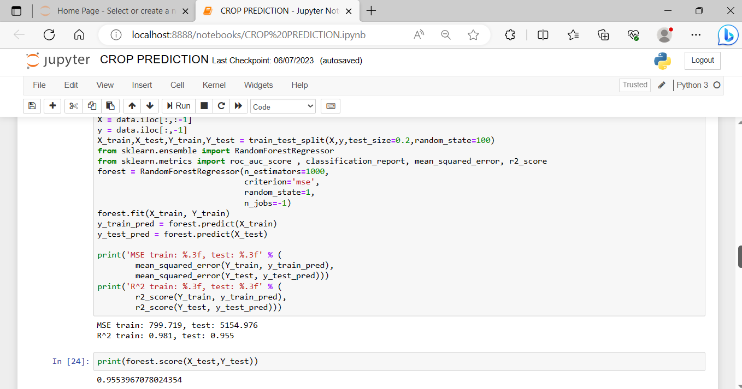

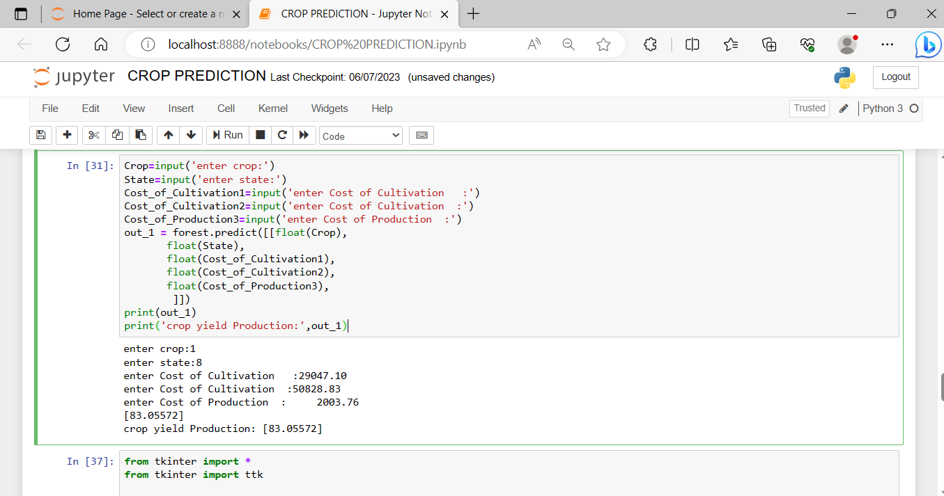

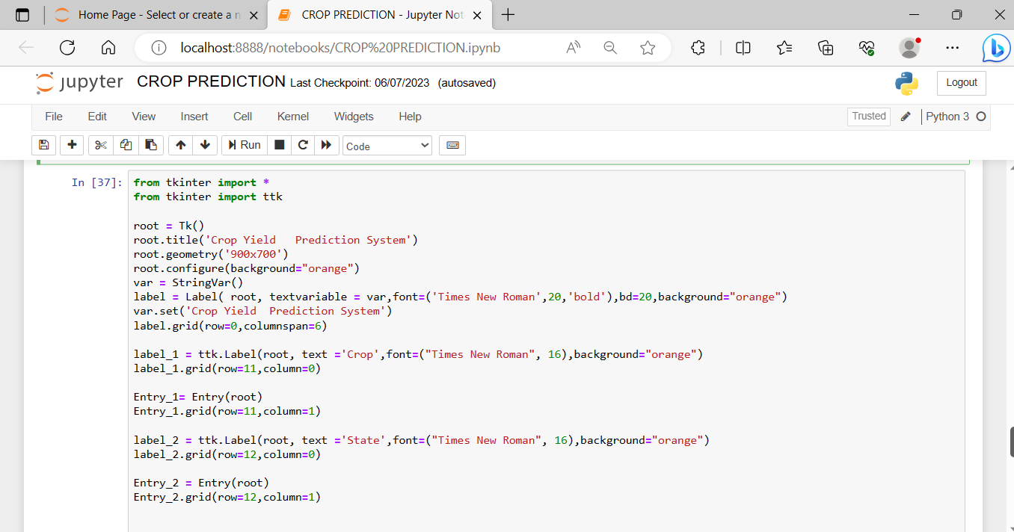

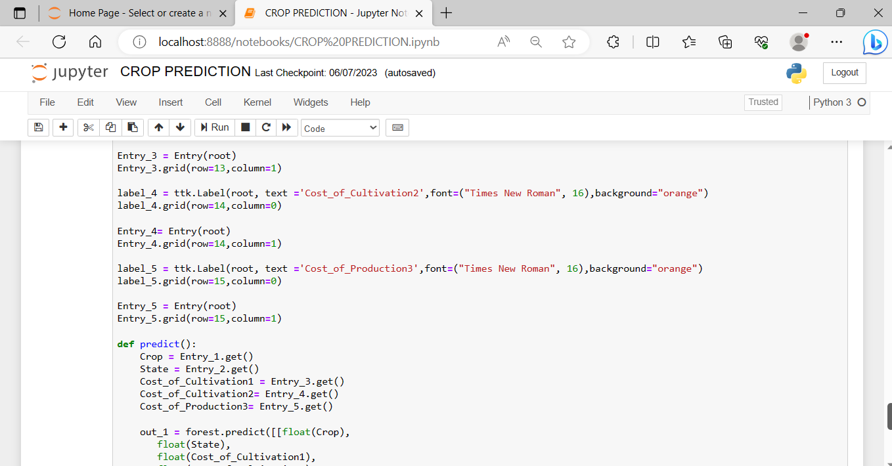

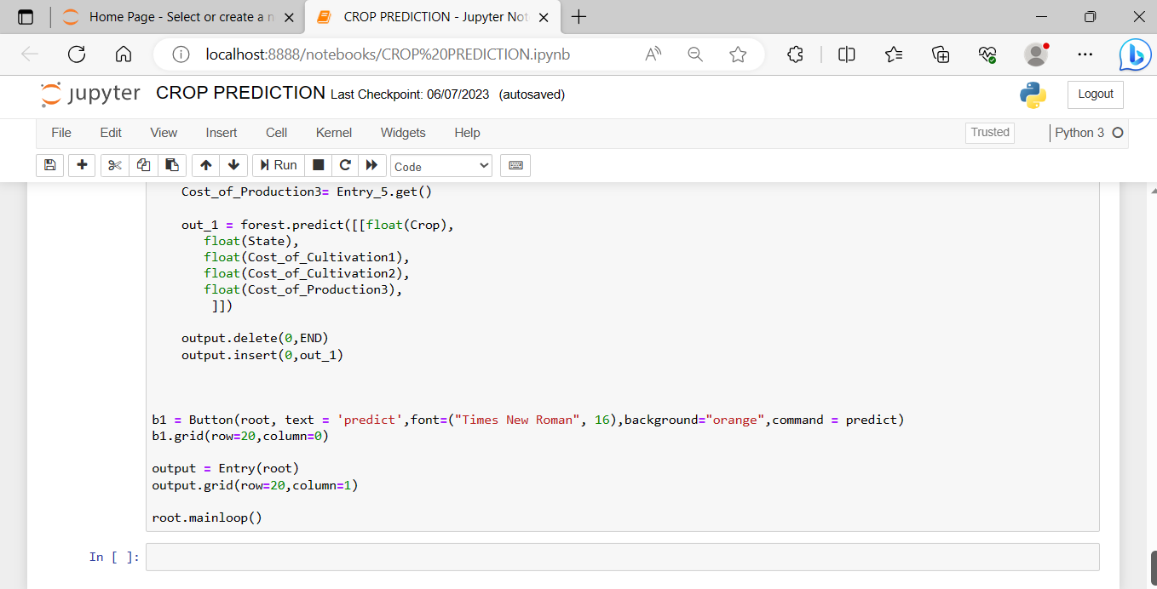

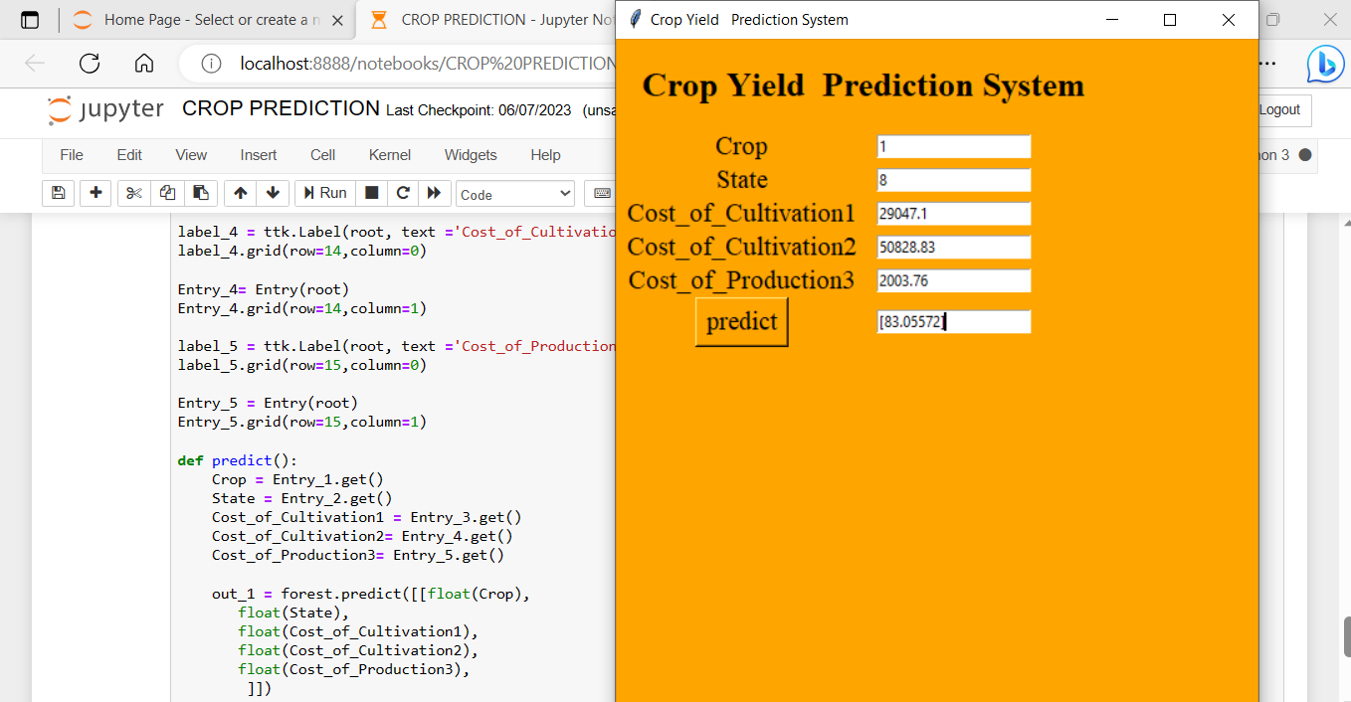

# My learnings

In this six week course we learnt lot of concepts based on our model. It will helpful for our career and improve our knowledge. First of all thank you so much for UPSKILL CAMPUS and uct for offering this wonderful opportunity at free of cost . We learnt so much things about data science and machine learning

Once again thank you so much.

**8 Future work scope**

In future we will develop our model it will provide which crop we need to provide based on that state and place , and need some clear interface and advance level prediction based on neural networks.